
Camp Activities for Relationship Building

Introductory
Name Game
Perspective Squares
Body Outlines

Mid-session
Legacies: An Experience of Dialogue
Masks and Culture
Pandora's Box: Difficult Issues
Historical Timelines
Identity with the Land

Ending
Transformation: High Points and Low Points
Unfinished Business
Riverside Closing

A collection of best-practices inspired by the
2005 Assimilation Weekend of North American Camps for the Middle East Public Peace Process
with contributions from

Seeking Common Ground
Denver, CO
Oseh Shalom ~ Sanea al-Salam Palestinian-Jewish Family Peacemakers Camp
San Francisco, CA

Compiled by Libby and Len Traubman
LTraubman@igc.org

Download this document at http://traubman.igc.org/campacts.pdf
Name Game

Objectives:
- Introductory experience. Ice breaker.
- Allows people to become newly-acquainted in a safe atmosphere.

Duration: 15 minutes

Elements:
- The group forms two circles, one inside of the other.
- As the circles rotate against each other and each person has a few seconds to share her/his name and hometown, then answer a new question announced at each new stop.

Staffing: One facilitator gives instructions to all participants.

Materials: Bell or whistle to announce each next question.

Location: Outside in grass, or any spacious area.

Staff: A facilitator. If needed, several staff to encourage continued movement.

Questions: (answers to be shared, after telling name and hometown):

- Favorite song
- Favorite dessert
- Number of siblings
- Meaning of your name
- Age
- Favorite hobby or past time
- Favorite sport to play or watch
- Favorite movie
- Favorite color
- Best vacation place
- Favorite food
- Number of languages you speak
- Something you are passionate about
- Something about you that would surprise me

Resources: Two documentary films stream online to illustrate this experience.
- PEACEMAKERS: Palestinians & Jews Together at Camp http://traubman.igc.org/vidcamp.htm
- THE PEACEMAKERS and their pursuit of understanding http://www.vimeo.com/10889360

Source: Seeking Common Ground
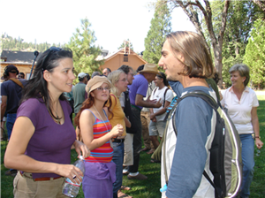
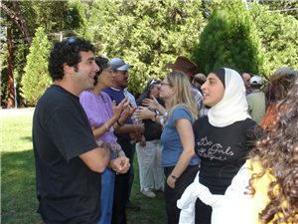
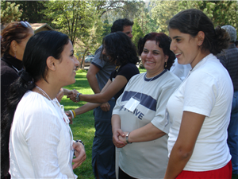
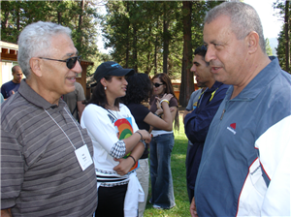
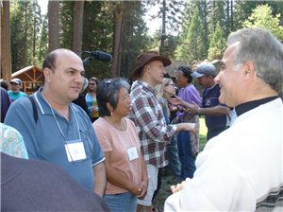
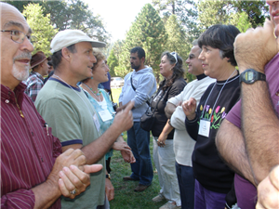
Perspective Squares

Objectives:
- Participants realize that others have diverse perceptions and views of life.
- There is more than one way, my way, to see a situation.
- People see 16, 17, 18, 40 and other numbers of squares.

Duration: 15 minutes

Elements:
- The whole group sits together.
- Facilitator says, “Take a minute to identify how many squares you see.”
- Invite individuals to come forward and share their answer and explain how they made their calculation.
- Ask other’s to give answers if different than the first. (5 minutes)
- Facilitator asks if the group has insights from the exercise and what they learned. (5 minutes)
- Clarify that working in a group helps you see how your view may be different than others’, and that a larger group of people have more insights and answers – collective intelligence -- than any one individual.

Staffing: Four -- one facilitator plus three helpers, two holding paper and one roaming with cordless microphone.

Materials: Pad of paper and black marking pen. Two microphones, one cordless.

Pre-Work: Draw 16-square grid on heavy paper to display in front of group.

Location: Spacious area.

Resources: Two documentary films stream online to illustrate this experience.
- PEACEMAKERS: Palestinians & Jews Together at Camp
http://traubman.igc.org/vidcamp.htm
- DIALOGUE IN NIGERIA: Muslims & Christians Creating Their Future
http://traubman.igc.org/vidnigeria.htm

Source: Seeking Common Ground
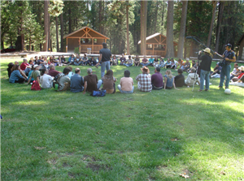
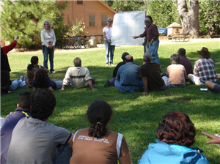
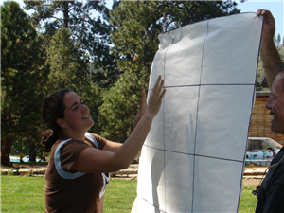
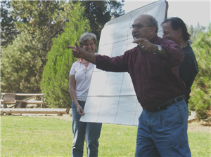
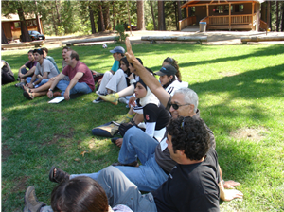
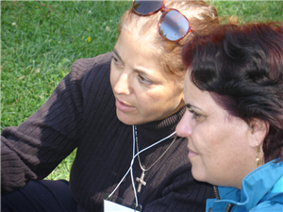
Body Outlines

Objectives:
- Introductory exercise,
- Allows people to become aware of their uniqueness and also similarities.
- Helps to overcome judgment and stereotypes.

Duration: 1-1/2 hours

Elements:
- Spacious room to allow lying on floor and drawing on paper. If space is limited, outline hands instead.
- Leader communicates instructions and distributes written instructions to each assigned pair/dyad. (5-10 minutes)
- Partners draw outlines of each other’s bodies lying on the floor, with one outline overlapping the other on a large construction paper. (5 minutes)
- “On your body’s outline, everywhere except where it overlaps your partner’s, draw or write that which describes what is unique to you. Include fears, hopes and dreams about the conflict to show differences. Also include your talents, gifts, and personal traits.” As each writes his traits, the partner is watching and listening. (10 minutes)
- “Write or draw things you appear to share in common, in the space where the bodies overlap.” (10 minutes)
- Create larger groups of 8-10 to share experiences. (5 min)
- Partners introduce each other, saying what was learned from the “other” and the experience. One way, no discussion. (~4 minutes per person
- Consider saving papers for future educational purposes.

Staffing: One facilitator gives instructions to all participants. Five staff float to remind participants about instructions and time.

Materials: Two 8’x4’ pre-cut pieces of butcher paper and a package of colored marking pens per dyad.

Pre-work: Pre-assign pairs. Clear space and place materials on floor ahead of time. Write instructions on large piece of paper to post on windows.

Resources: A documentary film streams online to illustrate this experience.
- PEACEMAKERS: Palestinians & Jews Together at Camp http://traubman.igc.org/vidcamp.htm
- THE PEACEMAKERS and their pursuit of understanding http://www.vimeo.com/10889360

Source: Seeking Common Ground
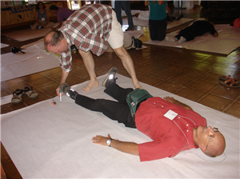
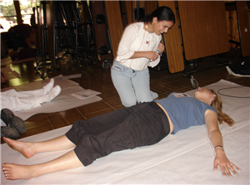
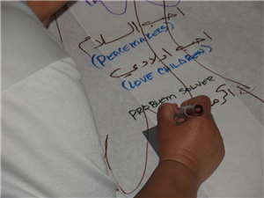
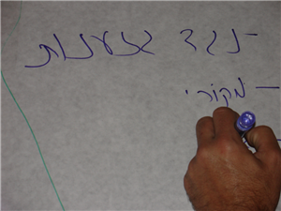
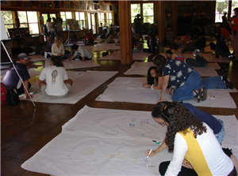
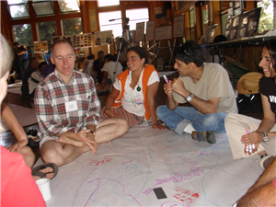
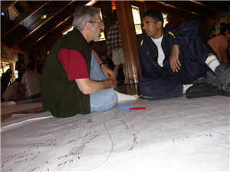
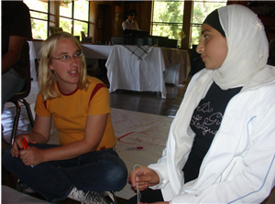
(with hand outlines)
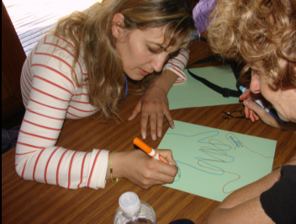
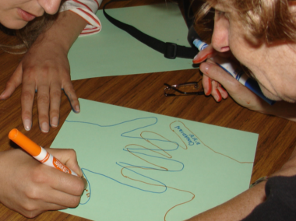

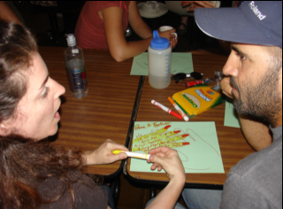
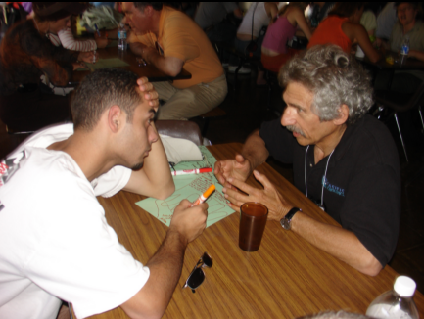

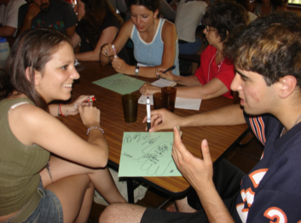
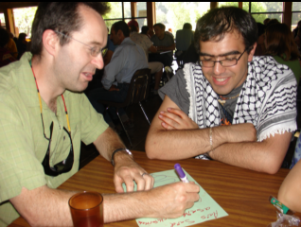

Legacies: An Experience of Dialogue

Objectives:
- Allows each person to share her or his life's narrative and relate to others.
- Each person experiences a new quality of listening-to-learn as well as being heard, while discovering that "an enemy is one whose story we have not heard.

Duration: 1-1/2 - 2 hours

Elements:
- Facilitator describes flow of whole experience.
- Prepare participants to experience authentic Dialogue, that rare form of engagement with it's new quality of deep, compassionate listening – without "yes,but." The motive is to learn more, expand one's own frame of reference, explore the speaker, and together discover new meaning and new social intelligence. Dialogue is between two individuals, and not between groups or institutions. Dialogue usually begins with personal narrative, to give the listener an insight into the humanity of the speaker. Dialogue is not:
- Conversation – casual, superficial, safe"
- Discussion – from percussion, concussion – batting around well-formed ideas, waiting for what you want to say next.
- Debate – one wins and is elevated, the other loses and is diminished, with the purpose to be right rather than learn or grow closer.
- Facilitator or another exemplar tells one's personal story of change and expanding identification including new perceptions about the "other." Or show a short video of two exemplars -- a Palestinian man and Jewish woman -- from the documentary film DIALOGUE AT WASHINGTON HIGH. The 18-minute portion is on the DVD and streaming at http://vimeo.com/77944663. Remind viewers to be aware of their quality of listening.
- Invite the participant to tell and hear their stories. Instruct them to select a partner -- to be in pairs, dyads.
- "Now, for a half hour you get to have this experience that almost no people ever get to have."
- "To hear each other's stories. To be truly heard. And to be able to listen to each other like almost never happens in our lives."
- "At first it may seem a little scary, but I promise you it's not. And the time will go by faster than you'd ever imagine."
- "In a moment, you will choose a partner – ideally someone who is not like you, perhaps someone you don't even get along with."
- "You will spend a half hour. For the first 15 minutes, one person will listen – only listen – while the other tells you her or his story."
- "You can begin many generations back, or even with your birth."
- "What did your family experience? Who were they? What were their high and low points? What was inspiring in your life and what was hard?"
- "What were you taught about others who were unlike you and your people? What have you learned and how have you changed?"
- "What has brought you to this point in your life in this classroom – today?"
- "For the first 15 minutes, one will be the Storyteller, and the other will be the Listener – to only listen in stillness."
- "But, for the last 5 minutes of that 15 minutes, the Listener will explore the Storyteller – inquire, to learn more from the person."
- "That seemed to mean a lot to you. Can you tell me a bit more about it?"
- "I was quite interested one thing you said. Would you say more about that?"
- "Then at the end of 15 minutes, you change. The Listener becomes the Storyteller, and the Storyteller will be the Listener."
- "Don't worry about time. Just focus on each other. I'll keep you fully informed about the time. It will go faster than you imagine."
- "Now choose a partner. Go to a quiet, comfortable part of the room. And begin."
- During each portion of listening and inquiry, the teacher announces to the pairs:
- when time is almost up. “Take one more minute to finish your present thoughts.”"Now choose a partner. Go to a quiet, comfortable part of the room. And begin."
- when to transition. “The Listener now becomes the Storyteller, and the Storyteller will be the Listener."
- Facilitator may drift from dyad to dyad to remind them, if needed, there is just one Storyteller and one Listener. “The Listener is listening only. The Storyteller is speaking.”
- Group assimilation completes this learning experience. (25 minutes)
- Facilitator instructs participants to return to a big circle, this time sitting next to their Dialogue partners.
- Ask participants to go around the circle to share by their self-selected pairs about the experience they just had.
- "Say a few sentences about your experience."
- "What was it like? What happened?
- "What did you realize from the experience and the stories you heard and told?"
- Let this be student-driven as much as possible, with a very occasional affirmation or question:
- "How was the quality of your listening?"
- "How did it feel to be listened to?"
- "What was it like to be a listener only?"

- Usually the unfolding group process reveals the different kinds of personal meaning and value – usually positive.
- The number of participants will determine how much time each person can share. If time is very short, ask for sharing from several dyads who are moved to do so.
- Depending on the nature of the group, in the final minutes it can be inspiring to close with a circle and affirmation of each other and the Dialogue.

Materials: Audio system with facilitator's microphone and two floating wireless microphones. Digital projector and laptop computer if DVD or graphics are used.

Pre-Work: Test all audio and video equipment far in advance.

Location: Spacious area for large, single circle and for pairs to find quiet, separated places for face-to-face engagement..

Leader: One facilitator. Perhaps staff to be remind dyads that the listener only listens.

Resources: Three documentary films stream online to illustrate this experience.
- DIALOGUE AT WASHINGTON HIGH http://traubman.igc.org/vidschool.htm
- CROSSING LINES IN FRESNO http://traubman.igc.org/vidfresno.htm
- DIALOGUE IN NIGERIA: Muslims & Christians Creating Their Future http://traubman.igc.org/vidnigeria.htm

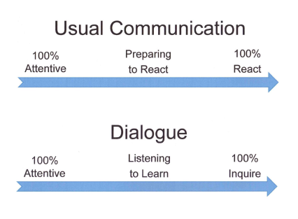

Source: Oseh Shalom~Sanea al-Salam and Jewish-Palestinian Living Room Dialogue
Useful graphics about communication and change are at
http://traubman.igc.org/changechartsall.pdf
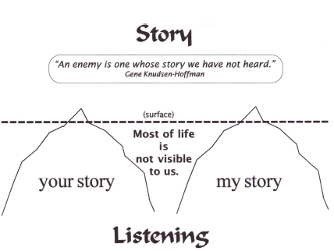
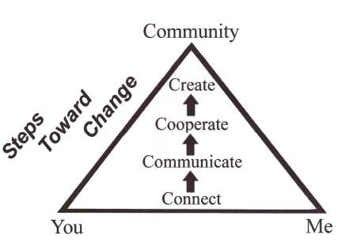

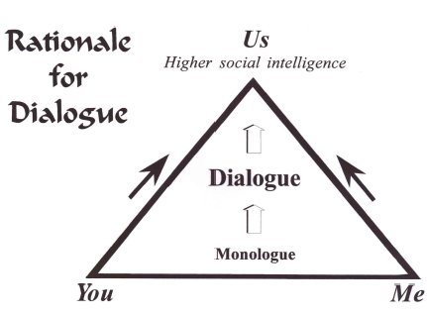
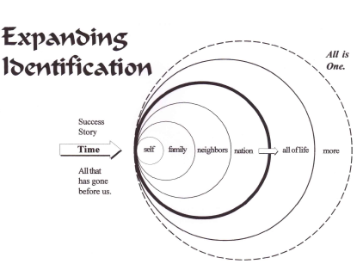

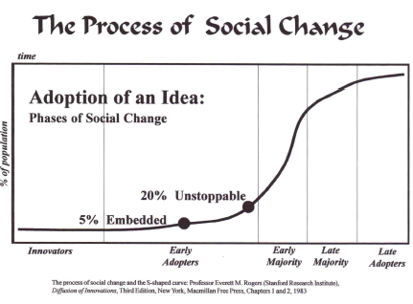
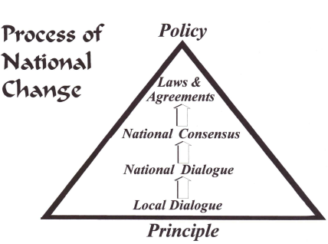

Masks and Culture

Objectives:
- See how one's culture shapes and influences personal responses to life.
- Increase self-awareness and closeness to one another by opening a window to oneself and common challenges universally faced in all cultures.

Duration: 2-1/2 hours

Elements: Large room or grassy field for reclining to draw on paper masks; leader; staff

Materials: Masks, paints or markers, ribbons to display finished masks, roving microphones. Order Papier-Mâché Masks from Nasco, Modesto, California, USA, http://www.enasco.com/product/9708291

Staffing: One facilitator gives instructions to all participants. Staff assistants distribute materials then float to remind participants about instructions and time.

Preparation: Clear space. Place masks, markers, ribbons, and audio equipment.

Instructions: (10 minutes) "Many of us wear masks we show to others, and by which we are known. This exercise is to consider the pressures and expectations on us from our own cultures that influence, shape, and control decisions, actions, and outward appearances in our daily lives. We'll discover these outer appearances and also discover who we really are, sharing what we learn with one another.

Decorate masks: (20 minutes) Pass out materials. In silence, participants in groups of five (5) ponder and create the masks they wear in their own communities. Use words, colors, symbols -- however you express yourself. "What do I show of myself to my own community or ethnic group?"

"For example, from my training I am polite and smiling most of the time with my family and friends while on the inside I feel restrained, worried, and angry about happenings at home and in the community, and frustrated and resentful that I cannot fully act on my own concerns, principles, convictions, and dreams for fear of rejection by my family, friends, and teachers."

Discover meaning: (60 minutes) "In your groups of five (5), you will now respond to a series of questions allowing each person two (2) minutes to share. Only that person speaks. The others only listen to learn, without any comments.
We will announce when to begin and when to move to the next person."

- Describe the mask you wear in your own culture. (10 minutes)
- How does your culture or group view you? (10 minutes)
- What masks have you worn here at the conference? (10 minutes)
- If we really knew you, what is your mask hiding? (10 minutes)
- Does your culture support or limit you from doing this type of co-existence work? Please explain. (10 minutes)
- What steps do you need to take to make your outer mask congruent with authentic you? (10 minutes)

Other questions to consider:
- What blocks you from pursing your dreams and passions?
- What do people fail to see about you?

Large group assimilation: (50 minutes) Small groups stay together while returning to the large circle.

Ask each group to share what they experienced. What did you learn? Would anyone like to share their mask with the large group? What did your group have in common? What are the main struggles we share in being our true selves in any situation? How would life be different if we each felt we could be ourselves all of the time?

The facilitator interjects minimally, rarely asking questions to help people express themselves and explore for new discoveries.

Display masks: (10 minutes) Complete the exercise by hanging the masks by ribbons in the meeting area.

Resource: A documentary film stream online to illustrate this experience.
- DIALOGUE IN NIGERIA: Muslims & Christians Creating Their Future http://traubman.igc.org/vidnigeria.htm

Source: Oseh Shalom ~ Sanea - al-Salam and Jewish-Palestinian Living Room Dialogue
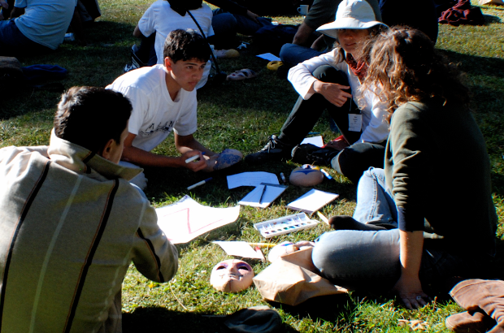
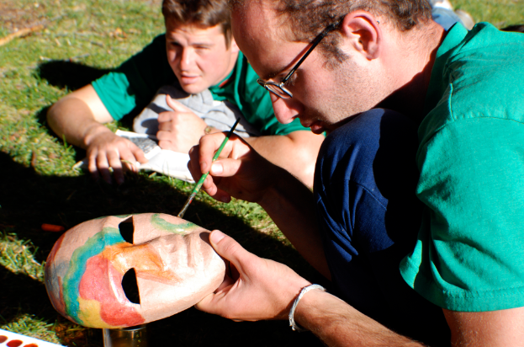
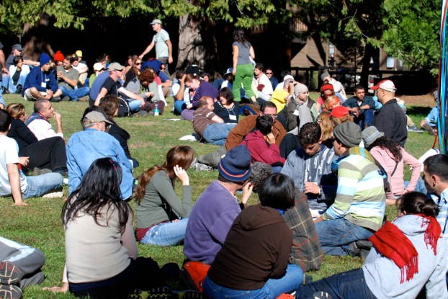

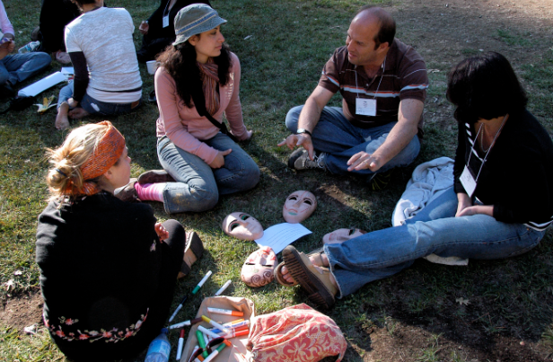

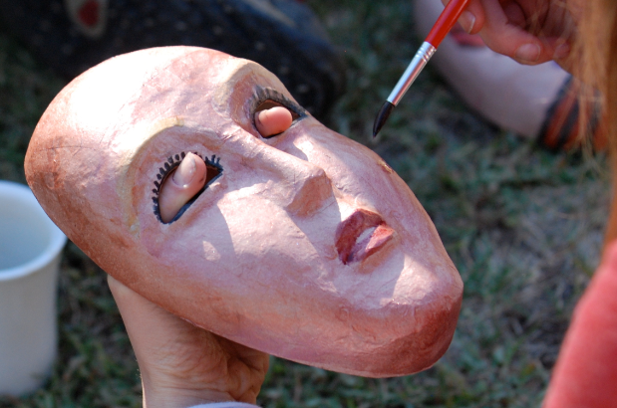
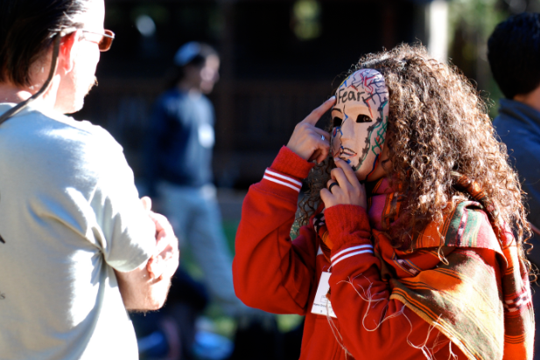

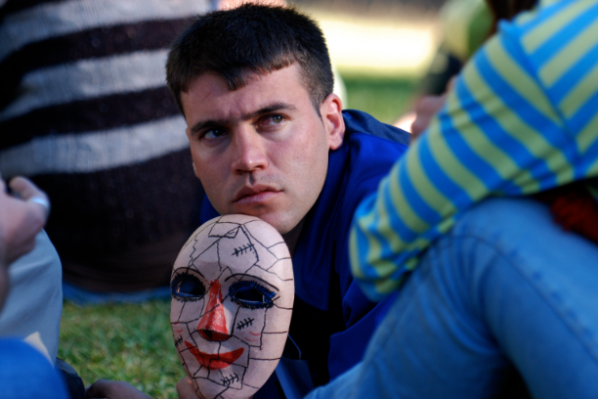
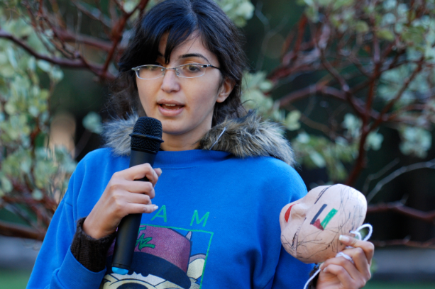

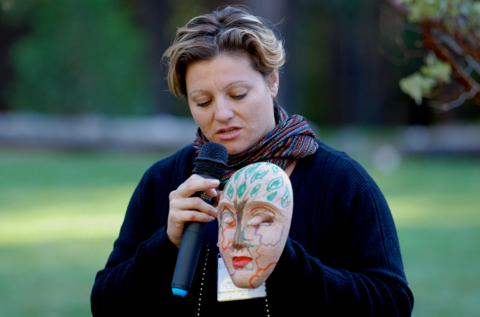
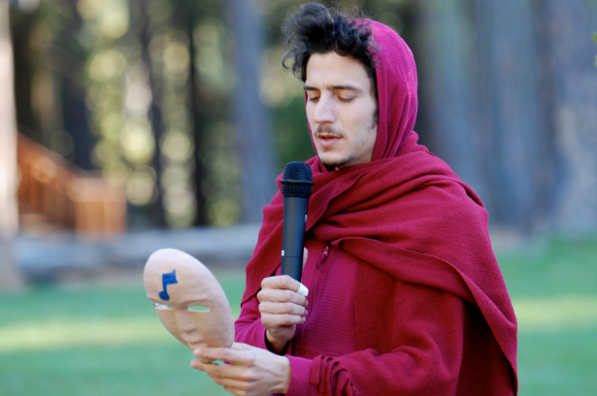
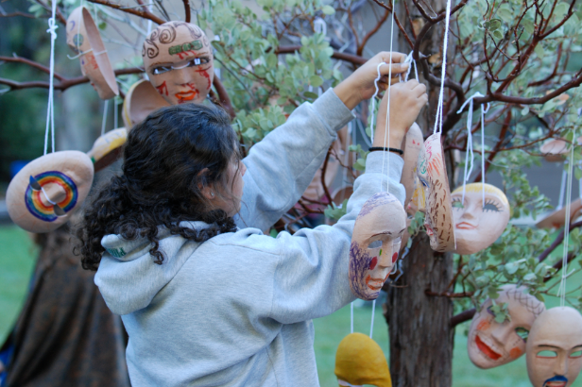
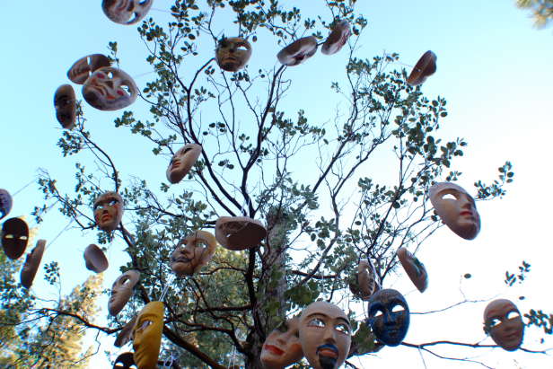
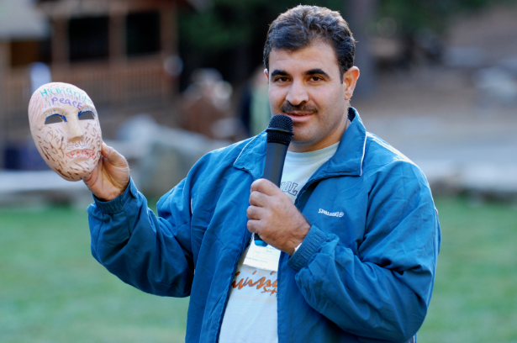
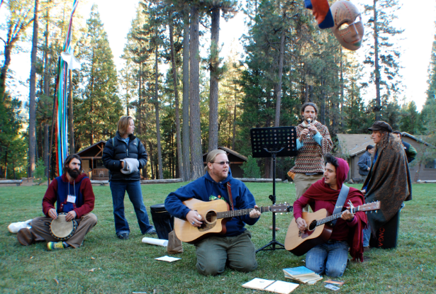
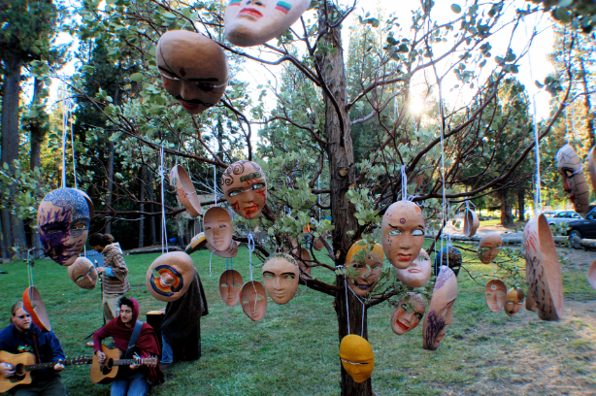
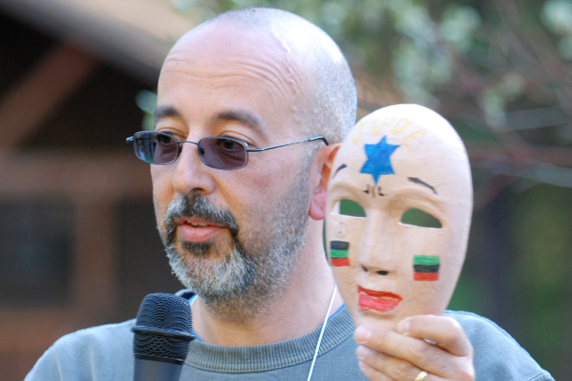
Pandora's Box: Difficult Issues

Objectives:
- Allow people to share deeply-held perceptions, fears, and hopes in a safe place without being threatened or questioned.
- Permit freely responding about difficult topics (“tough issues”) with a new quality of deep, compassionate listening-to-learn.

Duration: 1-1/2 to 2 hours

Elements:
- Sit in diverse groups of 4, forming a square with knees touching.
- Explain: There will be a series of 10 questions, with four minutes to respond to each. Each person gets 60 seconds to reply, then must stop. The facilitator will give a 10 second warning. Everyone must speak. There are no comments or questions -- no crosstalk. If people stop talking before time is up, the group waits in silence. Unfinished thoughts are okay. This exercise is not as much about sharing your position as about compassionate listening. You may hear what is not congenial to you, but try to listen to learn, listen without judgment. (10 minutes)
- Ask group to select order in which participants will answer questions.
- Facilitator asks questions, allowing 4 minutes (1 min. per person) for each of 10 topics. Warn "10 seconds" then say "change." (40 minutes)
- Create larger groups of 8 for facilitated assimilation. “How did you feel? What did you learn about others, about yourself, about life?” (30 minutes)
- Gather everyone in large circle for final assimilation. (40 minutes)

Staffing: One facilitator asks all the questions. A second nearby staff person helps with timing, and informs facilitator when to ring bell or say "change."

Materials: A clock for timing. Wireless microphones and audio system.

Location: Large space where groups of 4 can sit together and hear each other.

Sample questions related to the Middle East:
- What are your worries about being here this week/weekend?
- What would you most like for others to know about you?
- How would you describe the root cause of the conflict?
- How do you respond to the word “Jew”?
- How do you respond to the word “Palestinian”?
- What does Jerusalem mean to you?
- How do you react to the term suicide bomber?
- How do you react to the concept of right of return?
- How do you react to the concept of settlement expansion?
- What do you hope will come from a week/weekend like this?

Sample questions related to Nigeria:
- What are your worries about being here this weekend?
- What would you most like for others to know about you?
- What does the word "Muslim" mean to you?
- What does the word "Christian" mean to you?
- What does the word "Nigeria" mean to you?
- What does the word "indigenous" mean to you?
- What does the word "settler" mean to you?
- What does the word "security" mean to you?
- What traditions, symbols, or colors upset or inspire you?
- What is the biggest missing quality in our culture today?
- Who will change and lead?
- What do you hope will come from a weekend like this?

Questions for large group assimilation:
- What happened? What did you learn about yourself, others, life?
- What did you discover that was unexpected?
- What issues came up that you felt were left hanging and need more dialogue?

Resources: Three documentary films stream online to illustrate this experience.
- PEACEMAKERS: Palestinians & Jews Together at Camp http://traubman.igc.org/vidcamp.htm
- THE PEACEMAKERS and their pursuit of understanding http://www.vimeo.com/10889360
- DIALOGUE IN NIGERIA: Muslims & Christians Creating Their Future http://traubman.igc.org/vidnigeria.htm

Source: Seeking Common Ground and Oseh Shalom~Sanea al-Salam
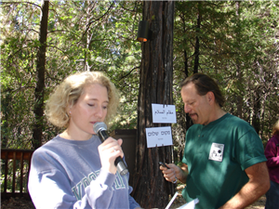
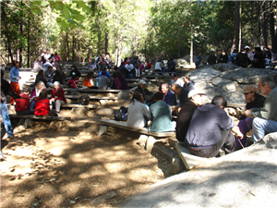
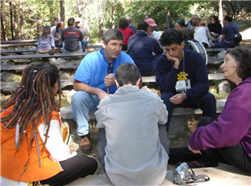
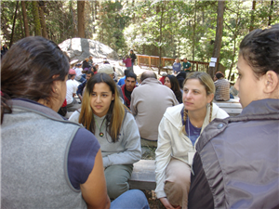
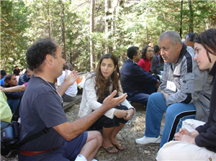
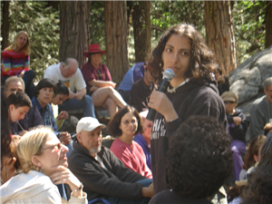
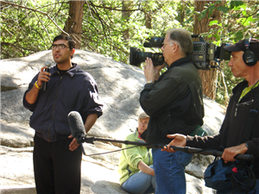
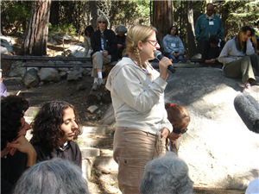
Historical Timelines

Objectives:
- Allows people to create a historical timeline, including personal elements.
- Share historical perspective and personal connection to it.

Duration: (1-1/4 hours)

Elements:
- Form pre-assigned groups of 8 people who identify with each other [Jewish Israelis, Palestinian Israelis, West Bank Palestinians, American Jews, American Arabs, neither Arab nor Jewish] (5 minutes)
- Ask people to create a historical timeline including personal elements [“I lost my brother during the 19__ bombing.”]. They should include relevant dates for them regarding the conflict. They can choose any beginning or ending they like. Ask them to pick a time in history that they or their family were personally affected. (30 minutes)
- Group by group, have participants hold up their outline for all to see. Each group chooses one or two spokespersons from the group to succinctly and clearly present the timeline to the larger group. Allow time for whomever else feels moved to add and express him/herself (5 minutes per group

Staffing: One facilitator to set context. One individual in each group to facilitate the process of producing the timeline elements.

Materials: Large pad of paper and marking pens for each group. Microphone is best.

Pre-Work: Pre-assign groups, if needed. Material distribution.

Location: Spaces for groups to sit in circles, plus drawing surfaces. Then a presentation area where vision and acoustics are good.

Resources: A documentary film streams online to illustrate this experience.
- PEACEMAKERS: Palestinians & Jews Together at Camp
http://traubman.igc.org/vidcamp.htm

Source: Seeking Common Ground
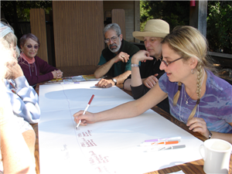
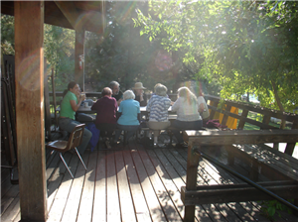
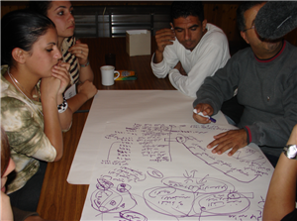
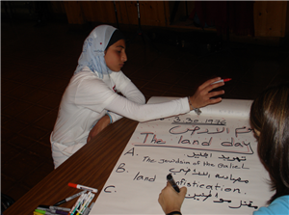
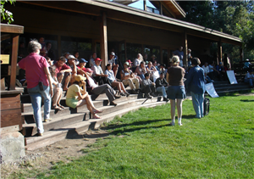
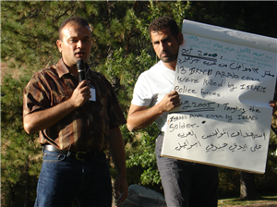
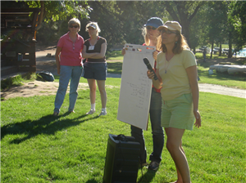
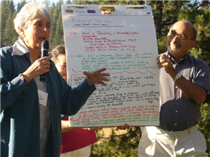
Identity with the Land

Objectives:
- Helps people express what the land means to them.
- Helps each one understand and accept differing and shared “meaning.”

Duration: 2 hours

Elements:
- Individual exercise.
- Ask people to write about their relationship to their homeland (Israel, US, Palestine or other). How has it changed, if at all, and how would you describe your relationship with your homeland today? (20 minutes)
- Play soft, neutral background music.
- After time to write, allow them to convert their writing into a visual representation with markers, magazine clippings, a collage or other art form (30 minutes)
- Break into smaller groups of 10 people each. (5 min)
- Ask participants to describe their artistic expressions and current relationship with the land. Others only listen, with no discussion. (3 minutes per person)
- Announce after dinner opportunity for further discussion.

Staffing: One person facilitates the large group, with a facilitator for each small group.

Materials: Pens and writing paper or pad for each person. Art supplies including paper, colored pens, pastels, and crayons. Stacks of magazines, scissors, glue sticks. Audio equipment. Microphone.

Pre-Work: Room set-up. Material distribution, Music selection.

Location: Large space with tables for writing and artwork.

Source: Seeking Common Ground
Transformation: High Points and Low Points

Objectives:
- Hear and share real life examples of transformation caused by trauma and difficulties, or unexpected assistance and new insights.
- Provide authentic stories to energize participants to re-evaluate their own life experiences, positions, choices, and personal potential, because "people become the stories they hear and the stories they tell."

Duration: 2-1/2 hours

Elements:
- Gather in groups of 8-10 diverse participants.
- We are going to think of events in our lives that influenced us. What moment was a low point that left you hopeless, scared, angry, depressed? Then think of an event that was a turning point and gave you hope, and new life and purpose?
- In silence, write or ponder for 20 minutes first about a very difficult personal situation. What happened? How did you feel?
- Then also write about a difficult challenge you overcame, transforming it into a new opportunity or new relationship.
- After 20 minutes, in the small groups each person will share both experiences in 4 minutes. There is only listening-to-learn with no discussion or crosstalk.
- After each has shared, take time to dialogue about what was heard and what you are learning together. What touched you? What happens when someone gets stuck in a Low Place? What enables people to shift and move into a place of hope? How can we help each other? What can a person do to help oneself and a community to continue moving toward a High Place?
- Tell The Wolf Story from Native American tradition. The young boy goes to his father and says “Father, I dreamed there are two wolves fighting inside of me. One is a good wolf and one is a bad wolf. Which wolf will win?” The Father responds: “The one that you feed will win.”
- We can choose where to give our time, attention, creativity, and love.

Staffing: One person facilitates the large group, with assistance with timing.
Materials: Microphone in front, plus floating wireless microphones.
Location: Large space where many groups of 8-10 can sit together.
Resources: Two documentary films stream online to illustrate this experience.
- THE PEACEMAKERS and their pursuit of understanding http://www.vimeo.com/10889360
- DIALOGUE IN NIGERIA: Muslims & Christians Creating Their Future http://traubman.igc.org/vidnigeria.htm

Source: Seeking Common Ground and Oseh Shalom~Sanea al-Salam
Unfinished Business

Objectives:
- Opportunity to express lingering thoughts, and leftover feelings and questions..
- Public expression of learning, self-reflection, apology, resolution, intention, and of work remaining to be done.
- Affirmation of progress together.

Duration: 1-1/2 hours

Elements:
- Return to same groups as in the Difficult Issues experience
- Respond to concluding topics of importance, in less structured way.
- Facilitator asks one question at a time, allowing time for each person to have 2 minutes within the small groups.
a) What questions remain unanswered for you?
b) What are you taking home with you from this week/weekend?
c) What are you going to do when you go home?
- Offer floating microphone to the group to answer: “Based on this last exchange, what do you think the whole group should hear?”
- Close with affirming music.

Staffing: One person facilitates the large group, with assistance to judge timing.

Materials: Microphone in front, plus floating wireless microphone.

Pre-Work: Plan closing music selection and music leaders.

Location: Large space where many groups of four can sit together.

Resources: Two documentary films stream online to illustrate this experience.
- PEACEMAKERS: Palestinians & Jews Together at Camp http://traubman.igc.org/vidcamp.htm
- THE PEACEMAKERS and their pursuit of understanding http://www.vimeo.com/10889360

Source: Seeking Common Ground and Oseh Shalom~Sanea al-Salam

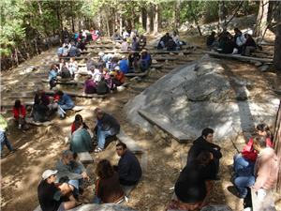
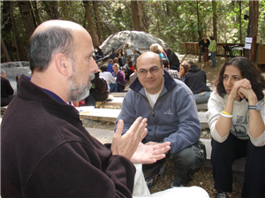
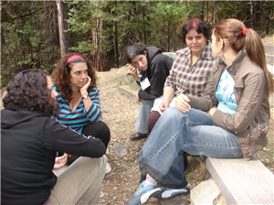
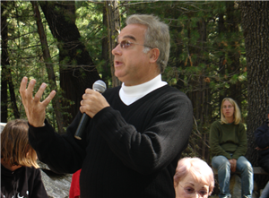
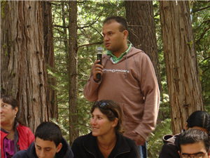
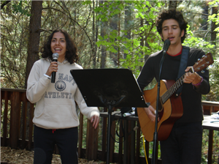
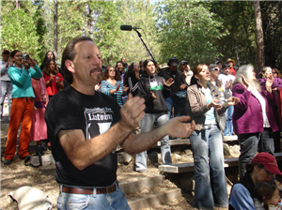
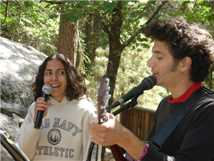
Riverside Closing

Objectives:
- Allows everyone to share their experiences, insights and feelings about the weekend and the situation in the Middle East.
- Allows people to focus on hope and action.

Duration: 1-1/2 hours

Elements:
- People congregate in camp. (10 minutes)
- Walk together (or elders may be driven) to the river. (15 minutes)
- This will be a spontaneous coming-together of pairs to wash one another’s hands in the river and express your hopes and blessings for each other. Change partners a few times. (45 minutes)
- Walk together or drive back to the camp. (15 minutes)

Staffing: Low-key facilitator encouragement by initiating at the river with a partner.

Materials: Vans to transport elders to the river.

Resources: Two documentary films stream online to illustrate this experience.
- PEACEMAKERS: Palestinians & Jews Together at Camp http://traubman.igc.org/vidcamp.htm
- THE PEACEMAKERS and their pursuit of understanding http://www.vimeo.com/10889360

Source: Oseh Shalom~Sanea al-Salam


