CONVERSATIONS FOR PEACE: AN ORAL HISTORY OF THE PATH TO PALESTINIAN AND JEWISH RECONCILIATION IN TWO CALIFORNIA COMMUNITIES
_________________________________

A Project

Presented to the

Faculty of

California State University, Fullerton
_________________________________

In Partial Fulfillment

of the Requirements for the Degree

Master of Arts

in

History
_________________________________

By

Allison Helise Rubalcava

Approved by:

____________________________________________ ____________
Dr. Arthur Hansen, Committee Chair Date
Department of History

____________________________________________ ____________
Dr. William Haddad, Member Date
Department of History

____________________________________________ ____________
Dr. George Giacumakis, Member Date
Department of History
ABSTRACT

This study examines the interplay of memory, myth, and history in the construction of collective memory, collective identity, and historical narrative. The result of this interplay is conflicting historical narratives. In spite of conflicting narratives, a number of contemporary Palestinian-Jewish organizations in the United States use dialogue as the foundation of their cooperative efforts to demonstrate that peaceful coexistence is possible between Palestinians and Jews. In the process a new collective identity is formed based on historical and biblical commonalities rooted in religion and culture. This project’s use of oral history technique is two-fold. First, oral history provides the narrative that comprises the bulk of this study and is used to broaden understanding of the Arab-Israeli conflict and issues of collective identity formation. Second, oral history (or dialogue) is the vehicle used by the peace groups in their meetings and community outreach projects. The two groups included in this study are representative of a larger grass roots movement of conflict resolution founded in dialogue.

TABLE OF CONTENTS

ABSTRACT………………………………………………………………… i

INTRODUCTION………………………………………………………….. iv

PART I
History, Theory, and Historiography…………… 1

Chapter
I. This Land is Your Land, This land is My Land:
Historical Identification of Arabs and Jews with the
Land of Palestine and its Manifestation into Nationalism……………… 2
The Jewish Situation………………………………………… 3
The Arab Situation………………………………………….. 9
Imperialism and Nationalism……………………………….. 13
The Palestinian Situation……………………………………. 20
The Current Crisis…………………………………………… 22

- My History is Better Than Your History:
The Implications of Collective Memory and Revisionism for
Jewish and Palestinian Identity………………………………………… 25
Historiography……………………………………………… 27
Collective Identity and Collective Memory…………...……. 33
Conflicting Narratives………………………………………. 35
Reconciliation……………………………………………….. 40

PART II
The Peacemakers Speak for Themselves……………. 41

III. The Establishment of the Dialogue Groups……………………………. 48

IV. Nobody has a Monopoly on Suffering…………………………………. 60

V. Who am I, Who are You, Who are We?………………………………… 87

VI. Areas of Conflict……………………………………………………….. 122

VII. Blessed are the Peacemakers……………………...…………………… 154

VIII. Visions of Peace………………………………………………..…… 189

IX. Can They Make Peace?………………………………………………. 202

APPENDICES……………………………………………………………… 208

- Arab-Israeli Conflict Timeline………………………………….. 209
- Maps…………………………………………………………….. 211
- Dialogue Group web-index……………………………………… 224
- Dialogue web-resources…………………………………………… 227
- Cousins Club of Orange County Documents…………………… 230
- Jewish-Palestinian Dialogue Group of San Mateo Documents…… 241

BIBLIOGRAPHY…………………………………………………………… 249

INTRODUCTION

We are a people without a state and therefore a people without credentials, without representation, without the privileges of a nation, without the means of self-defense and without any say in our fate.
David Ben-Gurion, 1945.

David Ben-Gurion, Zionist leader and first prime minister of Israel, asserted the right of the Jews to have a homeland safe from persecution with the political powers of a recognized state, a goal achieved in the 1948 war in which Israel declared independence. It is ironic that Ben-Gurion’s words can also be read as a prophecy of the Palestinian experience after the birth of Israel.
The core issue for both Jews and Palestinian Arabs is identity, a person’s connection to others and their connection to a land, expressed through collective memories that lead to a collective identity. Frequently in the modern world, issues of identity and the sense of belonging lead to nationalistic movements when power and control over one’s destiny is desired. The “Holy Land” reflects Palestine’s religious territorial identity. For Jews the Holy Land is the land of the Jewish biblical kings David and Solomon, and Jerusalem is the site of their sacred temples; for Christians this is the land of Jesus’ birth and the source of Christianity and Jerusalem is where Jesus last preached, was crucified, and then resurrected; and for Islam, a faith that also reveres the Judaic and Christian prophets, Jerusalem is the site of the Prophet Muhammad’s ascension to heaven on a night’s journey from Arabia. Likewise, Palestine is the land many Palestinians have lived in for centuries, and Jews have also had a continual presence in the land for thousands of years. Palestine holds both political and religious territorial identities for both Jews and Palestinians. The varied religious, political, and cultural collective identities that Jews, Muslims, Christians, Palestinians, and Israelis experience in regard to Palestine are continuously competing for superiority. However, interfaith and intercultural dialogue groups seek to merge these identities into one shared identity.
This oral history project seeks to examine the dynamic nature of collective identity formation through the experiences and reconciliation efforts of California-based Palestinians and Jews who belong to either the Cousins Club of Orange County or the Jewish-Palestinian Living Room Dialogue Group of San Mateo County, two encounter groups engaging in dialogue. The common thread between the dialogue groups is their affirmation of the basic humanity of Jews and Palestinians as well as the mutual acceptance that both communities have suffered tremendous spiritual, material, and physical losses. Jews and Palestinians both share suffering by virtue of dispersal and exile from their homelands and as a consequence of the loss of loved ones in violent wars. These common memories tie the Jews and Palestinians together, enabling group members to form a new and united cultural memory. The Cousins Club and the Living Room Dialogue Group base their respective dialogue on a common heritage reaching back in time well before the modern conflict. In fact the name “Cousins Club” is founded on the historical commonality of a shared Semitic heritage and of religious ties to the patriarch Abraham.
This study emphasizes the historiographical and methodological implications of memory, myth, objectivity, and truth. Memory and history are intertwined concepts frequently allowing the emergence of conflicting narratives of particular episodes on the historical timeline. Regarding Palestine, the question of conflicting historical narratives are infuriating some and invigorating others as scholars begin to re-tell the story of Israel and Palestine from perspectives other than the widely accepted Zionist viewpoint. Rather than focus on the differences between the historical narratives of the Jews and Arabs, group members look for issues that unite people around constructive changes, thus reducing the divisiveness of ethnic and religious tensions. These groups have a goal of reducing the disparity between the differing historical narratives of the Jews and Palestinians and minimizing stereotypes of one another through face-to-face dialogue that promote accommodation rather than confrontation.
History is the record of the human experience. Traditional primary sources including documents, letters, treaties between governments and correspondence between nations, all provide excellent understanding of the causal relationship between historical events. Thus, a document such as the Balfour Declaration has tremendous explanatory value in determining the origin of the Arab-Israeli conflict. However, personal testimonials of history facilitate a greater depth of understanding; and oral history is an excellent method for gaining insight of the experiences of marginalized and under-represented people. There are some that would refute the validity of oral testimony in the conveyance of real or true history; however, one should keep in mind that much of our knowledge of past times is based upon oral tradition. Oral testimonies offer the raw material for a more complete historical narrative and the oral histories recorded for this study remind us of the humanness of our experiences.
Chapter One is an overview of the history of the Israeli-Palestinian conflict from both the Zionist perspective and the Palestinian perspective illustrating the attachment of each to Palestine. This chapter provides the reader with an historical framework to understand the transcribed oral histories of the Jews, Israelis, and Palestinians who participated in the study. Chapter Two draws on the theories of the social sciences and social historians in the discussion of collective memory and the formation of collective identity and the impact of such on historical narrative. These social theories are used to explain the formation of collective identities and their culmination into nationalistic movements—the primary cause of conflict in Palestine. In a postmodern world that questions absolute truth, social theories have been employed by historians to focus on the narrative of underrepresented peoples encouraging a broader understanding of history. Also incorporated into the chapter is a historiographical review that demonstrates the complicated issue of truth for historians and the impact of revisionist histories of Israel as the narratives of Palestinians are validated and accepted by scholars further indicative of the dynamic nature of historical discourse. The activities of grass-roots dialogue groups suggest a wider recognition of the Palestinian experience that is mirrored in the new historiography that questions our understanding of Israeli history.
Memory has played a significant role in shaping the many historical narratives of the Arab-Israeli conflict. Well aware that historical narrative can be molded by memories, the Cousins Club of Orange County and the Jewish-Palestinian Living Room Dialogue Group of San Mateo County actively seek to bring two divergent histories of Palestinians and Jews into closer harmony in order to affect peaceful coexistence.
Over the course of several years (1997-2001), I tape-recorded interviews with Palestinian born Christian and Muslim Arabs, Israeli born Jews, along with other interested parties belonging to one of the two dialogue groups included in this study. Part Two includes the edited transcriptions of the interviews conducted for this study that are divided thematically into chapters Three through Eight and follow the usual progression of thought and interaction experienced in dialogue meetings. These chapters also parallel the issues of memory, identity–both personal and collective–history, and our understanding of truth in historical narrative discussed in Part One. The oral history chapters focus on reconciliation and accommodation, two significant goals of the dialogue groups. The reconciliation experiences of the people participating in the encounter groups mirror the validation of the Palestinian perspective found in the new historiography as well as demonstrating the group’s ability to create a collective identity.
Chapter Nine, the study’s conclusion, reevaluates the connection between memory, historical narrative, and collective identity by reflecting upon the possibility of peace in Palestine and how effective or realistic the efforts of the dialogue groups are for expanding their vision of peace via the new shared collective memory they have created among themselves.
Today, Israel is a politically recognized nation and it is both the inhabitant Palestinian Arab population and the Diaspora Palestinian Arabs that continue to seek the same political recognition and the autonomy of a nation-state as so eloquently asserted by Ben-Gurion in this introduction’s epigraph. This study’s major goal is to add dimension to the Arab-Israeli conflict and the efforts for peace through the oral testimony of those who have experienced the trauma of the conflict and work toward cooperation between what have become traditional intractable enemies
PART I

History, Theory, and Historiography

CHAPTER ONE

This Land is Your Land, This Land is My Land:
Historical Identification of Arabs and Jews with the Land of Palestine and its Manifestation into Nationalism

How did he give it to you? Do you have a piece of paper signed God?
Nabil Dajani

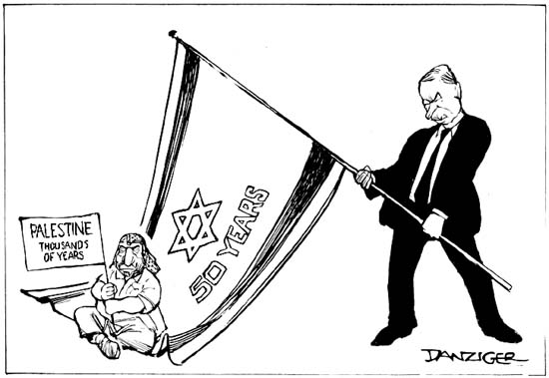

The Jews and the Palestinian Arabs both claim the land of Palestine as their own and both communities have validity to this claim of belonging and ownership due to their lengthy historical ties to Palestine. Because of these attachments to the land of Palestine, or Zion, or Israel, both the Palestinians and the Jews created a collective memory based on family heritages that honor the spiritual, social, and cultural customs that incorporated identification with the land of Palestine. This collective identity intensified during the late nineteenth and twentieth century as both groups of people sought political sovereignty in Palestine via competing nationalisms. Palestine has been in the collective memory of the Jews for close to three thousand years and they have incorporated into their daily prayers the desire and longing to return to the biblical homeland. Likewise, Palestinian Arabs have established and maintained centuries-old communities in Palestine. This chapter is intended to aid the reader’s understanding of the strong historical attachments of Jews and Palestinians to the land of Palestine.
The Jewish Situation

On that day the Lord made a Covenant with Abraham, saying, “To your descendants I give this land, from the river of Egypt to the great river, the river Euphrates.”
Genesis 15:18

On the ninth of Av in 70 CE, Titus destroyed the Temple, thus concluding the Roman-Jewish War. Although the Jews held on to a number of outlying fortresses for several years, the last remaining outpost, Masada, fell in 74 CE, with its inhabitants committing ritual suicide to avoid capture. The Jews were now dispersed. But Judaism was not dependent upon Jerusalem and the Temple; the threads that held the Jews together were faith in the covenant with Abraham, the Torah, and tradition.
The Enlightenment brought about the emancipation of the Jews in many Western European countries, thereby affording Jews an opportunity to assimilate into their communities. Jews progressed in position and class standing and became nationals of their home country. Judaism became a religious identity, separate from national identity. However, anti-Semitism did not disappear and seemed to increase with greater Jewish assimilation into mainstream European culture. Assimilation continued to garner support among some leaders of the Jewish community, though the more secularized and political Jews argued for a separate Jewish homeland.
Three factors–the Russian Pogroms, the new scientific anti-Semitism in Germany based on racial superiority, and the Dreyfus Affair–contributed to the immigration of Jews from their various host countries to Palestine and the subsequent identification of Jews as a separate nation during the late nineteenth and early twentieth centuries.
In Russia, Jews were forced to live in the Pale of the Settlement and were subjected to attacks and massacres instigated by government officials. In response to the Russian Pogroms Jews sought escape from Eastern Europe and migrated to Palestine and the United States. Anti-Semitism in the form of pogroms was the primary cause of Russian immigration to Palestine and Jews began to trickle in during the late nineteenth century, and by 1882 there was a larger influx from Eastern Europe. By 1879 the German Anti-Semitic League was established in Germany and called for discriminatory laws against Jews. These types of anti-Semitic groups (rather then anti-Jewish) based their ideas on a foundation of racial law and claimed that mixing of racial groups was corrupting. It was stated that the Jews were of a different race, the Semitic race. The Dreyfus Affair proved pivotal in the development of Jewish Nationalism.
France, the first European country to eliminate laws that applied specifically to Jews, saw the return of anti-Semitism in the Dreyfus Affair. Alfred Dreyfus was a well
assimilated French Jew serving as an officer in the French military. In 1894 he was falsely accused and convicted of treason. In 1899 one of the French officers confessed his culpability and then in 1906 Dreyfus was retried and his conviction overturned.
The Dreyfus Affair had a dramatic effect on Theodor Herzl, a Viennese journalist covering the trial, who subsequently became the founder of political Zionism. Regardless of the level of assimilation Jews assumed they enjoyed, the Dreyfus Affair led Herzl to believe that complete assimilation was impossible; the Jews would always suffer persecution. It was clear to Herzl that the Jews would never achieve equality and assimilate completely in host countries, thus solidifying his view that there was a need for a Jewish homeland–a sanctuary for Jews that would enable the Jewish people to achieve normalcy in their lives. Herzl’s view was articulated in the pamphlet Der Judenstatt (1896). Therein he examined the “Jewish question” and concluded that it was “neither a social nor a religious one . . . It [was] a national question . . . we are a people— one people,” and the cause of anti-Semitic tension arose because Jews were a nation of people living in someone else’s country. The only solution would be a homeland for the Jews Herzl believed, further outlining a plan for establishing such a homeland. In 1897 Herzl organized the First Zionist Congress that met in Basel, Switzerland. The results were the establishment of the World Zionist Organization (WZO) and the Basel Declaration that defined the objective of Zionism as the creation “for the Jewish people a home in Palestine secured by public law.” Clearly, the Zionists were now organizing a modern nationalistic movement seeking political sovereignty.
The first goal was the promotion of settlement in Palestine. This was accomplished through the WZO and the Jewish Agency, two organizations whose activities were later authorized in article four of the Palestine Mandate, a document ratified by the League of Nations as a part of the World War I settlement. The document recognized the need for a central Jewish entity with which the British government could negotiate the administration of the mandate. The WZO became this “Jewish Agency” and operated as a quasi-government during the mandate period. David Ben-Gurion was the head of the agency whose primary goal was to bring Jews to Palestine. The Zionist phrase of “A land without people for a people without a land” became associated with Herzl’s political Zionism. The goal was to populate Palestine with Jewish communities as quickly as possible.
By 1914 two organized waves of immigration to Palestine had occurred. The Jewish population swelled to 85,000, of which 60,000 were European immigrants. The other 25,000 Jews were of Arab descent and did not necessarily agree with the Zionist goals. The ever-growing population of European Jewry whom had particular designs for the land of Palestine understandably threatened the 600,000 strong (non-Jewish) Arab population.
Prior to the Zionist movement, Palestinian Arabs and Palestinian Jews had not had many conflicts with each other. However, problems arose between Jews and Arabs when the foreign Jews migrating from various parts of Europe and America became intent on restoring the biblical Jewish Nation. Ahad Ha-am, a Russian intellectual who did not support Herzl’s goals, negated the idea of Palestine as a land without people for a people without a land. He instead asserted that the Jewish problem could be remedied only by a cultural and spiritual revival and not by an immediate and rapid population of Palestine driven by the political motive of establishing a state. Ha-am also recognized the Arab presence in Palestine in 1891 when he said:
We abroad have a way of thinking that Palestine today is almost all desert, uncultivated wilderness, and that anyone who wishes to buy land there can do so to his heart’s content. But that is not in fact the case. It is difficult to find any uncultivated land anywhere in the country . . . The Arabs, especially the townsmen, see through the activities in their country, and our aims . . . But if the time should ever come when our people have so far developed their life in Palestine that the indigenous population should feel more or less cramped, then they will not readily make way for us.

Ha-am prophetically recognized the impending problem between the Zionists and the Palestinian Arabs. Palestine was not a land without people. The Zionist perspective of Vladimir Jabotinsky, the founder of the Union of Revisionist Zionists, represents a stark contrast to Ahad Ha-am’s desire for a Jewish cultural and spiritual revival in 1925. Jabotinsky’s minority group rejected partition of Palestine and advocated the establishment of a sovereign Jewish State. Jabotinsky believed that the claim of the Jews eclipsed the claim of the Arabs to Palestine, especially considering the number of established Arab states in the Middle East.
Unfortunately, both peoples believe that the land of Palestine is exclusively theirs and is indivisible. Palestine is the land of the Patriarchs and Islam’s claim to the land includes not only a reverence for the Biblical Fathers, but also the conviction that Jerusalem is the place where Muhammad ascended to heaven from the Temple Mount and met with God. The Dome of the Rock, built on the site of Muhammad’s ascent to heaven, is Islam’s third holiest site. For centuries, many Palestinian and Syrian Arabs claimed this land as their homeland. For Jews, Palestine is the biblical homeland. Palestinians and Jews associate their heritage with the land of Palestine/Israel, which holds special historical significance for them both.
During the period of the British Mandate, consistent with the spirit of the Balfour declaration, Jewish immigration to Palestine steadily increased. Between 1919 and 1920, ten thousand Russian Jews came to Palestine as settlers. In a speech on March 28, 1921, Winston Churchill expressed to the Palestinian Arabs the moral right of Jews who had been “scattered all over the world” to have a national home “where some of them may be reunited.” Churchill argued for Palestine as the best and logical location since the Jews had been “intimately and profoundly associated” with that land “for more than three thousand years.” Not only would it be good for the Jews but also “good for the world, and good for the British Empire . . . [and] it will be good for the Arabs who dwell in Palestine . . . they shall not be sufferers or supplanted in the country in which they dwell or denied their share in all that makes for its progress and prosperity.”
The increased immigration authorized by the British and the subsequent Arab fear of a Jewish majority resulted in skirmishes and riots against the British authorities and the Jewish settlements. In March and April of 1920, eight Jewish settlements were attacked and four settlements were abandoned. After Arab attacks on five Jewish villages and Jerusalem in 1921 the Yishuv organized the Haganah, a militia organization recognized as legitimate by the British government after the Arab rebellion of 1936 in which eighty Jews were killed. The Jewish population had reached 400,000, one third of the total Arab population. In response to the constant violent conflict and rioting, the British government issued a series of White Papers controlling Jewish immigration into the mandate territory.
The Arab Situation
Abraham and Ishmael built the House and dedicated it, saying: ‘Accept this from us, Lord. You are the One that hears all and knows all. Lord, make us submissive to You; make of our descendants a nation that will submit to You.

Holy Koran, 2:127

Islam emerged in the seventh century from Mecca, a southwestern Arabian Peninsula town important as a trading post and as the location of the Ka’bah, a sacred shrine that housed the idols and symbols of the various gods worshipped by the Bedouin tribes inhabiting the region. Muhammad was born about 570 CE to the Quraysh tribe in Mecca entrusted with the care of the Ka’bah. After experiencing visions, Muhammad believed that he was God’s prophet. He preached that there is only one God and proclaimed the new faith of Islam. During his lifetime he united most of the people of Arabia, and Islam became an established religion, replacing the old tribal loyalties with a new allegiance among all Muslims.
Muslims recognize Judaic-Christian history as a common heritage, with Arabs tracing their lineage to Abraham’s son, Ishmael, by Hagar. The inscription appearing on the Dome of the Rock—“The Mighty, the wise, declare that God and His angels bless the Prophet, and call upon Christians to recognize Jesus as an apostle of God, His word and spirit, but not His son”—illustrates Muslim recognition of a common ancestry. Because both Judaism and Christianity accept the covenant of God with Abraham, Islam recognizes both as true faiths. Muslims believe Muhammad to be the seal of God’s prophets to whom the final and perfect revelations were made, thus completing the teachings of Jewish and Christian prophets including Abraham, Moses, and Jesus.
Upon Muhammad’s death, his followers conquered the land that today includes the countries of Egypt, Iran, Iraq, Israel, Jordan, Lebanon, Syria, the Maghrib, and Spain. Most of the conquered people accepted the Arabic language and the Islamic religion. The Umayyad Dynasty (661-750) transferred the political center to Damascus from Medina; and the Abbasid Dynasty overthrew the Umayyads in 750, and then moved the capital to Baghdad. Islamic culture flourished as the new dynasty promoted commerce, industry, and science. The empire encompassed many ethnic groups, but emphasis was placed upon the community of believers rather than ethnic nationality creating common religious culture expressed in Arabic, the language of the Holy Book, thus uniting the Islamic world.
Invasions of Mongols from central Asia characterized the twelfth century, and the five-century-old Abbasid Empire ended in 1258 with the destruction of Baghdad. The Ottomans conquered most of the Arab Empire in the 1300s, ultimately defeating the Christians and capturing the city of Constantinople in 1453. The Ottoman Empire lasted for about 500 years, from the fifteenth century until after World War I when the empire collapsed and the secular state of Turkey emerged.
The Middle Eastern world continued to be ruled by different Muslim empires that unified ethnically varied peoples under the secure umbrella of Islam. During this period the Ottoman subjects lived under a Muslim law that provided for a degree of religious diversity based on Islamic scripture that clearly states, “There shall be no compulsion in the matter of faith” and protected those believers in the covenant with Abraham, the Jews and Christians. Although there was no equality between Muslims and People of the Book, these protected infidels were designated as dhimmi and were both exempted from military service and subjected to a special tax called the Jizya. With this in mind, it can be said that that the Jews fared well compared to their treatment in European Christian states. At times, Jews rose to positions of power and their scholarly achievements blossomed in Ottoman courts. As with any large empire, not all subjects were pleased with their master, and the earliest stirrings of Arab nationalism surfaced from the Christian Arabs against their Turkish Muslim leaders about the turn of the nineteenth century. It began as a movement against alien domination of Arab lands, first by the Ottoman Empire, then by the Western powers of Britain and France, and finally against the Jewish State of Israel, which occupies the historically disputed land of Palestine.
The Ottoman Empire began its decline well before the beginning of World War I. A group of young Turkish officers sought to arrest its disintegration through westernized reforms, beginning with the Hatt-I Humayun Edict of 1856. In 1876, however, the Sultan reversed the modernizing reforms, and exiled the Young Turks. In 1908, the Young Turks succeeded in overthrowing the Sultan in the Young Turk Revolution aimed at the “restoration of the constitution and parliament.” The Turkish nationalists, intent on preserving the Ottoman Empire, embarked on a program of Turkification that included the replacement of the Arabic language with Turkish. Since nationalism is frequently based upon a common language, and Arabic had been the language of the Islamic world for centuries, this action aroused Arab animosity. Arabs began to identify with their common history, culture, and language rather than with their shared religious identity with the Turkish Ottomans.
Early Arab nationalists focused on the ethnic differences between the Arabs and the Turks and resented Turkish control over ethnically Arab lands. A call went out to Arabs to address the differences between the Turk and Arab.
Arise, O ye Arabs! Unsheathe the sword from the scabbard, ye sons of Qahtan! Do not allow an oppressive tyrant who has only disdain for you to remain in your country: cleanse our country from those who show their enmity to you, to your race and to your language. O ye Arabs! Be united, in the Syrian and Iraqi provinces, with the members of your race and fatherland. Let the Muslims, the Christians, and the Jews be as one in working for the interest of the nation and of the country.

Arab communities were shifting from the idea of Islamic solidarity, represented by the Ottomans, toward the notion of independent Arab nationalism. The goal was an independent ethnically Arab state. Negib Azoury further expressed the desire for ethnic purity in Arab lands. In Azoury’s document, Program of the League of the Arab Fatherland, he argued that Egypt and the Arab Empire could not be unified under the same monarchy because the Egyptians are of the African Berber race and not of the Arab race.
Turkish nationalism led to the breakdown of the Islamic Caliphate system. The Young Turk Revolution provoked the Arab nationals to aspire to an independent Arab state and the nationalist movement sought to free the Arabs and their lands from foreign domination. During World War I, a distinctive Arab, and later Palestinian, national movement emerged.
Imperialism and Nationalism
It is manifestly right that the Jews, who are scattered all over the world, should have a national centre and a National Home where some of them may be reunited . . .. We think it will be good for the world, good for the Jews and good for the British Empire. . . . But we also think it will be good for the Arabs who dwell in Palestine.
Winston Churchill, 28 March 1921.

The geographic position of the Middle East has brought diverse cultures and religions into contact and conflict over many centuries. Although the relationship between Jew and Muslim plays a significant role in the history of Palestine, today’s conflict is only a century old and is directly related to the collapse of the Ottoman Empire and the protection of Western interests in the Middle East. The intrusion of the Western nations of France and Britain contributed significantly to this region’s political instability. Nationalist movements were on the rise at the turn of the century and maintaining control of these strategic territories was a priority for France and Britain. The De Bunsen Report of 1915 impelled the British to seize Ottoman territory, including Palestine and Mesopotamia, to secure their interests in India. Iraq, an especially strategic location for the British, would allow access to the Persian Gulf via the Basra-Kuwait port and Palestine, likewise, would allow access to the Mediterranean. Control of Iraq was a necessity for the British. During World War I the desire for Arab autonomy from the Ottomans was encouraged and used by the British in a scheme to weaken the German-aligned Ottoman Empire. At this point negotiations between the British and the Hashimite family of Mecca began. The Hussein-McMahon Correspondence of 1915-16 was a series of letters written between Sharif Hussein and Sir Henry McMahon, the British High Commissioner of Egypt. The British tried to secure Arab help in the form of a revolt against the Turks in exchange for a free Arab state. These letters constituted an informal agreement regarding the territorial boundaries for an independent Arab state. Sharif Hussein’s sons, Abdulah and Feisal, headed the revolt under the leadership of T. E. Lawrence (Lawrence of Arabia).
The first letter outlined specific borders for the Arab state; however, McMahon’s letter of 30 August 1915 brushed aside Hussein’s territorial requests, including Palestine. The boundary issue fills the majority of the following letters. However, Hussein’s statement in the 5 November 1915 message clearly indicates a change toward Arab nationalism from Islamic unity. He notes that, “. . . the two vilayets of Aleppo and Beirut and their seacoasts are purely Arab vilayets, and there is no difference between a Moslem and a Christian Arab: they are both descendants of one forefather.” The new arrangements linked the two Arab villages on the basis of the people’s common Arabic descendants in spite of their separate religious identities.
While the British promised Hussein that they would not accept a peace denying the autonomy of the Arab people from German and Turkish domination, they also made promises to the Zionists regarding the territory of Palestine. The Balfour Declaration of November 1917 affirmed that the British government favored the formation of a Jewish homeland in Palestine. The British likewise conducted wartime negotiations with the French, addressing the division of the Ottoman Empire lands in a manner that preserved French and British interests in the region. The Sykes-Picot Agreement of May 1916 agreed to divide the eastern Mediterranean lands of the Levant into zones under direct or indirect influence of the British and French. The agreement proposed the establishment of an Arab state to be protected by Western powers through involvement in foreign policy and defense issues. At the time of the Paris Peace Conference of 1919 that concluded World War I, the Arabs remained confused about British policy.
The Arabs viewed their support of the British war effort against the Turks as an exchange for British support of Arab autonomy. The French held the notion that the British had planned for France to retain power in the Levant. According to the Zionists, the British agreed to the formation of a Jewish state in Palestine. Apparently, the British made conflicting wartime promises to the Arabs in the Hussein-McMahon Correspondence, to the French in the Sykes-Picot Agreement, and to the Zionists in the Balfour Declaration. Clearly, contradictions existed between Britain’s agreements with the Arabs, the French, and the Zionists as Britain engaged in political maneuvering to protect her overseas interests.
After the collapse of the Ottoman Empire, the Imperial powers moved into the power vacuum left by the Turks and this situation created uncertainty among the concerned parties regarding the future of the region. The League of Nations partitioned the territories of the Levant between the British and French. The French retained Lebanon and the Holy Land became a British Mandate; and due in part to conflicting wartime promises made to both the Zionists and the Arabs, the current problem of two conflicting nationalisms vying for the same bit of dirt was born.
As discussions of the Middle East continued during the yearlong Paris Peace Conference, President Woodrow Wilson of the United States appointed a commission to determine the attitudes of the Syrian and Palestinian Arabs toward a League of Nations authorized mandate over the conquered territory. The King-Crane Commission, dispatched in June of 1919, determined that the majority of the Arabs favored an independent state over the French and British mandate proposal. The Arabs expressed hostility toward British support of the Zionist movement, which advocated the establishment of a sovereign Jewish state in Palestine. The Arabs considered the aggressive Zionist colonization of Palestine as contrary to the spirit of the Balfour Declaration that supported a homeland for the Jews and did not advocate a Jewish state in Palestine.
The San Remo Conference of April 1920 finalized the arrangements for the former Ottoman territories and approved the final framework of a peace treaty with Turkey eventually signed in August at Sevres. The Treaty of Sevres abolished the Ottoman Empire and preserved British and French interests in the Levant by a division of territories closely following the Sykes-Picot Agreement. It contained provisions for mandates governed by France and Britain under the supervision of the League of Nations until such time as the territories became eligible for independence. France obtained authority over Syria and Lebanon based on her historic interest in the Christian population in these territories. Britain achieved control of Iraq and Palestine.
During the conference, Emir Feisal had relayed a message to the British pronouncing that, “any decision incompatible with Arab aspirations concerning Syria, Palestine, or Mesopotamia taken without Feisal’s presence will not be acknowledged by Arabs and will cause great difficulties in the future.” Excluded from representation at the various peace conferences that ended World War I, the Arabs found themselves powerless to prevent the European powers from effectively exchanging domination by the Ottomans for that of Britain and France. Thus, the goal of an independent Arab state remained unrealized.
As the Arabs struggled with British and French influence in their lands, Arab national aspirations intensified. The British support of the Zionist movement became problematic for the Arabs, and hostilities between Arabs and Jews increased along with resentment toward the Imperial powers. The fate of Palestine became a pivotal issue in Arab nationalism.
In an effort to assuage Arab feelings of betrayal, Britain attempted to appease Sharif Hussein’s sons, who had organized and executed the 1916 Arab uprising against the Turks. The European powers established arbitrary boundaries and designated Feisal and Abdullah as “Kings” of the newly created territories of Iraq and Transjordan. Despite the establishment of a constitutional monarchy in Iraq, provisions guaranteed Britain’s effective control.
Once in place, the British Mandate of Palestine rapidly increased the animosity of the Arabs toward the Zionists. Frequent violent conflicts and rioting surfaced. In response to this Arab violence against Jewish villages, Britain released the Churchill White Paper of July 1922. This document reaffirmed Britain’s commitment to the Balfour Declaration but acknowledged that increased Jewish immigration provoked the Arab attacks and Jewish counter-attacks. The White Paper put restrictions on the continued immigration of Jews into Palestine. Arab violence increased every time Jewish immigration into the Holy Land surged. A series of White Papers ensued as a result of the escalating conflict. The Peel White Paper, 22 June 1937, described the problem as:
an irrepressible conflict between two national communities within the narrow bounds of one small country. The Arab community is predominately Asiatic in character, the Jewish community predominately European. Their cultural and social life, their ways of thought and conduct, are as incompatible as their national aspirations.

The Peel commission recommended partitioning Palestine into a Jewish State and an Arab state, leaving an international zone under a Britain Mandate from the coastal city of Jaffa to Jerusalem. This arrangement would secure the Holy sites of Christianity, Judaism, and Islam for all. The Arabs flatly refused any partition plan, claiming Palestine to be historically Arab and indivisible. In the final White Paper of 1939, Britain sought to grant independence within ten years to a Palestinian state that would ally itself with Great Britain. The Jews and the Palestinian Arabs, to insure the security of each community’s interests, would share governmental responsibility for the new state. Further, Jewish immigration was limited to 75,000 over the next five years and land sales to Jews were restricted. These restrictions did not slow the steady, purposeful, and methodical march toward the achievement of the Zionist goal, especially as the Holocaust unfolded in Europe.
As early as 1939, Nazi Germany began the plans for the systematic massacres of Jews in German territories. Once again, escape proved the best method for survival and Jewish immigration increased into Palestine. The British limits on Jewish immigration led to skirmishes between the Jewish community and the British authorities. The Jewish community felt compelled to organize and mobilize an underground militia to protect Zionist interests; this organization became known has the Hagannah.

The Palestinian Situation

If the Jews want a Jewish State—and I don't like the idea of any theocracy being officially a State—but if that's what they want, God bless them. Take it. I have no problem with that. But also, the Palestinians need a state. They need an identity.

Sami Odeh

In late 1947 and early 1948, as Britain prepared to end its Mandate of Palestine, tensions between Arabs and Jews increased. The small village of Deir Yassin became a rallying point for Palestinian Arabs. In April 1948 the Irgun, a paramilitary underground organization established by Menachem Begin, attacked the village killing two thirds (about 240) of the villagers and raping many women and girls. In some instances, bodies were mutilated and tossed down a well. Arabs interpreted the aggressive action against Dier Yassin as part of a campaign of terrorism instigated by the Haganah and the Jewish Agency to cause the flight of Palestinian Arabs to outlying Arab nations. Fleeing for safety proved devastating for the villagers in the Galilean Hills of Northern Israel, whose only mode of support was farming, as their land was seized and large Jewish farming communities (the Kibbutz) were established on the site of their Arab villages.
In May 1948, Israel was established and recognized by the United Nations. Palestine for the Arabs ceased to exist. Over 388 Arab towns and villages were taken over by Israel and one quarter of the buildings seized by the new Israel were formerly Palestinian dwellings, shops, and businesses. The Israeli war of independence resulted in 750,000 homeless Palestinians. Many fled to surrounding Middle Eastern countries. Some 210,000 were in Displaced Persons (DP) camps and another 150,000 remained in Israel.
Throughout the Middle Eastern countries a swelling tide of Arab unity and Islamic solidarity emerged in the form of political rhetoric. Although many Palestinians maintained refugee status with the hope of returning to their homes and maintaining their unique Palestinian identity, many other Palestinian refugees were refused citizenship in Arab countries (with the exception of Jordan). Even after living in these countries and producing the next generation, the Palestinian refugees remained aliens and as such had no real political rights and were subject to expulsion. When Palestinian Arabs discovered they would not be accepted into other Arab countries, they organized their own nationalist movement separate from the Middle Eastern goals of Arab Unity. Palestinians realized they had to liberate Palestine themselves. The other Middle Eastern countries could not or would not help even under the strong talk of Pan-Arabism.
The Palestinian Liberation Organization (PLO) was organized in May of 1964, a product of the earlier Arab Summit Meeting in Cairo. Ahmad Shuqayri was elected chairman of the PLO and was succeeded by Yasser Arafat in 1968. A covenant was drafted affirming the right of Palestinians to armed struggle in the liberation effort. The Palestine National Covenant asserted that the creation of Israel was illegal as Israel did not gain the consent of the Palestinian people and nullified Israel’s right to exist. Article 6 of the document defines who is and who is not a Palestinian— Jews who were living permanently in Palestine until the beginning of the Zionist invasions [1917] would be considered Palestinians. Later in Article 20 the covenant differentiates between Judaism as a religion and Jews as a people with a national identity, claiming the former to be accurate and the latter a creation of Zionists seeking political control of a land. According to the Palestinian National Covenant, the Jews should be citizens of the states in which they lived practicing their revealed religion. The Palestinian interpretation of Jewish identity differs significantly from the Israeli understanding of Jewish identity expressed in the Israeli Declaration of Independence that asserts that the Jews are a national identity with a historical and spiritual right to the land of Palestine.
Current Crisis
Nowhere in the world is there a country quite like the land of Israel, where so many weapons and so many holy places occupy such a small area.

Shimon Peres

Since the birth of Israel, four major wars have been fought to preserve the sovereignty gained in the 1948 war. The 1956 Sinai Campaign was tinted with cold war colors as Egypt’s leader, Gamal Abdul Nasser, conducted arms deals with the Soviet Union. In an act of Arab unity as well as rebellion against western influences he nationalized the Suez Canal and blocked the Gulf of Akaba. Israel, in collusion with the French and British, invaded the Sinai Peninsula and captured almost the entire Sinai, however it was returned to Egypt in March of 1957. The Six Day War in 1967 resulted in a tremendous defeat for Nasser and Israel captured the West Bank, Gaza, Golan Heights and the entire Sinai up to the canal. Palestinian nationalism increased dramatically due to direct Israeli rule in these captured areas. Between 1969 and 1970, Egypt waged a war of attrition along the Suez Canal zone. The last major war was in 1973. Acting together, Egypt and Syria attacked Israel. Although Israel eventually won the conflict, it was a difficult accomplishment and provided the Arabs with a psychological victory. The 1973 war led to the decline of power in Israel of the long- ruling Labor party.
The Arab-Israeli conflict is understood by the Western World through the Zionist and Christian perspectives and continues to perceive the conflict based on Zionist views due in part to a tremendous guilt the West feels for the atrocities that occurred to the Jews during World War II. For the Palestinian Arabs the conflict is between Arabs and foreign usurpers of their land.. After the 1978 Camp David Accords, Egypt was expelled from the Arab League and in 1981 Anwar Sadat was assassinated. In late 1987 the Intifada began. The Oslo Accords of 1993 resulted in increased terrorist activity by HAMAS and the killing of Palestinian worshipers in Hebron by a Jew. Progress towards the realization of goals in the Oslo agreement had been stuttering along. In November of 1995 a Jewish religious fanatic angry over Israeli concessions to Palestinians assassinated Israel’s Prime Minister Yitzak Rabin, and in the 2001 elections the Likud Party returned to power with the election of Ariel Sharon.
The splintering of ideologies of various political and religious groups further complicates the Arab-Israeli conflict. Within Israel there are significant disagreements between the ultra-orthodox, religious radicals, and moderates. Among Palestinians, Islamic fundamentalist groups have emerged waging a holy war against Israel as a reaction to the PLO’s lack of achievement of autonomy. What began as a political conflict between two competing nationalisms has intensified due to the stubborn refusal of each side to recognize the rights and aspirations of the other. However, across Israel and in Jewish and Palestinian communities around the world, small pockets of peacemakers exist. Working towards reconciliation of people on the human level is the goal of the Cousins Club of Orange County and the Living Room Dialogue Group of San Mateo County, both in California.

CHAPTER TWO
My History is Better Than Your History:
The Implications of Collective Memory and Revisionism for Jewish and Palestinian Identity

I did not know the dark side of the beginning of the state of Israel, because all that I heard was from the Jewish perspective and from Jewish educators.
Lenny Traubman
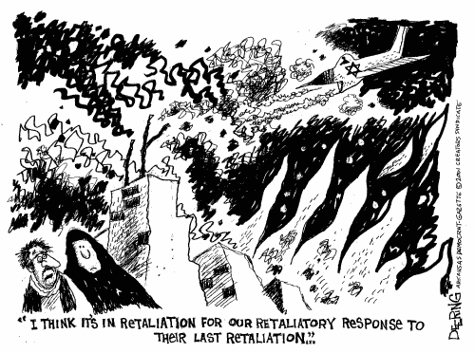
What is history anyway and why do we care? I have a friend who laughs and says “It’s done; it’s history; get over it!” She says this jokingly, but we really cannot get over it. Our past, our history, is the framework on which we hang our personal and cultural identity. Alone, history is simply a series of events occurring over time. However, when interpretation of these events occurs, we get something very different from a mere record of events. When memory and history are joined together history comes alive and takes on a new and fluid dimension. It is our memories, past events with emotional meaning, which give us our particular view of the world. How we view today is dependent upon how we remember our past.
Objectivity is elusive as we all carry our personal bias and particular cultural traditions with us wherever we go. Communities create historical myths and fables to serve a political purpose, to inspire patriotism and loyalty, as well as to justify a position or action. In this sense, historical narrative can serve a didactic purpose as well as memorialize great people and events, but can also reduce the objectivity of historical discourse. Unfortunately, a narrative based on collective memory and historical myths can promote ethnocentrism and xenophobia, thereby encouraging stereotyping and influencing relationships with those “others.” Myths, memories, and perceptions blur together in the quest for objectivity and truth when attempting to understand the Arab-Israeli conflict.
We are now in a period of historical thought that embraces many different methods of historical interpretation demonstrated by the proliferation of fields of historical inquiry including social history, political history, women’s history, and cultural history. Any one of these methods of interpretation can take a single event and provide as many interpretations as there are historians studying that event. This can be likened to a “History War,” where competing historical interpretations are fighting to become the accepted view of history.
It is a time of crisis for historians who trade in the realm of historical objectivity and this situation is dramatically exemplified by the current state of the historiography of Israel. In regard to Israel, there is a widely accepted Zionist interpretation of history. However, evidence is emerging of a history that contradicts this traditional narrative of Israel’s founding and is threatening the foundation of Israel’s claim to a just and moral existence.

Historiography
What are the motives that impel some Israeli historians to align themselves with Israel’s enemies, twisting and distorting the evidence?
Hyam Maccoby

Israeli history has long been examined through pro-Zionist and western Christian eyes. Although continuous debate among Israeli, Jewish, and Arab scholars is a hallmark of Israeli historiography, the 1980s and 1990s saw a dramatic increase in revisionist histories inspired by newly available Israeli government archival material and primary sources in Arabic. Currently, the heated battle between the “old” historians and the “new” historians continues regardless of a widening acceptance in academic and political circles of the revisionist interpretations of Zionist goals and the establishment of the State of Israel.
Several issues are fueling the revisionist histories. First, the passage of time allows for a more distanced and balanced view of history. But the new historiography owes its emergence to several other factors. First, postmodernist thought offers the appearance of veracity to all interpretations of historical discourse, thus allowing an outlet for alternative viewpoints. This permitted other stories to be heard encouraging new avenues of historical inquiry, for example the Palestinian perspective and Zionist self-reflection. Second, with the opening of archives and the availability of government documents in Israel and in Arab countries, historians have been able to utilize traditional methods of historical inquiry to support several of the alternative narratives of Zionism and the establishment of Israel.
The years surrounding Israel’s fiftieth anniversary have seen the debate on Israeli historiography continue with a renewed vigor and a pronounced line has developed separating the “traditional”— read pro-Zionist—historians and the “New Historians”—read anti-Zionist— historians. Through the use of new documentation and what revisionists claim as a more objective mindset, the “new Historians” aim to shatter the Zionist myth exposing a history in which Zionists are viewed neither as socialistic, liberal, democratic, or noble nor righteous with God on their side. What is different about this debate today is the number of scholars advocating the new historiography and the widening acceptance in academic circles of the theories subscribed to by the new historians. Since the beginning of the Zionist movement, scholars have debated Zionism and the methods employed by the Zionists to achieve their goals.
Israeli historiography has been dominated by political, religious, and economic interpretations of Zionism and the ensuing Arab-Israeli conflict, while the cultural and social interpretations have only expanded in recent years with the development of the new historiography. A decidedly “us versus them” attitude has developed between historians as the new historians produce controversial “revisionist” histories employing methods of cultural and social analysis in their re-examinations of Zionist and Israeli history that challenge orthodox interpretations.
Traditional Israeli historiography generally encompasses a political interpretation of Israeli history and aims to validate the biblical and historical connection of the Jews to Palestine and asserts the right of Jews to return to that homeland. This right to return to the homeland is strengthened by the continuous persecution the Jews have suffered in every community in which they have lived. Furthermore, the indigenous population lacked any cohesive national identity. Moreover, the Zionists improved an empty and arid land through western techniques of modernization and thereby enhanced the lives of all people living in the territory.
Terence Prittie’s work entitled Israel, Miracle in the Desert, published in 1968 provides a perfect example of a traditional narrative of Israeli history. The author begins the monograph by providing the date for Israeli independence in both the modern and the ancient Jewish dating system in which 15 May 1948 falls on the sixth day of Iyar in the year 5708. This is an example of the continuity of the Jewish connection to Palestine and lays the traditional foundation for the rightful return of the Jews to the biblical homeland during modern times.
In regard to the indigenous Arab population, Prittie describes the flight of Palestinians Arabs from their homes as “the direct upshot of the 1948 war.” Moreover, the Palestinian population is characterized as weak, lacking education, spirit, camaraderie, and most significantly, lacking any national identity of their own. This viewpoint has prompted Arab and some western scholars to produce works asserting the existence of a Palestinian identity prior to the first waves of immigration into Palestine, and thereby challenging the traditional Israeli viewpoint.
The Zionists held the belief that the few indigenous Arabs would be absorbed into the surrounding Arab nations leaving, the land open for Jewish colonization of Palestine. Central to the traditional interpretation of Zionist and Israeli history is the discrediting of both Arab and Palestinian national identity. This development has produced a wide counter-wave of scholarship (that has increased in quantity in recent years) propounding Palestinian identity and Palestinian rights to self-determination. Postmodernist tendencies, stressing cultural pluralism and minority rights, have certainly influenced Israeli historiography and are frequently regarded as hostile to the classic concept of Israel as the State of the Jewish people.
Debate is never absent from the historical study of Zionism, Israel, and the Palestinians. Before, during, and after the establishment of the state of Israel, scholars have quarreled over the historical facts surrounding Zionist motivations for and methods employed in the establishment of the State of Israel in 1948. The climate of relativism associated with the last several decades has been a catalyst for the re-examination of Israeli history.
There are deep conflicts between the revisionist narrative and the traditional view of Zionist history. The latter, reinforcing citizen loyalty to the state, asserts that the Zionists brought only good things to the land, such as sanitation, irrigation, higher wages and a higher standard of living. The current revisionist view of history shatters the traditional narrative in which the “concept of Jews as a merciful, compassionate people” is disassembled by explaining past events in the larger framework of the experiences of the indigenous Arab population. Indeed, Kalman Sultanik accuses the revisionists of blurring history “by deleting, denying or distorting events.”
The conflict between traditionalist and revisionist interpretations of history is highlighted through several book reviews of Efraim Karsh’s scathing attack on revisionist history, Fabricating Israeli History: The “New Historians.” In the first review, “Pernicious Revisionism Exposed,” Hyam Maccoby applauds Karsh’s work for exposing the superficiality of the theses of several prominent Israeli revisionist historians by accusing them of selective use of documentary evidence and of misusing and misquoting it to support a preconceived thesis. Exploring the intent of revisionist historians, Maccoby asks, “What are the motives that impel some Israeli historians to align themselves with Israel’s enemies, twisting and distorting the evidence?” Maccoby’s review appeared in Midstream, a periodical published by the Theodor Herzl Foundation, an organization subscribing to the traditional Jewish narrative of history.
In the second review by prominent revisionist historian Benny Morris, Karsh’s book is dismissed as poor workmanship. “What distinguishes good from bad historians,” says Morris, “ is the ability to sort out the (heartfelt) wheat from the (propagandistic) chaff.” Morris also notes that “massive documentation from Israeli and Western archives” became available in the 1980s, permitting scholars to objectively analyze these materials and produce less biased histories. Interestingly, whereas Karsh claims the revisionists are too easily “bogged down” in minute details that obscure the essential facts, Morris’s review essay argues that Karsh is himself guilty of “belaboring minor points while completely ignoring, and hiding the main pieces of evidence.” Karsh’s historical approach is further deprecated for “resembling those Holocaust denying historians who ignore all evidence and common sense in order to press an ideological point.” Israeli historiography, Morris observes, will likely follow the Hegelian dialectic of thesis (old history), anti-thesis (revisionist history), and synthesis (a more balanced and objective history)
Clearly, postmodernist theory and relativism has fostered the ability for historians to examine historical events from a wide variety of perspectives; this altered state of affairs is most important for minorities as historians can now validate their stories. The emerging evidence fueling the new historiography has brought the Palestinian story to the international arena and given expression to the Palestinian collective memory.

Collective Identity and Collective Memory
That there is a Palestinian community and that it has material, spiritual and historical connections with Palestine are indisputable facts.
Palestine National Covenant, June 1964.

A people’s heritage is created by a collective identity, which is what a group remembers and transmits about its past. Collectively shared personal experiences produce common political perspectives. This collective memory contributes to the formation of the accepted history of that community of people and, in turn, promotes concepts of patriotism and nationalism. In this way, communities construct national identities. Jewish identity is bound together by historical experiences—most notably in recent times by the holocaust. Many American Jews who identify culturally with Israel support its existence because of this cultural memory. One problem of basing historical analysis on a single set of memories, however, is recognition of the lack of memory’s reliability. Undoubtedly, there can be multiple interpretations of the same events, for “different people see different things.”
Recognition that there can be “changeability of memory” challenges how historians can provide a true and accurate story of the past. The concept of a Von Rankean style objective history advocating the attainability of an exact reconstruction of past events is tossed aside when one accepts the concept that memory shapes history and recognizes that memories of the same event are different from person to person. These memories change over time, all the while exerting influence on historians’ understanding of historical events.
How we remember, as well as forget, particular events shape not only our identity but also our world-view. The different collective memories of Jews and Palestinians have shaped modern history and current events, leaving the groups embroiled in a “history war.” Jewish collective memory has played a large role in political support for Israel by American Jews. As new and contradictory narratives of Jewish history emerge, Jews themselves are finding themselves confused about the “real story.”
A number of grass-roots inter-faith and inter-ethnic organizations across the United States (and internationally as well) comprised of Arab Muslims, Arab Christians, Jews, and Israelis, recognize the role memory and myth play in creating collective memory, collective identity, and consequently on history making. These groups are opening dialogues in an effort to reduce classic ethnic stereotypes used to discredit whole peoples and to quell the rhetoric war based on preconceptions and accusations in order to close the wounds of this “history war” and facilitate the negotiating of a cease-fire to the hostilities. These peace/dialogue groups strive to recognize the validity of other views and the contribution their opposites make in compiling the many historical narratives of the Middle East. Rather than focus upon the particulars of the different stories, they are finding common ground through their common experiences and are attempting to forge a new collective identity that leads toward peaceful co-existence.

Conflicting Narratives
We spent several months arguing about the history and what we thought were the facts, then we realized that was ridiculous; both sides had a different idea of the facts and it was a waste of time.
Ruth Shapin

The widely accepted history of the establishment of the State of Israel is supported on four bases. First, the Jews have a religious and historical right to the land of Palestine. Second, the Jews are entitled to a have a country of their own based on historical persecution and mistreatment, as exemplified by the Holocaust. This idea is supported and articulated by Kalman Sultanik, chairman of the Theodor Herzl Foundation: “It is the sacred task of the Jewish people and of mankind to ensure that this memory [the Holocaust] will never be forgotten . . .. And the State of Israel is the guarantor for the Jewish people that history [the Holocaust] will not repeat itself.” Third, the Jews have a political right to the land based on Britain’s Balfour Declaration, and fourth, the Zionist conquest of the land.
The Political Zionist movement, founded by Theodor Herzl, was intent on establishing a homeland for the Jews in Palestine with the goal of shaping a society in which justice and charity (tzedakah) would govern. After years of attempting to assimilate into the societies of host nations, the Dreyfus Affair in France (1894) re-affirmed the separate national consciousness of the Jews. The Dreyfus Affair encouraged development of a political consciousness that emboldened the Zionists to move forward toward their goals. As the Palestinians realized the Zionists meant to have Palestine for their own, a new Palestinian cultural memory began to form. The Palestinians would not form a cohesive political consciousness based on their collective memory, however, until later than the Zionists did.
Palestinian political consciousness emerged during the 1920s in response to the colonization efforts of the European Zionists. The Palestinians did not view the Europeans as an “indigenous people coming home,” but as the unjust continuation of European colonization and expropriation of land from the indigenous community. The Zionists held the belief that the few indigenous “Arabs” would be absorbed into the surrounding Arab nations. However, not only were the neighboring Arab States unwilling to absorb the Palestinian population, the Palestinians also “refused to submerge their Palestinian identity and disappear into the neighboring Arab states.” To the contrary, the desire to remain Palestinian and not assimilate into the neighboring Arab nations only strengthened Palestinian collective identity. Because of the Holocaust, most of the Western world sympathized with the plight of the dispersed and persecuted Jews. In the Palestinian view, their historical experience has not yet been heard, let alone appreciated, in the West.
Walid Khalidi, a prominent American-Palestinian historian, expresses this cultural memory as similar to the Jewish cultural memory that binds Diaspora Jews together. This Palestinian collective memory has been gaining strength in the years since the establishment of the state of Israel. Khalidi asserts that the “Palestinians have been pushed and pulled together by a multitude of shared experiences that have created a sense of national community . . . It has transcended geographic dispersion . . ..” This newly synthesized Palestinian collective will has brought attention to the Palestinian people. For the first time, the experiences of the Palestinians has been legitimized and validated by the outside world. Just as Jewish identity is bound by historical experience, most notably the Holocaust, Palestinian identity is tied to their historical experience–primarily the 1948 War of Israeli Independence and their continuing struggle with Israel.
The emerging historiographical debates are reshaping our understanding of the Israeli-Palestinian conflict. First, there is the disparity between traditional Zionist narratives and the emerging “new” history as expounded by Israeli revisionist historians. And second, there is the disparity between Zionist narratives and Palestinian narratives. Until the gap between these different understandings of history is reduced, the opportunities for peaceful settlement are slim.
Israel must hold on to its fable of moral right to the land and the idea that it was an arid and empty place just waiting for the Jews to arrive and “make the desert bloom.” If attention were focused on the actual issue of the condition and status of the indigenous Palestinian people immediately preceding and then following the 1948 war and the 1967 war, Israel’s view of its historical origins would be sorely challenged and the political balance Israel has maintained with other western countries would be at risk. Israel needs to portray its history as moral and just rather than exploitative.
However, as long as the Zionist interpretation of the history of Israel is accepted, the myth of Israel’s moral right to exist is safe and American Jews are not anxious to have their perceptions challenged. Rabbi Irving Greenberg Ph.D., the president and Co-founder of the National Jewish Center for Learning and Leadership, suggests “the widespread sense that Jews must hold themselves to a higher standard of ethics has increasingly come into conflict with the morally compromising situations that Israel has entered.” For example, a statement from Lt. General Dan Shomron of the Israeli army, proposed that the only way to stop the Palestinian Intifada would be through transfer policies, starvation, or physical extermination. Similarly, a story of Israeli beatings of innocent Palestinians Arabs is told with the author exclaiming, “that which was done to the Jews is now being done by Jews to other People.” Many Jews prefer to see Israel as depicted in “Exodus,” in which the Jews were completely noble, the chosen people, and the Arabs unquestionably evil. The war between the Palestinian and Jewish interpretations of history is inflamed as new evidence of Israel’s relationship with the Palestinians emerges. As Israel’s traditional history is further challenged and scholars examine the Palestinian narrative more frequently, the collective memory of the Palestinian people is validated, thus binding the Diaspora Palestinians with greater cohesion.
The Jewish/Israeli interpretation of events has been the accepted view for both western Jews and Christians. Today, in light of postmodernist views of history, Israeli revisionist historians have shown that some key “verities” about Israel’s founding have been based on distortions and deliberate fabrications. This lends credence to examining the differing historical experiences of the Palestinians and has opened a forum for a critical evaluation of the previously accepted “single narrative” of Jewish history.
The Jewish community and the Palestinian community have radically different perceptions leading to different historical realities. One particularly painful issue for Palestinians is the de-Arabization of certain cities and villages during the 1948 and the 1967 wars that produced a significant refugee problem. The conventional Zionist version of events portrays the Arab population as simply opting to leave the Jewish state for neighboring Arab countries and further, places the Jewish community in role of the under-dog defender against marauding Arab attacks; the Zionists were not the aggressors. In Jerusalem, prior to 1948, Palestinian Arabs owned some thirty-four percent of the land that later became West Jerusalem and Jews owned about 30 percent of the Jerusalem area with the remaining Jerusalem area belonging to “Christian Churches, state domain, roads and railways.”
As the search for a real and lasting peace in the Holy Land continues, the legitimacy of both the Jewish and the Palestinian collective memory must be recognized. A “just” peace will not occur until both parties accept the idea that Israel will remain a sovereign state and the Palestinians will gain greater autonomous rule. Logically, the best solution would be a democratic, pluralistic, and secular society. For many Palestinians this is the long held dream for Palestine, however, two separate sovereign states will most likely be the solution.

Reconciliation
You know, one time I saw a program. It’s about some Jews going to Poland and looking for their homes. So I wish I had a conversation with them that I am having the same feelings that they are having Nabil Dajani

As our memories change and re-define themselves we now find a proliferation of grass-root organizations opening dialogues in an effort to help heal and close the wounds of this history war. Both the Jewish and Palestinian communities have suffered. During group discussions of their respective losses and sorrows, the dialogue itself becomes a cathartic experience that in turn encourages healing. As the differing histories are brought into greater harmony a new community of shared loss and memory is formed. Of course, these groups have the ultimate hope that efforts on small local levels will one day translate into a greater peace for the territory of Palestine.
The immediate purpose of the Cousins Club and the Jewish-Palestinian Living Room Dialogue Group is to demonstrate the ability of Jews and Palestinians to peacefully interact and engage in conversation. The meetings become a place for sharing and validating one another’s memories acting as a type of historical reenactment. The competing histories discussed, and hopefully, re-imagined.
Areas of tension generally revolve around discussions of Israeli settlement policies and restrictions on Palestinian movements within Israel. Overall, the group members support the establishment of an independent Palestinian state and an end to the expansion of settlements in Gaza and the West Bank. When discussions of these issues become heated, they are set aside and the tension is broken with humor and a gentle reminder of their goals.
The Cousins Club and Living Room Dialogue Group are only two of many working demonstrations of reconciliation of a century old history war and the tangled memories such a history war invariably spawns. By accepting and legitimizing the different views of historical events as the actual experiences of those people, animosity dissolves and compassion for one’s fellow man is strengthened. Rather than focus on the differences between these competing histories, both dialogue groups are finding common ground based on a common heritage that reaches back in time well beyond the modern conflict

Part II

The Peacemakers Speak for Themselves

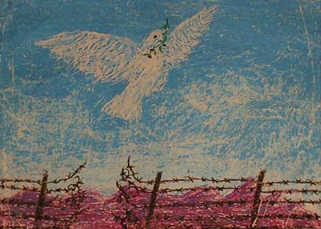
Salihcan Guner, from the “Messengers of Peace” collection

If history is “done” and we need to “get over it,” why do people continually look backward and remember things? Simply put, people do not want to be alone. We want to remember with other people who share similar memories. With our recollections we can create a network of memories upon which we travel thus giving meaning to our lives and allowing us to connect with others and generate a sense of community. Jews and Palestinians have become enemies as each community fights to maintain or gain sovereignty. But little pockets of peacemakers dot the landscape in Israel and the United states, small groups of Jews and Palestinians who come together and identify similarly themed memories and then build a new community based upon this shared collective memory. The development of a new collective identity for these Palestinians and Jews is rooted in the common experiences of dispersion, suffering, loss, and the desire for mutual respect, dignity, and peace.
The Speakers
Personal memories link the past and the present in a changing community. People are the carriers of memories and storytelling allows people both to evaluate their circumstances and justify their vision of the future. When a group of people come together and share common stories, circumstances, and (most importantly) a shared vision of the future, a collective memory is transformed into a collective identity. Generally, people who share a collective identity tend to seek control over the realization of their shared vision of the future. For the Cousins Club and the Living Room Dialogue Group the shared vision of inter-ethnic and inter-religious cooperation between Palestinian Arabs and Jews is manifested in community outreach, education, and political activism. Through face-to-face interaction, the Cousins Club and the Living Room Dialogue Group create a vision of the future and use this collective vision to guide decisions regarding their goals for peace and cooperation, not just between the members but also for their local communities and hopefully for Israel.
The interviews in this study were conducted over a series of several years. The participants range in age from their mid-thirties to their eighties, include both women and men, and all of the participants identify with one of the monotheistic religions of Judaism, Christianity, or Islam. For the most part, the interviewees were born in Palestine/Israel and immigrated to the United States as a result of the distress in the Middle East. Also included in the interviews are the stories of Jews whose families fled anti-Semitism in Europe in the late nineteenth and twentieth centuries choosing to immigrate to the United States rather than Israel yet also identify strongly with the “Jewish State.”
Considering that Jerusalem holds significance for all three religions, both the Cousins Club and the Jewish-Palestinian Living Room Dialogue Group have a small membership population of “interested others” that include people without a familial attachment to Palestine but who feel a connection through religion or simply have humanitarian interests in the region.
The narrators include:
Jamal Awad (Cousins Club) was born in the Golan Heights, in the Southern part of Syria now under Israel’s occupation. Awad, a gentle and soft-spoken man, was born in 1960 and vividly remembers the 1967 war and his family’s flight to the safety of Damascus. Although Awad is a naturalized U.S. citizen, he identifies strongly with the land of Palestine and considers himself Palestinian
Rosalie Abrams (Cousins Club), born in October of 1921, grew up in Brooklyn, New York in a politically active and progressive Jewish family. Abram’s political activism extends from helping to establish an Orange County Chapter of NOW (National Organization of Women) in 1969, to involvement in the New Jewish Agenda, and international peace activism leading to her participation in the Cousins Club of Orange County.
Elias Botto (JPLDG) was born in Jerusalem, Palestine in 1932. In late 1947, due to increasing violence in the region, his family fled to Bethlehem in the West Bank. Settling in the U.S. in 1954, Botto established a successful business in the Bay Area.
Nabil Dajani (Cousins Club) was born in Jerusalem in 1937. His family lived in the region for centuries only to be exiled during the 1948 war. Living and working in the U.S., Dajani is not only a founding member of the Cousins Club, but also an active participant in the group’s efforts at understanding and reconciliation.
Robert Gorden (Cousins Club) is an Israeli Jew who currently attends a Reconstructionist Temple. He was born in Tel Aviv in 1952. Gorden served in the military as a medic during the 1973 Sinai campaign. He is currently the co-chair of the Cousins Club and has spent most of his adult life involved in peace activism.
Samir Hijazi (Cousins Club), born in 1963 in a small town on the outskirts of Jerusalem, left the region in 1967. Hijazi has established himself as a successful businessman in southern California.
Melek Nasser-Totah was born in Des Moines, Iowa, in 1966. Her father grew up in Haifa, Palestine before the family fled to Egypt due to the violence of the 1948 war. Although Nasser-Totah was born in the U.S., she feels a strong tie to her family’s Palestinian cultural heritage and hopes that through dialogue and education people will better understand the Arab perspective.
Sami Odeh (Cousins Club) was born in Jifna, a small village near Jerusalem. His family lived under occupation conditions until Odeh and several other members of his family immigrated to the United States where his activist brother was brutally murdered by Jewish supporters of Israel.
Ruth Shapin (Cousins Club) was born in 1931 in Manhatten, New York. Her father immigrated to the United States from Eastern Europe. Shapin practices social security and family law in Santa Ana, California, and is the current spokeswoman for the Cousins Club of Orange County.
Elizabeth (Libby) Traubman (JPLDG) born in Lenoir, North Carolina, in 1940 and became a founding member of first Beyond War (now the Foundation for Global Community) and in 1992 co-founded the Jewish-Palestinian Living Room Dialogue Group.
Len Traubamn (JPLDG) is a pediatric dentist by profession and is also a co-founder of the Jewish-Palestinian Living Room Dialogue group. Traubman is devoted to the group’s outreach projects and has been able to expand the dialogue group’s reach through active use of the Internet. This has enabled the members to make contact with fellow peacemakers across the globe.
Although the Cousins Club of Orange County has experienced fluctuations in membership, they continue to meet regularly and participate in many local community outreach projects. Currently, Palestinian involvement has declined due to the 2000-2001 Intifada that has resulted in the stalling of the peace process. Interestingly, the JPLDG has experienced a surge in Palestinian interest in inter-ethnic dialogue efforts. Currently, in the Bay area, five spin-off groups are successfully meeting, two are in the developmental process, one is established in Palo Alto, and yet another in San Francisco. Mr. Traubman’s adept use of the Internet has successfully linked the Bay area dialogue groups with others across the country and in Israel.
CHAPTER THREE
The Establishment of the Dialogue Groups

A time to keep silence, and a time to speak; a time to love, and a time to hate; a time for war, and a time for PEACE.
Ecclesiastes 15:7-8
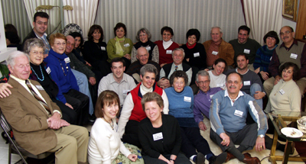

The Cousins Club of Orange County was established in 1988 and the Jewish- Palestinian Living Room Dialogue Group in 1992 as a result of frustration with the peace process. The goals of the groups combine dialogue as a cathartic and healing process with combating stereotypical views of Jews and Arabs by providing an open and safe forum for members to freely discuss their experiences as Jews, Israelis, and Palestinians. Integral to the groups’ activities is a desire to educate people regarding events in the Middle East, and most importantly to learn and teach respect and understanding for each other thus enabling members to participate together in community outreach projects and to fight for peace in Palestine.
Nabil Dajani recounts that the idea for the organization came out of his desire to speak with Jews and demonstrate the ability to live at peace with the Jews. He further expresses that Palestinians are not anti-Semitic but are more accurately against the political Zionist movement that displaced many Palestinians from their homes and catalyzed the tremendous refugee problem.
Well, to tell you the truth, the Cousins Club was my idea. Since I came to the United States, I always used to say to myself, “if I meet a Jew I am going to tell them that we are not anti-Semitic, but that we are against Zionists; like you are not against the Russian people but against the Communists.” I would tell them that the Jews and the Arabs are the same [both Semitic and related through Abraham] and that there was no problem until Zionism. But I never got a chance. When I did meet some Jewish people, they would tell me that they didn’t want to talk about politics. I was not able to establish any contacts with any Jewish people. So one day I was asked to go and attend a meeting and I didn’t know what it was but I knew there would be some Jewish people there. I went, and it was a meeting of the group organized by a man and he founded the Middle East Communication Foundation, or something of this sort. The aim of this group was to bring Palestinians and Arabs, Jews and Israelis together so they could listen to each other. It wasn’t for peace. It wasn’t pro-Israel or pro-Arab. Its aims were just to bring together the Arab and the Jew so they could sit down together.
When I was sitting there, I noticed there was a Jewish lady (pause, Nabil’s eyes begin to tear) who belonged to the Quakers. I figured I could establish contact with her since I went to a Quaker school in Palestine. I did talk to her and we started taking the names of another Palestinian lady and some Jewish people and we thought we could talk together. We took some names and phone numbers and we started the Cousins Club. (eyes tearing) I’m sorry. So this [first Cousins Club, in Los Angeles,] had been going on for fifteen years. It was a very beautiful experience, very rich. At least I felt I did my duty.
I have been politically active for a long time. I got involved in the Jessie Jackson campaign when he ran for the President the first time. He was the first politician to come and stand for the Palestinians. No other politician would even mention our name; otherwise he would lose the election. Now it is easier to talk about the Palestinians. But twenty years ago there was no way to say the word Palestinian.
Ruth Shapin, the current spokeswoman for the Cousins Club, provides an overview of the establishment of the Orange County Cousins Club:
Well, I was there pretty much at the beginning. There were some people [in Orange County] who had been attending a group called the New Jewish Agenda, which I don’t think is active anymore but at that time was very active. The goal of the New Jewish Agenda was to reach an accord with the Palestinians. There were some Palestinians like Nabil Dajani, who had been active in Los Angeles in a dialogue group. They had a dialogue group called the Cousins Club of Los Angeles. I don’t think that group is active anymore. So, there was a unity of sentiment among the members of the New Jewish Agenda to start a similar club here in Orange County. And much to the chagrin of the L.A. group, we adopted the same name, except we said Cousins Club of Orange County. And they said, “Well, wait a minute. People are going to get confused,”
and so forth. But we said, “No, we don’t think so, because after all, Orange County, that
distinguishes it.”
So, we came together and we had an initial meeting. I don’t know how we got the word out to these other people that came, for example Robbie Gordon. I’m not sure how he heard about it, but somehow people heard about it. We had an initial few months of dialogue to try to decide on a set of principles. I remember one of the original principles was that the PLO should be recognized as a representative of the Palestinian people (chuckle), rather than just a terrorist group.
The intifada may have been the catalyst for this group. People looked and saw this intifada going on and said, “What can we do? This is terrible.” And so the club was started about the end of 1988. We spent several months deciding what were we going to do, and we decided quickly that we wanted to be more than a debating society, which . . . Our impression was that the L.A. group mostly was just dialogue. We didn’t want to do that. We wanted to engage in activism like visiting Congress people and writing letters, speaking at organizations and educating. And we did all of that in the early years.
We spent several months arguing about the history and what we thought were the facts, and then we realized that was ridiculous; both sides had a different idea of the facts and it was a waste of time. So instead of trying to draw up a history that we could all agree to, we decided to just draw up some principles of unity. We drew up the principles of unity. I can remember one of them. . . I’ve already told you, to recognize the PLO. The other one was support of a two-state solution, which is a moderate solution because the radical solution is one state, one bi-national state. But we adopted the moderate solution of two-states, side-by-side, with peace and security for both states. I remember that we also called for the United Nations to get involved, which never happened (chuckles). The United Nations has not been able to help solve this. And I can’t understand why. It’s a mystery to me why the UN hasn’t been more active in this. So after we had done all that, drawn up our principles, then we continued to meet once a month.
Rosalie Abrams:
My husband was instrumental, really, in my becoming involved in the affairs of the Middle East because he had joined the organization called the New Jewish Agenda and we became very active in that. The people in the New Jewish Agenda formed the Cousins Club of Orange County. And my husband, as I said, was instrumental in helping Roni Lebauer who was one of the founders with Nabil Dajani, of forming the chapter. I've forgotten the exact date, but it was a very inspiring experience, and I began to read a lot of literature about what was going on in the Middle East and was horrified to find a lot of things.
We went on a trip to Israel, stopping in London first, in 1973 to see members of my husband’s family. At that time, I did not know as much as I do today about the Palestinians being deprived of their rights and their land. So I was angry, very angry in England. But when I got to Israel, and we were at the Dan Hotel, I believe, I had this impulse to want to go down and help. I just got angry because I felt, this is Israel and this is our saving grace. Then we came back home. And as I said, it was after that trip that my husband became active in New Jewish Agenda, and we both became active members of the Cousins Club. I read two books: the first was Blood Brothers and the other was The Hidden History of Zionism. I met many Palestinian people, and I was amazed at what I learned.
Well, what happened was that the New Jewish Agenda saw what was happening and were very pro-Palestinian. Not all the people. Because the Long Beach chapter of the New Jewish Agenda was not as pro-Palestinian as the Orange County chapter, so we had a little conflict there. When Roni [Lebauer] and Nabil [Dajani] said they were going to have this conference, and there was also a big New Jewish Agenda convention, and then an ADL (Arab Anti-Defamation League) convention that we all went to. Alex Odeh was head of the ADL here. We went to these conventions, and we came back very inspired by what we had heard and also horrified at what we had heard. Inspired to do something about it by being that horrified. We decided to form a chapter of the Cousins Club, which I think there was already one in San Francisco. There was one in L.A. So we decided to form this organization, and we did.
So we began to have meetings together. And there were more people from the New Jewish Agenda that came at that time. We met in a room on the UCI [University of California, Irvine] campus. There were a lot of Palestinians that came, and there were a lot of wonderful people that we met. But little by little, an erosion took place and some of the Palestinians dropped out and some of the Jewish people dropped out, and then new people came in, people like Ted Shapin came in then and other Palestinians about three or four months later. We felt we were growing and we were able to do wonderful things. We organized a big demonstration, and it was held at the old building of the Unitarian Church, and about sixty to seventy people showed up. It was a wonderful, wonderful meeting. And then we got a lot of publicity. We got a lot of negative feedback from the press, from Jewish people who didn't like the idea that we were so chummy with Palestinians. A lot of articles were written on what we were doing, we did get a lot of publicity in the early days. We flourished as an organization. And it still is.
We don't have as many Palestinians, I think, as we used to have, but there are some meetings that have more than others. I must say that in the past year and a half, because I've been taking care of my husband, I have not attended regularly but I still join, I still pay my dues, and when they have the meetings at the Unitarian Church, I certainly do go to them. And if I have somebody who's going, I will go to the meeting.
The Living Room Dialogue Group located in San Mateo, California, founded in 1992 and led by Elizabeth (Libby) and Lional (Len) Traubman, holds a similar philosophy to the Cousins Club of dialogue and validation as a cathartic experience that will lead to cooperation and peace. Included in their group’s membership are Holocaust survivors and native-born Palestinians with generational family histories in Palestine. Conflict is inevitable and Libby Traubman asserts that many earlier attempts of similar groups failed due to an inability to work through tense moments and pain. However, after close to sixty meetings, this group has moved from positions of fear and distrust into an atmosphere of cooperation. The only requirement for membership is listening skills, empathy, and a willingness to try to understand a different point of view. Once again, people’s experiences are validated, and issues have been argued over, but it is genuinely accepted that neither position takes precedence over another. Here, in a three-way interview, the Traubmans describe the rational, evolution, and philosophy that lead to the establishment of the Jewish-Palestinian Living Room Dialogue Group of San Mateo:
ET Well, there’s kind of a history that goes back before this particular dialogue group. We were involved in relationship building work during the ‘80’s with the Soviets, and during the Cold War, trying to discover how to break through what we talked about as “the image of the enemy.” When ... at the end of the ‘80’s and the early ‘90’s, when the Berlin wall fell and our relationship with the Soviets kind of changed and things opened up and they began to come here and that became less of a preoccupation, we had learned some things about that particular relationship and all the energy we spent in protecting ourselves from the Soviets and living off propaganda. So then we turned and said, well, how could we apply some of this knowledge and some of this experience into other areas? And we did know some people who lived in Israel, Palestine, and a couple people from our foundation [The Foundation for a Global Community] went over there and went to a conference, and they met some citizen leaders in the Jerusalem area. And one thing led to another, until we became involved in bringing Palestinians and Israelis to the United States for some conferences that we had here in the early ‘90’s. And after that happened, to make a long story short, we continued to support those people. Len and I went back over there for a week and worked with that small team, and a document was written, and it was the first time that the Palestinians and the Israelis had signed a document publicly together, because Stanford University was involved and that made it legitimate. And we said, okay, that was acting globally, but we obviously can’t continue traveling back and forth and bringing them here. What could we do to continue this in a supportive way? How could we continue thinking about building better relationships between Palestinians and Jews, Israelis, but from here? And out of that thinking, we started our own living room dialogue group. So that was how we got started with it.
LT Yes. I think the experience during the decade of the ‘80s, when Libby and I actually reached out and had Soviet visitors to our home, and then we went to the Soviet Union with medical people from North America who wanted to bridge the political gap, professionally, with Soviets, we learned the value of meeting people face to face. And also our experiences meeting with blacks and whites in the early ‘90s, and that really gave us the courage, and affirmed the supreme value of people meeting face to face as a required part of taking the peace process to fulfillment. And so that is why we started, because that is the way that people experience their common humanity and we knew that we had to do that.
ET I’d like to add too that we worked with Dr. Harold Saunders, who was the Assistant Secretary of State under Jimmy Carter, and he worked with Palestinians and Israelis as a facilitator at the Camp David Accords in 1973. He was the one who invented the term “public peace process,” or brought it to awareness. He helped us with bringing the citizen leaders here from Israel/Palestine for these conferences. We continued to use that phrase, Public Peace Process, really adding on to what Len said, believing that there are things that governments can do, like signing treaties and talking about borders and boundaries, but there are also things governments can’t do, like building relationships. And there are things that citizens can do, like building relationships and bringing people face to face, that they can’t do in the formal arena. So we feel like what we’re doing is “track two” diplomacy or “track three” diplomacy, and it’s a very important part of the big picture of building peace. We know that we’re not the ones who finalize it, but we feel like we can provide the building blocks.
LT We were talking about faith at dinner, but also, we do this out of faith. You know, this is our spiritual work, that’s how I define it. And yet I would say also that faith is not sitting down on a chair that isn’t there. We learned that early on. And I personally feel that if this can be done in a living room, it’s done. And this is the way that we bring it down onto the planet, you know, and demonstrate and act the changing of the relationship at a local level one to one. And once that’s done, then it is a reality, and it’s only a matter of time until it happens on the planet. And so that is the motivation and the method that I think works to transform citizens’ hearts, minds, and relationships. Does that help?
LT And it is the process is of hearing the other’s story, because dialogue is not conflict resolution, but it’s to provide the other a window into your humanity and into your own psyche. And when we give other people a window into ourselves, it changes the nature of our relationship, and we see our shared humanity, how we
are the same and how we are different. Then we want the best for each other. And once you want the best for one another, then the treaty process and the government process can go to conclusion rather quickly. If that has not happened at the public level, the governments can try to break through to a new place, but
the government processes will never flower or go to completion, because the people aren’t there yet. So both public and official government processes are required to work in parallel, as Libby said, to culminate in an authentic peace.
ET I think another reason we meet is because, like we said earlier, this country has incredible power and influence, and we know that our government supports the Israeli government. We also know that our media is very pro-Israel, or has been, and we feel like what our group does is it provides a format where both sides can be represented more equally– a common voice. Israel is never going to be safe and secure as long as they’re enemies, and their neighbors are threatening them. And the Palestinians will never feel safe and secure as long as their neighbors are threatening them. And yet we have people in our group who have relatives who live in Rahmallah and the West Bank. And we have Jews who live here who have kids who live in kibbutzes and live in Israel. They have influence. They send money. They send ideas. They send support. So what kind of money and ideas and support do we need to send? Do we send financial, intellectual, and emotional support to build a better shared civil society with relationship skills and dialogue that changes minds, hearts and encourages cooperation? Or do we take sides and send them money to buy arms to encourage them to scare or oppress, and further hurt each other? So I think we need here to show that it can happen, but also to help be a voice of influence for the positive, as small as it may be.
Once a dialogue group is established, monthly meetings are scheduled. Members must learn to listen compassionately and respect each other’s stories before outreach projects can begin. Central to the success of the dialogue group is the unification of group members through recognition of the mutual suffering of both the Palestinians and the Jews.
CHAPTER FOUR
Nobody has a Monopoly on Suffering

Red, this is the color of blood. We all have the same red blood that runs in our veins. You’re not better than me, I’m not better than you. What’s keeping us alive is that color red. Your blood is no different than my blood, and my blood’s not different than your blood.
Elias Botto

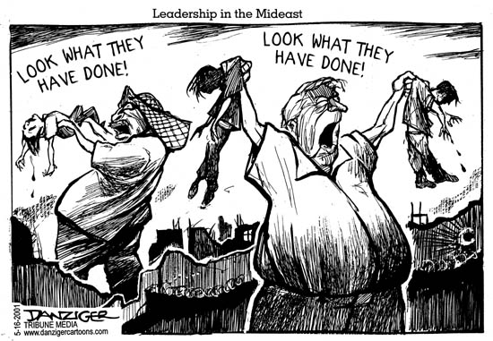

The foundation of both dialogue groups is the realization that both Jews and Palestinians have experienced similarly themed memories including stories of dispersion, suffering, fear, and loss as a result of the Holocaust, anti-Semitism, anti-Arab stereotyping, and the 1948, 1967, and 1973 Arab-Israeli wars. The dialogue group members recognize that their painful memories and those of their counterparts has shaped both their own world view and their perception of each other. However, open dialogue illuminates the similarities of their remembered experiences. Compassionate listening is the key for successful dialogue. During gatherings, Jews and Palestinians practice listening to each other rather than debating with each other and seek to restore the respect and dignity of each individual; this maintains the integrity of the group.
Nabil Dajani describes his family’s flight to Egypt and subsequent dispossession of their family home in Jerusalem as a result of the violence in Palestine immediately preceding the 1948 Arab-Israeli war
Well, my family has been a long time in Jerusalem. I just want to tell you a small story connected to that. A branch of my family, we are a big family, was the custodian for the King David Tomb for three hundred years and our branch of the family became nicknamed after King David so we became known as Daudi, David in Arabic is Daudi. So we became known as Dajani-daudi, and ultimately we had all the property where King David is buried. King David for Muslims is a prophet, so we were responsible for the upkeep of where King David is buried. This belonged to my family . . . well, not my father, but my uncles, my extended family and so on.
My father spoke Turkish. He did not speak English; he spoke Arabic and Turkish with his friends. With his Armenian friends he spoke Turkish. There were many Armenians that were massacred in Turkey [and they] came to the Middle East and they spoke Turkish. My father’s best friend was Turkish. But I also remember my father was a business man and we had a big warehouse and we used to have quite a number of Jewish families that used to come and have dinner with us at night and these Jewish families were always disturbed about the problems we were having. So this carries a good memory in one way towards what I want to call the enemy, (laughs) you know what I mean.
I remember during my childhood, it was between ‘37 and ’47, my family had to move almost every night to a place where there was no shooting from the IRGUN or the Hagannah. These groups, we called them terrorist groups. There was always shooting so we had to move around and stay in other people’s houses. My parents were always wondering where we would spend the night. So for ten years it was very difficult for us. These memories, (pause) maybe I can’t remember what I had for breakfast this morning but I can remember these things sixty years ago, almost sixty years ago.
I know there was a big conflict. I was in the YMCA [Young Men’s Christian Association], which is across the street from the King David Hotel, the day the King David hotel was blown up by the Irgun– and that leader would become Prime Minister Begin. I remember the day very vividly because of the noise. When the King David blew up, where part of the Hotel went down, the ground, it was truly shaking, oh shaking, so I remember that part.
We went to Egypt in 1948. My father was well-to-do and we went to Egypt for ten days thinking that we were going to come back, (pause) but we never did that. For ten days we were hoping that we would have peace and we never thought that what happened to us would happen [dispossession of their family home]. I mean some Palestinians had it worse then we did, so for me, I am one of the lucky Palestinians because my father had money. Of course in Egypt the money ran out (laughs) but being a businessman, my father was able to get a bank loan and start a business in Egypt and was able to support us. We were never able to retrieve our belongings. It was gone. I mean the way my father left things, it was as if we were coming back, you know, just like when you go on vacation and you expect to come back after ten days.
There are four Jewish families living in our house right now. And we were never compensated or paid rent. I went one time to Jerusalem on a vacation and I tried to, I wanted to just see the house of the family, see inside and they told me no, I am not allowed to go in. You feel that one day you want to return to this place and the urge that this is my house and I want to go back to it doesn’t go away. I want to.
My father had a store and he was in the store all day. However we did listen to the news everyday. We would listen to the news from the BBC [British Broadcasting Corporation], from Voice of America, from the Egyptian broadcast. Whenever there was news, we listened to the news. Not only one time a day but we listened to it at 11:00, at 2:00, at 3:00. Whenever there was news, the radio was on the news. Just to listen to what was going on, what was happening, you know, because at that time Nasser came to power and the Middle East was going through different times. Most of the Middle East was under colonial powers like England and France, France in North Africa, between Algiers, Morocco, Tunisia and England in Iraq and Jordan. There were always changes going on. So we were following the changes because we knew that somehow we would be affected by whatever happened. We always thought that when the rest of the Arabs got liberated [from colonial powers] that it would give us more strength. (Pause) Unfortunately they got liberated but [laughs] they didn’t help us at all.
Later in my youth my father sent me to a Quaker school in a small town ten miles from Jerusalem, called the Friends Boys School. It is a famous Quaker school. When Jerusalem was divided, I used to go on the roofs of the houses that were next to the border so that I would be able to see our house. Just to look at it.
I went back after the borders were open, and I knew exactly where our house was and exactly where places were and it was a fantastic feeling to go through. And I went by myself, I did not want anyone to come and show me the way, I just walked from the old city. We lived in a place called German Colony in Jerusalem and you had to cross by the King David Hotel. These are the same routes I used to use when I was living there and it was just fascinating to go and walk back where you grew up, where you were deprived from seeing, you know. And sometimes I would pass by some houses that were my neighbor’s houses in Jerusalem and I knew them one by one. I went to all their houses and looked at them.
Well my parents passed away. My mother is buried in Egypt; my Dad is buried in Jordan. I have three brothers: one in Jordan, one in Saudi Arabia, and one in Pittsburgh, Pennsylvania. And I have a sister, one sister only, who lives in Jordan presently. But my family is a big family, so I have lots of cousins. My Father has eight brothers; my cousins and I are very close. I hope when I retire I will be close to them. Some of them, very few of them are in the West Bank, most of them are also scattered. I imagine most of them would like to retire in Jerusalem, but it looks like most of them are going to retire in Jordan. My brother, in Jordan, he retired there; he used to live in London. So when I retire, I hope to go and teach, free of charge, at the Quaker school where I went. This is my wish and my dream.
You know, one time I saw a program. It was about some Jews going to Poland and looking for their homes. I wish I could have had a conversation with them and tell that I am having the same feelings that they are having. I [also] feel very sorry for the “Native American,” to be politically correct, (laughs) well, you know this is their country and they were just slaughtered and the reservations that I feel very sorry for them.

Ruth Shapin describes her family’s connection to the Holocaust:
My paternal grandparents were killed in the Holocaust, but at the same time, two sisters of my father and one of the daughters escaped, and they went to Israel. I have an attachment to Israel. I have relatives in Israel, whom I visited in 1999 for the first time. It kind of chokes me up because this is a part of my history. So the story goes that this little girl, who is exactly my age and looks a lot like me, well her mother was killed and her aunt grabbed her and they ran to the forest. They survived by going to homes and getting food, and whatever they did, and eventually they did get to Israel. I met the daughter. The mother had died, but I met the daughter, who, as I say, is exactly my age. So it was a very emotional meeting. They live in a suburb of Tel Aviv. They live in Herzliyya. I have another cousin who lives in Jerusalem. I met her also and her husband and a child. There’s a whole family, a lot of family.
The sad part is that, in talking to them, they don’t want to know anything about the Arab situation. I, in my short visit, saw more of the West Bank than most of them have ever seen or want to see. I was all over the West Bank and also a little part of Jordan. And they just say, “We don’t want them . . .” It’s apartheid. “We don’t want them to bother us and we won’t bother them. Leave us alone. We’ll leave them alone.” It’s just a horrible, horrible thing. It’s racism. And for Jewish people who went through the Holocaust to have that attitude—and maybe I’m overstating it; maybe it’s not as severe as I’m saying—but to have that kind of attitude is reprehensible and shows that the Jews never learned from what happened to them. They didn’t learn the lesson. They see it in very chauvinistic terms. You can’t talk to them about the suffering of another people. Although we had a friendly visit, there was a gulf. And you could see the gulf. When I came home, they probably thought I was some kind of radical (laughs). And worse yet, probably, “Well, she’s pro-Palestinian,” and so, you know, wrote me off. But, we are still cordial and we e-mail to each other, and so forth. So I do have a strong tie to Israel.
Sami Odeh reflects on his life under occupation in the West Bank and describes the watershed event that led to his deeper understanding of the implications of the 1948 War.
I was born in a little village near Jerusalem called Jifna on September 15, 1950. I grew up there until 1974, which means I lived under occupation between '67 and '74. I came to the U.S. in April of '74.
We always lived in what's now referred to as the West Bank, so my immediate family was not much affected by '48. But I later learned that the 1948 war greatly affected our extended family, especially those that have to leave their homes. I mean, either they left in fear or were forced out. We had lots of cousins that were living in the west Jerusalem area, and they were affected more. So I don't recall '48 but naturally we were studying that in history at school, although history was not one of my favorite topics as I was going to high school.
I do recall very vividly 1967. I was sixteen, almost seventeen years old. Our village was extremely close, and still is extremely close to the Jalazone refugee camp, which is built actually on the outskirt of the village on land owned by the villagers that supposedly was used by the United Nations in '48 for a few weeks until things settled down. These few weeks turned into fifty-two, fifty-three years almost. The refugees at the camp have grown in numbers by natural birth and now the camp has a greater population than our village of about six hundred people.
I was off in the field near the main road heading to the refugee camp in '67, and what I saw was actually something I've never seen before. I saw people running down from the camp hysterical. It didn't look like a natural reaction to anything. They were coming down completely disoriented, running in every direction, looking for caves, screaming stuff that didn't make sense to me. I'm in my field and I'm watching these older people running in all directions screaming, "It's '48 again." This was as the 1967 war broke. As a sixteen, seventeen-year old, a young kid of that age would not be engulfed in the history and all the details the 1948 war. That's when I went home and I asked my dad, as well as other older people in the town, about what had happened in 1948. I used to sit with them and try to get as much information from them as I could, because this reaction I saw in the refugee camps, the running, the refugees, did not make sense to me. I've never seen anyone so scared, so disillusioned, disoriented, and running like wild animals screaming stuff that didn't make sense. So that would be what really triggered me to want to understand more of what the hell was going on. The conflict, the whole thing really hit me at that age.
I talk to a lot of people older than I am and they still have strong yearnings of going back, they exhibit so much pain from the separation that took place in '48. Some of them have been here forty, fifty years, and I find this striking. I also feel the pains of separation from the land. I talk to some people and one gentleman, who could be my father, cries when he remembers how he and has family were herded out of Palestine like sheep. I cry, which is unusual.
On the Murder of his brother by fanatical Jews:
In 1967 Alex was finishing his education in Egypt and was not able to unite with us in the West Bank, so he stayed with relatives in Amman (Jordan), got a job, and eventually came to the U.S. in 1971, I believe. He went to Cal State for a time, got his master's while finishing his Ph.D. We lived together in a small apartment at the beginning.
Alex was a quiet but determined man. Being a political scientist, it was very important to him that he explain what happened to the Palestinians in '47 , '48 and ‘67. He believed that we needed to forge a lot of alliances, and he practiced that in his teaching jobs at Cal State, Golden West, and Coastline. He also practiced this in his interactions with people. Eventually he got a job as the west coast coordinator for the American Arab Anti-Discrimination Committee, or the ADC, which started very small.
The ADC came to life after ABSCAM, if you remember those days. James Abourezk, senator from South Dakota at the time, did not like the FBI [Federal Bureau of Investigation] using the Arab sheik to create a stereotype of the Arab or the extent of the operation ABSCAM and decided to form the American Arab Anti-Discrimination Committee to fight the negative image of the American Arab in the United States. It started as a grass root organization, and eventually it grew bigger and bigger and bigger
and had more offices than just Washington. So Alex became the west coast regional director for the ADC and eventually moved from a small office to a little bit larger space on Seventeenth Street in Santa Ana. During his tenure in that position, he built extremely good relationships with the media and with the Jewish community in Orange County. He spoke at several synagogues, and a rabbi was one of his friends. Other well-known Jews used to come and visit, used to come and stay with him or have a meal with us. He also made alliances with the leadership in the Hispanic community in Santa Ana.
On October 11th of 1985 he stopped first at my office to have coffee, (pause) like he used to do all the time; then twenty minutes later when he got to his office, a bomb exploded as he opened the door. The news announced it hours later at Santa Ana Western Hospital. He left behind his wife Norma and three daughters. Susan was about two and a half years at the time.
You know, I think on the journey from birth to death what happens is . . . You know, you lose Mom and you lose Dad and you are somewhat expecting that but something tragic like a brother . . . It seems like every time this happens a piece of your heart is cut off, and eventually it will expire. It's easier to accept that little piece being cut off when it happens more normally to a father or to a mother, but when it happens like it did, well, I don't think I'm still quite all over it . . . still, it doesn't have closure yet.
I watch these scenes happening [the 2001 Intifada] and I am always asking myself, "I wonder what Alex would have done if he was still around," or "How would he have felt . . ." for example, like with me when the Palestinian and Israeli leadership shook hands in the White House, and I wonder what he would feel or how he would react to election of Ariel Sharon today.
When he was alive, I delegated practically everything related to defending peace in the public arena to him, and I did not pay much attention. But then, all of a sudden after that day, I was propelled into the public arena. I had to meet with the police and the FBI and the media on a daily basis. Then as it settled down we had to deal with the reality of taking care of what would to happen to Norma, and the children, and school, and daily life. No, I don't think I'm totally over it yet. I probably will never be.
Supposedly, the case is still open. Occasionally, every couple of months I call one of the FBI agents. They keep assuring me that the case is still open and is a top priority. Sometimes you wonder. But I think I got through the tough time. As I said, being a realist probably helped me a little bit.
As recent as couple years ago the FBI offered a million dollar reward for information regarding the bombing and I said publicly then that we really do look for closure. What's revenge going to get? But if we don't even have the satisfaction that whoever did this terrible thing is punished, well, it doesn't help. It is hard to have closure. Alex is gone. This is the reality of it. I am a realist and have been all my life. Whether we catch them or we kill them or we put them in jail or we give them a star, the reality of it—Alex is gone. Then how do you deal with that?
On traveling in Israel:
If you are of Palestinian origin, your American passport doesn't go far at all. They have complete disregard for you. If you are not of Palestinian origin, it might afford you some sort of protection but if you are of Palestinian origin, all bets are off. So, other than the normal attempts at (pauses) dehumanizing me and humiliating me at the airport or at any checkpoints or stop, I can have a thin skin when it comes to that, but I can pretty much resist the attempts to be humiliated. One time I stayed at the airport and refused to succumb to whatever they were trying. That was okay, because I go there for a week or two. But for people living there . . . I remember when I used to be stopped four or five times on my way to Biet Jala where I used to teach. You can take this for a day or two or three or four, but as I said, if I were still living there, I would be fighting like hell. I'm surprised at how well that the Palestinians have refrained from violence all this time. When you think about all the humiliation they've been going through, you'd expect their actions to be much stronger than that. I know if I were still living there, I probably would be fighting more fiercely.
Robert Gorden on the horrors of war:
After World War II my parents came to Israel. They are Holocaust survivors in a sense; they were not in a camp but they survived the Holocaust. I was born in Tel Aviv, Israel, in 1952. I was educated with a strong sense of nationalism that was part of school, although my parents were a bit left wing. They are left wing, but not as much as I'm considered left wing. At the age of fourteen I was active in the first peace movement that was in Israel, and it was outlawed. It was an illegal peace movement it was really bad to talk about peace with the Arabs at that time. I did serve in the military; I was a medic in the service. There was no way not to serve in the military. It was jail, tough jail, and to choose between jail and the military, probably my principles were not so strong then, to go to jail. . . but I tried to be a medic. I tried to be something more . . . not actively engaged in warfare. I hated the guns and I hated everything associated with war. I saw all the time the results of war. I got awards because I was such a good medic; all my awards were because people got injured, blown into pieces and I put them together. Alive or dead, it's not . . .[quiet] What for? What for? For the land? It is insane.
You know, there was one thing that did impress me very much, and I didn't know it at the time. It was not a point, it was a process, and there were milestones, there was not one thing. I just know I was afraid of dying. I was afraid of the army, I was afraid of war. Maybe I was a coward, I don’t know. I remember when I was in the army and I had to stand guard, I was afraid because I thought, "Why shouldn't the Arabs come and shoot you? They're right!" So that's why I was afraid. My fear came from understanding.
When I was fourteen I was, as I said, in a peace movement that was outlawed in Israel. We had our first rally, and the police came and took all the organizers and put them in handcuffs. Really, these people came to talk about peace, and the police came and took them in handcuffs. I was young then, so I wasn't a big organizer. I was just sitting there in a seat, and suddenly to see that, it seemed to me really unnecessary, because I was sitting there. We were just sitting for an hour and a half and everyone was talking about how to create peace, things like this and bam! For me it looked so euphoric and so good and so pure, and to have the police come and take them, it really was a milestone in my understanding.
I was always working for peace and I have been the co-chair of the Cousins Club a long time. It was not legal for Jews to talk to Palestinians until the Oslo Accord, by Israel's point of view. I remember when finally the Oslo Accords were signed, well, I had people who tried to give me a hard time. People even threw tomatoes once when I made a speech in Long Beach– the religious Jews. But I remember people calling me after the Oslo Accord and saying, "Now you are legal." It was like till then my actions weren’t legal.
I have worked toward peace when it was not legal, and although maybe I said that I'm a coward, I went this year to Israel. We [the Cousins Club] are in connection with all the peace schools. This is a peace school that teaches peace in the West Bank. The Reza School of Israeli and Arabs, it's called [unclear], that's in Israel. It's a whole small village. Look how poor the school looks. There's nothing on the walls. I brought the supplies there and I went to visit. I went during a closure. If I had been caught, I would have gone to jail. And I still went and it was scary. So that was this year [1996]. I was scared. The thing is, the settlers are allowed because they have a pass. The Jewish settlers are allowed to go to the West Bank because they're going to their home. I didn't have a pass, and we drove as if I was a settler. And it was scary because when they have a closure, they have to make it both for Jews and Arabs, only the ones with a pass cross the closure. And I didn't have a pass, and there was no way I would get a pass, especially with my background, you know. I'm on so many blacklists because of my involvement in peace activism.
Jamal Awad:
I was born in 1960, in the Golan Heights, in the southern part of Syria, which is now under the occupation of Israel. My parents actually were born in Nazareth. So, in 1948 they took refuge up in the mountains. When the Israelis started shooting or bombing Nazareth, they were separated from Nazareth in a way [that] they could not go back to it. They went to another city and another city, and there were already many cities that fell to Jewish control. My parents finally wound up in Lebanon and they took a ride all the way back to the West Bank, by Janin, and that's where my second sister was born. They stayed for a little bit. Then my dad got a job with the Red Cross and then with the United Nations Work Relief Agency, UNRWA, and that took him to Dar'a, which is also a large city in southern Syria. From Dar'a he went to Quneitra, and I believe that we went to Quneitra in about 1956, because that's after my fourth sister was born. Then my brother, my youngest sister, and myself were all born in Quneitra. So I think 1956 is when we moved to Quneitra, and we left in '67 to Damascus.
A little bit before the war, I was about seven years old, a few days before the war, my sister, the oldest sister that I have, was married and she lived in Damascus. So, my parents actually sent me to Damascus to be with my sister. My sister happened to get ready to deliver right on June 5, the first day of the war, so at that time I was in Damascus. All the rest of the family, my parents and my sisters, were in Quneitra, in the Golan Heights. I still remember my sister had to go to the hospital. She left me by myself with the neighbors to play. I remember all the war news. I remember airplanes flying over the skies of Damascus. There were even some pieces of either used bullets or some pieces of artillery or something that would fall by the apartment building where my sister was. We used to go and kind of try to collect them or look for them. A lot of sirens and warnings, we had to go to the basement on a constant basis. My sister's husband was a pilot in the Syrian Army, and he was a senior pilot, so he was actually involved in the war activities. I think he participated in some bombings on Haifa. He's the only pilot that survived coming back from that bombing, if I remember correctly.
The events of the war are fairly vivid. A few days after the start of the war, my whole family, of course, had to leave. Israel bombed the center of the city in Quneitra, and that scared everybody. My dad was a cashier officer for the United Nations in Quneitra and he had to take the money from the office and transport it to Damascus He took my mom and my sisters and brother and transported them to Damascus. We went by my aunt, so that must be the second or third day of the war. I remember my aunt had one-room, she was renting one room from some family there. So we all gathered by the radio, and listened to the war news. It was quite . . . it was traumatic, in a lot of ways. I still remember the announcements that Quneitra had fallen to the Israelis. I was crying, as I was a little kid, and I was asking my mom, "Does that mean we cannot go back to our house now?" or something. She was crying with me and she said, "No, we cannot go back to the house".
To kind of go back a little bit, the house was something we built ourselves. I always helped my dad in the construction activities of building the house, and so it was . . . I can't remember any time after that that I cried as much. It was the most traumatic thing for me, and I still remember vividly being by the radio and crying when they announced the fall of Quneitra to the Israeli forces. So that's a little bit, just an overall . . . And of course the loss of all of our belongings. We were in Damascus with almost nothing, except a T-shirt and pants or something. That's about it. I don't remember that we had much that we took out of the house. It's all gone.
Anonymous:
My grandfather on my mother's side told me the story that led them to leave Russia. He had been apprenticed as a young child of about nine to a candy maker, which was a common experience for young boys when he was growing up, to learn a trade. He learned the candy-making trade, but because he was Jewish they lived in a ghetto, which was a segregated portion of the town. I don't recall the name of it.
In any event, one day when he was just barely into his teens, on the way home one evening, two Cossacks, who are Russian mounted police, cornered him against the side of a building. They were drunk. And they proceeded to whip him, literally shredding his clothes and leaving scars on his back for the rest of his life. It was at that point, he told me, that he decided he would leave because he didn't want to stay in a country where this could happen, because he knew that there would be no retribution, no justice, no action taken against the Cossacks who had whipped him. And the only reason that they had attacked him was because he was just a young Jewish kid walking through the ghetto, and they thought it was something fun to do. And that prompted him to leave.
I don't know the reasons that prompted my grandmother or my grandparents on my father's side to leave. They never told me their stories, other than to make very vague references to the fact that they had heard that there was more opportunity in America to live what they called a "better life" and that they could practice being Jewish and run their lives as they saw fit without being persecuted. But they didn't make a real emphasis of that. It could have been economics just as much as religious freedom that prompted them to leave. It was also cultural. It was a very common occurrence for the underprivileged throughout Europe to look to find a better place to live, and America was touted as a place of real opportunity. The fact that they were coming with foreign languages didn't necessarily deter them. If there were job opportunities and if they worked hard, they could make a decent living, and that's what prompted them, I think, in the final analysis, to make the trip.
As a very young child, perhaps about the age of four-and-a-half or five, I remember hearing the stories and vaguely recall some of the specifics. Our family was living in St. Louis at the time, and we were renting space in a large Victorian-type house. The owners lived in a portion of it, and we lived in some of the rented rooms. One weekend, some relatives who were living in St. Louis came to visit us, and they had heavy Jewish accents, what we call Yiddish accents. The owners, it turned out, were Germans, or Americans of German descent. This was in . . . probably 1937, 1938. The German-American bund was very, very strong throughout the Midwest, particularly in St. Louis. And they asked my father and mother whether they were Jewish, having heard the accent. My father was not one to deny his heritage and said, "Yes." Whereupon we were immediately evicted and given, literally, seven days to get our possessions out or we would be thrown out. And in those days, apparently, that could happen.
Other instances of prejudice, one summer when I was working between my first and second year of law school, I worked in a paint factory for the summer and worked for a crew that labeled cans, paint cans. The foreman somehow . . . I don't recall how it came up. I didn't go around advertising the fact that I was Jewish, nor did I deny it or hide it. But he learned that I was Jewish, and he was absolutely incensed that there was a Jew working on his crew, and really angry. Constantly used to hit me and then deride me about how come I wasn't smart enough or rich enough that I had to work in a factory with my hands, because Jews weren't supposed to work with their hands and weren't supposed to do hard manual labor, and he was going to teach me a thing or two. That was an interesting experience working that summer for a guy like that.

Samir Hijazi:
I was born in a small town, which is on the outskirts of Jerusalem It is a town on the periphery of Jerusalem. It's actually closer to Bethlehem, I guess, than Jerusalem, but it's part of Jerusalem, so . . . By definition, it's Jerusalem.
Well, the annexation of the West Bank definitely changed all our lives around. I probably wouldn't be here [the United States] if that (chuckle) didn't happen, in one sense. The annexation of the West Bank necessitated, at the time, that we leave the West Bank. My mother and my brother and my sister and I left to meet up with my father, who was working in Saudi at the time, and he had to make arrangements to receive us after the annexation. I mean, the whole family moved. We didn't go back, no, although we tried in the years after to apply to the Israeli authority, military authority on the West Bank.
Well, my immediate family, as I was telling you– excluding my father because he had already been in Saudi Arabia working, well, it was, I think, seven or eight years prior to '67 that he had been working in Saudi Arabia. So my mother and my sister and my brother and I, all of us had to leave. I was four at the time, or barely four, so I have very little memory of that time, but I do remember crossing the Allenbee Bridge between the West Bank . . . well, between the sides of the river. And I remember being on the bus, and I remember . . . I remember the sound of airplanes, jets, at the time we were leaving in a bus . . . Glass shattering up into the bus. I don't remember any shooting, for example. That wasn't in my recollection. But airplanes flying, I remember a lot of that. I remember seeing a lot of tanks on their way and soldiers. We had time; we had time to pack suitcases. We didn't take anything with us. I mean we basically just took suitcases with us. It was an organized effort by the Israeli government as far as leaving. Because we left after the Israelis had already taken the area . . . from what I was told. And I think it was . . . As far as I remember, I think it was an organized effort. They were giving people all means of transportation to leave, in other words. I mean, there were buses, this is how we got on . . . there were buses, and they were going eastbound, so if you want to get on the bus, there it is. Get on, go.
Melek Nasr-Totah tells her Father’s story of his family’s flight from Haifa, Palestine in 1948.
A lot of the experiences I've had are directly related to the trauma that has happened in the Middle East. I can communicate things that happened to my father and his family, which are obviously very tragic and I live with today. But my experiences are more here in the United States, how I've had to deal with Jewish people and the perceptions of Arabs here as well. So the dynamic that happens in the United States is probably more what I can explain, as well as the story that I have that's been passed on.
My father came from a pretty wealthy family. They lived in Haifa. I think my father's grandfather was a trader, so they were very educated people. They had a big, big home there in Haifa. There were quite a few families that lived in the area, or I think in the home itself. It was maybe like a six or seven bedroom villa. So because of the fact, I guess, that my family was a little bit wealthier, when the fighting started in Haifa, they were able to leave easily enough and a lot of them went to Egypt, because I think we might have had a summer home there.
We had an aunt, Aunt Marta, who was a little bit older. She was probably in her maybe early seventies, and she decided to stay in the home. She was going to be the one that was going to stay there while the fighting was going on and protect the home while most of the other people actually went to Egypt. So as the story goes, fighting got worse to the point where eventually the Israeli army came and broke into the home and found Aunt Marta and told her that she had to leave immediately. And she pleaded, "Can I at least get a few things?" The answer was, "No, you have to leave now." So she just left. And that was the end of our home and everything we owned there. And she went to a nunnery down the street, which is apparently where she died. So of course, we were never allowed back in, and we lost everything.
So the family was extremely bitter, because it's not just a home that you lose, obviously. It's an identity and a culture and a family, a community. So that's what you lose. And it's extremely sad and difficult. And I know most of my family, when they do speak about what life was like in Palestine before the war, it was just a great life for them, and many people loved it and they had many fond memories of how wonderful things could be. It was sort of like the Paris of the Middle East, I think a lot of people said, and Haifa was a beautiful place.
So it was really sad. And I know some of my father's family who ended up here in the United States never fit in. It was a very sad life, because the culture's quite different, and it's hard to understand the American culture if you're not an American. As I said, it's kind of superficial in a lot of respects. So it's quite a sad transformation. Even me, an American by a lot of accounts, I find it difficult to fit in here in a lot of respects. Those are two very difficult cultures to mix, I think.
But that's the story of my father's family. And then when he came again to the United States, his way of coping was to forget and raise his children as Americans. So he thought anyway.
Elias Botto shares his story of the end of the British Mandate and the subsequent Arab-Israeli war of 1948.
I’m a Palestinian. I was born in Jerusalem on October sixth in 1932. I just celebrated my sixty-seventh birthday. I’ve been here in the United States since 1954. We used to live in Jerusalem but in 1948 during the Arab-Israeli conflict we took refuge in Bethlehem, being Christian. The name Botto is one of the old Christian names in Bethlehem and most of the Christians, they trace their origins somehow back to the Holy Crusades and so they say maybe our roots come from Europe, from Italy. The name Botto is Italian. And there are a lot of Bottos here, and back in Europe and Italy.
There was so much conflict between the Jewish colony behind us and the Muslim colony in the front of us, and the British barracks also nearby. We were sandwiched in the middle. I remember school giving us an early recess and my father thought, we are eight in the family, it was safer to take the family and go to Bethlehem for a while until things settled down. So, as Palestinians, even though I was what, fourteen-fifteen years old, at the time, as citizens, we didn’t really know exactly what was happening to us. I was fourteen-fifteen years old and never took it seriously. It was just skirmishes, it was just street fighting to us. We hear bombs, we hear explosions, you know. We go to the windows to watch, we were just kids and our parents pulled us back from the windows and would say come back inside, it’s to dangerous, don’t do that.
Well the British, of course, were maintaining peace and tranquility over there but when the time came for them to withdraw . . .well, I remember it very well. In one incident I had to go with my father to one of the apartments we had owned, it was occupied by the British officers and used as a mess hall and supposedly before they left they were to surrender the key to my father in Jerusalem. So I went with my father to the apartment and the front door was open, and it was, the whole building completely vacant. They withdrew without telling us. I remember my father put a guard, a Muslim, to take care of the building—a guard to see what was happening and then my father went to where he used to have his machineries and equipment. The British were occupying that particular space and talked to an officer there, the guard said, ”well everybody is gone” and my father said, “my machines.” My father was in the construction business. The guard said, “Oh, don’t worry Mr. Botto, the British won’t withdraw from there until the Red Cross comes and they set up the hospital compound next to it. It was supposed to be a safe place for my father’s equipment but it wasn’t, the truth of it was the Hagannah came, the Hagannah is the Jewish underground army, and took all this. As a consequence, Jordan, came to help us from the East, to fight and to defend us and then the Egyptians, it wasn’t even the army, “Falahin”—they were volunteers from, they came to help us from the back land area, they were a bunch of peasants who of course didn’t know how to hold a rifle because you know, they were not a battalion they were not a military.
We went to Bethlehem hoping that the conflict would subside, that it would be a matter of weeks…and we never came back. We could have [taken our belongings], but you see, again, we didn’t know. If somebody had told us that this war would end in partition and that chances are that you wouldn’t come back to your property . . . We would have prepared ourselves differently. We packed ourselves like we were going on vacation [for] a couple of weeks. And my poor mother, in Bethlehem, you would stand by the fence and look across the street and see our house separated with barbed wire. And you would say “my God, this is my house!” It is a matter of just a few yards. But here I could see somebody moving into it. Again, this is my house and I can’t go in. It was more detrimental to my mother than anybody. My father built it brand new for her, for our family. This was our jewel, beautiful, to suit eight kids. We had hardly lived a year in it. We took what we needed to take with us to go. To me, again, I was only fifteen years old, so I missed my friends there; you get attached. So we became refugees, we took refuge for security reasons. Where we were living… at that time it was not safe.
It’s my Parents who really suffered because at least that war [1948] gave me the opportunity to come to this country [United States], otherwise I would not have been here. I always say that my parent’s misery was my good fortune, to be able to become an American. If my parents didn’t lose everything and become refugees I would have been in [Jordan].
The United Nations would come and issue the ration card. I would stay on line to collect wheat, and flour, and sugar, and blankets, and rice. We were very rich, affluent people, but then we became refugees, going in line for rations. My father was in the construction business; he was doing very good things you know. We were among the few that had a car. I am sure that many people suffered. But you know, we are a very family oriented people and that helped us to sustain ourselves. I know it did make me very strong that I shared this experience with my sisters. We always asked for mercy. When we went to Bethlehem we lived with family, my father’s family. They made room for us and took care of us. We had almost a dormitory with all of the kids and all of the beds. But I think it made us richer people that way.
To us, to me and to many Palestinians, the whole thing was again just a scenario put on by all the participants of the 1948 war. Whether we are speaking of the Arabs – the Egyptians under King Farouk, the Jordanians under King Abdullah, and the rest of them. It was a plot; it was a plan, already pre-fabricated by the British, the Zionist organizations and the Arab rulers around the area to do what they wanted to do with Palestine. I would dare say, even to the point where according to the United Nations we are supposed to partition Palestine between Palestine and Israel. And I think there were words of negation put into our mouths to not accept partition of Palestine. Not by choice, but maybe those people, those Arab countries around us, they put those words in our mouths, they spoke on our behalf. It wasn’t really the consensus of the Palestinians, because we were completely detached from politics. You know, Palestine was for so many hundreds of years under occupation. Let’s go only from the Ottoman Empire. Ottoman Empire, I think it was 1400 years they ruled us and then came the British. So as Palestinians we have always been occupied. We never got very involved in politics because under Ottoman rule we had our land and our villages. I think we were a more tribal, family, type of people more than a nationalistic movement at that time. Now it is starting to spring-up because the situation has changed with Israel, everybody wants to tend to the needs of his own family and that means fighting the occupation because it is repressing the Palestinians. We are a very family-orientated people and the occupation made us closer towards each other as a family.
As a society, as a group of people, we are really very pragmatic, I think. Even though, supposedly, the Arab world came to our rescue and they came to defend us, and all that. But retrospectively you could see that it was all a scenario put on by the big powers and by those Arab states. They had the intention of creating the State of Israel, and they were hoping that the Palestinians would be absorbed by the Arab world and that there would be no more Palestine. Israel would have no guilty conscience about the Palestinians. But then, good or bad, the Palestinians stayed in refugee camps. I really don’t know if it was the Palestinians per say, or it was the Arab world who thought it would be best to keep them as refugees, as pawns, for the day when we negotiate to reclaim the land. Since the Clinton administration some people have recognized the Palestinians plight and said, “well, we have to recognize those Palestinians,” that has fortunately come to pass.
When the Palestinians took the struggle on themselves to fight the occupation, to fight Zionism, it started what the world would call terrorism. But yet if we were to look at the Second World War and the underground movement, they used to call it freedom fighters—right—so for me as a Palestinian, I would rather call it a freedom fighter for our rights and it is because of Arafat and other organizations that took the route of struggle that the world started to recognize us. It has been said by Golda Meir, “Who are those Palestinians, they don’t exist.” But really we do. I think she said it for so many reasons. One main reason was for her own guilt that she did sin against the Palestinians and for another reason to discredit the Palestinians for the world consumption, for the world Jewish consumption. They even said, hey, Israel was created on a void land, a vacant land, there was nobody there. But once you start asking questions, well yes, you created Israel in Palestine but were there people there? Who was there and did you have to kick them out of there and so… two can’t occupy the space of one unless they are willing to share.
I am thankful to the American government for allowing me to come and seek a better life. When I came in 1954, I saw the goodness of this country. After becoming a refugee and being almost destitute, we lost everything, that is why I would like my parents and my sister to come. . . .
So much of the suffering experienced by Palestinians and Jews is directly linked to their political, national and religious identities. People connect themselves to a variety of communities based on their individual and collective historical experiences. Founded in shared experiences, dialogue members reflect on their lives and their identity.
CHAPTER FIVE
Who am I, Who are You, Who are We?
I do believe that there is a need to have a place like Israel, especially because of the history of the Jews. They are people who need to feel safe from persecution.

Robert Gorden
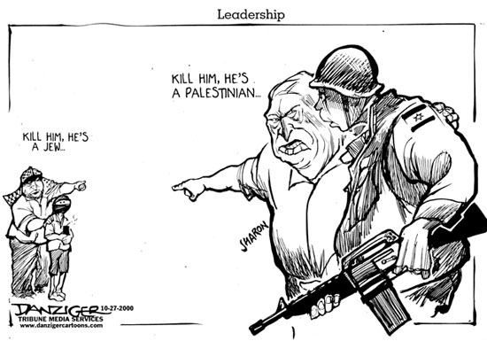

Personal identity is multifaceted. Not only do most people claim a national identity but also possess many different affiliations that include gender, religion, class, and regional ties. However, issues of identity can be further broken down. In a tribal sense, people carry family identities based on surnames and a family tree. At the local level we identify with our neighbors, our school communities and our towns or villages. There is a sense of community among people that do not even know one another based upon belonging to the same collectivity, whether in religion, nationalism, or simply the same alma mater.

A collectivity is a named group of people with myths of a common ancestry, shared historical memories, a connection to a homeland–occupied or not--and a sense of solidarity. The dialogue groups trace their ancestry to the biblical Patriarch Abraham and call themselves “cousins,” indicating that all of the members share a real or emotional connection to Palestine and bond through their shared memories of similar experiences. Most importantly, the groups have developed a consciousness and established solidarity within their groups that motivate the respective group’s political and outreach projects.

Despite the spirit of cooperation among the members of the Cousins Club and JPLRDG, they still have strong ties with their ethnic, political, national, and religious identities associated with the conflict Israel. Dialogue offers the opportunity to move beyond the rigidity of those identities and to create an atmosphere of acceptance prime for open discussion of painful issues and focusing upon issues of humanity. With the understanding that people identify with one another in a myriad of ways, dialogue group members have shared their personal views on their own religious, political, and national identities.

Ruth Shapin:
I guess my national and religious identity are really, . . . In one way, you could say they’re one. I consider myself to be Jewish, and I see that as an ethnic and national identity; however, I am a secular Jew—I’m not a religious Jew—and so I observe cultural holidays and things like that. I belong to a Jewish group, a secular humanistic Jewish Group called the Pacific Community of Secular and Humanistic Jews, here in Orange County, which is part of a national movement. My religious identity, I am a Unitarian. I am a humanistic Unitarian. I don’t consider myself to be religious. As you know, Unitarians come in many different varieties. So I consider myself to be a humanist.
On Zionism:
It is a very complicated question. I can understand the motivation for Zionism after many centuries of persecution, especially the Holocaust. Jews felt a need for safety and security and began to yearn for a homeland of their own, so Zionism started out as a good thing. The founders of Zionism wrote, in various places [documents and philosophical treatises], that they wanted to have their own homeland but that they did not want to discriminate against the Arab people who lived there. They wanted everyone to be equal. They had very idealistic ideas. Many of them were socialists; they believed in equality. They were great people. Somewhere along the line, Zionism became distorted, and it is a very sad thing for me to see that they admittedly do not treat the Arab Israelis equally. They don’t give them the same amount of funds; nor do they have the same rights and responsibilities as the Jewish population. So this is something that’s very serious, and it’s now all coming to a head with the issue of the right of return.
Jews have the right of return; any Jew, no matter what, from any part of the world, can go to Israel and immediately become a citizen. You have many Arab refugees who cannot return to Israel, people who lost their homes, and whatnot, during the two wars, of 1948 and 1967. This has to be solved in an equitable manner so that it preserves the Jewish state and at the same time justice is achieved for Palestinians. So, I would like to see some kind of compromise worked out where a sizeable number of Palestinian refugees could return. In a two-state solution, many of them will go to the Palestinian state, the new Palestinian state. Some should be able to go to Israel. The rest should be compensated financially and absorbed by other countries, including the United States. So that’s kind of my take. It’s a moderate view. There are people like Ygal Arens, whom I respect greatly, who believe in an open right of return. He says, after all, when Israel was founded, it was mostly Arab at that time. The Jews were a minority then, and everything seemed to be okay, so why do they fear that now, that they might become a minority in Israel? So that’s a radical viewpoint. I don’t think that the Israeli people will accept that, so I am for some kind of moderate compromise.
Nabil Dajani:
I am Muslim by religion, but I am not a religious person. I do go to the mosque (pause) on certain occasions but I am not a frequent visitor. Sometimes I think of God and he is for all people. I think of myself as a Muslim. I try not to eat pork. I try not to drink alcohol; I don’t even care for alcohol. So this is the way I believe myself to be with religion. In our house there was no pork, I mean my father drank, scotch and beer, he
wasn’t an alcoholic but he participated in some social drinking.
On Zionism:
Let me tell you a story. The Armenians were massacred in Turkey, in the First World War, and they came to the Arab countries and we lived together with them. We had no problems with them. But when the Zionists came to Palestine they said that this country is going to be Jewish, and if you are not Jewish we don’t want you here. That is the problem that has been created by Zionism; even if some Palestinians don’t understand that. Let me put it this way, Palestinians–and I am one of them–used to say that we wanted to create a Palestinian State with the Jews, Christians, and Muslims, for we look at the Jews as a religion, not as a nationality. It took me some time, many years, to find out that the Jews in Israel don’t want that idea, that Muslims, and Jews, and Christians can live together. They want a state with a Jewish majority. So we have to reconcile with the idea that we will live together on the west bank on one side and they live on whatever they took on the other side, rather than live together.
So now we have reconciled that Israel is there and that there are people there and that we can live together. And I am sure that most of the Israelis, at least fifty percent of them, want the same thing. It’s the fear of the radicals from the extremists on both sides that make some of the people afraid to speak out.
I don’t think that it is a conflict of religions; it is conflict of two peoples using religion to create a problem. There is no conflict between Judaism and Islam, there cannot be. [As stated in the Koran] Yes (laughs) it cannot be. But it is the people who misuse religion for their own political purposes. I mean I am sure that Netanyahu is using religious Jews to get what he wants and, like, the Arab countries they use religion to run the country, to control their people. There is even a theory that man used religion to control [dominate or suppress] woman especially in Judaism, Christianity and Islam. These religions are man made and man designed it with ways to control woman. Before the coming of the monotheistic religions, all of the Greek Goddesses were women, then with the coming of Judaism God became a man and it’s used to control woman, so that’s the theory (laughs), there is a lot of truth in it you know.

On Palestinian identity via attachment to the land:
Well, when I talk about Palestine or Israel it depends on the conversation I am in, with whom I am sitting that will make a difference. When I think of Palestine or Israel, I really think of the towns, like, I think of Jaffa, Hebron, Nazareth, you know, and Akkar, where we have relatives; so I identify with the towns like Haifa. We have relatives in Jaffa. One of my relatives had a hospital in Jaffa. They still call it Dajani hospital, until now. I even met some Israeli’s who were born in Dajani hospital. (Laughs) So we really think of the cities of Jaffa, Haifa, Akkar, we think of these towns and we think of our childhood when we used to go and visit these areas. But when we speak to people you know with Americans, we just say Israel I mean, we, at this stage, we recognize Israel. Israel is there and people are there and buildings are there and we have to live with that.
On the PLO
I identified with the PLO as the spokesperson for the Palestinians but not with Arafat himself. The Palestinians were scattered all over the Arab countries and we didn’t have any connections between us. I had no connection with the Palestinians in Lebanon, or the Palestinians in Syria, or the Palestinians in Gaza, so the PLO was able to connect us together. The Arab leaders, they were not interested in the Palestinian issue and so the PLO started thinking about the Palestinian issue. That’s why we supported the PLO as a movement. And at that time it wasn’t Arafat, it was just a group, his name just became popular. So that’s how we became connected to the PLO. It connected the Palestinians together. Before that King Hussein wanted to speak in our name and the other countries wanted to [speak in our name] and we didn’t want them to speak in our name, to represent us.
Oh, we identified with the larger Arab cause, we did. But it was the Arab cause that did not identify with the Palestinians. They were incapable of doing anything. They didn’t have the means. Take Egypt, Egypt is a very poor country, extremely poor country [and does] not have the means to do anything for the Palestinians except talk. This is politics. Nasser never thought of going into a war, and neither did the rest of the Arab countries. They didn’t have their own money. The barrel of oil was about a dollar and they didn’t have any money at the time. Nasser was a very good speaker, he was a very honest man. He could not tell them that “Hey, I’m not going to do anything for the Palestinians.” He couldn’t help the Palestinians as much as they thought he was going to help them. I mean, he just said maybe one day we will liberate Palestine. But all politicians, they have something they tell their people publicly, but privately they have a different story.
On Judaism as religion or national identity:

Well, what I hear is that orthodox Jews are the winning party and that reform and conservative Jews have no place in Israel. They [the Orthodox] do not even recognize them; it is the orthodox Jews that make the decision of who is a Jew. How religious Israel is I do not know, because I have not lived there [for a long time]. I meet mostly with liberal Israeli’s; they are not religious. Some of them even don’t believe in God, they call themselves Humanitarian Jews or secular Jews, or something like that. I mean they [liberal, secular Jews] think of themselves as a nationality, but they don’t believe in God. But sometimes I run into someone who tells me that God gave them this country [Palestine], [that God] gave the Jews this country. But God just gave this country [United States] to the Indians too. Why do you think you are better, and how did he give it to you? Do you have a piece of paper signed God, (laughs), so you see it is all based in mythology. So, some people believe in their religion and unfortunately that is what happened.
On religious identity in the Middle East:
Generally speaking, in the Middle East, religion is important. When you meet people, and you shake hands with them, they want to know what religion you are. Not for anything [purposeful], they just want to know. Sometimes from your name they can tell. If they cannot tell from your name, they want to know what religion you are. I don’t understand it but that’s the way they are. And even in Arabic, it is not a matter of being religious but being believers in God. For example, when people leave they say, “ May God be with you,” or “God Willing,” everything is “God Willing” I mean nothing would happen in this world if God Doesn’t will it. So this is part of the conversation with which they talk. “May God give you good health,” everything is may God do something. The word God is even in the love song. God is involved in love songs. So religion, it is not like in the United States, it is part of the [Middle Eastern] culture I think.
After the Israeli occupation some of the people turned to religion because they have to have God to save them because of the cruelty of the occupation, the injustice of the occupation. You know in the old days people used to turn to communism, become communists because communism was the saver. Now people turn to God, they must turn to something so they turn to God to resist the occupation. So this is the way that I explain it.
You know religion is very sharp weapon. It is like a knife. One side really cuts you the other side is really very blunt, you can put your hand on it. Now the other day I was watching a show about Checheno, which was the Russians, and how hard they fought, all in the name of religion. So if they did it in the name of religion, [the Palestinians] can make life for Israel very miserable. If they win or lose I do not know. If you look at these young kids who put bombs around them, and kill themselves you can see how religion, how strong it is.
Robert Gorden
On nationalism:
I try to be the least nationalistic as possible. For me this [California] is the best place, and mainly because of the weather, for one, (chuckling) nothing else. And in ways of life, it's easier to live in America than anywhere else, and it's true. I've worked a lot in the peace process in the Middle East and I've been very active with it all the time, because I believe in trying to create peace. I mean, my children are completely number one Americans, but I tell them, "If ever America gets into a war, you run out of this country as far as you can and I'll come and join and help you there." I don't believe in any war, and there is no cause that justifies any bloodshed. So I'll try to work for peace. I'll do anything that I can towards the peace process, anywhere. In the '70s, I was here in '73, and I was against the Vietnam War. I believe in peace, I will do anything [to work toward peace]
I think that nationalism is really bad. I wouldn't put a flag on the Fourth of July and I won't put a flag on Israeli Independence Day, neither one. You see, nationalism and the patriotism associated with that is the primary problem. Once people have a belief that's stronger than life, they can do anything, but I don't believe that it should overpower one’s reasoning. There is no reason to go to war and kill, nothing that is justifiable, from my point of view. What for? What for? I just don't believe that there is anything that's worth going to war over. . . I think there is something wrong, because all these wars that were in Europe, between England and France, between Russia and the rest of Europe; they were based on nationalism. The point is that once you make an excuse you have a reason. An excuse that there is something more important, then it will happen.
It's the same way as you get to the point that you're wiling to do anything for that national cause. It was the guy who put the bombs . . . who convinced the Arabs to put the bombs in the bus. It was on 60 Minutes [television magazine program] here. Well, he was caught. He convinced his cousin, his own cousin, because he knew his cousin believed very much, to go and give his life. Because when you put a bomb on yourself and you explode . . . It means he was ready to cause this pain to his cousin, to the parents of the cousin, everyone, for a better reason. What is a better reason? But the same thing is the guy who went to the mosque, the Jewish guy who went and shot all the others. I don't think that one is better than the other or one is worse than the other. I believe that we both have to work on it, not give it [national identity] so much importance.
I don't identify with any land. I do believe that the Jewish people have to have a place to live, especially after what they have gone through. But who said that they have to have the extra land? You can attempt to justify anything . . . At one time, the Jewish country was from Iran to Syria. So, will we go and get all of it then? I don't believe this . . . And so what? Who said that you have to have a four-story building instead of a twelve-story building? It's not an impossibility for the Israeli’s and Palestinians to share the land. Look how many people are living in Hong Kong. You want the land? You want more people in this place?
Compared to the [Jews in the] United States, you are raised in Israel with much more nationalism. You can't even imagine. There is the land that the Jews live on now, but there is land that the Palestinians have lived on for the last hundreds of years, and who will say that they have less right than the Jews?
On religion:
Yes, the Jews are a people. I do believe that there is a need to have a place like Israel, especially because of the history of the Jews. They are people who need to feel safe from persecution. I have probably an atheist point of view to God.
As a Jew, probably more than the average Jews in America, I go to synagogue probably once or twice a month. I study a lot the Kabala. I don't know if you're familiar with that. I do a lot of that. I celebrate the holidays. We have a Shabbat dinner here once or twice a month. I do all these things, but I'm not zealous with anything. I go to a Reconstructionist Temple. It's more liberal than the Reform Temple, and it is very interesting.
You see, I've been to most of the synagogues around here. I've looked. I believe that I should give my children some religious affiliation. My children go to Hebrew school, I celebrate the holidays, but I don't go to extremes. We do the Seder, we do all these things, but we have both matzos and bread. It's not like . . . well, as I say myself, I like to find a meaning in everything, although my children hate the meaning, and I've found the meaning in every holiday, and to me it's a lot. As you know, the research now says that the whole thing in Egypt didn't even exist. They didn't find any movement of
people at that time from Egypt to Israel. No evidence of the Jews exodus from Egypt. There were Jews living in certain places, [but] no evidence that they were the slaves, and no evidence that they moved out. So, will they [my children] see the beauty [of Judaism]?
I still celebrate Passover. I tell my children, that the beauty of Passover is that the Jewish people made up a story that they were slaves to show . . . to be humble, that they came out of slavery, not from a kingdom of princes and kings and things. That's the beauty of Passover. So I continue to tell the story of Passover. It's a story to show you humility before God. The same thing with the matzo, don't say that they didn't have time to bake, because, first of all, if they didn't go out [exodus], it was not a question of time to bake the bread. Now, secondly, let's say some people went out. They say that maybe there were a few people who moved during that time, but it wasn't a big exodus of the Jewish people or something like that. If they went and they did have time to make bread, whoever had bread from the day before probably took it. Therefore, I am against being so extreme of only matzo and no bread. So we eat matzo. But the matzo for me is a symbol again of being humble. So I've studied all the religion. I think people think of me as a religious personality and I'm called to perform the blessing and all this, but I do it with all the explanations that are definite explanations, of how people see it. I see it as understanding of the history of the Jews.
Religion plays [a] very strong [role in the Arab-Israeli conflict]. Too strong. Because once you believe that God told you to do something, it's very hard to work with people—actually both sides, the zealous people or the religious people. Baruch Goldstein, the Jew who went to the mosque, was a very religious Jew. They are the minority. It's also a minority of the Arabs that are very [fundamental or fanatical] religious, but these are the people who do all the bombings. Both sides [Jewish and Palestinian], I mean, Baruch Goldstein and the [Arab] people who put the bombs in the bus, there is no difference between the two. And both are very radical religious.
On Zionism:
Zionism comes from the word Zion, which is the word in the Bible for Israel. So it's a question of how you interpret Zionism. Do you interpret the love of Israel as Zionism? Everyone is allowed to love whatever they like. They might be allowed to love what they want. But you're allowed to love only Zion? No, you can love ten countries if you want to. I love southern California, I love Paris, I love Italy, I love Israel. It's not like you have to choose, it doesn't mean you can't love more than one. You can love more than one place also. So, if you call Zionism just the love of a country, which is, I think, the definition, then it's okay. The problem is, like with everything, when it becomes more holy-than-thou.
When Zionism is love for Israel, then it's wonderful, but if anything it is used for an excuse to be militaristic. The Hagannah is Zionist and delivered a strong military force. There were few organizations like the Hagannah. Probably it had to be the same way as the Palestinians [the need for a para-military organization]. I would have loved to have the Palestinians be able to come and say, "We would like to make an agreement with Israel." Maybe they would make it and probably the Intifada wouldn’t have happened, but they didn't agree to do it. The same thing with the Hagannah, I would have loved if Israel could have said, "We want to have a country. Just let us have it." But they had to fight against the British, who were occupying Israel then, and probably . . . If they had to go to the extent that they went, the same way with the Palestinians, they had to go . . . Once an organization gets the momentum, usually they all exaggerate and go too far. I think they went too far in both organizations.
Sami Odeh:
I was born a Catholic I have a brother who's a priest and a sister who's a nun, several cousins are priests, so I come from a very strong Catholic background.
When I think of nationalism, the word that jumps to my mind is I am a very proud American. By birth I was Palestinian. Through no choice of mine I was handed a Jordanian ID, a Jordanian passport, under Article 3 for Palestinians who do not have a country. But I'm very delighted that, in spite of all that, I was able to raise my hand and pledge my allegiance to the flag of the U.S., and that's the country I have by choice and I'm very proud to be one of that.
My attachment to the Palestinian land– for somebody like me who has been here twenty-six years–would probably be the childhood memories that I'm sure everybody cherishes regardless where they come from. But I must be very honest with you, if a Palestinian State is established tomorrow and it said, "Look, as a Palestinian, you're welcome to come here and live and work," I probably would not. I love the U.S. and I think of it as the country I choose and the country that welcomed me, and I'm happy with that. My love for my childhood memories of where I grew up, in my mind, does not conflict with being a damn good U.S. citizen myself. On the other hand, I talk to a lot of people older than I am, and I feel the pains of separation from the land, although many of them have been here longer than I have, they still have much stronger yearnings of going back. They exhibit so much pain from the separation that took place in '48, and some of them been here forty, fifty years.
Some of the refugees, especially the children that were very young in '48 or were born shortly thereafter, have successfully completed their higher education and are earning enough salaries to [successfully] establish themselves, whether being in Jordan, the West Bank, Syria, or Lebanon. And their attachment to the land will grow strong, naturally not as strong as their parents because simply . . . I mean, they can repeat a description in detail of what the parents told them, but there is no . . . Like they didn't play in these alleys and streets. To me, it's very important where I played hide-and-seek as a five year old. These people have not been part of the land; therefore, they probably are more willing to give it up than somebody who had lived there all their lives
Anonymous:
I'm Jewish, and my religious affiliation is that, one of a Jew, not a practicing one but still consider myself a Jew, as my religious orientation. I identify it [Judaism] also as a cultural experience, one that I grew up in and one which I still am involved with. My grandparents came from Russia. Both my parents were born in the United States in the teens. My dad, actually, I guess, about 1907; my mother, I guess, a little later, 1913. But all of my grandparents on both sides and all of my great-grandparents were all born in what is now called Russia. I've always grown up thinking of myself as being Jewish and comfortable with that fact, somewhat amused at some of the stereotypes that people attribute to people who are Jewish, good and bad. But I don't think it had a real effect on my outlook.
On the Zionist endeavor and 1948 War:
Well, for the Arabs, they must be absolutely both terrified and infuriated by it, because hundreds of thousands, if not well over a million or so Jews, had immigrated since the end of the second world war, just flooding into a country that had never seen that kind of immigration. And the people that came into Israel were not really attuned to any of the mores, customs, practices of the area. They brought their basically European customs and practices and a whole perspective which was totally different from the Arab perspective that prevailed for generations before the War of Independence in '49. As a youngster—and I was about, I guess, fifteen or sixteen—I was very excited about it. It was promoted in the area of Brooklyn where I grew up as a wonderful expression of independence. I remember that a number of my friends, who were similar age, sixteen, seventeen, talked about—but I don’t think anybody ever acted on it—possibly volunteering to go to Israel to sign up to fight as part of the independence movement.
Jamal Awad:
I'm a U.S. citizen by citizenship. I was of Palestinian origin and Palestinian national identity, I guess. It may conflict with my U.S. citizenship at this time, but in terms of nationality, prior to obtaining U.S. [citizenship], I was Palestinian. I identify fairly strongly with Palestine. I feel I'm connected there by the fact that my parents were born there, we had property that was taken away from us, and I still have . . . A lot of family still live there. I have my grandmother, my uncles and my aunts . . . Quite a number of family still live in Nazareth, so I'm fairly connected. I have a lot of roots and I'm quite attached to Palestine psychologically because of the trauma that was put on the family during the years of my parents not being able to go there, my mom not being able to see her brothers or sisters or her mom. We have experienced a lot of separation, family separation. We communicate through pictures and letters that go through Europe, then come back to Syria. So Palestine is quite deep in my psyche.
I identify with the land because of my roots there and my family and my history there. So I always have trouble with the religious aspects of the claim to the land from the Jewish side. I don't have a problem with anybody having a claim to it in terms of having their family live there or their ancestors lived there or they want to live in that part of the world. There is no problem in my mind.
But I do definitely have a problem with the Jewish claim to it from a guy in Russia or in Poland or anywhere else who has no connection to the land except religious and a nationalist aspiration. The Jews deserve basic human rights but that is legitimate for everybody, and it definitely does not legitimize a claim to the land in Palestine. I am referring to the initial wave of people who I would say did the harm to the Palestinians by deleting their national rights and claiming the land as their own
In terms of the present time, there are certainly people who were born in the land, that's all they know, that their roots are right now in that land. I do not promote the removal of their rights or claims that they could live and prosper in the area, regardless of religion, as long as they don't consider that their rights come ahead of other people.
I'm a Muslim and the most meaningful teaching in Islam for me is the sharing of our wealth and being with others, and also providing guidelines for good and proper behavior in our life. I always have trouble understanding the claims of land based on religion. I do not identify with the land of Palestine as a place of . . . as a religious connection, although it's very important from its religious aspects to me as a Muslim. But I don't connect with it because that's where the Al Aqusa Mosque is and that's where Mohammed ascended or descended from heaven.

Rosalie Abrams:
On Jewish Religion and Culture:
I was born in 1921, which means that I will be eighty years old in October of this year. I grew up in a very progressive family in—I was born in Pittsburgh but grew up in Brooklyn, New York, and moved to California in 1954 after I had been married for several years. I was always politically active because I came from a politically active family.
I had grown up in an atheist family, so I was not particularly religious, although my mother kept a kosher house because of her parents and my father's mother, who were deeply religious. And I do remember going to the synagogue and taking my grandmother home when I was about seven years old, walking her home so she wouldn't get lost. And I do remember my grandmother singing Yiddish songs to me when I was a little girl. I grew up, just like a lot of Jewish children, in Brooklyn, where your big holiday is the Jewish holiday. Nobody goes to school on Jewish holidays.
It is a common perception that people think of you as Jewish being your nationality (chuckles) and not as your being American. I was born in Pittsburgh, Pennsylvania. (chuckles) I'm an American. I'm not embarrassed by being Jewish. I've never denied being Jewish. There are things about my heritage that I really admire. I admire the great people who were wonderful Jewish people. And the fact that I grew up in a milieu where the Jewish people were the most progressive people around. Some of my best friends are Jews (chuckles).
I feel strongly about the culture I grew up in. I give Hanukkah gifts; I don't give Christmas gifts. We have Passover. Ironically, my daughter makes a Shabbat every Friday night. She wasn't brought up with that, but she does it. And her Shabbat is about all the people in the world who are oppressed. She taught her son to say the prayer in Jewish. Where she learned it (chuckles), I don't know. She didn't learn it from me (chuckles). But she feels strongly about being Jewish and having this identity and having her son have this identity, because her father is not Jewish. He fact, he's got a little bit of an Indian background. So she wanted him to have this identity as well.
She feels a strong cultural tie because, as my kids grew up, we always went to a Seder with our relatives, and some of the fondest memories my children have were at these Seders where they met their cousins and their relatives, and we were a very close family. These were younger people in the family. They were my nieces and nephews. And I did talk to them about the Cousins Club because I felt they were younger and they could handle some of things, but I was never able to influence them to the degree that they would feel the way I felt, but they did listen.
I don't have a strong identification with Israel because I'm angry at Israel for what they did, you see. And even though I wish it was a country where everybody would be safe, I don't like what they've done, because I think that what they've done is what was done to us as Jewish people in other places. So it would be so contradictory for me to feel differently about it. But what I do have is a cultural identification with the holidays.
On Zionism:
Well, because I wasn't in a religious household, I would just read these things about the Zionists who came and established Israel, and that was wonderful, because so many of us had relatives that were lost in the Holocaust. Many who I didn't know, but I know that my aunts and uncles knew them, and that certainly affected me. It affected me because I wanted the right to be Jewish and not to be persecuted.
I grew up in a family that was very supportive of people who were being oppressed and learned very early on that no one is free when anybody else is oppressed. , I am certainly an anti-Zionist. I do not approve of secret agreements and all the things that they did with the British and all the things that happened in terms of setting up Israel and displacing the Palestinians. Basically, it's the Zionists who did what was done to the Jewish people, and that parallel was very enlightening to me in terms of how terrible it was that we were doing to the Palestinians. And here I had gone to Israel, so enthusiastic about it, and then read this book and realized that the Zionists were so responsible for encouraging our government give them all this money so that they can continue this horrible procedure of displacing the Palestinians and really taking the country away from them.
Prior to, and contrary to what people believe, the Zionists did not make all these wonderful changes. By the turn of the century, they had Zionist villages all over that were productive, that do to the land what the Zionists claim that they did. But the Palestinians accomplished all these things as well. And they lived side-by-side with the Jewish people without that conflict until they began displacing them, took them off the land. And then I began to read a lot more and met more Palestinian people and realized that I had been wrong my whole life about my Zionist relatives, and it became difficult within my family to explain these things to people.
I realized when I started to meet other people that I really was anti-Christian and that I really accepted a lot of things in blind faith, both politically and in religious ways. And although, upon reexamination, because the things that my father taught me about religion and atheism turned out to be the things I really felt were correct, I made an effort to learn about other religions. I let my children go to any religion they wanted to go to. And they did. My son didn't particularly care about it at all. He wasn't interested in being bar mitzvahed, or anything like, although he had that option. And my daughter would go with her Catholic friends to Catholic school, with her Presbyterian friends to their churches.
And when we came to California, we looked around and joined the Jewish Temple's Cultural Group, because I wanted a Sunday School for my kids, because they had no support group. When I was growing up, I had a support group of families that were like my family, and we were young pioneers is what we called ourselves. So I had a support group that I felt out here my children did not. We moved to Orange County and it was quite anti-Semitic. My kids were the only Jewish kids in their classes, and my daughter got picked on because she was Jewish. She was still in elementary school. Nothing happened to my son. But they made her feel very uncomfortable. I spoke to the children, and they were very unhappy with the cultural things at the temple. They made fun of Steven because he wouldn't be bar mitzvahed, so I said, "You don't have to go there."
So we went to the Unitarian Church on the advice of a friend. And I asked my son about the first day that he went to their Sunday School and he said, "Well, we talked about integrity." And I said, "Steven, that's a very good religion." (chuckles) And so that's how we came to the Unitarian Church, and we've been there ever since. And it's been a wonderful experience all the way around because it was like an oasis in the desert here, and that's where I met Ruth and Ted Shapin.
I find it's the dogma in most religions that is offensive, and the unrealistic results of how people feel. I know my husband had four major surgeries, and each time, everybody in the hospitals and everybody was praying for his recovery, and if that made them feel better, that was fine with me. He recovered, but I think he would have recovered (chuckles) without the prayers. I do know one thing. It's never been proven to me to believe in any of these things, or the dogma, or the contradictions I find in so much of religion. So that's the way I feel about religion.
Samir Hijazi:
I don't know when my family first got to Palestine or how exactly they became Palestinians, so to speak, because Palestine had been an area of a lot of émigrés coming from a variety of regions. You have religious factors. . . You have all the three religions coming in and out of Palestine. Then when we had the Crusades, the Crusades at one point and the Muslims at another point, and all those people. It's really difficult to say homogeneously how it all started. My original last name, however, is not really Hijazi. It's part of . . . Hijazi is part of my last name. There is a very strong belief in the area that we actually were part of the Crusades that came through the area around 1100 or 1200 CE, from a Germanic background. This is why when you're in the Left Bank or Israel or Palestine, or whatever you choose to call it these days, you will notice that people look different. They don't all look the same. There is this idea of what an Arab looks like or a Palestinian looks like, but then, every once in awhile, as you walk through the markets, you'll notice that's here's a blonde guy with blue eyes, and here's a red-headed guy. So, it's a wide mix of people.
Now we can trace my family’s Palestinian heritage at least, four or five hundred years. My grandmothers, both of them, are alive and live there. The great majority of the family still live on the West Bank in the town of Al-Khaleel. That's the Arabic name of it. Hebron is the English.
My family is Muslim and although I consider myself Muslim, but I don't necessarily see Islam in the same light that everybody sees it, even how Muslims see it. I think coming down to it is that the most important thing about it [Islam] for me, is that my relationship with God is direct. I don't have to have an intermediary, and I don't have to have anybody telling me whether I'm doing the right thing or not. That's probably the most attractive thing about it, as far as I'm concerned.
On Palestinian identity:
These are my roots, undeniably. I can't dismiss that for any political or geopolitical . . . or whatever the final disposition of it is in my lifetime, it will still be the place I was born in and came from and where my roots are. I have no doubt in my mind that my claims are legitimate, obviously. But in the minds of many, my claims are not legitimate. It's very difficult to accept the argument that God's chosen people (chuckle) get it. If we believed in the same God, well let’s just say that I really have a difficult time accepting the facts as the other side presents them. But it's a fact of life. Israelis are there. There is Israel and the world recognized that. We even, as Palestinians today, recognize that for the lack of any other solutions to the problem. I mean, it's much bigger than the Palestinians in their current status. So it's a fact of life, but it's not something I necessarily like.
On the PLO:
Growing up as a child, that [the PLO] was the thing to support within the family, within the community, because that's what was going to free us. And I did support them. Every kid wanted to be part of the PLO for a higher purpose. I think the PLO enjoyed very wide support throughout the Palestinian community in general, and the Arab world in general, also, until basically the break of the PLO in Beirut in 1982 and their relocation to Tunis. I think the PLO basically achieved their goal until that time. I think from that point on they continued to achieve goals but not totally at the rate or desire that most people wanted them to do so. I'm of the opinion that the PLO did the correct transformation from a guerilla-type warfare, hits here, hits there, you know, and grew to a political group, although I don't necessarily think that the current leadership is necessarily the correct leadership for that role. That remains to be seen and is also another disputed or . . . you know, a big argument even among the Palestinians whether the current leadership is the right leadership for what they're trying to achieve.
I would like to see a different leader for the Palestinians. Arafat will still be an important figure. That is most Palestinians will respect and appreciate him. With his ideological views, his demeanor, his ability to come across media, I don't think it's one of those necessarily conducive to a statesman-like politician type of guy. I think that Arafat is viewed as a terrorist, and continues to be, and it doesn't matter how much he tries to be a politician, he will always look like the guy who would hold the gun in one hand and tries to do something. That image still sticks in many people's minds. A lot of it is perception.
Len Traubman:
I was born in Duluth, Minnesota in 1939 of ... my father’s family were German, that is, Bohemian Jews, and my mother’s heritage is Russian Jewish. And when I was five, we moved from Minnesota to Southern California, and I grew up as a Jew, American Jew, in West Los Angeles, and then came up to UC [University of California] Berkeley to go to college. I never returned to Southern California.
I’m an American Jew. I identify with the United States, and with, I think a very high destiny of this country, to be a model of how people from different backgrounds live together, and to live up to that destiny; to help the world cooperate, and not be a consumer nation or a dominator nation, but to really be a model of taking care of the planet and helping people cooperate for the good of all.
I would like to add that as an American, what I’ve experienced is that we are unique on the planet, and like no other nation we feel and have a freedom of wealth and of mobility and of freedom and know-how for change. And so, in other nations, the people do not feel that freedom, and I think it’s the characteristics of those who came to America. And so I really feel like we are those who can help the planet and ourselves change.
Israel does hold special meaning to me. When I grew up, our family helped start University Synagogue in West Los Angeles. I was in their first Sunday school classes when we first met at the local Congregational Church. I remember when 1948 came and we helped save money–Zedakah–in little blue metal banks, for the newborn State of Israel. I was in B’nai B’rith youth organizations and Sigma Alpha Mu undergraduate fraternity; I was the president of the Bay Area alumni of Alpha Omega, the Jewish dental fraternity, and so I’ve always identified as a Jew, but also with the larger community. So Israel, to me, is a very important place. It was a saving factor for the world Jewry after World War II. And I have only since 1990 understood the imperfection about the genesis of Israel, how it began. I never knew what a Palestinian was until 1990. So I think that is pretty typical of an American Jew, that I did not know the dark side of the beginning of the state of Israel, because all that I heard was from the Jewish perspective and from Jewish educators.
Melek Nasr-Totah tells the story of her family’s difficulty assimilating into American culture and living with media produced stereotyping of Arabs as terrorists that value life less than other ethnic groups despite her father’s efforts at creating an American life for his family.
I was born in Des Moines, Iowa, in 1966. And our family moved around a bit, around the Midwest, but remained mostly in that area. And I went to Des Moines, Iowa, Drake University, and graduated in '88. And then I received my MBA at Thunderbird in Phoenix, Arizona.
On national identity:
My father was born in Haifa, Palestine, in 1921, and he ended up immigrating to the United States, I guess, in the early fifties. And a lot of that was due to the fact that it was after the war and he really wanted to get away from that area of the world. So I guess the important thing to say about my father is that when he came to the United States and married an American person, he really wanted his children to be American and not have any contact with Arabs or his family really—he changed our family name and didn't teach us Arabic. It was kind of like he wanted to completely sever all ties to the Arab culture and history. Which, quite frankly, I'm finding was kind of common in my family.
In regard to his motivations for assimilating us, I can guess, but of course I've never really had a conversation directly with him. I think it was a couple things. Number one, he felt that there was prejudice in this country for Arabs, and our name was Nasr, -a-s-r, and I think that was—At the time that he came the Egyptian Nassar had some problems with Truman because of the canal in Egypt, and I guess Nassar went to Russia for funding because the Americans turned him away. And I think there was a lot of anti-Arab sentiment, and probably in particular that name.
So that probably was one item, as well as the fact that he felt that being Arab in this country, he felt a real threat from, I think, Israelis. He actually mentioned to me more than once, "Don't speak about this kind of stuff on the telephone because people could be listening." So he was always very paranoid about the Jews and the Israelis and any type of retaliation, or just maybe terrorism toward the Arabs here. I think that was another reason he wanted us to not have anything to do with it—it would be safer.
On religious identity:
I'm very mixed up. (chuckles) My mother came from a Methodist background. My father was raised Greek Catholic in the Middle East. When he came here, I think he kind of experimented a bit. When he met my mother, they became Unitarians. And my very early years, I remember going to the Unitarian church. Then my parents were divorced and my father kind of went back to Catholicism, and we ended up living with my father, actually, after my parents divorced. It was probably when I was about six or seven. So from my early years until the age of six or seven, it was Unitarian, then from six or seven on it was Catholic. And as an adult, I pretty much walked away from it all, and now I'm not really—I would say probably I'm agnostic. At this point, I feel very comfortable saying that.
On cultural identity:
As I said, my father really tried to sever all ties with the Middle East for us; however, he was very Arab. I know that sounds like a contradiction, but he didn't come to this country until he was in his late forties. From a cultural standpoint, he was about the farthest thing from an American as possible. So although he raised us in the United States, we had incredible Arab influence regarding basic thoughts and values.
Family was extremely important– family and friends. Just a loyalty that he felt toward people that were close to him was so incredible. He's so different than meeting your average American. An example would be that my brother, as a teenager, had a lot of friends that were kind of—he went through a couple bad years where he got into some trouble, and some of the friends he associated with were what you'd call troublemakers. And when they would come into our home, these kids, the first thing my father would do was say, "Come in. Sit down. Have some food. Tell me about yourselves." And they were just so taken aback. Here's this person who's interested in me, which was never what would happen to them even in their own home or anyone else's. So it was very much, like my dad would say, When you come into my house, you are important. You matter. I want to hear from you, I want to feed you; I want to take care of you. It was just so different than any other environment in the United States, I think.
And that, to me, was just very clear, and I feel like that was how we were brought up, like you're very respectful to others, and you pay attention, and it's important. That bond. That human bond is really important, I think. Again, I have a lot of trouble with that in the United States myself because a lot of Americans don't feel that. They meet you, it's just superficial, and that’s it. So that's one thing I feel that was good and very difficult for me living in this country, because I'm sort of like my dad in that sense. That's probably one thing.
And then just the work ethic. My dad had an extremely strong work ethic, like a lot of first generation Americans or new immigrants to this country too, and their children. So I think that's also something that's different. Those are a couple of examples, I think.
As I grew up, I became very interested in learning about the culture that my father came from, and I ended up studying Arabic when I was in graduate school. I ended up going and visiting some of my family in Egypt because my father's sister married an Egyptian and lives in Egypt now. So when I was in school, I studied abroad, and I actually went to Egypt on a trip and met some of my cousins and family there. And I ended up trying to meet some of the other cousins that my father has lost touch with. So I guess I do feel an affinity, in a lot of respects, to that culture and that part of the world. It's sort of like through osmosis, although maybe my dad didn't tell us directly about it, I still very strongly about it. And I can relate to the culture, because it is a very warm culture, and I really enjoy that aspect of it.
I think the biggest thing that I'd have to say, though, about—I don't know that I personally feel a strong identity toward the Palestinians as much as it is more at a consciousness level, and I think that what's going on there is wrong, and I want to do as much as I can to help and to educate people in the United States about it. Not so much that I've lived there and I feel like I'm being done a wrong personally. I feel the same way about what's happening in some of the other countries, and I feel terrible about what's happening in Rwanda, and there are probably many examples that you hear about—Macedonia and Albania. I feel strongly about a lot of that. In general, I just have kind of a heightened consciousness about the world and humanity and how we as humans should treat other humans. That's probably more of where I'm coming from. But the Palestinians are particularly interesting to me because of my heritage. I have a lot of empathy for different cultures that have gone through a lot of problems, like the Palestinians, like Rwanda, the Macedonians
I feel that the Jews are another culture that I think have had a tremendous history, a lot of problems throughout their history. I do believe it's formed and shaped their identity. And people today, because of that history, and I think in a lot of respects, unfortunately, it's made them into sort of a victim culture. Understandably. And I think that that's probably one of the saddest things. Because of that victim culture, they're very hardened to other people's suffering, because they're so into their own, and I think that's one of the reasons why this is a particularly difficult situation in the Middle East is because they're very—It's not very easy for them to look at the others because they're so focused on themselves.

Elias Botto:
On Palestinian Identity:
In essence it’s the idea of being born, being raised, being under a Palestinian identity. I mean, I could answer a question with a question! Why all of a sudden Bosnia and Kosovo and all those ethnic groups in East Europe. To us, to you, to me it was all a part of the Soviet Union. Look at Armenia. Look at Azerbaijan. What is in a nationalistic aspiration? You tell me, maybe they thought we will be absorbed, we will be diluted and become a part of Jordan or Syria or Egypt or Lebanon.
I was born Palestinian, my parents were born Palestinian, my grandparents were born Palestinian, and so on. And now, all of a sudden, you want to came and rob me of that? If I were to be in Israel and become Israeli I am no longer Palestinian? And if I happen to be in Jordan I am Jordanian? It was just, I think, the fact that I used to posses that identity and you are coming to rob me of it.
It was brutal. Like if I were to tell you to forget about English language and speak Arabic only, you probably would not. I mean, how could you? You have your roots in speaking the English language, you have American friends, you are used to the American environment. You can’t just change who you are.
We were talking about “Palestinian” identity and I would like to say that I am a Palestinian first and then an Arab. Because I have to ask the question, what constitutes an Arab? I always bring the example of South America; they call themselves Latin Americans. You can call them Latin Americans. Yet they are subdivided into various states: Bolivia, Argentina, etc. Each country is independent of the other; in fact, one country could declare war against the other. But what do they have in common? They all call themselves Latin America and they are majority Christians, and the majority speaks Spanish. And so is the Arab world. But Egypt, in reality, Egypt geographically is northern Africa, Algeria is Northern Africa, Morocco is Northern Africa, they are not even part of the Middle Eastern Arab world. See the difference? That is why I will say I am Palestinian first. Now, maybe I will not mind saying that I am an Arab if, the Arab world were to become like the United States where you are a New Yorker and I am a Californian but we are both under one federation. There is a federation, there is a sharing of wealth, power, and security and money; the Arab world doesn’t have that. Saudi Arabia, with all its billions in wealth, and Kuwait, and Iraq is Iraq, and then there is Jordan, Jordan is Jordan. The difference for Jordan and Palestine, even before ’48, the Jordanians and Palestinians were mixing up. They were crossing the border between one and the other and they married into each other and now Jordan, so much of Jordan’s population is really Palestinian.
There was a movement for a greater Syria, from Lebanon to Syria to Iraq and Palestine. That would have been great. No problem, I would still be Californian and you still New Yorker; so I would still be Palestinian and you could be trans-Jordanian. That’s what it used to be called, Trans-Jordan, and who created that? The British after the First World War. The French went in there and they said, “here you take this and I’ll take that”, and that is what they did. They sub-divided [the land], they put walls between us. Going back now, that’s how I feel about the Arab world and Palestine. Until the rest of the Arab world is willing to have a federation between us, then I would say I am Palestinian. Even though I say, hey, I come from California, I am an American Palestinian, and I pay my taxes to the federal government. So maybe someone needs to wake up and see how the American system [works].
There is no focus [in the middle east]. There are to many “big-cheese’s” to do anything in the Arab world. But that is a shortcoming of the Arab world. That’s why I would rather concentrate on saying I am a Palestinian, concentrate on being able to talk to you as a Jew, that you are occupying part of my home and try to find a compromise on where you and I can share and live in peace, where you could profit and I could profit, and build a secure life for our children. And who knows, if not for our kids now, then maybe for our grandchildren. A couple of them could fall in love and marry. Whether it is a Jew religiously speaking, or is a Muslim religiously speaking or a Christian religiously speaking, but we are all from that land and your belief or what kind of church should not matter. That is when there is going to be peace for Israel. That is when there is going to be peace for the Palestinians.
I like to always put the burden on the Israeli’s and say, “Israel, there is a big heavy task to perform in order to achieve peace and security for yourselves, and that is that you must carry along the plight of the Palestinians who are living next door.” Israel must bring them [the Palestinians] up to there [economic] level because I don’t think that Israel wants to come down to the [economic] level of the Palestinians the way they live now [in the occupied territories]. It behooves them [Israel] to be the ones to extend the helping hand to create a better society for them all. SO when I sit at this table with you, I sit as an equal with you and I don’t feel inferior to you, I don’t feel suppressed by you, so that I can hold my head high and we know tomorrow that we can meet, not to face each other and kill each other but to meet and discuss our water resources. There is a lot we need to share you and I, over there. Once we recognize the plight and the welfare and well being of each other.
On Jew and Palestinian:
There needs to be a marriage between Palestinian and Jew because you know what? We come from the same lot. You claim, if you are to go back in history to the bible, in religion, to Abraham and his children; you are Sarah’s granddaughter, I am Ishmael’s grandson. Both of them were the children of Abraham so…Biblical connection is there. And biblical connection provides for my right to that space as much as it provides for your right. So please be honest with me and be willing to share it. And don’t call it Greater Israel just Jews alone.
On the Arab-Israeli conflict as a religious war:
And you know, our conflict, many people say it is not religious. Even in our own dialogue group. But I like to say that it is a religious war we have. There are so many indications that it is religious more than anything else. When Israel came to occupy that land, there were so many other areas where Israel would have found a vacant lot and could have pitched their tent there. But they chose that part of the world. Why? Isn’t it because of religion? Isn’t it because of the Biblical connection? Well, if so, if you respect your religion, why not respect my religion as a Christian and you and I respect his religion as a Muslim? Because you know all three religions lead to the same God that you worship, that I worship, and he worships. It was like I was saying, the only difference is–You drive to school in a Volkswagen, I ride on a bicycle, and he rides a camel. But all the transportation is leading to the same terminal and that is what is religion. And we are fighting in the Holy Land to secure a safe place for us in the future day with God? Our relationship with God? The fighting, it is all man, it is not God-like. That is from a religious point of view. From a political point of view, who came first? The egg or the chicken? I mean, who occupied Palestine three thousand years ago? The inhabitants of that area regardless of them being Christians, Muslims, or Jews should be able to live together, regardless of religion and under the banner of Palestine.
Identification with a particular religious group or ethnic/national group instills a sense of loyalty to that collectivity and shapes one’s world-view of events. The passage of time allows for a more balanced view of the Arab-Israeli conflict. However, varied interpretations of current events—and historical events as well—is inevitable. Group members are diligent in their efforts to remain respectful toward one another during discussions of sensitive issues.

CHAPTER SIX

Areas of Conflict

The settlers, they’re having a nice backyard with beautiful swings for their kids. And you see Palestinian kids standing behind wires across the street, watching their freedom . . . If the settlements keep going on there won’t be peace.

Nadim Zarour

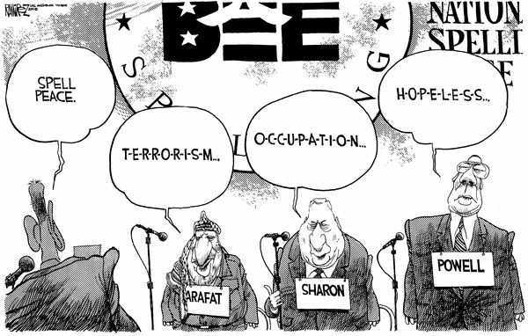

History is arguable because the collective memories of different cultures shape their perception of events. As areas of conflict are exposed, we can begin to understand the Arab-Israeli conflict through real people. The conflicting interpretations of events in Palestine/Israel along with the motivations for political actions provide fuel for heated discussion in the dialogue process. The Palestinian interpretation can differ significantly from the Jewish or Israeli perspective directly paralleling issues of revisionist history writing in academia. At dialogue meetings, some Jewish and Israeli members hold very strong views regarding the security of Israel and therefore support the protection of settlements, continuation of the occupation, and retaliation against acts of terrorism. Palestinians, of course, view these critical issues as a Zionist continuation of oppression of the Palestinian people and repression of their nationalistic aspirations. Some of the “hot button” topics have included the occupation of Lebanon, closures of access routes between Palestinian areas and Israeli areas, civil rights violations and the issue of democracy, the Zionist endeavor, terrorism, Israeli settlements, Jerusalem and the circumstances surrounding the refugee problem. The voices represented in this chapter reflect the moderate and conciliatory attitudes of the majority of the peace group members.
Although heated debate can occur as well as accusations of changing history, these peace-oriented groups strive to validate each other’s perceptions as true for them regardless of how the interpretation fits into traditional historical discourse. Also important to the process of accommodation and reconciliation is the willingness of members to hear each others’ stories and find those stories validated in new scholarship that is utilizes new archival primary source material. Group members also strive to focus the larger issues of cooperation and meet hostile situations with reminders of their greater goals.
Ruth Shapin on Democracy and Theocracy:
Big issue. It’s a theocracy. Now, the secular Jews, of course, rebel against that. The Jewish State is in control of marriage. The rabbinate is in charge of marriage and divorce. I’m not an expert on exactly what’s going on. I do know that the secular people run into problems. The orthodox get angry if they do certain things on the Sabbath. I think the status of women, from what I read in the newspapers—and I brought some clippings home with me, which I should have brought—women have problems over there. There’s abuse. There’s domestic abuse. I don’t think there’s . . . There are not as many women—similar to this country—they’re not in the government in the numbers that they should be. And they cannot . . . They have a separate section of the Wailing Wall, which I saw. It’s a small section. The men have a very large section. The men have a large section; the women have a little small section. So, many different ways. You go to the museums there and again women’s contributions are kind of slighted. Of course, this is . . . I’m getting away from the issue of a theocracy. But I don’t think it’s a complete democracy. They don’t have a constitution, no Bill of Rights, so there’s a lot . . . To be a true democracy; I think there’s a lot that’s yet to be done. And I think the rabbinate has too much power and the orthodox have too much power. And so do the secular Jews. That’s an ongoing battle in Israel.
Yet the West still perceives Israel as a bastion of democracy in the Middle East.
Compared to the states that surround them, that’s probably true (chuckles). At least they have freedom of speech, freedom of the press, and they have newspapers that are critical of the government and they get away with it. And they have human rights groups that support the Palestinians. They have organizations that work for justice for the Palestinians. So, they have some of the same trappings of democracy that we’re used to here, so in that sense, yes. But it’s not a perfect democracy, but neither are we.
Nabil Dajani
On the Jerusalem issue:
Well, because of the presence of zealous religious Jews, Jerusalem is going to be a stumbling block. I don't see it as a stumbling block personally, but I am speaking for myself. I don't care who lives in Jerusalem, as long as there is freedom for everyone to live there. For me now, I cannot live in Jerusalem. Many Palestinians cannot go and live in Jerusalem. It should not be a conflict. There are places of worship [for all three religions] and people should be able to go and worship. I just can't understand [why it] can’t be shared. Among the religious people, there is going to be a conflict [regarding Jerusalem].
On the expansion of the municipal boundaries of Jerusalem:
I remember Jerusalem as a very small area. It is like you think of Anaheim as Disneyland. I think of Jerusalem as the area around Disneyland; that’s how big Jerusalem was, almost, by figure of speech. But Israel went and extended the borders of Jerusalem to San Diego, right, and they call that Jerusalem. So really what they are interested in is the religious places in the whole city. That is where the religious places are and where some people want to live, I can’t understand it. They [the Israelis] took all the areas and they made it a big area. If you want to take that part of Anaheim and extend the borders of Anaheim up to San Diego and still call it Anaheim, you know (laughs) it’s a trick, it’s a trick.
On the Har Homa development:

This government, Netanyahu, just wants to expand. They want to bring more Jews in from all over the world and make life miserable for the Palestinians at any price. In the long run, if Israel is going to live in peace with the Arabs they have to reconcile life with the Palestinians. Israel is extremely powerful, especially with the blind support of the United States, both politically and financially. But the United States is not living next door to Israel.
There needs to be fewer Zionists. There are different shades of Zionists. There are some Zionists who just want a small state with a Jewish majority, then there is Likud, they want to expand and expand. People won’t trust them. Expand to where? How much do you want? What do you want?
The Palestinians have changed, we have accepted the fact that Israel exists, and now the Likud has to recognize that we exist, that we have rights too. The Jews, they surprise me. They are mad at the Palestinians. The Jews left and now after 3,000 years they want to come back to our country, after 3,000 years. Now the Palestinians, they had to leave and now they want to come back to their country. What is the difference?
They [the Israeli government] do not want peace. Their main aim is to expand. Their main aim is to control. That’s what they want. I mean Shamir, when he was in power, he said that he would sit down and negotiate for ten years and never give the Palestinians anything. But you see he had to save face and say they are for peace; let’s negotiate, and he is going to keep people talking and talking and never give anything. So the current government, no, the Likud, they don’t want to give anything up.
On the Oslo Peace Accords of 1993:

It did give me hope, yes; because it was the first time we reached an agreement together. It wasn’t a perfect peace for the Palestinians, for example a Palestinian like me, cannot go back. There was not compensation [from the Israeli government for lost real property]. Instead of the Israeli soldier’s policing us we are going to have Arafat there instead. So we said, at least it is a step in the right direction. But there can be reconciliation in the future.

On the PLO:

Right now, I just hear rumors that they are not running the Palestinian organization efficiently. Can they be excused? I really don’t know. There is a lot of pressure on Arafat; people are without jobs, he has no money. Maybe he has to let some inefficiency pass by him since he has so many problems to take care of.
I listened to a person working for the World Bank in the occupied territories, and he was talking about the problems Arafat has when there are closures and 70 percent of the population is unemployed. He has to offer them jobs, and he has to please everybody. I think he should have negotiated better peace terms in Oslo, but he wasn’t able to. This is one thing I wish he did. He is trying to act like the rest of the Arab leaders; I shouldn’t call them leaders, but dictators really. We [the Palestinians] don’t want a dictator really. We didn’t struggle all our lives to have him sit down [as a dictator]. We wish he would change and that there would be new leadership [in the PLO] other than Arafat. But in many countries you always find . . . for example, in Vietnam there was Ho Chi Minh, in Cuba there was Castro, you know and certain of these revolutions there was one man who stood up and took care of that place. So I think it is about time for Arafat to hand them a different leadership.
On Gaza:
[Gaza] has no economy and there are, for example, no banks over there. Israel closed all the banks. They cannot export their products. If they grow any vegetable or anything, Israel controls what is exported. They [Arabs] used to depend on oranges and Israel will tell them what they can export or what they cannot export. And sometimes they want to export it from the Israeli ports. [Israel will leave] their vegetables [to] rot in the port. It created an economic hardship for the people of Gaza. Of course nobody would invest money in Gaza as long as there is an occupation. So it is quite a problem.
Rosalie Abrams:
On Zionism:
As far as what the Zionists have done to Israel in terms of [industrialization and modernization], it's been colored by what they've done to the Palestinians. And I really feel strongly about the right of return for the Palestinians. I think that this whole question of continuing to make these settlements and putting these roads around those little conclaves where the Palestinians live so that they can't really get out, or they can't get the water, or they can't do any of these things, is horrendous.
On United States support of Israel:
I was upset about what we were doing, what the United States was doing. We were sending all this money to Israel to help them make the settlements and do all the things that were oppressing the Palestinians and giving our approval to what they were doing. That was very upsetting. And we, the Jewish people here in the Cousins Club, felt it was our mission, really, to try to get our government to stop doing these things. We, in a sense—at least I felt we had that responsibility, to let our government know that our tax dollars were going over to do this to the people and especially in view of the Holocaust. That was horrifying. I thought it was going to have a terrible repercussion, and it has had a terrible repercussion because there's a part of me that's still aware of how anti-Semitic this world is.

Sami Odeh:
On the Zionist endeavor:
My perspective of Zionism, since I did not confront it in '48 on a first-hand basis, formed as I started studying history and asking people. I know the words always get mixed up, Zionism and Judaism. And that's not fair because I think this was a deliberate attempt on the part of the Zionists to interchange the words Zionism and Judaism, because they could foster some sort of sympathy that way. But my understanding of Zionism as I read it in Herzl's words is that it's a national liberation movement for the Jews, for the Zionists, similar to the PLO. The biggest mistake that I see in Zionism was its exclusivity. The Jews were living with Arabs in Palestine way before Herzl was thinking of having that Zionist movement. The problem is when the Jews started running away from Europe to Palestine and instead of telling the people, "We're coming to live with you," they came with, "We’re coming to live in your place." If they had, they would have probably lived happily ever after.
On Theocracy and Democracy:
Israel, the way the Israelis see it and quite a number of other people see it, is the only official country that wants to be religious. I know some Arabic countries keep saying, "We're Muslim countries," but to the majority of the Israelis, the Zionists, to have a Jewish State is very important. That's what is complicating, for example, the issue of the return of refugees. Everybody is trying to guard this Jewish identity. The Jews say they need the Jewish State because of the events of Europe of how the Jews were
prosecuted. This is used to justify a Jewish State. But I don't subscribe to that theory. I think that the biggest mistake was not saying, "I want to live with you” but [rather] saying, “ I want to live in your place." The last fifty-two years have noticed that the suffering still goes on and will continue for a while.
One must differentiate very clearly between Israel of the Bible and Israel the State. They are not the same. And that might be another clever Zionist scheme to use the biblical word for the country and lot of people get confused. They always see Israel in the Bible so Israel must be there forever and ever. One has to try and envision the future with the realities of the day. For years after '48, many refugees were waiting for the day that the Arabs could crush the Zionists . . . our countries could crush Israel, and the Palestinian refugees could go back to their homes. Some Palestinians have since accepted– some reluctantly, others not– the reality that Israel is just staying in the Middle East. The question is, what kind of a relationship would Israel like to have with its neighbors. I think what happened is that the victory of 1967 encouraged the Israelis to behaved like drunks [belligerents] in the streets of Jerusalem and the West Bank, and to some extent they are still behaving like drunks, which is very unfortunate. I am a firm believer that might does not make right, and those Israelis like Sharon that believe that might will make right and force will resolve everything are not doing themselves or the Israelis any favors. Existence in the Middle East is not easy. Unless Israel and the Israelis are forced to sober up and try to forge a relationship so that they can coexist in peace with their neighbors, well, eventually they will be the losers. So it's to their advantage to somehow sober up from the drunkenness of 1967.

On the status of Palestinian refugees:
I know that the current status quo cannot continue. Although I never lived in the refugee camps, I watched what life is like there. As long as there are refugees whose basic problem is not acknowledged in an honest way, peace will be elusive. Israel, first and foremost, has the responsibility to confront the problem head on. This issue of the Palestinian Right to Return that's going to create a different balance with Israel being a Jewish State. Now, these people cannot stay where they are. We have to address that problem. These people are living at a level not acceptable for dogs and cats in the United States. We will not accept animals living under these conditions in the United States, yet we are tolerating human beings living that way for fifty-two years, going on fifty-three years. That's the shame of it all. And there's no magic formula. As I said, the vast majority of the Palestinian refugees and non-refugees came to accept that Israel is here to stay. But Israel here to stay does not, and should not mean that the Palestinians will stay in their present situation. We need to address the basic needs, the needs for nationalism, as well as the basic civil rights [accorded to all human beings.] How do we resolve that?
Obviously, there are two distinct people in Palestine. That's what I have addressed when I participated in the '88 convention when I said: “Two people, Two states, because you cannot force yourself on the other.” If the Jews want a Jewish State—and I don't like the idea of any theocracy being officially a State—but if that's what they want, God bless them. Take it. I have no problem with that. But also, the Palestinians need a state. They need an identity. They cannot be handed out the meager stuff that's handed down from the UN. Then again, it is dictate that some of these refugees can and will be returned to Israel proper of '48. The criteria, if there was the will to address their situation, can be defined easily; some will have to be returned to Israel proper. These will be the people who have families established mainly in northern Israel, in the triangle. They can go back to a well-defined, well-structured family-type thing that is still intact, that they can fit in and function. Then you have the other part of the Palestinian refugees that would not want to go back to Israel even if they were given that right. See, they don't only give it up on principle, but if you approach them and said, "Israel and the world and the United Nations and America and everybody, agreed that you have the right to return, would you not return to Tel Aviv?" They would say, "No, thank you. I want to stay where I am," because through their hard work they have replanted themselves someplace else.
On Israeli democracy:
Israel is as close to democracy as the Middle East gets. And you know that old saying that if you have only one eye that you can see with, you will look like a king among the blind. So Israel has a resemblance of democracy, and when it's compared to Saudi Arabia to the south or to Jordan to the east, it looks like, wow, this is a democracy. But in reality, it's not. I've watched first-hand, and I'm well aware of the strata system. The European Jew is the king, and the Oriental Jew is not that much liked and not much respected, and then you have the third-class citizen, which is the Arab Israelis. And then, depending on where you come from, if you are Shamir, you would call them cockroaches, and if you are somebody else, you might use a different word for the Palestinians. That's the Arab's situation since they've been under occupation since 1967. Now, how could that be a democracy when you have four strata of citizenship? But, as I said, in the context of the Middle East, Israel would be as close to democracy as we would likely see. Israel has introduced a lot of very valuable concepts to that area and I'm hopeful that the Arab countries will incorporate and build on these concepts. I'm aware that we've been saying, for a long time, "This is the only democracy in the Middle East," and we'll say that to the point that we will start believing what we're saying. But a true democracy, Israel is not.
On the United States relationship with Israel:
I think our [the U.S.] official policy when it comes to the Middle East and Israel is a betrayal of the principles of being American. The total bias towards Israel, turning the other way when we see human rights violations and Israeli aggression. You've seen on the news, as I've seen, rockets being fired at each other. When prime ministers say, "We're going to break their legs and arms until they stop throwing stones." How long do you think that people can take this b.s.? And had this happened [stone throwing by Palestinians met with Israeli gunfire] any other place, you would find our president and our congressmen lining up to condemn it and see how holier than thou we are as Americans and how much we value human life. Then you look and you see about four hundred dead Palestinians and so far—utter silence, which is shameful and a betrayal of the American principles of life, liberty, and justice and human dignity. But, again, being a realist, I understand the grip that the Israelis and the Jewish lobby have on our Congress and the shame is a result of acquiescing to that kind of pressure.
But eventually, things will change. By virtue of being in this business [real estate], I'm always out there talking to people on the street, people I meet all the time. And I honestly believe that the American citizen—your average American citizen, Joe on the street and Jan in the office—are honest to God very good-hearted people and very just people. Those who are silent or biased towards Israel, I believe that is because they were fed a bunch of lies and they believed those lies. However, as the world gets smaller and you see instant messages arriving here . . . In '48 by the time the news arrived to us it was three or four months old. Now, somebody shoots a bullet in Jerusalem and we hear it at the same time, sometimes faster than the people who are two hundred yards away. So that will change, and eventually, the real face of Israel and its so-called democratic value will show up, and the average Joe on the street is going to start questioning what the hell went on and what's going on right now and ask himself if he really wants his tax money to go and bombard these defenseless refugees? And the average Joe is going to start asking his congressman, “Explain to me why every refugee in the world should [be able to] go back home and [the United States] will fight for them, but we won't help the Palestinians go back.” We're not doing anything to help them that way. Why should we send our kids to the Gulf to take Saddam out of Kuwait, covering ourselves with a flag of freedom when we have 170 nations against us that we don't even mention, not once asking, “What's going on?” Eventually, war will break and our congressman will have to make a serious choice between his constituents, his conscience, or his pocket and the pressure coming from the Israeli lobby. I'm optimistic that it's coming very slowly but one day will be there.
Jamal Awad:
On Zionism:
The Zionist idea was not that popular in the early stages; the majority of the Jewish population in Europe did not support it. Nobody really wanted to accomplish the Zionist dream like it was promoted until there was a large-scale persecution of Jews. That the [Zionist] idea became popular as a method of accomplishing some human rights for the Jews. So they identified with the movement to accomplish some minimum human rights and dignity and a way of protection, more or less. So, the early Jewish population did not believe in the movement, but it really took a different turn after the large-scale persecution of Jews in Europe, which I definitely don't support. I don't think that it is right for anybody to be [persecuted] because of their affiliation, whether it's religious or political. But the outcome [of Zionism] was disastrous, of course, to the Palestinians. There are very few things that could convince me that the action [of expelling the Palestinians] was justified.
There was no justification for the movement to come and really what I would consider raping the land from its inhabitants. There was some existing Jewish population in Middle Eastern countries, and even some early immigration to Palestine by some Jews did not alarm local residents and did not really materialize into any conflict. It wasn’t until there was a political announcement through the Balfour Declaration that they were going to establish a homeland for the Jews in Palestine that the conflict took the political shape and resulted right away in opposition to the movement. Of course, when you get opposition to a movement, that’s when all kinds of terrible things happened.
On the militancy of Israel, the PLO, and Hamas:
I tend to believe, contrary to what a lot of people think, that people do not have a truly good nature and people are definitely capable of doing a lot of violence and committing horrible things, and I don't think that has changed through history. People always committed horrible crimes. And some of them tried to justify [their actions]to themselves and some of them didn't have to justify it to anybody, they just liked to do it. The Hagannah’s actions are no different from any other human tendencies and the crimes that are committed throughout history. It's definitely not something that people should be proud of that they've done. People truly did things that . . . it just goes against any justification. That doesn't mean that they were the only ones in history, but certainly they tried to justify to themselves that this was to protect themselves. The Zionists were driven toward achieving [sovereignty] and some rights for themselves without knowing that they really were raping and causing harm to other people similar to what was done to them. Victims do have a way of justification every now and then. I mean, I can think about it that way; I cannot tolerate it or accept it.
On the PLO:
The PLO is a nationalist movement and was established by the fact that nobody represented the Palestinians and there was a necessity to defend the human rights and the national rights of the Palestinian people. So, as a movement it came through the masses; it did not come out of a vacuum. It was not imposed on the Palestinian population; it was a true child of Palestinian national aspirations. The PLO is credited in a lot of ways, especially in the early ages, of crystallizing the national aspirations of the Palestinians and moving those aspirations forward and making some of these rights recognized by a lot of international countries and being accepted by others. So, in those aspects, the PLO has done its share of that, of what they were set to do.
In terms of whether they've done a good job in everything that they've done, I don't think there are a lot of people that would argue against the fact that they've made quite a number of mistakes, and in some aspects they probably set back some of the resistance movement of the Palestinian population. Some other things that they achieved turned out to be not as good for the Palestinians in the long run. But you don't expect people at every turn in history to know what's coming down the line, and they certainly didn't have the ability to know everything. They made what I think [were] major crucial mistakes in some of the decisions that they've made. I also believe that the PLO as a structure was well penetrated by the Moussad [Israeli secret service] and Israeli intelligence and other international intelligence agents. So, in some aspects, there are those forces that worked within the PLO to hinder the Palestinian national aspiration, even though they pretended that they were actually working for them. So we saw a tremendous amount of penetration by the Israeli intelligence of the PLO. It's definitely well-documented in the historical events and in the assassinations that they have carried through, in their ability to gather information within the PLO structure and knowing moves and knowing plans and so on. So there was always trouble for the PLO, especially because the PLO is an open community. It's part of the Palestinian population, it's an open organization, so anybody has access to it
On Hamas:
The emergence of Hamas is not an emergence; it's the reconfiguration of Palestinian resistance toward Israel. The Hamas did not come out of a vacuum either. The PLO, in terms of the general resistance to Israel, probably absorbed Hamas. Some of the people within the Hamas movement that was part of the PLO structure started taking note that this secular resistance to Israel was not working, and it definitely, the last ten, twenty years, was not working out. The PLO represents all aspects of the Palestinian population in the movement. Hamas comes to be when some forces within the Palestinian movement started realizing that [the PLO was ineffective] and started taking note of [how successful] the Islamist control of power in Iran was. The Islamic movement, in terms of the Lebanese resistance to the Israeli occupation of Lebanon and how they fought the war in Lebanon, and all these successes have convinced a lot of religious people in the PLO to break away and establish their own forces of resistance. In many ways, those forces of resistance have had greater success against Israel than the PLO has had against Israel; because, for the first time, there are religious aspects to their claim. So it's not only the Israeli side and Palestinian side; it started drawing a Jewish against Muslim side to the conflict. So, it widened the conflict against Israel and also put out a different resistance and motivation to people. The PLO was quite successful in its struggle, I would say, through the mid-'70s; after that, we see a decline in its accomplishment for the Palestinians.
The Camp David Accord is actually the start of the decline of the Palestinian accomplishments of the PLO's ability to represent all Palestinians. We see that Egypt was able to break ranks and return to an accord with Israel, even though Palestinians were not part of it. And that was a first. And Sadat, of course, paid for that.
The PLO, gosh, I can't remember any action in the PLO history that people have gone through death for. That act requires a different psychology. It cannot come from a national resistance movement. It came from a religious resistance movement, and that's where their success is right away . . . their movement sparked success, and it took a different support from the Palestinian population. And you actually see that in how the Israeli Army deals with Hizbollah forces in Lebanon. For the first time, the [Israelis] really are being defeated every day. They don't have the same motivation to fight, they don't have the same superior power, in terms of being able to penetrate the enemy and gather intelligence information on them as much. All of a sudden, it's a power or struggle or war of determination and motivation. While Lebanese Hizbollah forces have the highest degree of that, the Israeli Army then having a very . . . Its weaknesses become quite obvious to fight that kind of war, and they've been losing because of it. Because here's a guy saying, "I don't care if I die, I'm going to resist and I'm going to fight you to the end." And all of a sudden you are saying, "Well, I do care." And the Israeli guy is [saying], "I want to live, I'm willing to have peace with you." Well, that guy's motivation to fight, because you are fighting not to relinquish control, whereas the other guy is thinking, I'm going to kick your butt, and I will kick you out of my land, and I don't care if I die in that process," it's quite different. I've heard some really low-morale statements coming out of the Israeli Army personnel about how they feel weak fighting Hizbollah people in Lebanon. They admit it, that they no longer have the upper hand in the psychology of war. And half of war is psychology. So, are they defeated in Lebanon? Already Israel is defeated in Lebanon. It's how far they want to prolong their defeat and how long they want to be able to cut their losses.
So Hamas in the Palestinian movement seeing all the successes, and the Palestinians seeing the success of the Lebanese forces being able to achieve all these victories against Israel is a tremendous boost to the way that they are promoted within the Palestinian community. So you see that continuously on the rise. When you're willing to die for a greater cause, you have more power. Oh, that's obvious not only on the Lebanese front but throughout history. When people are willing to die for their cause, it definitely puts a different spin on their strength.

On Jerusalem:
It's not only Jerusalem, if I may say. Jerusalem has emotional aspects to it and it certainly carries a lot of weight in the Jewish and Christian or Muslim side. But contrary to what a lot of people think, it's not Jerusalem, although Jerusalem is mentioned quite a bit, it’s people having the ability to relinquish control over the fate of other people.
Throughout history, I can't really find any example where people who are in control over other nations or other populations decide out of the goodness of their heart that they will now relinquish control. It just does not happen. People always love to control others and use them for their own purposes. So, in that respect, what Israelis are doing is practicing control over the Palestinian population and saying, "We do have control. We want to move anywhere we want to be in the West Bank. We do have the control over your life, we do have the control over your security, we can block your life at any time we want to, and we're going to practice those and we're going to have this done at any time we want it." Of course, the Palestinian side of it responds, "No, we're not going to give you control over this, you're not going to have control over our life, you're not going to have control over Jerusalem, you're not going to have control over this or that or whatever.” They are resisting control, and I don't think there'll be peace until the Israelis are willing to relinquish power. And throughout time, I don't think people have relinquished power without pressure.
The pressure on the Israelis, whether it's internal, whether it's international pressure, whether it's moral pressure, whether it's U.S. pressure, or whether it's military pressure, all these pressures combined will force Israel to a peace stand. But since they're in power, there will be no peace until there is something that they're willing to give power for. So the Jerusalem issue is really, well, Israel is saying, "I do have the power. Jerusalem is my capital; it's going to be undivided. We will have whole control over it, and that will be the end of it." And the Palestinians are saying, "No, no, no, no, no," to all this. And it depends how it plays out. It resembles those aspects of the struggle, and because it has the emotional aspects that tie religion into the conflict, it will carry a lot of weight in the conflict. It's a major element of it, not the whole thing. You may get a different answer from a religious person, you know, being very emotional about Jerusalem, but it's really just a piece of the whole thing. Once Israel decides to relinquish power, all these issues get resolved real quick: you take the West Bank and Gaza, Jerusalem becomes an international city. We have our offices here, you have your offices there, everybody has access, all religions have [access], and all of a sudden things seem so simple. But you have to be able to relinquish control. It's kind of interesting, but I think it's a self-destructive approach [for] people, their inability to share power. They always want to have control. They struggle in the beginning to have control, and when they have it, they can't get enough, and that's actually the way for them to be defeated.
On Israeli peace efforts:
I don't think the Israeli people want peace. I don't think the international Jewish population wants peace. They say they want peace, and I believe they want peace in terms of really wanting to have peace, but it's a peace on their own terms. So I would say there's still about 60-70 percent of the Jewish population in Israel and internationally that are not willing to give up some of their controls, or they're not willing to give up what the Palestinians will accept to come to a peaceful settlement.
Now, you have to agree on some terminology. If you look at the Israeli population, there's about 20-30 percent that are way out to the right. They're not willing to give any control to the Palestinians and they think that "this whole land is mine, and you can go and do whatever you want in your life but don't bother me." There is about 20-30 percent of Israelis of the Jewish population that are willing to give the Palestinians what they would accept, and then there is about 40 percent in the middle that really, if you ask them the question, they would say, "Yeah, I want peace with the Palestinians," and they're really not a war-driven people or violent and so on, but they're not willing to give what the Palestinians will accept. They still want the lion's share of the settlement. So almost they just wish that the Palestinians would forget about it, or they can give them some money and they'd go away or something. They are peaceful people but they are not definitely acting to achieve peace. So that's what I think. That's why I can make the statement that I don't think the Israeli government or the Jewish population in general really want peace. Because if they want it, they would have to be able to give what the Palestinians would accept to make that peace happen, but they're not.
On the Palestinians terms for peace:
I would think that the Palestinians would accept what they have stated and what has been put on the table for a while. The problem with the Palestinians' negotiating position is that they truly put on the table what they accept as a start in their negotiating position. They said, "We accept the West Bank and Gaza, we will have a state in there, we will have East Jerusalem as our capital and be able to trade and do all the economic functionality of a state, and be able to prosper within that and have the right of some Palestinians to return to the land," and there's some kind of compromise on some population issues and people's movements and so on. So they started their negotiation position with what they accept. And that's why I think that they made a mistake. They should have put the claim to the land exactly what the Israelis had put: "All this land is ours and Jerusalem is our capital, and you should go and live somewhere else." That is the same claim of the Israeli government. Why should I make a claim less than my negotiating partner in the whole process? But since they don't have the power, and they never had it, and they don't have the same luxury to make these decisions, they probably had to come up with a more reasonable starting point. So, until they came to a very reasonable starting point, they didn't want to talk with them. That's my belief.
On religious and cultural differences:
I would say, in general, part of why the Palestinians or the Arab population has not succeeded in presenting their case into the international arena in trying to get recognition of their rights is quite a bit religious. Islam is quite foreign to the West, and the population in the United States and Europe does not look at Islam as a religion with much respect, and specifically those forces at this time carry most of the weight in the world and they definitely dictate how some of the events take place. So, the fact that Islam came after Christianity and it carried some of the teaching with them, and Christianity had no connection to it, Christians don't have the connection to Moslems. They have the connection to the Old Testament and the Jewish symbols and stuff like that, and it truly made the conflict quite harder to be presented on what's right and what's wrong and who should get some of this and how to come up to a peaceful settlement. It definitely has not been an easy thing to come across. So there's a lot of misunderstanding of Islam and the population, and that is not doing the conflict any favor.
The other aspects of conflict that people forget about is the cultural conflict between the people in the Arab world and in the Western world and how they approach life in general, and that is quite problematic in a lot of ways. Arab politics is done on trust and emotions and handshakes and understanding, and Western politics is done based upon hollow promises and common interests and strategic planning and alliances, and it has kind of put a spin on the Palestinian-Israeli conflict. I mean, here you have a kind of Westernized party in the conflict, which is Israel, [and] most of the Jews have come from Western teaching, and you have the Palestinian population [that] come from a cultural background that is based on a different way of life. You see them trying to communicate in the conflict and really not doing the same thing, and it's going to be way down the line before there will be peace because of that difference. That's what I said to the Palestinians when they put out their Reasonable Solution. They put it out at the start of the negotiation. That comes out from their look at what's fair before they propose. That's not the corporate America approach. Corporate America is: You get as much as you can in the negotiations and you start from a completely "we take all," then work your way back from there. And that's definitely the Israeli approach in the negotiations. And that's going to be a problem because right now they're going into negotiation and the Israelis are saying, "Okay, we'll give you this. What are you willing to give for that?" We don't have anything to give. We already made our compromise. And Israel says, "Well, wait a minute, how are we going to present it to our population? We give this for what? You have to give us something." It's becoming quite a bit of problem in the sense of negotiation. So I think those aspects are overlooked quite a bit in how the Israeli and Jewish population approach the Palestinian problem in negotiations.
The final thing I want to add, I truly believe that most of the actions by either the Israeli government or the Jewish population in the U.S. is a self-destructive approach. They are not leaving a lot of good will for people to accommodate them during their negotiation. On the contrary, they are creating a lot of bad feeling on the Palestinian and on the Arab side that they are not going to be leaning back when they are not in power. I don't think they're working for their own interest right now. I can almost see it coming down in history, you know, twenty years or thirty years. When you're not in power, nobody will look with mercy on you because you just did not do any of the good will. You did not build up any good will when you were in good shape. They're definitely not paying their insurance premiums. So I'd say they should definitely, if they are looking to resolve this conflict and have a presence in the Middle East a hundred years from now, they will have to start paying some insurance premiums. And if they don't realize that, it may be too late when they start paying. Because people are done. They don't record late payments.
Samir Hijazi:
On Israeli Settlements:
In my personal view, the settlements that are expanding the boundaries of Jerusalem, it's illegal. It's illegal in many senses, and the closest one is named the Oslo Accords. So that's one issue. It's illegal because it's . . . Jerusalem, even until 1967, it was always part of the Jordanian mandate and territory, and so there was no final disposition of that, so it's illegal in that sense. You're doing something that you're not supposed to be doing. And the actual . . . the feelings of people and the controversy that is going on. I just don't like it. .
On Israeli peace efforts:
Do the Israeli’s want peace? Peace as I understand it or as they understand it? I guess that's the question. Do they want peace? I guess they want peace. What are the terms of the peace? What kind of a peace is the question. I don't think their intention is to have the peace that reasonable people would understand and agree upon. So I think it's just whatever serves their interest is the kind of peace they want. These are not definitions of peace. If you were to be in your own cocoon and . . . or in our own cocoon and if you come out, we'll deal with you. These are not necessarily definitions of peace.
I don't think it's anything about religion. It's about land and the ability to live in dignity. This is really what it's all about. People want to live. I mean, that's . . . Nations want to live. If you don't let them live, they're going to revolt and they're going to have problems.
Libby Traubman:
On water issues:
Water is a huge issue, and if they [Israel] use power play and hold back water that is needed for survival, there will never be peace. There are certain things that are going to have to be shared, and they’re going to have to work ... it’s going to have to be equally ... and to meet the basic human needs. And I think if there are Arabs that continue, Palestinians that continue to live in the state of Israel, that they should be treated equally, that they shouldn’t go to separate and lesser schools, that there has to be some proof that there’s not an oppressor and there’s not the oppressed. And all of that is critical. Borders and boundaries, I don’t know, but on the emotional and psychological level, and the practical level, like with working and sharing jobs, it’s going to have to be worked out where they’re all on a balance. And like our Palestinian friend, Elias, you talked to him, he talks a lot about right now, the Israelis, if you’re looking at a balance, are way up here, and the Palestinians are way down here. And he said if they’re not in balance, it’s never going to work; and there will never be a sense of the Israelis feeling safe and secure. And if one is in danger, the other one’s always going to be in danger.
Melek Nasr-Totah:
On prejudice against Arabs in the United States:
I feel there is a lot of prejudice in the United States. I think the American media has done a great job of helping to create that prejudice. I think that a lot of the acts that happened in the Middle East that were very violent, were sort of like the last [straw]—not saying that I condone the violence that's happened, but I think that in a lot of respects it's understandable given the fact that there are not a lot of avenues for Arabs, especially Palestinians, to voice discontent. And when there's no other avenue but violence at times like that, that happens, I think. So I believe that the Americans have, as I said, done a great job of kind of communicating the situation in a very one-sided way here. And I believe there are a lot of very successful Jewish people in positions of power in the media that help propagate that perception to be maintained here.
So I think in general there is sort of a feeling about Arabs as being terrorists here. I also think in the Middle East, especially with Israelis, there's a perception of Arabs being sort of less important, less valuable as humans than Israelis. And I think some of that has happened because they have to justify the fight and the struggle there. And it's really easy to make somebody else look a lot worse so you don't have to feel for them, and I think that's really happening over there as well. And I think that happens here in this country to an extent as well.
So that's what I feel. I feel that it really exists here, and I sense that and I see examples of it. Actually, my husband and I went to the movies last night, and we were watching a movie, and there was a scene in the movie where a woman admitted she was Jewish and that going to Palestine and fighting for—that was the only place you could go to fight for your land. That's the true land of the Jews and that's the place where they should fight. And I just thought that was so out of place in an American movie, and I just sort of in the back of my mind thought, Well, obviously, some Jew is trying to make a point somewhere here. It was Enemy at the Gates. I was just astounded. My husband and I wondered, my goodness, why is that piece in this movie? Where does that come from? And it's just to me like I see little points all over the place. We were watching Law and Order, and they were interrogating some witness on the witness stand for—it was an honor killing, and I think they were Afghanistan families. And when they were interrogating him on the witness stand—it was some friend of the family—they said, "Isn't it true that in Palestine and the West Bank and Gaza Strip that three percent of all deaths are related to honor killings?" And I just thought to myself, Where in the world is that coming from? This show has nothing to do with Palestine. And that's the example they give on television to justify—To me, it's obvious again that they're making a plug. It just looks so . . .this kind of subtle enculturation of this perception that I find very, very upsetting to me, and I think it's a lot more prevalent than we realize
But I do think in general that the media is—I don't know that it's orchestrated necessarily, but I think that—I guess part of me is puzzled as to how this happened, but I definitely feel that the American media is very biased, and I'm not exactly sure how that's come about. It would be interesting for me to kind of research that a bit more.
Like I said, when I listen even to the BBC, which is the British radio that I listen to every morning, I also feel that they're very biased. For example, just the other day we were listening to BBC, and they were saying how Bush had demanded that the Palestinians stop the violence. My husband said, "It's interesting, because when you hear the Americans announcement that Bush told both sides to stop the violence." But when the BBC announced it, it was just that he was telling the Palestinians. It was interesting. I do feel that when they interview, they're interviewing very articulate Israelis, and when they interview the Palestinians, it's usually somebody you can't really understand well, and they don't have a good point, and it's not very clear. So to me, it sort of helps people to think, “Here's a barbarian,” to themselves. It seems very unfair, I think, so it's frustrating, bottom line (chuckles). But I have a personal opinion, of course, I guess. Actually, I'm not even sure if I do. And I can definitely see both sides of it. It's a really tough decision. It's a really tough situation.
On the Jewish experience in history:
The most heated aspects of our dialogue group have probably been when we talk about what the Jews are doing in this area of the world in the first place and what's happened to them throughout history and how—their right of return and the settlement, things like that. It gets a little dicey when we start talking about why are they there in the first place, are they justified? And of course, that's the most heated part. So what's tough is when you start focusing on the rights or wrongs that have happened in the past versus how can we get ourselves out of this and work together in the future. That's when it gets difficult.
And to me, that's very representative of the conflict in general. People focus on the past and the right they have to be there, and you never get out of that. If you focus on the future and you focus on how we can live together and how we want our children's children to interact with each other and create a goal a hundred years out, and then let's work toward that goal, versus you killed my brother, I'm going to kill you. It's just that we never get ourselves out of it. That's what I think is really exciting about our group– although we've had moments when we revert to the past, and it's been tough. We do very often focus on the future, and it's really nice.
On the right of return:
The whole issue of right of return is also kind of a heated one. It is a tough issue, not just in our dialogue group, but also in the greater dialogues that happen. I don't know that I have an answer for you what the solution is there. I'm somewhat ignorant to all of the aspects of what's going on over there. I admit that freely. I mean, I have a lot of emotional feelings, but I don't know that I have a solution that makes sense to me personally. I would love us to think about eventually being one people instead of having these short-term ideas of separation and living autonomously. I think that's not the right idea. I think we should really try to come up with solutions that make sense for everybody. As I said, [for] our children's children. And that's what to me makes sense. But I know we're nowhere near that.
And I guess what also I find very troubling is that we don't think of ourselves as equals. It's not like the Palestinians and the Jews are equal. They're separate. We don't look at each other as equal humans, and I don't know how to answer that question. So I'm sort of at a different level altogether. It's hard for me.
Elias Botto:
On the United States support for Israel:
Bethlehem and some parts of the West Bank, which we call the West Bank, which is a another new name which our Western world created for us to make it easy again, I am speaking as a Palestinian, even though I favor reconciliation, but to show you the crookedness. Not of Israel per say, but of the whole world. And number one is America—America’s double standard in dealing with the whole foreign affairs, especially in dealing with that part of the world. Whatever Lola wants, Lola gets; whatever Israel wants, Israel gets. And America is willing to turn the other way.
The strongest country on earth supports Israel and millions of dollars are sent to Israel by the United States. If it wasn’t for America and . . . why is America so willing to give into what Israel wants. I have thoughts about it. When it comes to the Middle East and foreign affairs, there is a double standard. You would think most of the Arab world has what America wants—oil! And you would think that the Americans would give in to those countries. They take the oil and say to hell with you Palestinian Arabs.
On Israeli democracy and theocracy:
Maybe I have to have someone define democracy and theocracy. I think Israel is far away from democracy. It is a country based on religion. It is a theocracy, not a democracy. But I grant you, compared to the Arab world, or most of the Arab world, there is one thing that Israel possesses that the Arab world doesn’t and that is freedom of speech. That’s the only [democratic principle] that Israel has and the Arab world doesn’t. They can stand up, they can go on TV, they can go on radio, go in newspaper, and denounce the government and criticize the government, and say anything they want to. That is something you cannot do in the Arab world. And in fact, when I meet with my friends, the Palestinian and Arab friends, well, if I could ask Arafat one thing—because he considers himself to be the leader of the Palestinians and he represents the Palestinians—I as a Palestinian would like to ask him to give me the freedom of speech to criticize you Mr. Arafat without fearing for my life. This is the only difference between Israel and the rest of the Arab world.
On the relationship between occupation and terrorism:
When we talk about Palestinians, you know, we look at them like, ai-yah, here’s the PLO. PLO, it’s the terrible terrorists. But you know, no matter who you are—and I am 67 years of age—we are all children at one time, whether we are Palestinians, Israelis, Christians, Muslims, whatever. We are children, and that’s what I saw in them [a group of Palestinian youths on tour in the United States], you know. I said, my gosh, if the world could look at them, you know, these are some young kids that could be molded into a beautiful body, [they should be] protected, instead of them living in suppression with no future, no hope, no dreams whatsoever. So these kids, they were [between] 12 and 18, what are they going to do? They wake up to hopelessness and violence and everything. See what I’m saying? If we were to grab those [kids] and embrace them while they are still young, and make beautiful roses out of them, instead of violence [leading them into terrorism], that would be the most beautiful thing. Really that’s what is brought to mind ... I said, I wish the world would wake up and say, hey, the Palestinians, they started as a human being before terrorism. They were children, and we all love children, children of the world. You know, if they’re part of that, let’s love them early in life and extend our ... I’m not saying it to you as if you aren’t the world. I’m saying it to my own people, to the Palestinians, to help the whole Arab world. Get them out of that misery there. Those kids, six years, seven years, eight years? What does a birthday mean to me? I never celebrated birthdays. I never blew out the candle. Only one candle was blown out in my house, and that’s 12-year-old brother, meaning that’s his life. You know, when tragedy came to your brother, that he was blown away, you know.
Through face-to-face interaction, the central concept behind dialogue based conflict resolution, and practiced compassionate listening, member Jews and Palestinians find their hopes for peaceful coexistence restored. These dialogue based grass-roots peace groups now set an example for others to follow and group members engage in a variety of community outreach projects.

CHAPTER SEVEN
Blessed are the Peacemakers

I really have genuine delight and admire everybody that has the stamina, the guts, to be there, especially my Jewish friends.
Sami Odeh

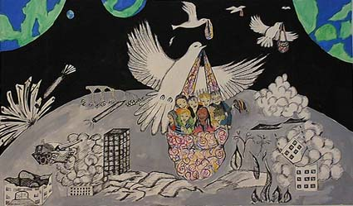
Bilge Harey, Magical Travel, from the “Messengers of Peace” collection

Resolution, reconciliation, and activism are the focus in dialogue meetings and members are always respectful, even in disagreement, and are bound by their shared vision of peace. The Cousins Club and the JPLRDG have the immediate purpose of first establishing trust and then reaching a position of peace and friendship between group members that includes embracing their rival cultures. After the achievement of an amicable relationship between dialogue group members, the groups can begin outreach projects that include speaking engagements at universities, synagogues, churches, and schools to educate the public regarding the Arab-Israeli conflict; television, radio, and newspaper interviews; and letter writing to their United States representatives. It is clear that the value of direct face-to-face interaction with the “enemy” cannot be dismissed as both groups successfully rely on this type of dialogue to engage actively in outreach projects.
Ruth Shapin:
A lot of trust and a lot of good feeling has been built up over the years. A couple years ago we had a joint Seder with the Palestinian community at Jamal’s bagel shop (chuckles). We actually had a Seder. It was very nice. It was a non-traditional Seder. I’m trying to remember where we got it. We might have gotten it from Michael Lerner from Tikkun magazine. He’s the editor. He’s a Rabbi up in the Bay Area, San Francisco. So we used that Seder, which very much included Palestinians and that whole issue.
On the effects of the 2000-2001 intifada:
When it first hit—the big flare-up—we didn’t know what to do. Ironically, I got a call from the {Orange County] Register. We often get calls from the Register or the [Los Angeles] Times. But we got a call from the Register saying, “What are you doing?” We weren’t doing anything (chuckles). So I said, “I’ll tell you what I’m going to do. I’m going to call an emergency meeting. We’re going to meet at Jamal’s (Awad).” Jamal has a bagel shop, which is kind of cute. “We’re going to meet there at Jamal’s bagel shop and you can come and monitor this discussion.” So we got everybody together. I think Nabil (Dajani) was there too. Met at the bagel shop—on last minute notice, we must have had about fifteen people plus the reporter—and had a discussion. Everyone was able to voice how they felt, not that we solved anything. And we did get publicity out of it. The Register gave us publicity that we had this meeting, that we were still together, which was very important, even if we didn’t solve a thing; the fact that we were still together and still had good feelings [is important enough]. So far, the group is staying together, but we’re short of Palestinian members.
So lately, especially with this second intifada, the Palestinians have been more [focused] on unification among themselves and having their own demonstrations. At first, I did go to their demonstrations, but then I realized that I couldn’t be a part of it because their slogans just were too extreme. And even they say they didn’t want them to be that extreme, but they can’t control all their people. They had things like Nazi symbols and all that, things that would be very upsetting to Jewish people. So I couldn’t do that. So, it seems like we’ve had trouble in the last year or so attracting Palestinian cousins. They’re concentrated in another direction. There’s a certain amount of despair and a certain amount of giving up hope that any dialogue is possible, which some of the Jewish people are feeling too, especially in Israel, some of that same despair among the peace groups.
So, it has affected the Cousins Club. As I say, we’re down on Palestinian membership. Interestingly enough, we have a large segment of what we call “others.” These are well-meaning Christians, and that’s great because they give us a certain amount of support that we need, and it’s very nice having them. There was some discussion in the early days whether we should do that, and the group won out that thought, “Yes, anyone who wants to belong should be able to belong,” because we don’t want it separated by ethnicity or religion. That wouldn’t be right.
On peace activism in Israel:
I’ve been in touch with Israeli peace activists by e-mail and met quite a few of them while we were over there, so I’m able to keep my finger on the pulse to some extent, of what’s going on there. In particular, there’s a Mideast Peace Web, and the founder [editor] of that is Ami Isserof. He writes excellent articles, and he and I communicate. And he has pointed out that something is happening to the Jewish Left over there, the Jewish peace movement over there. There’s kind of been a division. And of course, Ami is right in the middle. On the left you have people like Uri Averni, who are very outspoken, very down on the settlers, which he has every right . . . which he should be (chuckles). And then you have those on the right like Amos Oz, who is a very well known peace activist, who are coming out and saying that the Palestinians are not being moderate enough and kind of taking a different view, saying that the Palestinians are insisting too much on this right of return, and so forth and so on. So there’s been kind of a big split. And Isserof is right in the middle.
Yeah, it’s interesting because he kind of attacks people on both sides (chuckles). Actually, he attacks more the Left. I think he’s more toward the Right himself. I think he thinks the Left is too visionary and unrealistic.
On the immediate and greater purposes of the dialogue groups:
Well, purpose number one is to have friendly relationships between Jews and Palestinians in the United States—and other Arab peoples. And of course, doing that through these dialogue events. The second purpose is to achieve peace in the Middle East between the Israelis and Palestinians. How do we do that? I don’t think anybody knows (chuckles). Not even the great leaders have the answer to that one. We are the grass roots that will prod the leaders to keep working at it, to let our nation know and the world know that there are Jews here—Jews and Palestinians—who believe that war is not the answer, that violence is not the answer, who believe that peace is possible. So we feel that in order for that to happen, in order for the governments and the leaders to work this out, there has to be a groundswell at the grass roots [level], and that’s our role. That’s our role here; it’s the role in Israel. They have a fairly well developed peace movement in Israel of women. Peace Now, of course, is the most well known.
It is also our goal to inform ourselves, to see what action we can take. For example, recently we drew up some points of agreement. This is something that we worked out between all the members, about nine or ten points of agreement on all the different issues, like Jerusalem, right of return, so forth and so on. And the intent of that was to publicize it, send it to our Congress people. That is kind of the next step.
On Meetings:
At our monthly meeting we have a speaker or topic, we might show a video, try to educate ourselves, and try to decide what should we be doing. We try to do something of interest. One of the things we’ve decided to do is have another joint event with the ADC. We’ve had joint events with them in the past. Since we’re not getting the people coming to the club as much as we’d like, if you want Palestinians, you go where they are. And through the ADC we certainly have access to the Palestinian membership. So the next thing we’re planning now is to have Rabbi Mark Ellis. He’s very well known, and he’s a spokesman for justice, probably somewhat radical, but he’ll be speaking in March (2001), and we’re going to do that jointly between the Cousins Club and the ADC. The funny part of it is, we’ve been holding these events at the Anaheim Unitarian Church, of which I am a member. It’s a nice location. It holds about eighty people, so it’s a good spot. We’ve had at least two events jointly with the ADC at that location, and now this one coming up in March. So, yeah, we’ve . . . whatever people think we need to be doing. In March we also have the Great American Write-In at UCI. I think that’s in March. We’ve signed up for that again.
We got involved in the Great American Write-In at UCI. That was very interesting. We applied to be part of that, and initially we were turned down. They didn’t think that we were worthy, I guess, or maybe too controversial. They also had some Jewish members who may have objected. But ultimately, we were accepted, and so the last few years we participated in the Great American Write-In. We have a table and literature, and so forth.
Now, in the last year, we started having different types of problems. First of all, we’ve had some attrition, especially among the Palestinian members, with Angela (Odeh), for example, moving. Here in Orange County, there is the ADC, Arab Anti-Discrimination Committee, headed by Michel Shehadeh. He’s one of the Palestinian eight that have been targeted by the federal government. There’s a long-standing case against them for who knows what, having to do with the violation of some law. I don’t know (chuckles). To me, it’s harassment.
On outreach projects:
One of our greatest achievements is the Orange County Middle East Peace Fund that was established as a non-profit by members of the Cousins Club in 1997. The purpose of the Middle East Peace Fund was to support projects in the Middle East that were promoting peace, peaceful reconciliation, and democracy. We were very fortunate to find out about the Hope Flower School, which is on the West Bank near Bethlehem, through an American over there, a very outstanding American named Gene Sangretto, who is neither Jewish nor Palestinian—actually, he's Christian—who has been doing volunteer work over there. So we adopted this as the first project of the Middle East Peace Fund, to support that school. We found out that this school had been established by Hussein Issa, who grew up in a refugee camp, a remarkable man in spite of his experiences in the refugee camp, [he] had come to believe in peace and democracy and had managed to put together this school, which has boys and girls, and he managed to set up liaison with a Jewish project, the Jewish school, to get the kids together and do things together. And it was just extremely inspiring that one individual could accomplish so much. It's really an example to all of us of how much we can accomplish as individuals if we just have the vision and the will to do it. So, we have raised, primarily through Gene's efforts I have to admit, but we have raised thousands of dollars in the last few years, a good part of the school's budget. Of course, tragically, Hussein died last year. We had incidents that we were told about where he was harassed by either one side or the other because the school is so unique; it actually calls for peaceful reconciliation. So, that's right now the main project that we're supporting, but we're open to other . . . If we identify other projects, we will raise funds for other projects of that nature. We have given small amounts, for example, to the Mideast Peace Web. There are other projects. There's a bilingual Hebrew Palestinian school in Jerusalem. So we have given small amounts, but the largest amount has gone to the Hope Flower School.
Nabil Dajani
On reconciliation:
I don’t want other people to suffer. There is physical suffering and there is emotional suffering, the emotional suffering is just as strong as physical suffering, . . . I just hate to see other people suffer. I am always interested in relieving the suffering from people. And maybe I am this from my mother . . . my mother was . . . [she] taught us to be kind to everybody, even to enemies. She didn’t know how to read or write, but she knew this.
Well, I just want to tell you about after 1967 when my father went back to the West Bank when the borders between Israel and the West Bank were open. He went back to find some Jewish friends. Some of his Jewish friends were looking for him when the border opened. I have one relative; he had a special blood type. There was a Jewish man, a friend of his, who happened to have this special blood type and my relative donated his blood to this Jewish man. He [the relative] passed away later. Then in ‘67 this Jewish man came over and was looking for this relative because his blood was part Palestinian.
My father and this one guy were partners together, and he came to look for my father to be partner’s again. So at one time Arabs and Jews lived together in better, well better than now-a-days. Well, I am sure it will come back again, in a different form, a different way, when the Palestinians are treated like humans.
Robert Gorden provides an Israeli voice of accommodation and understanding of critical issues for Palestinians.
On Jerusalem:
Jerusalem is [a] wonderful city. It should be a place for everyone who wants to live there. The city can be part Jewish and part Arab. And who says that the Jewish part should be extended east [into the East Bank, an area of Jordan before the occupation of 1967]? Go west. If you want a bigger Jerusalem, develop it west. Don't develop it east where it's taking houses of existing Arabs. You want to build Jerusalem? Build it all the way to Tel Aviv. Go all the way west. You go for forty-five minutes with nothing, no housing. Build it all the way to Tel Aviv. We'll take Tel Aviv over and call it Jerusalem. I don't care, but why should you take Arab Areas? Let the Arabs have their homes. You also want to call [the expanded territory] Jerusalem? Call them both Jerusalem. If the Arabs want to call it al’Quds, let them call it al’Quds. What do I care? Have some kind of authority that will work like a Vatican City and have it's own identity.
On Jewish settlements in Arab areas for Israeli security:
The building of a Jewish community in Harhoma is a particular methodology by the Israeli government to expand their territory and exclude Arabs. Again, why do you have to build there? Build west of the city. If you look at Jerusalem, and here is Israel, Harhoma is here east. Here is Tel Aviv. There is forty-five miles of nothing [between Tel Aviv and Jerusalem], just here a few houses, there a few houses. Here [points to map of Jerusalem and area] it's all built by Arabs. There are a lot of Arabs. Why do you have to take something that's in the middle [of an Arab area]? Well, they say they build there, I think, because they want to secure Jerusalem for . . . Secure it for Jews, at the exclusion of Arabs.
This is the least secure thing they could do from a security point of view. If you put a large Jewish housing project among Arabs that you took their homes and their land from, is this security? It is the least security that you can ever talk about. They're talking about a united Jerusalem. Before, Jerusalem was divided. There's no united Jerusalem. Right now, if you're Jewish and you go to west Jerusalem and you want to go to the eastern part, there's a gate here, and there's police, and the police tell you that you go at your own risk and they recommend that you don't go. So what is united? We wanted a united place. The Arabs are afraid of every person that comes, God knows what he will do, so they throw stones. So God knows what they will do with me. The point is that if you didn't take this entire place, probably you would be able to go and visit. So there is no united Jerusalem. There is no security.
Security is a word that I remember. We were at the Cousins Club and Angela [Odeh] was there. She is very bitter. She was very bitter. And I remember her brother, Angela and Sammy, their brother [Alex] was killed in Santa Ana by a bomb that was mailed in a letter by the Jewish Defense League. So they are very hostile about it. So I remember Sammy said the word security; when he hears "security," he gets an allergy. And what is right? Come on! What is security? This is how Netanyahu [won] his election: [advocating] security.
There is no security in Israel. Really. Look what he's [Netanyahu] doing. He makes it the opposite; it's just brainwashing that the settlements make security. And he is not a person who keeps his word or anything. I am very much against him.
On the Likud Party:
The Likud is really . . . I don't think that they want to settle this. They say they want to, but they don't. Likud wants to have a big Israel, to have as much as he can annex. The whole thing about Harhoma, it's just a kind of annexation. Bethlehem and Jerusalem, build settlements until they are connected then you just call it Jerusalem.
Netanyahu would make an Arab free Israel if he could do it, but he can't do it. He won't be able to do it. He is so stupid, he would have liked that [an Arab free Israel]. I don't give him a lot of credit, you know, he doesn't see beyond his nose. . . Actually, from the time Netanyahu came to power, there were many more terrorist attacks. And he was chosen for security? So, where is the security that he promised? I was there when there was a problem [a bomb] in Tel Aviv and there were immediately closures. They [Likud] blame the Labor party, from what Rabin did in the peace process. You know, it's very . . . it's terrible. He [Netanyahu] works a lot on the emotions of the Israeli people. It seemed like he was not going to get anywhere as long as Rabin was in power. After Rabin was assassinated, it still seemed like he was in power. I do blame Netanyahu for the assassination of Rabin, not directly. Netanyahu, the way he talked about Rabin, he was helping the people who wanted to do it. He had Rabin with S.S. clothes, with the swastika arm covering, with his pictures, and created a lot of hatred. And the more hatred you create, the easier it is to do it. So they [did] it. Still after the assassination he wasn't popular. But he is a person who's an opportunist and he doesn't have any principles. He doesn't keep his word to anyone, in his own party, anywhere, including his wife. (chuckling) This is already something that doesn't matter. How do you say, what is the difference between Leah the wife of Rabin, and Sarah the wife of Netanyahu? Leah knows where her husband is, and Sarah never knows where he's lying. (chuckling) Okay? But this is the kind of personality he is. He is a person who doesn't keep any of his word, and he thought, because the last two polls were just before the election, the whole country wasn’t supporting him, but he knew how to work with emotions. There were as many blank ballots in that election as the amount of ballots in favor of Netanyahu. So, if the people with blank ballots had voted for Labor, Netanyahu wouldn't have been in power.
Unfortunately, a lot of the Arab citizens in Israel voted with a blank ballot to show that they were protesting both sides. I understand that they wanted it better, but they were not being pragmatists and probably working on an ethical point rather than a practical point.
In Israel, the law says that you can't vote unless you're an Israeli. I mean, I can vote in Israel. I have dual citizenship. I can vote in Israel
On the PLO:
Right now, the PLO is not talking so much about liberating Palestine. If you talk about Arafat, he's talking more about a partitioning, a separation, not liberation, he's talking more about working things out. Every organization is considered a terrorist organization as long as it is not a country. Begin was, before '48, considered a terrorist and then became prime minister. Same thing with Arafat.
On Oslo:
There's always euphoria after you reach a goal, and then there is a down time in everything in life. If you're working on your studies, once you get your degree, ah, you felt so good! I have several degrees in my life. Every time I got a degree it was wonderful, and then you ask yourself, "What did I get? What do I do with it?" So it's the same thing, at first it was wonderful. There were problems, I agree that there were problems but I think it was a good agreement for both sides.
In a word, I think that, you know, they choose what we have. And it was the best [agreement] I think we could have made. I don't know, it's such a complicated issue. I don't know if somebody else could have done any better. It [Oslo peace accords] has its flaws; but at least it was an agreement.
On the Cousins Club:
My association with the Cousins Club has been as the co-chair for I don't know how many years. I was always interested in dialogue between Arabs and Jews. And actually I wasn't a founder. I wasn't among the founding members, Nabil Dajani was among the founding members, and I met Nabil in a workshop about peace, and then he told me about the Cousins Club organization. I knew about its existence a little bit before. My children were very small, I was a single father and I raised the children by myself. When I met Nabil, they were of an age where I could have a baby-sitter and that was the right time. So a year or two after that, I think, I joined the organization.
We have goals. The problem is that we need more people to help. We have helped schools in Israel, like this school [the Hope Flower School]. We sent $300, which is not a lot, but when I came that day to deliver the money, the phone company came to disconnect their phone and they wanted money, and the phone bill was $350. I had $300, I added another $50 and I paid the phone bill. So we do things, although it’s not big. We collected this summer for the same school about $1,000. We have tried to raise more than that amount. It was a little bit more than a thousand. We have helped other organizations, peace organizations. We have a whole agenda that we developed. We became a nonprofit organization.
We had an idea two years ago that we could make a bank that would enable anyone who wanted to, to start a small business in poor Palestinian areas. We wanted to develop a bank that would be called like Bank of Palestine or something like that. There are grants, government grants to get money and to have it loaned interest-free just for Palestinians that are small businessmen. Like the maximum loan would be two or three thousand dollars to help them start small businesses. It's a wonderful idea but we didn't get anywhere. We tried to collect money; we didn't get any donations. That's what we're trying to do every so often
We also have written letters . . . I have written letters about peace and my name and Angela’s name are on it [the letters] and we get a nasty letter back. We write in the paper what we have done. When people ask us to speak we go and speak.
Sami Odeh:
On the motivations for joining the group:
The Cousins Club began after Alex's death. And had he been alive, he probably would be there. I know that for a fact, and I wouldn’t . . . or maybe I might attend one or two meetings, but after his departure, I felt the sense that I needed to carry on what he would have done and I always try to anticipate what he would have done had he been around. And it's in that spirit that I agreed to join the group. We started our discussions at UCI, and in '88 I was elected to be a delegate to the Democratic Convention in Atlanta and worked in Washington and another Jew in that area. We had a nice brochure: two people, two states, green dove on it. And for the first time, the national convention addressed the situation from Palestinian point of view.
In the beginning, I remember there was a rabbi. His name was Steve. I don't remember his last name, but he was pretty much a radical and did not like some of what he formed--some of his Jewish programs are conceding to much to the Palestinians--and eventually I think he deserted the group. But I was one of the few people that stuck around and stuck around and stuck around and continued the discussion and tried to move it in a positive direction. Two or three members were able to agree on certain principles.
I mean, you cannot be effective unless you receive something and you give something. I know some . . . especially in the beginning. As I said, Steve and a couple other rabbis thought that I'm too hot-headed and two obstinate, but I hope in my own way I was able to contribute something to the group. But I know I learned quite a bit from being involved in it for the last . . . since '88, twelve years or so.
On the limitations of dialogue:
In November '99, I was invited to the White House to participate in the Hate Crime Conference and after I came back, I kind of made a promise to myself, and the family, that I would find more time to spend with them. The kids started college, and we had to be around to be available for them. I have other activities that are, at this stage in my life, more important to me. Not that the dialogue is not good, but again being a realist, the dialogue, as good as it is, is not producing any results. So if you have a limited time and limited energies, the question becomes, where do you want to spend them? And I thought since I came back from the White House that I probably should slow down and spend some of my energies in something more productive and less irritating. I don't want to be running around all the time angry with a chip on my shoulder. That's not my style. So I haven't been to a meeting for probably over a year, although I'm still a member and I believe myself to be a member. I really have genuine delight and admire everybody that has the stamina, the guts, to be there, especially my Jewish friends.
One of the members, who hasn't been meeting for over two or three years, we keep in touch and send each other article from the New York Times. He sends me The New York Times. He is a retired attorney from New York. So we still keep in touch, we keep talking once in awhile. We share the optimism that eventually things will change, so whenever we have . . . When we see something hopeful, we make sure we cut it out and send it to each other. If you deal in that particular area of the Middle East [Palestine], sometimes you wonder, “Why am I optimistic?” I mean, there's absolutely no reason for optimism. Yet, if you search very hard, you will find that there may be a ray of hope among all these clouds after all. So to the extent that it's [the Cousins Club] a venue for the members to continue enforcing each other's belief and continuing enforcing the principle that dialogue is better than fighting, the bullet, it serves a purpose to that extent. Not for me personally the last couple years, the last year and a half or so. But I think it serves other people's purposes. I know people are still doing it, and dialogue is always preferable to shooting. In southern California, as you know, you have the distances that makes practically every social or political organization very difficult, because even social clubs from back home, like Jifna Club, have to have a meeting and to have a good number of people participating. Talk about people driving half an hour to forty minutes if the freeways are okay. So the geography of southern California creates its own limitation. The second limitation is that neither group that's part of the dialogue really has much influence with the leadership of it being the Palestinians with the PLO or the Israelis with the Israeli government. You know, we write letters and we send them to the prime minister or wherever we need to send them, but you and I know that writing a letter once in a great while is not going to be effective in changing policy. So that's another limitation. And then, financially, you don't have enough resources to have something dramatic to show, so that's another limitation. So to the extent that it serves the purpose of a few people getting together, fine, but its effectiveness is determined to be not so great otherwise.
Rosalie Abrams:
I've been a political activist all my life. I'd rock the boat a lot, and I've, well, taken positions that are not very popular on things. But I had the right to do them here without being thrown into prison. So I guess the little things, much of what I did, the demonstrations I went on, and all that didn't really threaten the status quo that much I'm not a nationalist in any sense of the word. I like the diversity, the ethnic diversity of people, which is beautiful. I merely believe that everybody should be comfortable wherever they live. I really and truly believe that. And I don't see any need for there to be a Jewish country, based on religion. Here, we are rapidly becoming a fundamentalist country. And I despise all that.
There's a part of me that felt for a long time that if there was a Jewish state and it was a haven for people, that would have been great, but it's not, because it can't be a haven for Jewish people and persecute the Palestinians. So, I have this conflict in that part of me.
On the activities of the Cousins Club:
The immediate purpose of the meetings was educational at the beginning. As I said, I showed you the Seeds of Hope thing. We tried to get people to go around and do—I did one little TV thing with Nabil, and Ruth did a lot of speaking engagements with Sammy, and even though they don't know it, I was the one who set up the big TV thing that they had on Channel 7. I spent all day long talking to them, because the woman who was supposed to do it didn't do it because she had to work. She called me and I made all the negotiations. And Ruth and Sami and a couple of other people went down and did that TV program. So we tried to get out in the public eye and do a lot of speaking engagements. I did a lot of them, and Ruth was a wonderful speaker, and she did a lot of them, and Sami did, and some of the others. Wherever we went we would carry material. And at our meetings, we would get guest speakers, and we would also have parties and fundraising dinners, and things like that.
I thought it was educational and also to get us to know each other better. And we did. I mean, at least I did. I felt very comfortable. I never felt uncomfortable with Palestinians, because I had no reason to feel uncomfortable with them. I met them, and we were friends. I guess maybe in the beginning—That's not entirely true. I think that I was a little hesitant about what I would say and how I would approach things in terms of offending them or saying something, because I didn't feel like I was that knowledgeable in the very beginning. So that's a more accurate statement, that I was a little hesitant. But as I got to be closer to them, that feeling disappeared. You relax and you just feel comfortable with everybody.
I think in the beginning when I was very active, it was helpful toward the group because I was able in the beginning to help set it up. I helped to get speakers, helped to run that Write-in thing, and then set up the booths at the Democratic Convention and get all these people involved in that and everything. So I was very active. And then Ruth and Ted became very active and I didn't have to be all that active except to speak to people and participate.
We were at the Democratic Convention the first time that [Diane] Feinstein was running [for the Senate], must have been about six or seven years ago, and it was at the Anaheim Convention Center when they had the Democratic Convention. And I was instrumental in setting up the booths for the Cousins Club and assigning all the people who were to come and take care of it. And there was a very good response. I printed up a lot of the leaflets. And we had a lot of people stop at the booths who had never heard of us. So I'm very proud of the organization. I think it's a wonderful organization, and I think that it certainly was instrumental in helping a lot of us gain a lot of understanding just by getting to know the people personally.
On the effectiveness of Grass roots organizations:
Oh, I think that that's where change comes from, actually. It does not come from upstairs. There's no one sitting up there saying, Today is Thursday, we're going to give women the vote. Susan B. Anthony made fifty speeches practically all over the country every time she went out, and it took her years and years of helping us to get the vote, to change things. I think it comes from the grass-roots efforts of people. I don't think that there is anybody who's going to want to change the status quo up there. It's got to come from the people.
I think it's a wonderful organization, and I feel badly that a lot of the Palestinians have drifted away. There are some that still come. And I think that there are people who still work very hard in it. As far as I can see, it's still a functioning group. And there are people like Ruth and Ted [Shapin], who when they went there in the beginning became very active as soon as they got in there. Well, Ted's a sort of takeover guy anyway, but when he takes over, it's very helpful for the group. He does the mailing and all that stuff and gets a lot of the speakers, so they are in leadership with some of the others. So there are always those people, and they get wonderful speakers. I do think it's a good organization. I'm glad it's still there, and I wish I had the opportunity to go more frequently.
On overcoming Arab stereotypes in the United States:
It's a little harder for people to see the logic of what you're saying when there's so much anti-Arab publicity and they had these ten Arab people in prison. They tried to persecute them here. So in light of all of that and the anti-Arab feeling that's generated, just the way they portray them in the newspapers and how they're equipped to say these terrible things about, oh, what we've done in Baghdad and in the Gulf War and just vilify the Arab people. There's a lot of impressionable things. The Taliban and all of those terrible things that are going on are really terrible things. But the Arab people themselves are being persecuted by their own countries, and it isn't just because they're Arabs, it's because of the leadership and what's been done. Hussein is no miracle worker; he's a vile man. But there's lots of reasons why he's not captured or killed yet. He's very valuable to keep him alive to persecute his own people so they can say, See this terrible villain. Now we'll go in and we'll drop another bomb. He plays a role.
Jamal Awad expresses reasons similar to Nabil Dajani for joining the Cousins-Club. Like Nabil Dajani, Jamal had never met an Israeli and the Cousins-Club created an opportunity to meet with Jews/Israelis:
I participated in a Jewish-Palestinian dialogue group back when I was in college. I can’t even remember what was the objective of the group or any particular agenda. It was not called Common Sense. We named it the Olive Branch. It was quite controversial at that time among Palestinians and Jewish organizations on campus. They didn’t want to see that dialogue group, for whatever reason. So, in terms of what I believed in, I have never really had hatred toward Jews, nor a racist feeling toward Jews in general. I do have quite a bit of strong feeling against the political aspects of the Zionist movement and what it caused the Palestinians in their life, but I never really developed any feeling toward Jews as religion or as a population. So I never had a problem communicating with Jews or communicating with . . . At that time, actually, I never had a chance to meet an Israeli, so I’d never met a Israeli before. The Cousins Club of Orange County offered a chance to listen to how certain stories impact other people who are associated with the conflict from different sides, and do they feel about it really that different? How do they see these events, whether historical events or current events? There’s probably a lot more support for the Palestinian argument in the Jewish population than there is in the Palestinian population for the Israeli argument. I never really see a Palestinian arguing the Israeli point of view. And that’s natural, due to who is in control, who is not, and who is really driving the conflict. So it’s been kind of a good thing for the Palestinians to communicate on a human level with the Jewish and Israeli populations and listen to their side, or have them see the human aspects of the conflict and come to terms with it on a human level and say, “Okay, all these political agendas aside, could we make it together on a human level?” And you’d see that people are people and from all aspects of life, they’re the same in their aspirations, all the same, and they could come together at this level, they just have to get rid of some of these I would say hostile feelings.
Of course, I wanted to get into . . . really, however nice or however we claim that we are not racist and we don’t have feelings toward other religions and stuff like that, there is always some of that in us. We always make stereotypical comments about others of different races or religious groups, and I certainly wouldn’t be human if I didn’t harbor some of those feelings. I look at that as a way of claiming some of these feelings, and certainly it has been good to me that way. I don’t consider meeting a Jewish as something that is going to get me up tight right away. I may be meeting a friend, you know, which is quite different than having constant conflict with people that you just develop [your views of] from the news and current events and nothing through direct contact. It certainly was good and is still a good experience for me to be in that group. And it’s really a wonderful group, in terms of seeing . . . you legitimize your right as a human. Your rights become validated and acknowledged, and it’s not something that’s just a dream.
Samir Hijazi:
A friend of mine who is also Palestinian introduced me to the Cousins Club. I hoped to achieve a better understanding of the Palestinian-Israeli problem. Especially in the United States because this country has a lot of influence on both, whether it's an Arab or an Israeli. There is a large population of both that reside in this country. The greatest financial contributions to Israel come from this country. The United States Government and its Jewish population, well, this is really the lifeline of Israel. It's this country. So, if we have a better understanding of what we're trying to achieve, and if that is peace, truly peace, then what I would hope is that through a club like the Cousins Club, we would be able to influence people.
There needs to be real peace in the area, and the basis of that peace should not be self-serving interests like it is right now, and it should be an equal and just peace. [We have made] a lot of progress within the Cousins Club in that direction [of equality and just peace] then hopefully, [our ideas] would influence the people in the area over there. So if at least that is ascertained, and this is the goal that everybody would like to see, then in the long run, maybe the Cousins Club did help.
The Traubmans discuss the activities and goals of their dialogue group in a three-way interview.
ET Our group has been going for seven years, and in the beginning, for the first year, we didn’t reach out, because we felt like we couldn’t reach out with any kind of influence with anything to say, necessarily. But once we started changing our views and having some concept of what it means to get into each other’s frame of reference and hear each other’s stories and how it changed how we got along with each other and how we felt concern for each other, then we began to move that into the public at large, and have events where other people could come and have a similar experience, where I’d say that we’re educational about the process. And we have had a number of public forums, where we invite Palestinians and Jews to be together more intimately. We have them sit at a table, usually with food, where they experience a dialogue that is facilitated. We’ve gone into temples and given presentations. We’ve presented some cultural work by the Palestinians in a temple. We had a huge dinner, where 420 Palestinians and Jews came together with keynote speakers. And they sat at tables, they had a dialogue. So we’re educational, and we try to model. And we try to take the ideas that we see work and put them into newspapers and get publicity on them, not to make a big deal out of our group, but to just keep putting the word out, keep putting the message out, look what’s going on, to inspire other people. And as a result of ... after seven years, there are now other dialogue groups that have spun off from that. There are three others that are really actively going now. What else would you say, besides educational?
LT Well, we’ve raised money, for schools and for hospitals. But whatever we do, it’s equal. So we raise it equally for a hospital in need in Gaza, and a women’s hospital in Jerusalem; or a school in Ramallah, and a school in Netanya, Israel. And in regard to giving money, it’s especially difficult for a Jew to ask for money for an Arab, to go out to Jewish friends and do that. It takes a lot of identity and courage, but it takes more identity and courage for the Palestinians in our dialogue group to ask their Palestinian relatives and friends for money for Israelis. And so we are in awe of the courage that they have gathered and together we have some very rewarding experiences reaching out to the community. We’ve [also] worked in the public school system, to take the knowledge of our successful relationships into the schools and seed the ideas there. And also we’ve used the Internet to great advantage to pass on the stories of these successes and the stories of others’ successes, and to help network and help people meet one another and work together to network.
ET Len’s done a fantastic job networking. Nobody has a clue of the time that he spends writing to other people who both see the web site or get our name from somebody, and then call and say, “I’ve tried to start a program, I’m trying to do this, I’m trying to do that.” And Len not only gives them names and puts them in contact, and helps them build bridges and stuff; then he writes letters of encouragement and really it’s quite amazing what ... the number of people I think he’s touched. And I think that’s another important aspect, that if more of us could be devoted ... and this isn’t saying negatively about our group, but there’s a dynamic in the group that people really appreciate what’s happening, but it’s very hard, even after seven years, to have especially the Palestinians believe that it makes any difference. And I think it’s been only in the last year that they do see that it’s made ... it’s making a difference. They can see attitudes change, more people are aware of Palestinians in this country, [President Bill]Clinton went and, you know, met over there. There’s been more media coverage, more speakers coming through about the Palestinians. But if more of them could do the same kind of encouragement that Len does -- write letters, tell people success stories, give a lot of encouragement, plant seeds -- we’d be in a much different place. But with so few people being that with real totality, it makes the process a lot slower.
LT When you talk about dialogue, I think it’s not ... no longer adequate for any of us to talk about dialogue, but to talk about sustained dialogue. Because, as Libby said, for us it’s been seven years and ninety dialogue meetings. And only now have some of the Palestinians and Jews begun to really get a hold that what we’re doing is making a difference. And also I think that with the Internet and the success stories ... it’s not enough to do something successful, but we also need to tell our stories to others, broadly. As Elie Wiesel said, “We become” . . . “People become the stories they hear and the stories they tell.” So that we must not only do what is positive and creative, but then we need to tell the story about it because then as we tell stories to our children about our own lives, it becomes part of the new living myth, a new possibility.
ET It’s not a hobby. It’s a lifestyle. It’s a way of life. It’s a way of thinking. And if it’s only a hobby, then people tend to put other events and activities ahead, and they don’t make it their top priority. And I always have felt like if both the Jews, but especially the Palestinians, would make what we’re doing a top priority, see that it’s the most important thing they could do, more important that going and playing poker on Friday night or going to another big whoop-te-do, that they could be in a different place. I mean they ... the Palestinians want to be in a different place, they want people to know who they are, they want to be recognized. I mean, they want to feel that they have a sense of power. But as long as they stay quiet and to themselves, they will be powerless. So Len and I have felt like the thing that is the most important that we could do is just keep encouraging them to be present, come to the meeting, be at this big event, show your face, let people know who you are; or you’ll never be recognized.
Melek Nasr-Totah:
On the reasons for joining the group:
I do have a lot of issues growing up, and like I said, the experience that I've had in this country with prejudice and, I guess, the dynamics between the American Jews and the Arabs, and I've probably grown up with a lot of anger toward Jews and Israelis in particular. So for me, I saw the Living Room Dialogue Group as a way to sort of maybe heal some of that and actually discuss it openly. So for me, what's really important about the Living Room Dialogue Group is to come together and feeling a healing, and it is cathartic. And as an outshoot, to actually do some good and heighten awareness in the country and impact others to understand what's happening. Those are the two motivations for me.
We, in general, I'd say are pretty like-minded in a lot of respects. Nobody in our dialogue group is very sort of anti-Arab. I would say everybody in the group believes that the Palestinians have a right to their own homeland, to their own states, and there's a lot of sorrow for what's happening in the Middle East on both sides, in general.
It's a big group, so we don't basically start on a subject and then come up with a solution that everybody agrees on (chuckles). That would be a very lofty goal. It would be great if we could. But usually, it's a lot of good dialogue, a lot of good points. And we don't necessarily come up with a solution. It's more of here's an opportunity to vent and to show your feelings and discuss. Lots of times our subject tangents here and there. So again, I don't think the purpose is to necessarily find concrete solutions. It's more of just sharing ideas and thoughts with each other, and getting closer. That's what the purpose is.
I think there's a tremendous amount of suffering that's happening on the Palestinian side, and I think that people don't see it and they don't want to see it because they say, "Oh, they're terrorists. They bring this on themselves when they kill their children. They're antagonistic. They teach their children to hate us and kill us. Therefore, why should we care about them? We've given them everything we can now and they won't take it. What's their problem? We just need to be harder with them." It's just that kind of dialogue, or that kind of point, I just don't know how to respond to that. I feel like they're on a completely different level. They're not open, and I don't know how you open that door. It's a really tough door to open.
Personally, I think it's dealing with the young children. And I think a lot of the battle in the Middle East needs to be fought in the United States. As I said, I think there's a tremendously strong Jewish lobby and Jewish influence in the United States, and that's why I believe it's really important to spend time here educating Americans and American Jews of the other side in a non-confrontational way, just speaking with them as one human to another, and then having sort of slowly opinions change here. I think that's the way that we win in the Middle East.
On counteracting stereotypical views at community outreach programs:
We've done a couple of things that are really exciting. The dialogue group is bigger than just the San Francisco group that I belong to. There's the San Mateo group and a few other groups in the Bay Area that all sort of do different things. What my group, and what I particularly have done a few times now is we've met with American Jews, and we presented either individually or on a panel our history and our opinions, and we've had dialogue. And all the experiences I've been to have been really incredible. We presented to the San Francisco JCC [Jewish Community Center], we had a day where two Palestinians and two Jews spoke to the JCC about their personal experiences and why they joined the dialogue group. It was a great outcome. Everybody was happy. I would say everyone was pretty pleased with the evening. And a lot of people came up to me afterwards, a lot of Jews, and just wanted to talk. And we got a few new members out of that.
We also presented to the Jewish teen group at the JCC, which was really interesting because a lot of them, they have amazing stereotypes about the Middle East, and a lot of them said, "Why are the Arabs even fighting? What's happening? Why are they so angry? We don't understand." And it was so interesting to me because no one—they completely did not see the other view at all. And at the end of the evening, a few of them came up and said, "Wow. What used to be so black and white to us is now very gray. We're really confused about what's happening." And that was so awesome to hear that.
And then we presented to the Palo Alto High School—Palo Alto High School had a World Fest Day a couple weeks ago, and they invited a lot of different groups to come and speak, and the kids got to choose which group they wanted to go to. We had quite a huge turnout. It was like forty kids and we had two sessions. It was great. It was the same kind of thing. We had four panelists. We all spoke briefly, and then we let the kids ask questions. And the questions were great. A lot of Jewish kids were there, a couple Arab kids. And it was just a really great time. And a lot of them came up afterwards as well and said—I know one young girl asked, "This is amazing. We've never heard this kind of stuff before. Why don't we hear this kind of stuff?" And, "What can we do?" Those were kind of their responses. So it's really exciting, and that's what it's all about. It's like changing people's views, or at least allowing them to be open, to sort of pick for themselves and learn that there's another side. And it's not so black and white. And so to me, again, I say focusing on the kids and the younger adults who are a little bit more open to it is what's really—I think that's where the key is. In a few years when they grow up and as they raise their children, things will slowly changed, I believe. But I think it's going to be really hard. We're going to Stockton also next week, and there's a panel there. We're going to present a panel as well. So those are the kind of things we do. We do public speaking and different specific activities like that.
What I think is kind of exciting in some respects is that there's a lot going on in Israel today, and a lot of the younger generation are starting to question and challenge, I think. Kind of like when the United States was in the Vietnam War. Actually, I brought this example up when I was speaking to the young Jewish group in the JCC, as well as the Palo Alto Day. A lot of American Jews believe that they have to go with whatever Israel does, right or wrong—Americans were as well. However, I believe the younger generation now is starting to believe that they can challenge, and they feel more comfortable in challenging. And that's what I'm starting to see. What I basically have told the groups is that you can be pro-Israel and pro-Palestinian at the same time. They're not mutually exclusive concepts. You can love Israel and everything it's about, but you can also say, Hey, I embrace humanity. I want to be brothers with the Palestinians. And you can do both. And that's like defining what Israel is, is basically what I'm suggesting. And I think, to me, that's the key. Because I think you're not going to be able to win that battle with the hard line Zionists or the folks that are above a certain age because it's been so ingrained in them. The kids, I think, is where the reformation is going to take place.
Elias Botto:
I ran across it through a friend of mine, Len Traubman. He was in it and when he found out that I lived in the neighborhood [he invited me to participate]. I said I would try and ever since I did I am a regular member of the group. I love being a part of that group for many reasons. Number one, for satisfaction, it gives me the opportunity to express myself. Day by day I get to be more involved in expressing the Palestinian plight. You could say that I am using the dialogue group in order to . . . if it were not for the dialogue group I would not be able to sit down and talk with you about my point of views, which I think in many ways expresses the views of other Palestinians.
The Traubmans are the philosophers of the whole concept, but I agree with them. The greater purpose is that we are from the grass roots. We could do so much. As well as the government can do so much for us, we citizens, we can do so much to enhance, to support and to encourage the peace and negotiation that could take place. Especially here, for us in America, in a democratic country where we can always write to our congressman or contact our president.
The dialogue group can enhance the coexistence of the two people in the United States. Our group [feels] it is important that you bring the Jews in and the Palestinian in a living room kind of a dialogue where they could express each other’s feelings and they can build a common ground for ourselves. And actually, we stand on equal rights of the two people, on the Palestinian statehood, and in sharing Jerusalem, and in saying that the settlements are a hinder to peace.
The reason that I’m in that group is to promote and to make a better understanding of the Palestinians. I like to be heard not because I’m a scholar, by all means I am not. My political aspiration and my belief and my thoughts developed here in the United States. So, I was glad to see this group, and I figured, you know, it’s a bandwagon. It’s worth getting on, because without out, I couldn’t be heard. And I tell that to everybody, you know. We as Palestinians, we have no bandwagon. And this link with the Jewish community here is [important]. We have the dialogue group. We could sincerely see eye to eye. So that’s my attitude.
I think the time has come for us Palestinians to, instead of staying dormant, and saying “oh look at what America did to us and look at what the Jews did to us, we are the underdog,” well, the time has come to open your mind and to say something and to educate the American people. Through the dialogue group I am able to and have more ears to listen to what I have to say about the Palestinian plight then by my self. I think that the American people need [to hear] more than the Israeli’s story. They have to know the truth about Israel. Because, to be honest with you, I think that the Americans are mislead and misinformed by the media, whether it be TV, radio, newspaper, movies, you know, Hollywood, the misrepresentation. They glorify one and condemn the other completely. Again, this is not only a detriment for us but also a detriment, in the long run, for the Israeli’s. It is very rewarding to know that in the dialogue there are some Jews who see things the way I see it. They know that Israelis did wrong to the Palestinians, they didn’t go there and find a vacant lot and pitch their tent, and there were human beings there, like me.
I hope the time has come where maybe both sides are going to share. I always like to give the example of me…well… five years ago with the handshake between Arafat and the late [Yitzak] Rabin it signified a big concession on my part to share for the sake of peace. [I am referring to] the home I used to live in Jerusalem. I still hold the deed to it. I still have it here in California. So with the handshake, I as a Palestinian am willing to concede and share that house that used to be one hundred percent mine. But who is living in it? Some Jew from Iraq or whatever. I say, you are welcome to it now but please make room for me. Now we shook hands and I don’t want to get rid of you and you supposedly don’t want to get rid of me. And share it. And if we are both sincere in doing that there will be peace and do you know what? There is room for everybody, no matter how small the place is there is room. If our intentions are positive, on both sides, there is big room for both of us to live. That is how I look at it. That is why I am [involved in] dialogue group [activities]. That is why. For so many years the struggle is destructive. All of the killing, the injuring, it is correctly sad to fight for reconciliation.
[We must work] for co-existence and to build our future on the positive, on what unites you and me, you as a Jew and I as a Palestinian. We must look not at the differences that separate us from each other. There will always be differences, but you compromise, you concede towards each other, and you compliment each other. And that is what we [Palestinians and Jews] should do.
Before the dialogue groups, they never had any contact with the Palestinians, they didn’t even know what a Palestinian looked like. I am enjoying it very much and I am learning a lot from it, and that is why I am in it. It gives me the opportunity to see people, meet people, and express myself to people, and to see their point of view. Before I would have thought that Mr. Netanyahu was deceiving us, that this “security” thing was just an excuse to continue to stay where they are and collect more land. But you know, now I think that the [Israeli] paranoia is a real thing; they really fear, they want to feel secure, and they don’t feel so secure from the Arab world, but before I thought it was just an excuse to keep the status quo. But after talking to some of those people in the dialogue group my [understanding changed]. By luck we have two or three Israeli’s in our dialogue group, and in fact there is an Israeli Palestinian—an Arab, Muslim from the Nazareth area, and he is an Israeli, and he has a lot of stories to tell. So, the paranoia is there about security and that is one thing that I have learned, and by learning it, my answer to them is “well, if you are sincere and honest with your neighbor, you don’t have to feel so insecure; if you feel so insecure with the Arabs then you must be doing something wrong to that person to feel insecure towards them.” Do you see what I am trying to say? You see, if that person is contented with your relationship, you should feel secure with them. But if you know darn well that you are cheating that person, and you start having that paranoia of being insecure, then you damn well have a reason to feel that insecure. You see what I am saying? That is exactly the problem. Look at the Palestinian and give him his rights and help him. Not only give it to him but also help him. Because for fifty years he has been so down that it is going to take America to bring them up.
There is destruction within the Palestinian society too. We have our problems. I shouldn’t blame the Jews or Israel for all our woes. I admit there is so much within, whether it is authority, whether it is the other citizen, whether it being the Christian or the Muslim. Palestinians have to start to verbalize . . . There is a lot to be clarified in our own community. It is not like tomorrow there is going to be a Palestinian state authorized by Israel. We have to wash the inside, the infrastructure of the whole Palestinian [community]. That’s going to be, might be destructive.
On freedom of expression and community outreach:
For me, to be here in America, I think I will satisfy myself by saying I have talked to you, I have talked to people. They could really see my point of view and appreciate a Palestinian as a human being, not as an ugly terrorist who is just there to kill a Jew, because that is how we have been presented. Unfortunately, I admit, many, many of my people, friends even, don’t see it that way. And of course I don’t fight with them, and we don’t become enemies. I just let it be. I’ll always express myself, but attempt to get them on the bandwagon, but unfortunately they are so resigned to this issue of Palestinian [hostility toward Jews they keep thinking I am wasting my time. I said, yes, I’m not going to solve the Palestinian problem with Israel, but I’m able to sit down and express my feeling and to have somebody else to listen to me, and sometimes they agree with me.
Through the dialogue group I was asked to give a Palestinian perspective [of the Arab-Israeli conflict] to a group of senior citizens. And when I told them the story about the deed and the house that used to be ours but with this peace initiative going on, I am willing to share that house. If it’s a matter of coexisting, and this is part of coexisting, let it be, half a cake is better than no cake at all. The Palestinians at one time, they couldn’t see sharing it, and then after fifty years ... and actually there are so many people who think like I do, that the time has come. Life is too short.
Community outreach projects become cathartic experiences for participants as they share their personal and family stories with their audience. Clearly, Jew and Palestinian have forged a friendship based on respect and trust and are bound by a shared vision of peace expressed through the dialogue group.

CHAPTER EIGHT
Visions of Peace
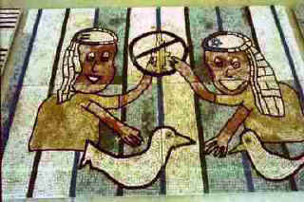
Pieces 4 Peace tile mosaic constructed by over 150 Palestinian and Israeli children who hope for a safer future.

Ruth Shapin, the pragmatist:
I'm envisioning a two-state solution. I'm envisioning that the occupation will end, that there will be free movement back and forth between the two countries, cooperation on agriculture, water rights, and tourism. It's incredible to go over there and see the tourist sites that the whole world wants to go and see. There has to be some kind of joint ownership or joint management of some of these famous sites that all the religions want access to. There has been some talk about Jerusalem being an international city. It may be worked out in that direction. So, that's what I'm envisioning.
It's kind of like the United States of America decided early on that they needed to have some kind of federation rather than fifty separate states. Ultimately, maybe there will be some kind of federation in the Middle East. I feel creativity can solve this, and a certain amount of goodwill. I just hope that I live to see a peaceful accord between the two. I'm not optimistic, but I would like to live to see that.
Nabil Dajani, the sentimental vision:
The way I envision this peace, it would be two countries next to each other with open borders in the sense, that I am living for example in Jerusalem, the Palestinian side, and I want to go to the beach in Jaffa I can just grab my car, show my I.D. card at some check point, and go to Jaffa and swim in the Mediterranean and eat fish over there and come back. There would be free trade, or open trade, together, freedom of movement, cooperation in different areas, in agriculture, education, and water, and humanitarian work, and medicine. There are many areas where we can cooperate together. We can make life easier by helping the sick people. We can declare war on diseases, diabetes, and high blood pressure, cancer, [laughs] instead of declaring war on each other.
Well, the way I look at it, but I’m not much of a statesman, a line where mine begins and the Israeli side begins. Hopefully to be an open border in the sense that there is freedom for people to move from one side to the other side. And if there is a Palestinian state, I won’t mind if there are Jews that come and live on our side. But I don’t want these settlers to come and other kinds of [Zionist] Jews to come because they have different ambitions, yes, and attitudes that [want to] rule the Palestinian.
It would be divided but united. I mean, it was divided before, but nobody can move from one side to the other side. If you want to solve the problem, there can be ways of sharing Jerusalem together. If you want to create problems you have always obstacles you can put. Where I would draw the map? The best way would be like the borders of the ‘67 war.
See the thing is, we are not anti-Semitic, and we are not anti-Jewish. But I do not want someone to come and throw me out of my home. So there is no hatred [of Jews], that is what I am trying to say. As people, I mean like I look here in the United States, there are some people who maybe hate the blacks, well you know, African-Americans. They just don’t like them period and we don’t have this kind of feeling. So it is not the same thing.
Robert Gorden, the hopeful vision:
What my vision would be for . . . I think it will be in the end very successful because it will come. Hopefully it [peace] will come. Because once there will be peace, you will see prosperity, economic prosperity in the area. A lot of companies, big companies, don't want to invest in that area because of the danger. Now, you have to remember that you have in Israel . . . There is a Silicon Valley in Israel, which the manpower they say is similar to the one we have here in California. It's very successful. And we [Israel] have the best scientists, and they have done very well. There are a lot of new scientists who came from Russia. So you have really wonderful manpower. You have cheaper labor from the Arabs who do the work, and together it can be really very successful.
In the beginning, it [peace] will be very political. Nationalism will overpower goodwill. It will be both nations, because each one wants to show the other how[patriotic they are]. Each country will be more and more trying to show their identity. But after a while, I think the process will quiet down, and then there will be more good feeling and cooperation . . . I think the economy will make it work.
Sami Odeh, the skeptic.
Many people who are refugees are just like me. I know many people here that were refugees in '48 and/or '67, or both, and they established themselves in Europe and the U.S. and Canada and Australia. So unless we confront the situation with the Palestinian refugees and find a way to address their grievances honestly and humanely, peace will not take place. Shamir can think of them as cockroaches; Begin can think of them as animals; Sharon can try and kill some of them, and unless he's successful eliminating them all, as long as one of them left, we have to address the situation.
We have the larger issue of surviving within the Middle East and must acknowledge the responsibilities and not keep hiding by saying, "Oh, these people fight on their own." "The Arab leaders told them to fight." It doesn't make a difference. They know better than anybody else that the majority of them fled in fear. As I told you at the beginning, my first confrontation with what happened in '48 was as a sixteen-year-old in the field seeing these refugees mentioning 1948 and all these towns that I never heard of. It was explained it to me how the Jews came in and slaughtered everybody. I'm talking everybody, human and animal. Stop this nonsense of saying, "Oh, they've caused this themselves" or whatever it is. So Israel must officially accept the responsibility of the Palestinian refugee that created this miserable situation we are in today, by itself, this will go a long way of resolving the conflict and set the ground rules of how we're going to address it. And unless that is done, I don't see peace being achieved. You have to go back to the root of what created the whole thing.
All of the Arab world–Jordan, Lebanon, Syria, Egypt, or Iraq, whatever you want to call it–their involvement in this conflict will continue to be secondary to the issue of the Palestinians. And that Israel made peace with Egypt, it's good, but still does not answer the basic question here. And eventually, unless the situation of the Palestinians is addressed, the Egyptian on the street is going to start telling their leadership that they need to do something for their neighbors in Palestine.
So we can pretend that the Palestinian refugees don't exist and continue the conflict from an Israeli point of view, or Israel can become realistic and have enough courage to say, "I created this problem. I'm going to participate in resolving it." And if that step is accomplished, or if that stage is reached, the rest of it is easy. The land is big enough to accommodate both people, and if enough genuine thought went into it so that both people will feel secure enough and live with enough dignity toward them they could be living in peace. And unless that is achieved, we can sit here and be intellectuals and address all kinds of nonsense, but first things first, deal with the refugees.
There seem to be some signals at one point in time, you feel like you're encouraged there. Some Israelis are willing to acknowledge the misdeed that has taken place and acknowledge responsibility for it, but when you are somewhat encouraged . . . That's the thing that's so damn tough when you deal with that area. I mean, you see Barak saying, "Okay, we might let some hostages . . ." and you hear something, and then a landslide election of a war criminal surprises you. How do you deal with that?
Rosalie Abrams, the romantic:
The country would be open for all of them and that the Palestinians would have the right to go back, and efforts should be made to get them settled again and have the opportunity to have the businesses and the homes. And there should be a political government [comprised] of both Israelis and Palestinians. It should be one country, just the way we are, one country, with a tremendous amount of diversity. And it would be a healthier country and a more beautiful country because of that. There would just be human beings living together, not Palestinians and Jews. They each could have their own particular culture and synagogues, and whatever they please without one being oppressive to the other. Without the Arabs being oppressive to the Jews or the Jews being oppressive to the Arabs.
But in a practical sense, I do not see that ever happening, or maybe it will some day. I don't give up on the human race. I think that that's what would be wonderful, for all people to live together, and maybe there will be some things that will happen that will be so cataclysmic that it will bring people together so that they see the humanity in everyone. And of course, I think people behave the way do not because of what is innate but because of what they have learned culturally. We don't speak out enough about things that are wrong, but in our hearts we feel differently and say, I don't believe in that.
Jamal Awad, the academic:
Peace is what people feel. It's not a formula that you can achieve saying, "Okay, you have that piece of land and we have this piece of land." It's these rights that you have to be given. It's a collective way of life. You have to be able to feel peace in your living to have peace. Your life has to be free of a lot of what's called superficial limitations that are put by others because of your race, religion, or whatever it is. So, if somebody comes and puts a limitation on you because of the way you look and the way you feel, right away there are a lot of pressures, which results in resistance from the people who are being unjustly treated. Peace, it's a state of mind. So, however you define peace is what peace is, and people define it in different ways because it means to them different things. If I cannot travel, peace would be that I'm allowed to travel. If I cannot pray, peace would mean that I'm allowed to pray. If I'm economically repressed, peace would be if I have economic opportunity. Many of these aspects all put together resulting in people all prospering regarding their thinking of religion, their race, their color.
So, in terms of the Palestinian-Israeli conflict, peace is accomplished by what the Israelis are willing to give and what the Palestinians are willing to accept and for the majority of their respective populations to say, "Yes, we are willing to forget──not to forgive, but we are willing to forget." So it's the formula in between, where, say, 70 percent of Palestinians and 70 percent of the Israelis could come to terms and live together.
If I could close my eyes and envision peace, I would create a secular state that has no religious . . . kind of separated from the church or religion. In that aspect, the Jewish population or Palestinian population could come and live in that area if they wanted to, and the right to return is given to the people who were driven out of the land first. So they could come back and live there if they want to, and it could be one state with a government that resembles the national interests of all the people living in that country. However, I think in reality a two state solution is best.
Samir Hijazi, the realist:
Basically, peace would be the ability for anybody, be it Palestinian, Israeli, Syrian, or Lebanese to be able to go anywhere without having to worry about where they are, without having to worry about getting killed or harassed or expelled or whatever. And the ability to . . . If I wanted to live in Tel Aviv, I should be able to live in Tel Aviv, regardless of being Palestinian. . . you know, with the people of Tel Aviv they decide who should live there. If I wanted to live in Jerusalem and I can afford it and I would like to buy property, then I should be able to. I think Israel with its peace with its Arab neighbors, like Jordan for example, has made that possible. I heard that the Israelis can come to Jordan and buy property whether they live there or not. That's another issue. But you also heard this in the meeting with the Cousins Club the other night that an Arab is not allowed to buy in Jerusalem, or even not allowed to buy his own, whatever was taken from him, and when he went back to bid it and buy it back, and he couldn't buy it back. And also, politically . . . if you're Palestinian or Israeli, for example, and there's an election, it doesn't matter if you're Israeli or Palestinian if you're running for the mayor of Jerusalem, and everybody should be able to Vote. . . This is the kind of peace that would be conducive to good relations between everybody. But not you're in your state, I'm in my state; don't cross. If you cross you will be killed, and that's not peace.
I'm skeptical about what's going on right now, as far as the peace process is concerned. But even in this skepticism, there is hope. And I would hope that . . . I know justice and peace will not be served through what they're trying to do right now, but I think it should be encouraged and I would hope that the people here and the government also would make a difference, in the same way they made a difference in creating Israel. If they were able to create Israel, they're also able to make it a livable place for Palestinians, so I think that's probably the one thing that I would hope to see.
The Traubmans, the activists:
LT I definitely envision cooperative activities, and Palestinian and Israeli visiting one another, knowing one another, and somehow meeting face-to-face. I think that’s going to be the key and I see it as a process. It’s not going to be a moment in time, but they must start reaching across the chasm, whether its the Israeli Palestinians and Jews within the state of Israel, they just start moving into each other’s villages or visiting and somehow doing something together, or across the Green Line. Between the Palestinians and Israelis there have to be people actually working together, at least some of the people. I think when you’re talking about something that’s never happened before, you can’t know everything step by step. But I know that meeting face-to-face has to be the first step. People have to decide to do that, just as we have decided to go into each other’s living rooms.
ET I would add that I can’t speak to borders and boundaries. You know, I have no clue what different size they’re going to be willing to settle on. But I think philosophically and practically there are a couple things that absolutely will have to change. And that is, there can no longer be the oppressor and the oppressed. When there are two states, and I assume there will be two states, there’s going to have to be a way that there is not that sense of the oppressor and the oppressed. That will have to be eliminated. And there are certain resources that will have to be shared equally. For example, if Israel holds the upper hand in a way that the Palestinians don’t get water, well, peace will be elusive.
LT I think the underlying principle that I would hope people would see is in a religious context, I think of the shema , “Hear oh Israel, the Lord our God, the Lord is One.” To me the two most important words are the first and the last. Shema means “hear.” And I think it is the destiny of the Jews, speaking as a Jew, to hear, to really listen, and with compassion. To hear the other story and to see people as human; and to learn from our own exodus experience, that we were strangers in another land, and to understand that we have a shared land and a shared destiny, and that we’re neighbors forever. The last word in the Shema is one, the Lord our God is one. And I think that simply means, and it is true in all the great religions, that they acknowledge a common creator and the oneness of all life, and they just have to ... we’re just learning what that means, and that we just need to learn to live our lives that way.
ET And I was just going to add something about the religions too, religion is certainly a huge factor in the Middle East. And although there are a lot of secular Jews, I think almost all the Palestinians are either Christian or Muslim. So the three religions are certainly represented there, Christianity, and Islam, and Judaism. So if the three religions could follow the basic intent of what they say in the Qur’an, the Bible, and the Torah, things could be resolved. But I think all the unresolved conflicts come straight from the roots of the political struggles and struggles for land and resources and personal power. And so I think people need to go back to the basics of what it means to be a good Muslim or a good Jew or a good Christian, maybe, in time, Jerusalem could be a city of peace after all. Right now, one would visit there and not feel like it is a very holy place, because of all the tension and threats and distance between the peoples. And it’s a very sad, sad statement on what a beautiful place it could be. So I don’t know whether it’ll be in our lifetimes, and maybe it won’t be, but I hope the path continues forward and not backward, so that eventually somebody gets to enjoy the beauty and the spirituality of the place.

Melek Nasr-Totah:
Part of me deep down simply doesn't understand why we're fighting. I just don't get it in a lot of respects. I understand sort of the cycle of violence and how when you kill my brother, I kill you. Not that I condone it. I can understand it. But I don't really understand why we can't be brothers. I just don't really get it. So to me, that's what I think.
My idea of peace is that there are no walls or barriers between us. We embrace the differences, and we embrace the similarities, and we embrace the humanity among us. To me that's what peace is about. I know there are a tremendous amount of steps to get there, but I have such a problem, as I said, really understanding why we're fighting.
Sometimes I struggle with—I do have a lot of Jewish friends here in the United States. Some of them are a lot more religious than others. One thing I also struggle with is the Jewish religion and how they believe that the Jews are the chosen people. I struggle with that concept quite a bit because to me that creates walls and it creates barriers. And I think that—I don't know how to answer that. I'm not sure if that came about because of the history they've had, which has been very difficult, so this is a way of dealing with it. I'm not really sure. It's a hard concept. If you can create a wall around yourself and your community, it's really easy to not embrace the other person. So again, to me, that's the thing that's difficult. There are many, many cultures that do that. I understand that. I guess the one beauty about the United States is that a lot of people do mix here. Anyway, that's my idea of peace that everyone should live together in harmony and embrace the differences.

Elias Botto:
My dream is to go and walk the streets of Palestine like a native, yes, I would. I would love to do it. I would love to see that there is peace. And the peace that I envision is any peace that [offers] the people equality. The Palestinians and the Israelis help each other, from an economical to a political to a security point of view between them. It is something that could be done. It’s not impossible because before 1948, Palestinians and Jews, they lived together under the British Mandate. My childhood classmates were Jewish kids from Jerusalem as well. The difference was, [it didn’t matter if you were] the Jewish kid, [or] Christians, or he’s a Muslim, or you’re a Jew. You’re all kids playing on the same playground at the same school. That’s the peace I would envision.
The peace among our head of states, they should be respectful towards each other and be helpful towards each other, because, again, we are not a big country but yet we are very big country. Not big territorially, but we are so close to each other, we have to help each other whether it’s the water resources or whether it’s economics. And with the know-how and the worth of Israel, and the technology of Israel, I mean, they could do ... and with the manpower of the Palestinians, they could complement each other, where they could be one of the strongest powers in the Middle East.
I have a soft spot for the Jordanians because after we became refugees, good or bad, they were the security, the force that was there to protect us in a way, you know, to run our affair, to govern us. And of course so much of my family, my relatives, via marriage or whatever, they are Jordanian. And I would like there to be an alliance, a federation between the Jordanian and the Palestinians, and then the three of them together to be one.
Let me summarize by saying, not too long ago, before the peace negotiations started Hanan Ashrawi, that’s the Palestinian spokeswoman came to the Westin Hotel to speak. And by luck, I was sitting in the hallway by the bar with a couple of friends, and having a drink. She was there waiting for her counterpart, and I invited her over for a drink with us. She said, “Yes, I will have, but, cold orange juice will do,” because she was thirsty. So we sat down and start talking. I asked Mrs. Ashrawi, why have the Palestinians join hands with the Jordanian and have a federation; and then go to the Israelis and have a coalition where we could become the strongest economic power in the Middle East?
“Not now.” That was her answer to me. She said, “The whole world, they have to recognize the right of the Palestinians first, as Palestinians. And then that’s all possible.” Then she said more. She said, “The world, Mr. Shamir, and America must realize they have to respect the Palestinians as people, as an entity, before, you know, they go into the detail mechanics of how we are going to create that peace between them.” And you know, I think that the day will come when the Jordanians, the Palestinians, and the Israelis become a coalition, a beautiful force, economic force in the Middle East. “Inshallah,” like we say, God willing.
CHAPTER NINE
Can They Make Peace?
There are some things that only governments can do, such as negotiating binding agreements. But there are some things that only citizens outside governments can do, such as changing human relationships.
Dr. Harold Saunders

Violence, occupation, fear, terrorism, surrender, power, control, inhumanity, and intolerance– all of these concepts must be overcome to achieve peace. But then the question that begs to be asked is: What is peace?
Peace is a state of mind dependent upon respect, dignity, and generosity of spirit– an idea that requires a complete shift in the cultural thinking of both the Jewish and Palestinian communities. Politically contrived peace solutions simply slow the hostilities because, again, that state of mind needs to be reached between the people. Until then, the conflict will not resolve. The Cousins Club and the JPLDG have achieved peace and teach us that tolerating your neighbor is not peace, but befriending your enemy and sharing your bread is.
More than the Palestinian issue divides Israel. As in any nation, there are opposing political factions, but especially unique to Israel is the dynamic of religion within Judaism itself and in relation to the other monotheistic Abrahamic faiths. Political, religious, and ethnic tensions continue to plague the state as Jews from ethnically diverse lands immigrate to Israel, further highlighting the paradoxical questions of whether or not the Jews are a nation unto themselves or if Jewish identity is a religious identity and whether the two are mutually exclusive. A source of ethnic conflict is cultural differences, most notably linguistic—one reason that Hebrew is quickly taught to new immigrants—and religious—cultural variations of Judaic practices are inevitable, for example, Askenazim Jews and Sepharidic Jews have tremendous cultural differences. Internal conflict in Israel is not absent.
Within this Jewish state, the issue of “Jewishness” cannot be avoided. The orthodoxy continually seeks to exert control over a very large secular Jewish population. As Israel grapples with its identity as a multiethnic Jewish nation, the right and left political factions continue to debate the approach to peace. All the while, terrorist acts and retaliatory strikes continue. Peace, once seemingly within grasp has once again slipped away and the children will suffer the legacy.
Israel is a Jewish state, created by Jews for Jews; the theocratic implication of this fact cannot be ignored. Although Israel is a nation that embraces democratic principles—and is certainly more democratic than any of the surrounding Arab nations—when distilled to its essence, Israel is a theocracy. More rights and privileges are granted to Jewish nationals, rights and privileges not enjoyed by non-Jews or most notably persons in the occupied territories.
In terms of today, collective identity and sharing are central issues in the conflict. Sharing power, sharing control, sharing land– politics does not have generous rules for sharing. The typical mode of operations for political entities seems to be getting what you can and doing what you must to keep it. In the case of the Arab-Israeli conflict the strong identification of people with their various ethnic, religious, and political groups creates a situation that makes cooperation with other collectivities complex.
Although, the Arab-Israeli conflict is primarily a political problem, religion is ever present and is frequently used in the righteous rhetoric of both sides to bolster their respective claims to the land. The purpose of the scriptures found in Torah, the New Testament, and the Quran provide a path to civilized and moral behavior; they guide us to peaceful existence with our neighbors. Religion is so easily twisted by fanaticism and not only successfully pulls people apart but also strengthens member identity to that collectivity. Perhaps if the Jewish and Palestinian communities relied more on the religious teachings found in their scriptures and if religion played a more productive role rather than a destructive role, the problem could be solved.
Scholars have long sought to explain the mechanisms for nation formation and the phenomenon of nationalism and its relationship to modernity. Clearly, the link between collective identity, ethnicity, and tribalism to the modern nation state cannot be dismissed, as collective identity is the root of nationalism. Sociologists agree that an ethnic group is a named collectivity that has a myth of common ancestry, shared historical memories, elements of a common culture, a link to a homeland or a symbolic attachment to an ancestral land, and a sense of solidarity, or consciousness. In this sense, a liberal interpretation of an ethnic group can be described as a culturally defined collectivity that is used as a method of classification of groups of people to define their relationship with others. It creates the boundaries between “us and them.”
In the examination of the dialogue groups and the formation of collective identity–the basis for nationalism, it is clear that these grass root groups have fulfilled the broad sociological definition of an ethnic group. But how the dialogue groups achieve this and how liberal the interpretation of the criteria defining a culturally based ethnic group is are both reasonable questions for the reader to ask.
Common to all of the dialogue groups, and explicitly articulated by the Cousins Club of Orange County name, is the relationship with Abraham, the patriarch of the three monotheistic religions as well as the father of the Semitic people, both Arab and Jew. This identification creates a named collectivity—the people of Abraham—and a myth of common ancestry through the biblical connection. The Abraham connection also provides the mechanism for a shared historical past, again tied to the bible incorporating shared memories of a common past that include biblical heroes and their commemoration in joint cultural events. Integral to the definition of a cultural ethnic group is a link, real or imagined, to a homeland. Throughout the interviews, dialogue group members expressed a connection the land of Palestine/Israel and a desire for its security for all people.
The dialogue for peace movement is in its infancy in terms of size and momentum. However, the idea of dialogue, or conversations for peace is growing at a rapid pace as more individuals realize the power of face-to-face interaction. But what connects all of these little groups of peacemakers across the country and around the world? The Internet is the mechanism that unites these disparate little groups of peacemakers shaping a larger movement. The Internet is the medium by which a constant flow of communication travels between the different groups. Through active use of e-mail and web pages ideas and information is instantly accessible to participants in the dialogue for peace movement.
The Cousins Club and the JPLRDG share similar philosophies of cooperation, education, outreach, and activism. The motivations behind membership are also similar. American Jews tend to be motivated by a humanistic philosophy; the Palestinians are guided by a desire for normalcy in the region and want their plight to be heard. Israelis that have grown up in Israel and experienced first hand the violence also seek normalcy.
The two groups included in this study function differently in meeting structure and format. The Cousins Club has become somewhat less personal in respect to meeting places opting for more neutral sites like community center rooms and Unitarian Church meeting halls. The effect is a more business-like atmosphere where guest speakers and group members discuss particular issues. The JPLDG prefers to focus on first personal relationships between people and then community outreach and education projects. The meeting place is always a living room and involves sharing of food. The JPLDG recognizes the intimacy of inviting someone, especially an “enemy” onto the sanctuary we call our home.
Both groups have achieved successful relationship building among the dialogue group members and have worked hard to extend their cooperative sentiment to the larger community. The JPLDG enjoys a growing membership and the expansion of dialogue groups to other communities. The Bay Area now has eight established dialogue groups with approximately 150 members. The original group founded by the Traubmans has thirty participants. With the increasing number of dialogue groups, outreach projects have also increased. For the Traubmans, the desired “ripple effect” has begun and is demonstrating the quiet, yet assertive power of grass roots movements. Two new dialogue groups are active in San Diego and another is beginning in Brooklyn, New York. The Cousins Club, although still actively meeting, has suffered a certain degree of stagnation and thus has not achieved the same level of success as the JPLDG. Several reasons may account for this. First, membership has not increased significantly. Many of the original members are aging and less able to engage in community outreach projects. Second, the Cousins Club does not utilize the Internet, a tremendous resource that has increased the outreach ability of many dialogue groups. However, members of the Cousins Club have built close-knit and trusting friendships among themselves and continue to engage in speaking events and fundraising. The locales of each group may also account for differences in success. Orange County is traditionally more conservative then the San Francisco Bay Area.
In conclusion, the two dialogue groups in this study are representative of a larger worldwide grass roots effort to use dialogue as the mechanism for conflict resolution. The Cousins Club and the JPLDG are linked to similar Jewish-Palestinian peace groups around the world creating a unique culture of peace. Although both groups continue to educate and build relationships between people they have yet to achieve the power necessary to influence governments and impact the peace process–but that is why there is hope.
APPENDICES
Appendix 1
Time Line of the Arab-Israeli Conflict
1516-1918 Ottoman rule over Palestine
1881-2 First Aliya to Palestine
1894-1906 Dreyfus Affair in France exposes European anti-Semitism
1896 Theodor Herzl writes The Jewish State
1897 First Zionist Congress meets in Basel, Switzerland and declares Palestine the Jewish Homeland. The The World Zionist Organization and the Jewish National Fund to acquire land are established.

1915-16 Hussein-McMahon correspondence. Britain promises the Arabs an independent Arab state in exchange for war support.

1916 Sykes-Picot Agreement, Britain and France secretly agree to divide the post war middle east between them.

1917 Balfour Declaration. Britain promises the Jews a national home
1922-48 British Mandate over Palestine
1936-39 Palestinian nationalist uprising against the British
1945 World War II ends resulting in the murder of six million Jews in the Holocaust. Many Jews seek refuge in Palestine.

1947 Britain can no longer govern Palestine and turns the matter over to the United Nations. UN Resolution 181 calls for the partition of Palestine into separate Palestinian and Jewish states.

1948 British Mandate is terminated. Israel proclaims its independence resulting in the first Arab-Israeli war

1948-50 Approximately 725,000 Palestinians are displaced by the 1948 war. By 1950 over one million refugees line in UN sponsored refugee camps in Gaza, West Bank, Lebanon, and Jordan.

1956 Suez War. Britain, France and Israel attack Egypt

Appendix 1

1964 Establishment of the PLO

1967 “Six-Day War,” Israel capture the Sinai peninsula, the Gaza Strip, the Golan Heights, the West Bank and East Jerusalem. Approximately 250,000 more Palestinian refugees flee, or are forced into Jordan.

1969 Yasser Arafat heads the PLO

1973 “Ramadan” or “Yom Kippur” War, Arabs attempt to regain territories lost in the 1967 war. The United States provides arms support to Israel. Arab countries institute an Oil Boycott against all nations helping Israel.

1974 Arafat’s UN “Gun and Olive Branch” speech

1977 Menachem Begin becomes Prime Minister. His Likud party advocates unlimited settlement in occupied territories.

1978 Egypt and Israel sign the Camp David Accords

1987 Intifada.

1994 Oslo Declaration signed

Appendix 2-a
Early Zionist Colonies
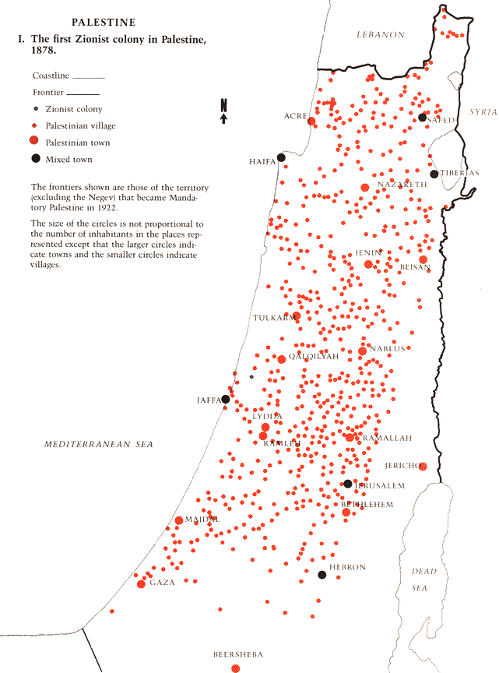
Appendix 2-b
Early Settlements 1881-1914
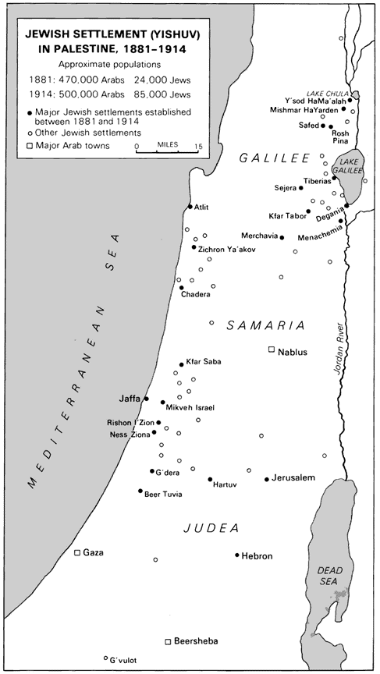

Appendix 2-c
Hussein-McMahon Agreements

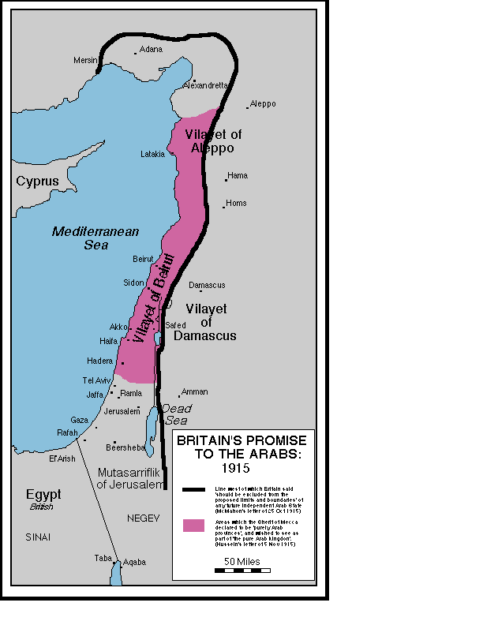
Appendix 2-d
Sykes-Picot Agreements

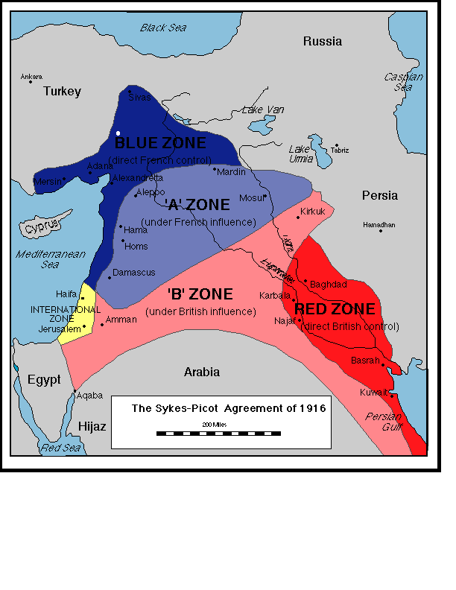
Appendix 2-e
Partition Plans

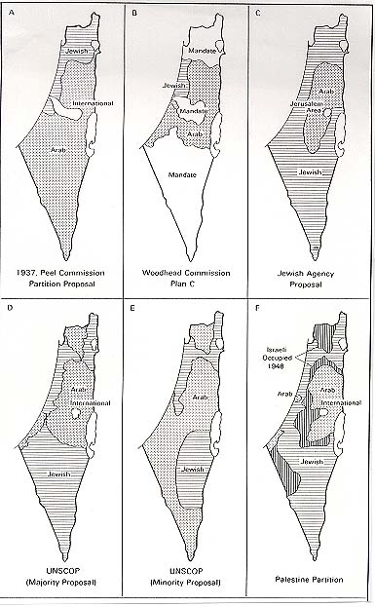
Appendix 2-f
UN Partition Plan 1947

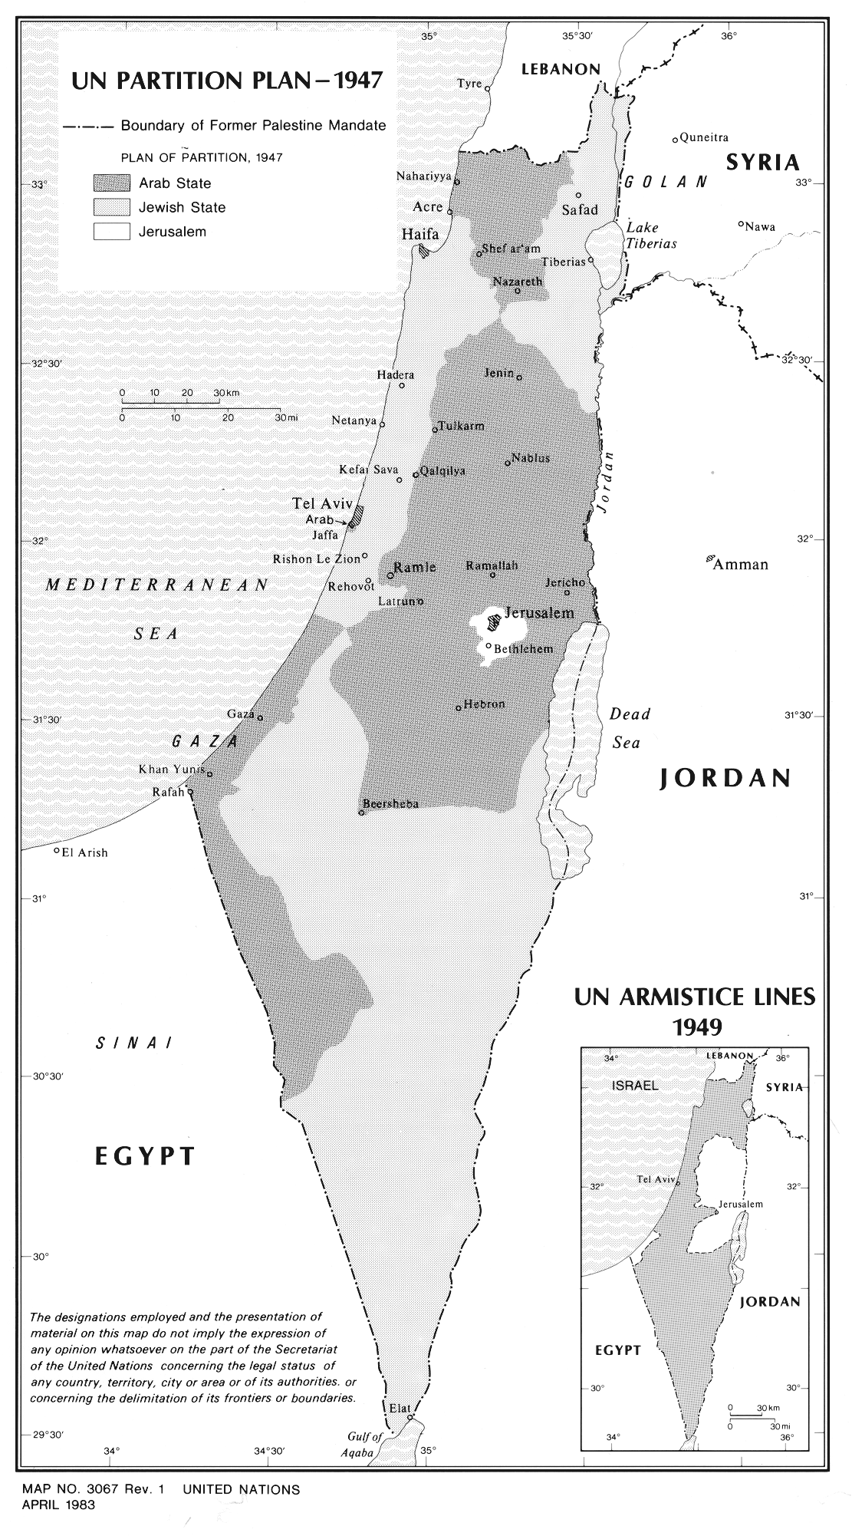
Appendix 2-g
Refugee Camps 1948

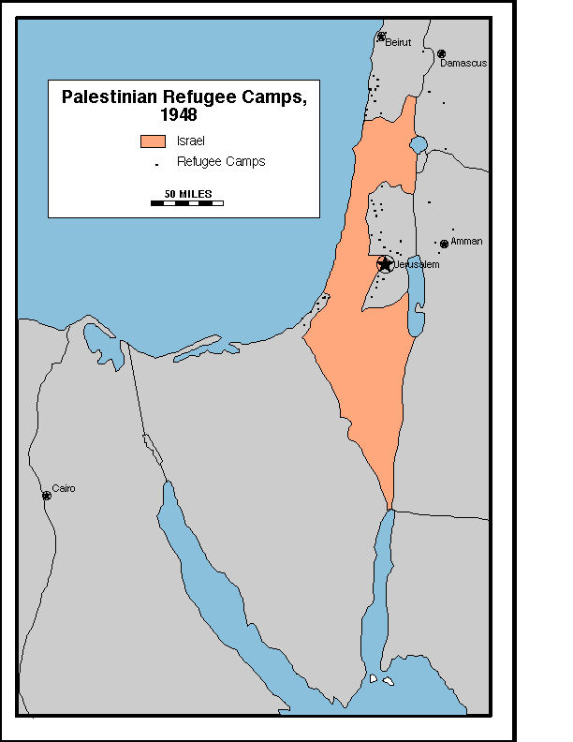
Appendix 2-h
Israeli Settlements
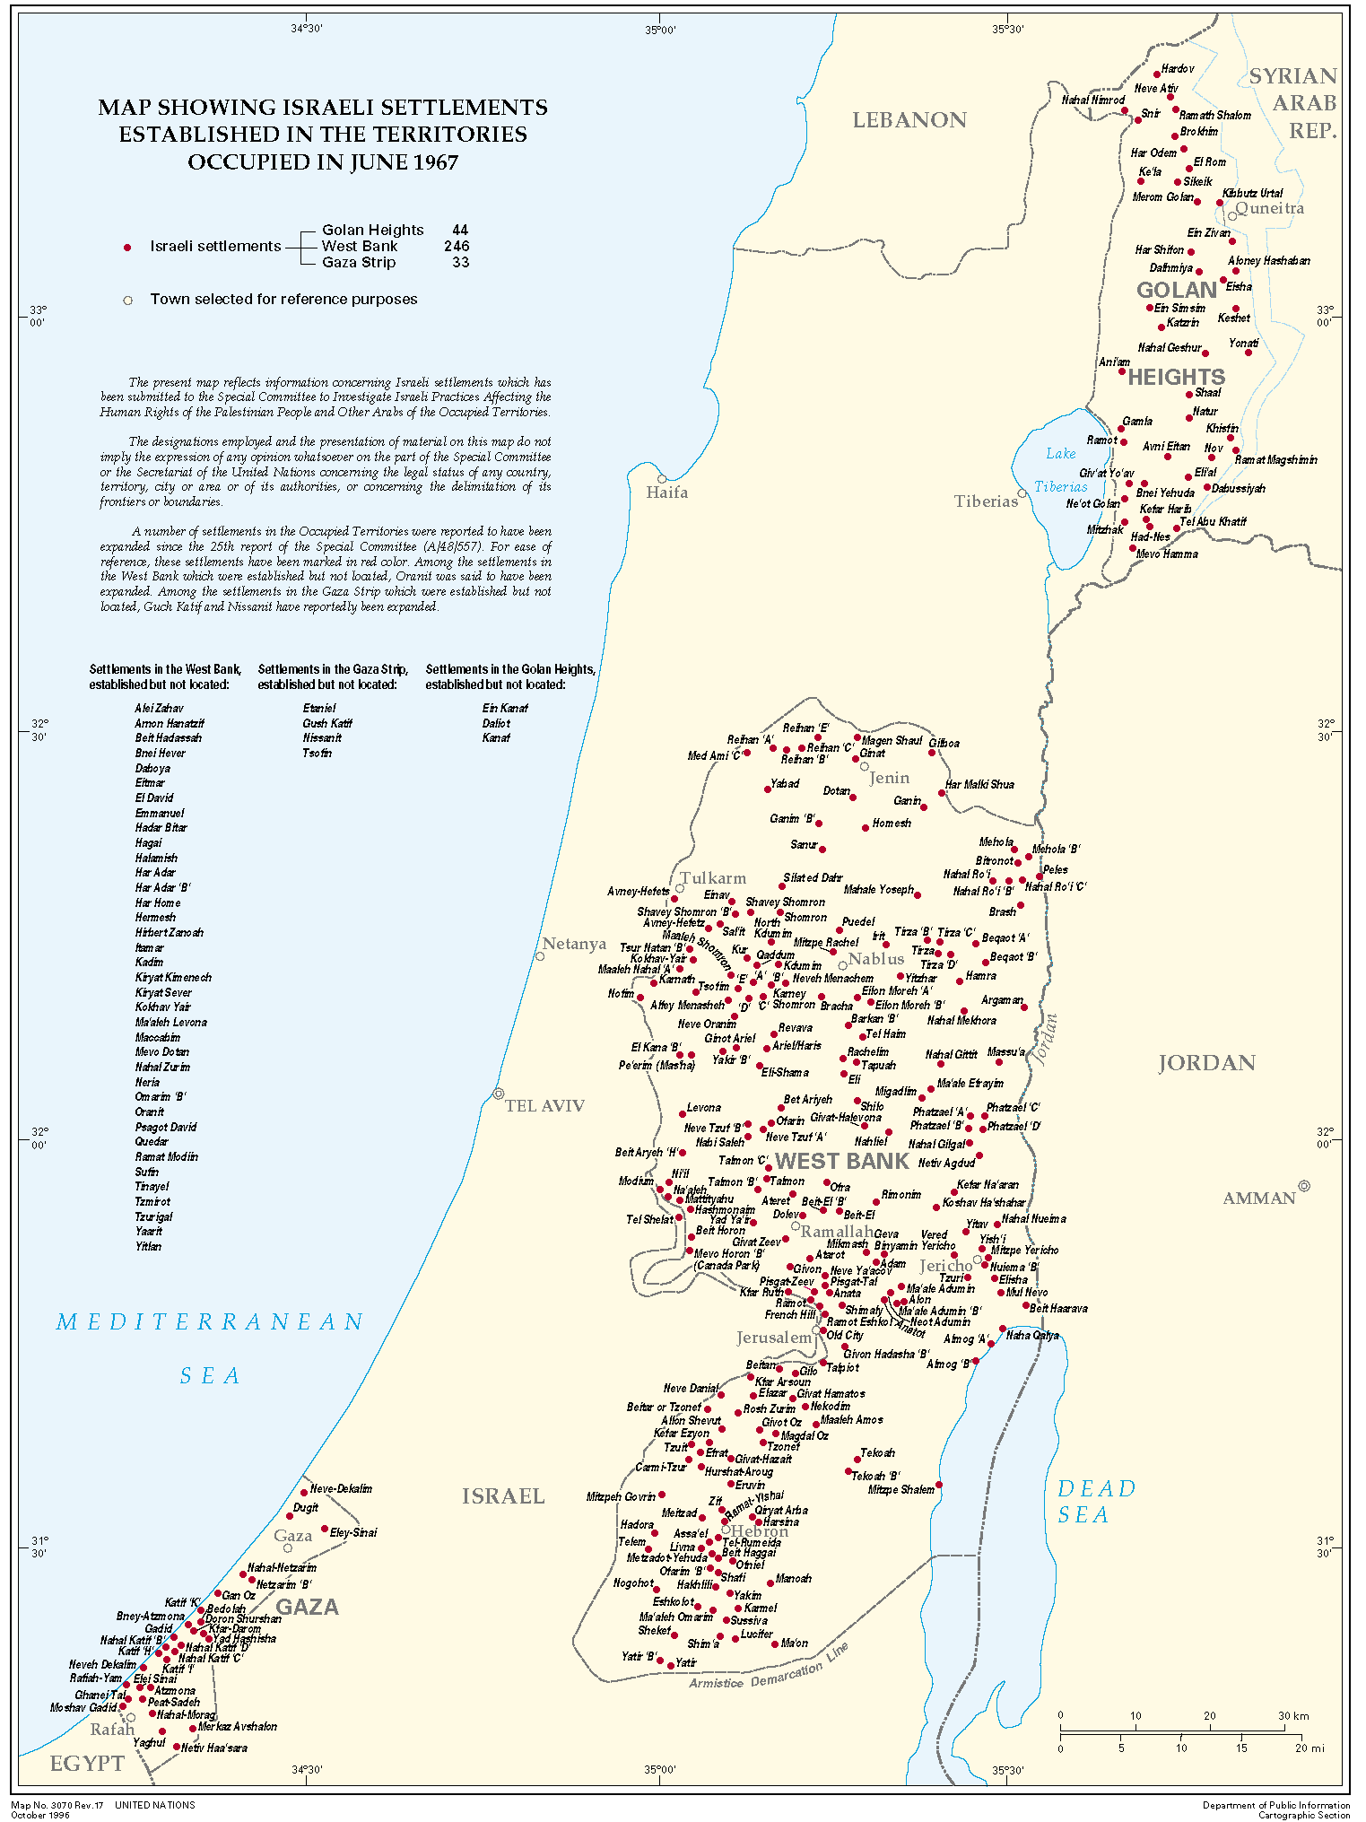
Appendix 2-i
1967 Israeli Occupation

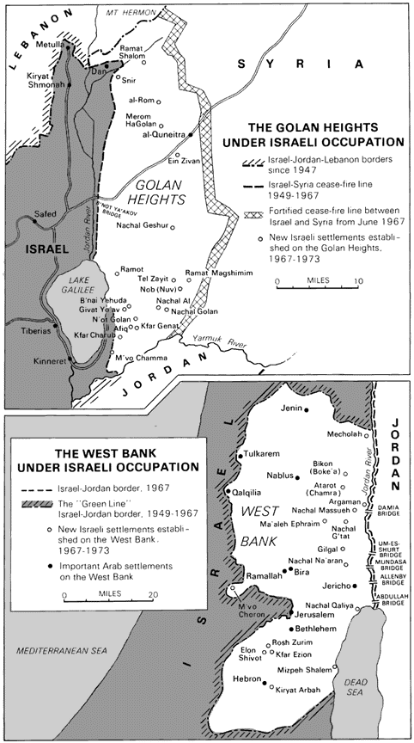
Appendix 2-j
Refugees 1993

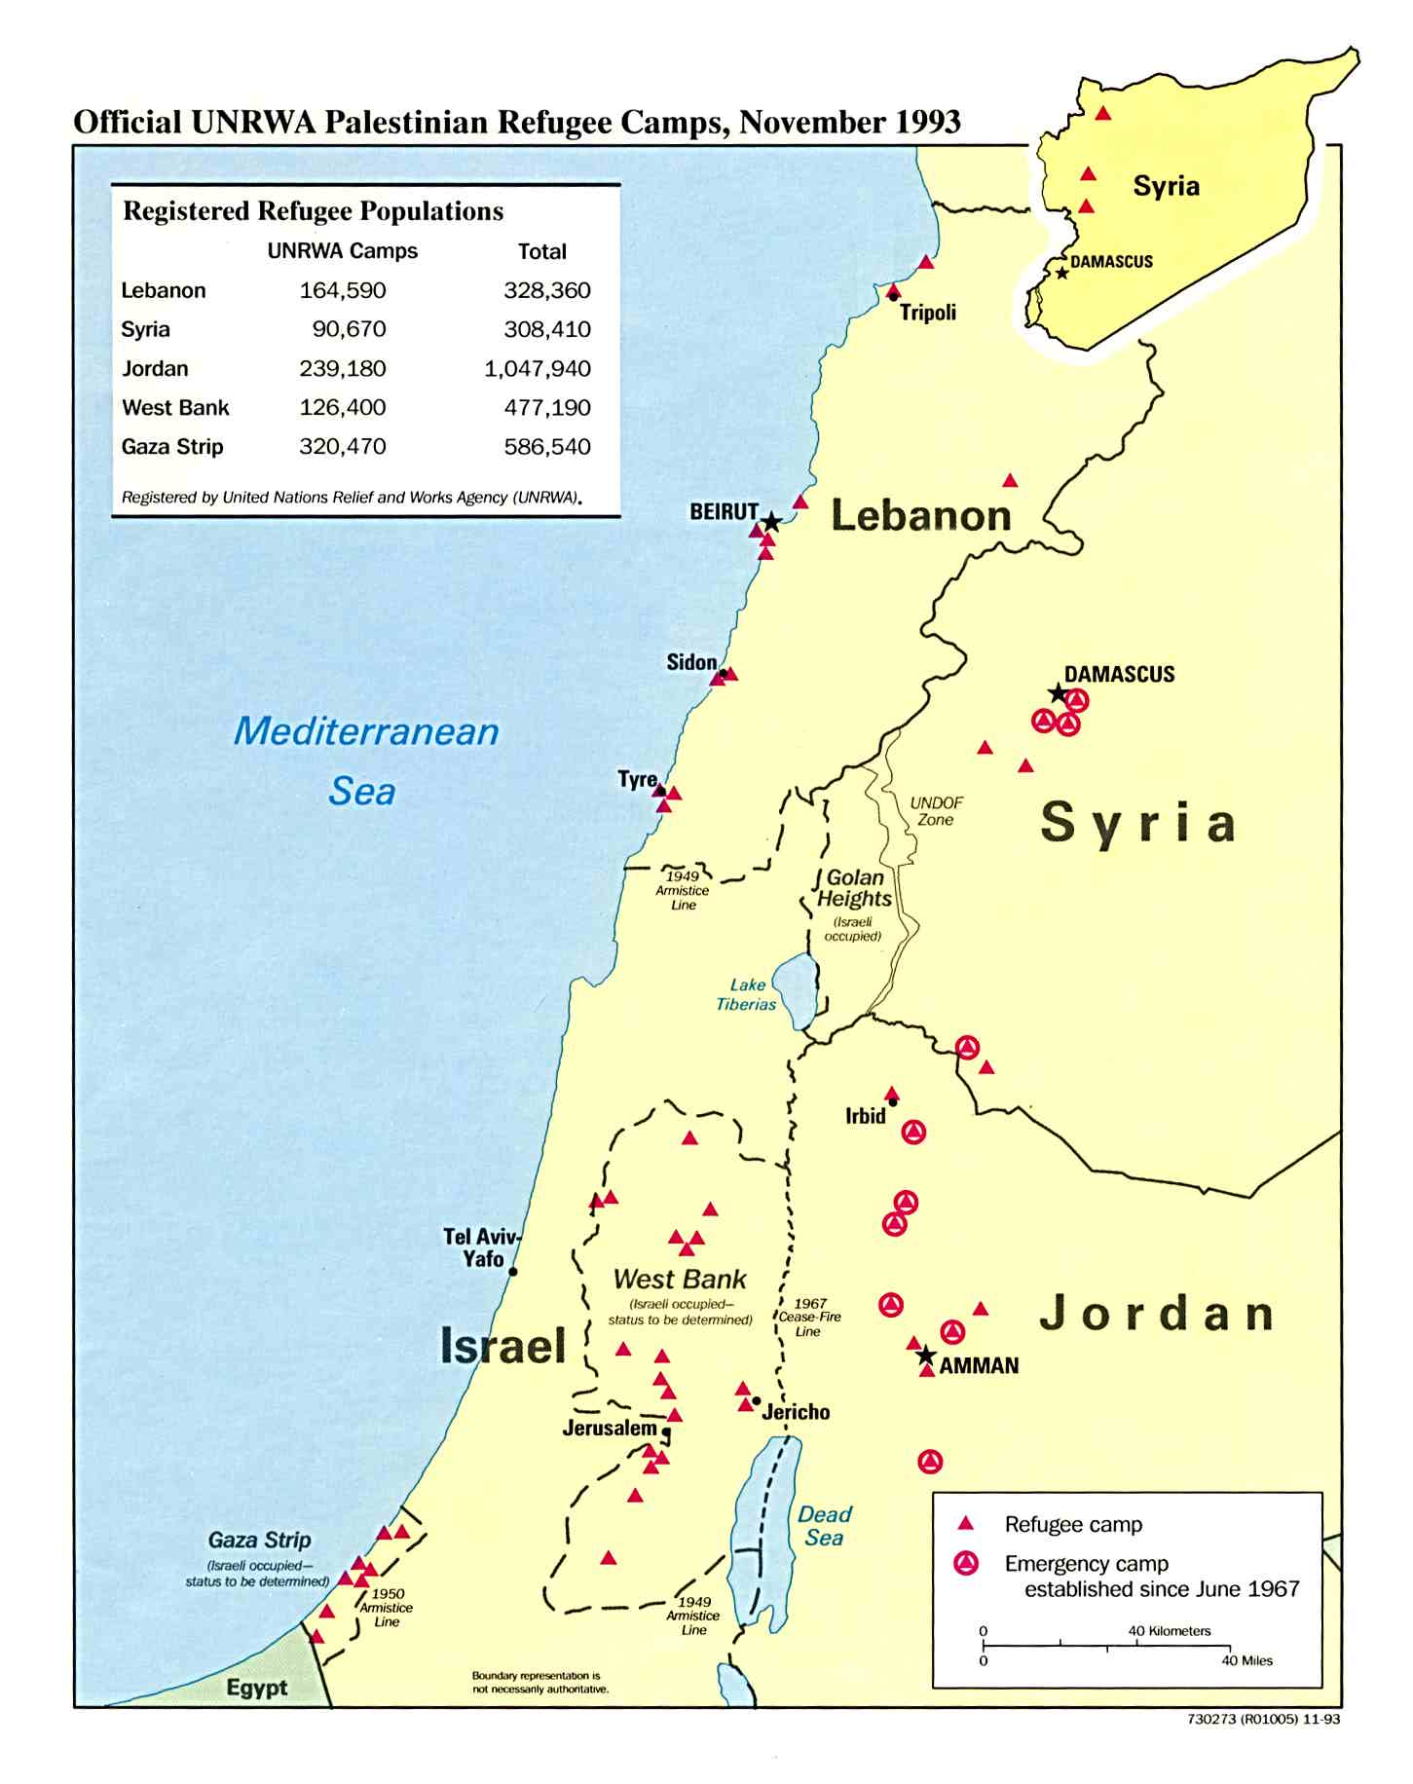
Appendix 2-k

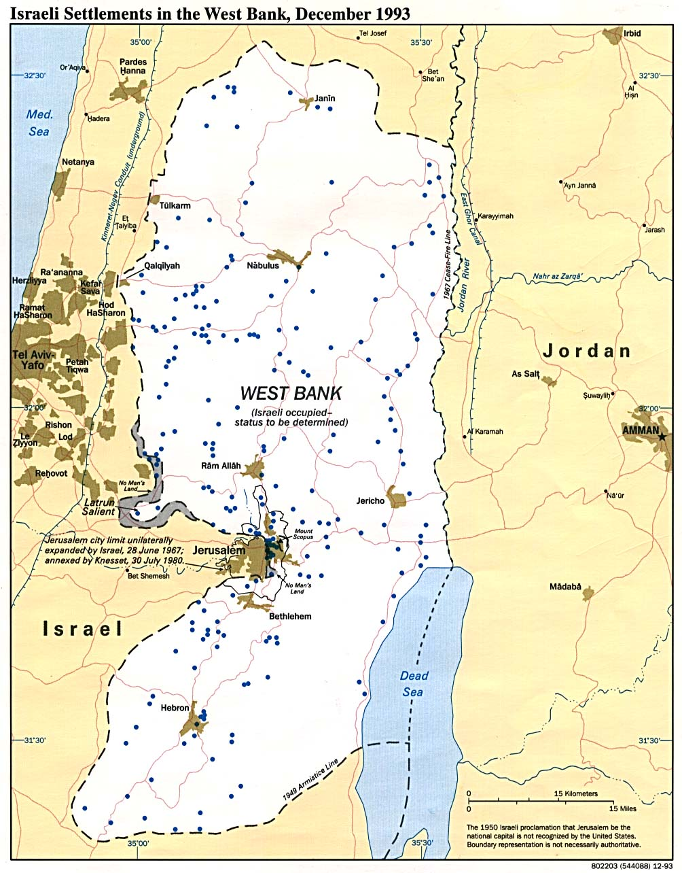
Appendix 2-l
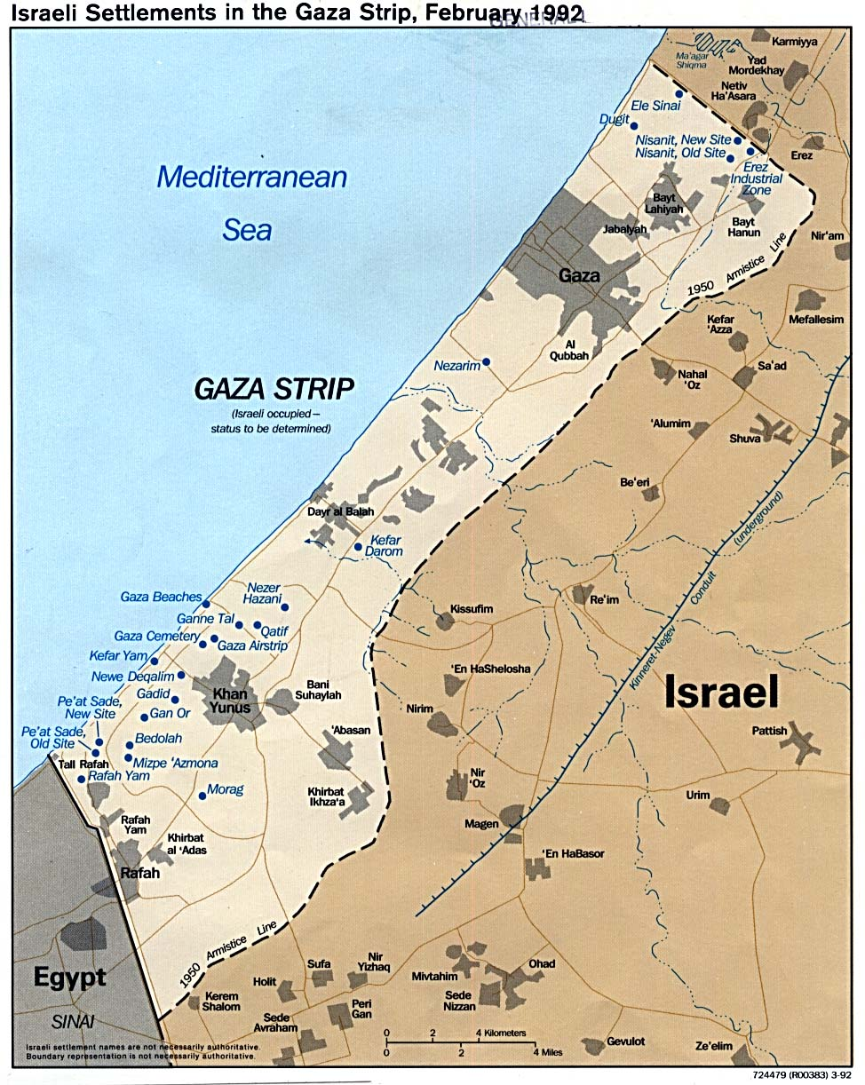
Appendix 2-m
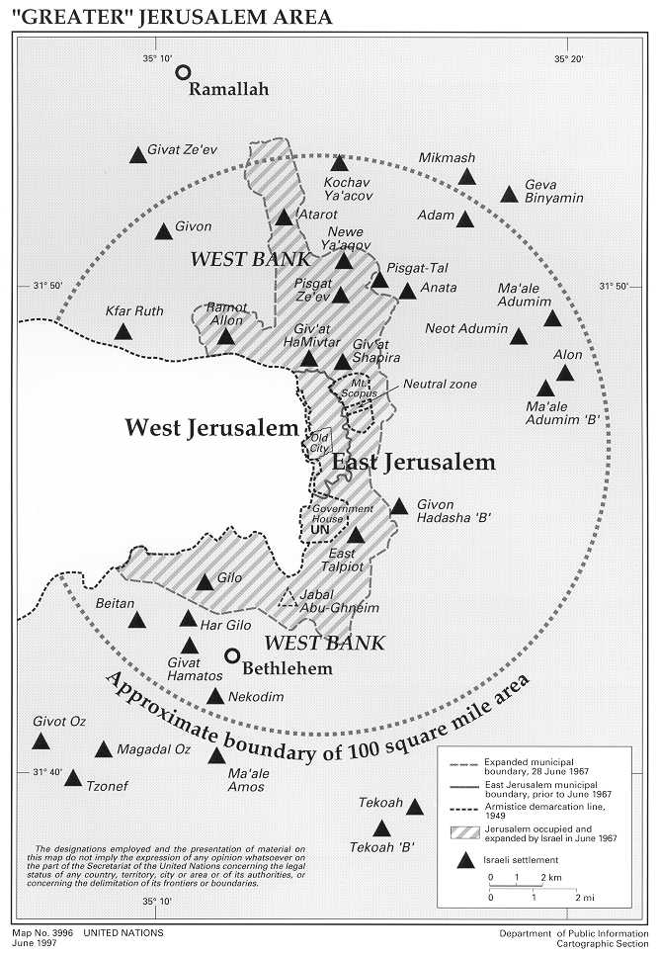

Appendix 3
Dialogue Directory

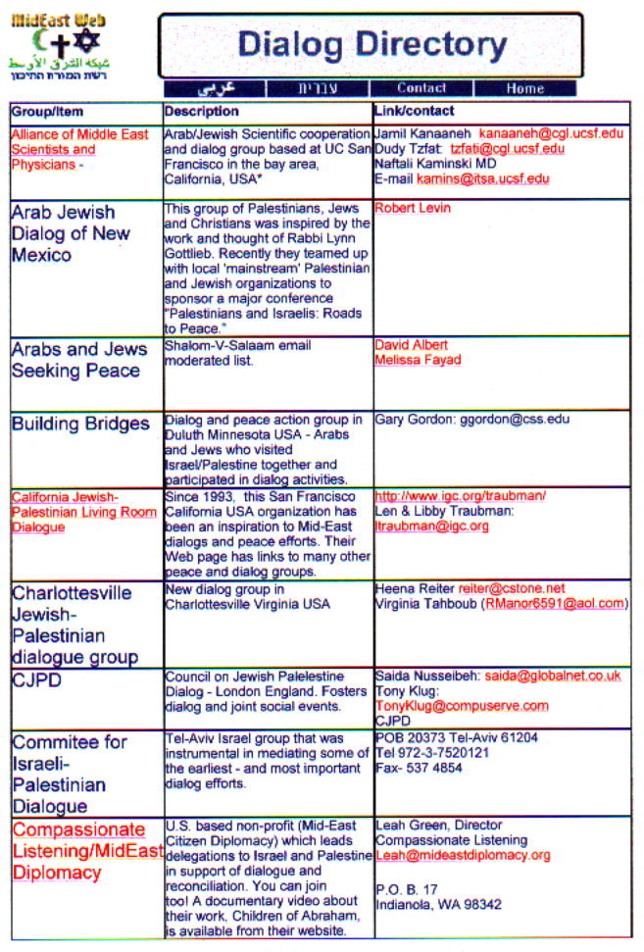

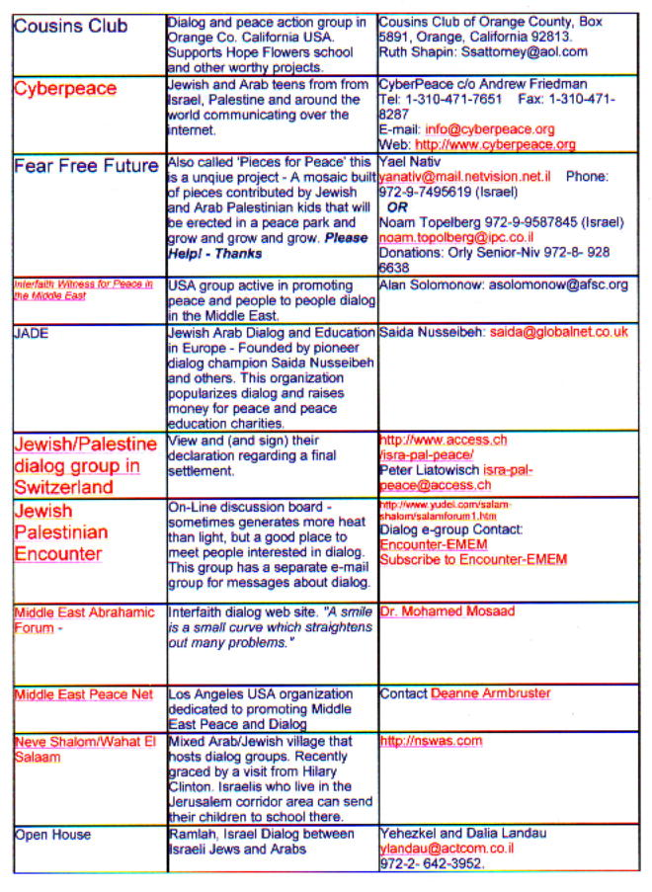

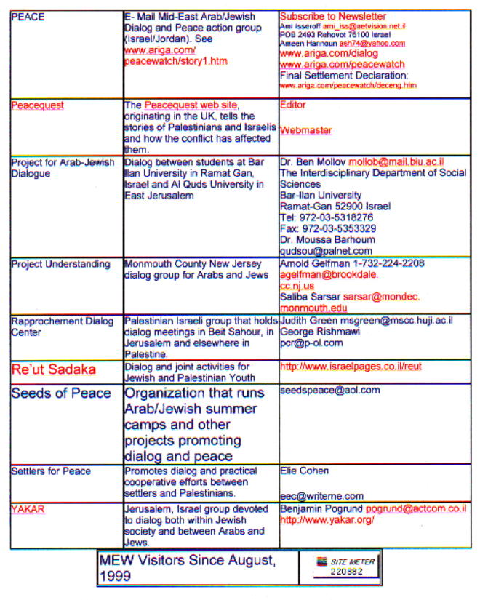

Appendix 4
Dialogue Resources
Websites and lists
  - Bohm dialogue links maintained by William van den Heuvel
  - David Bohm Dialogues Home Page
  - Dialogue information (Krishnamurti Foundation of America)
  - Listening-L Discussion Group (Krishnamurti) created by Dirk Lutzebaeck
  - Oregon Bohm Dialogue Group
  - Co-Intelligence Institute dialogue
Books
  - The Art of Focused Conversation: 100 Ways to Access Group Wisdom in the Workplace by R Brian Stanfield
  - Dialogue and the Art of Thinking Together by William Isaacs (formerly of the MIT Dialgoue Project), with an intro by Peter Senge. New York: Doubleday, 1999
  - On Dialogue by David Bohm, Lee Nichol (Editor)
  - Thought As a System; David Bohm (Editor), Lee Nichol
  - Unfolding Meaning : A Weekend of Dialogue With David Bohm; David Bohm, Donald Factor
  - The Ending of Time (dialogue between J Krishnamurti and David Bohm)
  - The Dialogueic Imagination by M M Bakhtin
  - Koinonia: From Hate Through Dialogue to Culture in the Large Group (1991) by Patrick de Mare
  - On Dialogue: An Essay in Free Thought (1996) by Robert Grudin
  - Dialogue: Rediscover the Transforming Power of Conversation (1998) by Glenna Gerard, Linda Ellinor
  - The Argument Culture : Moving from Debate to Dialogue (1998) by Deorah Tannen
  - More Precious Than Light; How Dialogue Can Transform Relationships and Build Community (1996) by Margreet Van Den Brink
Appendix 4
  - Death or Dialogue?: from the age of monologue to the age of dialogue (1990) by Leonard Swidler et al. .
Miscellaneous dialogue sites and resources
- Dialogue Group: Site describes what Dialogue is, and available seminars, books, and public programs.
- Dialogue Project (MIT Center for Organizational Learning)
  - Annual Report 1993-94, William N. Isaacs
  - Dialogue research
- Open Space Technology : A User's Guide by Harrison Owen
- International Listening Association: promotes the study, development, and teaching of listening and the practice of effective listening skills and techniques.
- Action research resources
- Radical constructivism
- Relating: Dialogues and Dialectics (1996) by Leslie A. Baxter, Barbara M. Montgomery
- Dialogue With Nature (1997) by Irene Van Lippe-Biesterfeld, Irene Lippe-Biesterfed
- Dialogue and Discovery : A Study in Socratic Method (1986) by Kenneth Seeskin
- Gathered meetings of the Quakers
  - Quaker Business Meetings: how Friends make decisions
  - On speaking in meetings for worship
Interfaith and intercultural dialogue
- Ecumenical and Interfaith Dialogue Resources: Organizations, research institutes and scholarly associations.
- Global Dialogue Institute (GDI): The purpose of the GDI is to promote dialogue in the broadest sense among individuals and groups of different religions and cultures, focusing especially though not exclusively on the "opinion-shapers" of society, e.g., scholars, professionals, and institutional and business leaders.
- Institute for Interreligious, Intercultural Dialogue (IIID) translated the fundamental research published in the Journal of Ecumenical Studies into concrete activities and partnerships. It sponsored numerous conferences on interreligious, interideological, intercultural dialogue
Appendix 4
- All Under Heaven : Transforming Paradigms in Confucian-Christian Dialogue (1994) by John H. Berthrong
- An Apology for Apologetics; A Study in the Logic of Interreligious Dialogue (1991) by Paul J Griffiths
- A Blessing to Each Other : Cardinal Joseph Bernardin and Jewish-Catholic Dialogue (1996) by Joseph Louis Bernardin, et al
- A Bridge to Dialogue : The Story of Jewish-Christian Relations (1992) by John Rousmaniere
- The Buddha and the Christ : Explorations in Buddhist and Christian Dialogue (1993) by Leo D. Lefebure
- Christianity and World Religions : Paths of Dialogue With Islam, Hinduism, and Buddhism (1993) by Hans Kung
- One Earth Many Religions : Multifaith Dialogue and Global Responsibility (1995) by Paul F Knitter
- Reclaiming the Great Tradition : Evangelicals, Catholics & Orthodox in Dialogue (1997) by James S. Cutsinger (Editor)
- The Dialogueical Imperative; a Christian reflection on interfaith encounter (1989) by David Lochhead
- Beyond Dialogue: toward a mutual transformation of Christianity and Buddhism (1982) by John Cobb Jr.
- Guidelines for Dialogue with People of Living Faiths and Ideologies (1979) by the World Council of Churches.
- The Intrareligious Dialogue (1978) by Raimondo Panikkar.
Political dialogue
- European Union proposals for political dialogue (ASEM)
- Political Dialogue in the Field of Educational Policies
- Mediterreanean Dialogue (NATO)
- Campaign For Common Ground (transformation of political dialogue in the USA)
- The Euro-Arab Dialogue : A Study in Associative Diplomacy (1983) by Saleh A. Al-Mani , Saleh Al-Mani
- Allied planning for peacekeeping and conflict management: summary of a transatlantic dialogue
- Human Rights : A Dialogue Between the First and Third Worlds (1983) by Robert A. Evans, Alice Frazer
Conflict resolution, mediation and negotiation
- Mediation Information and Resource Center
Negotiating at an Uneven Table: A Practical Approach to Working with Difference and Diversity by Phyllis Beck Kritek
Appendix 5-a
Cousins Club of Orange County Documents

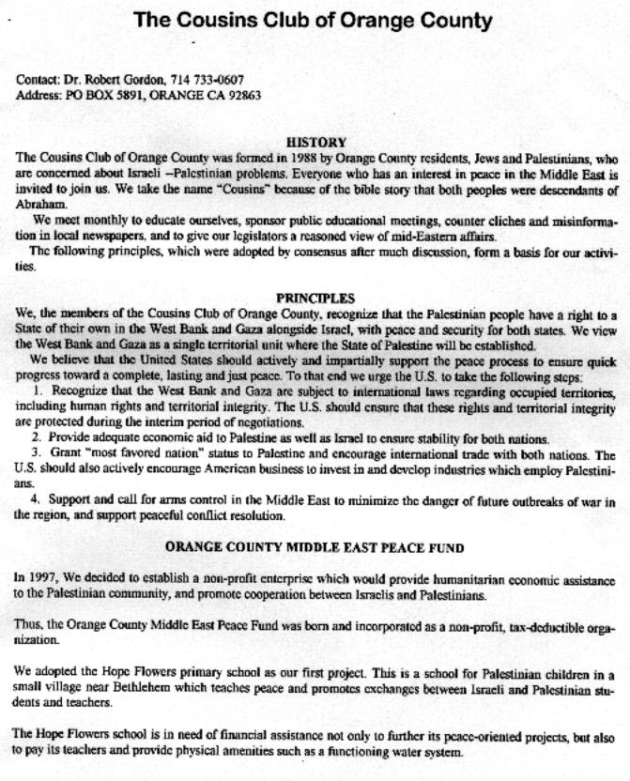

Appendix 5-b

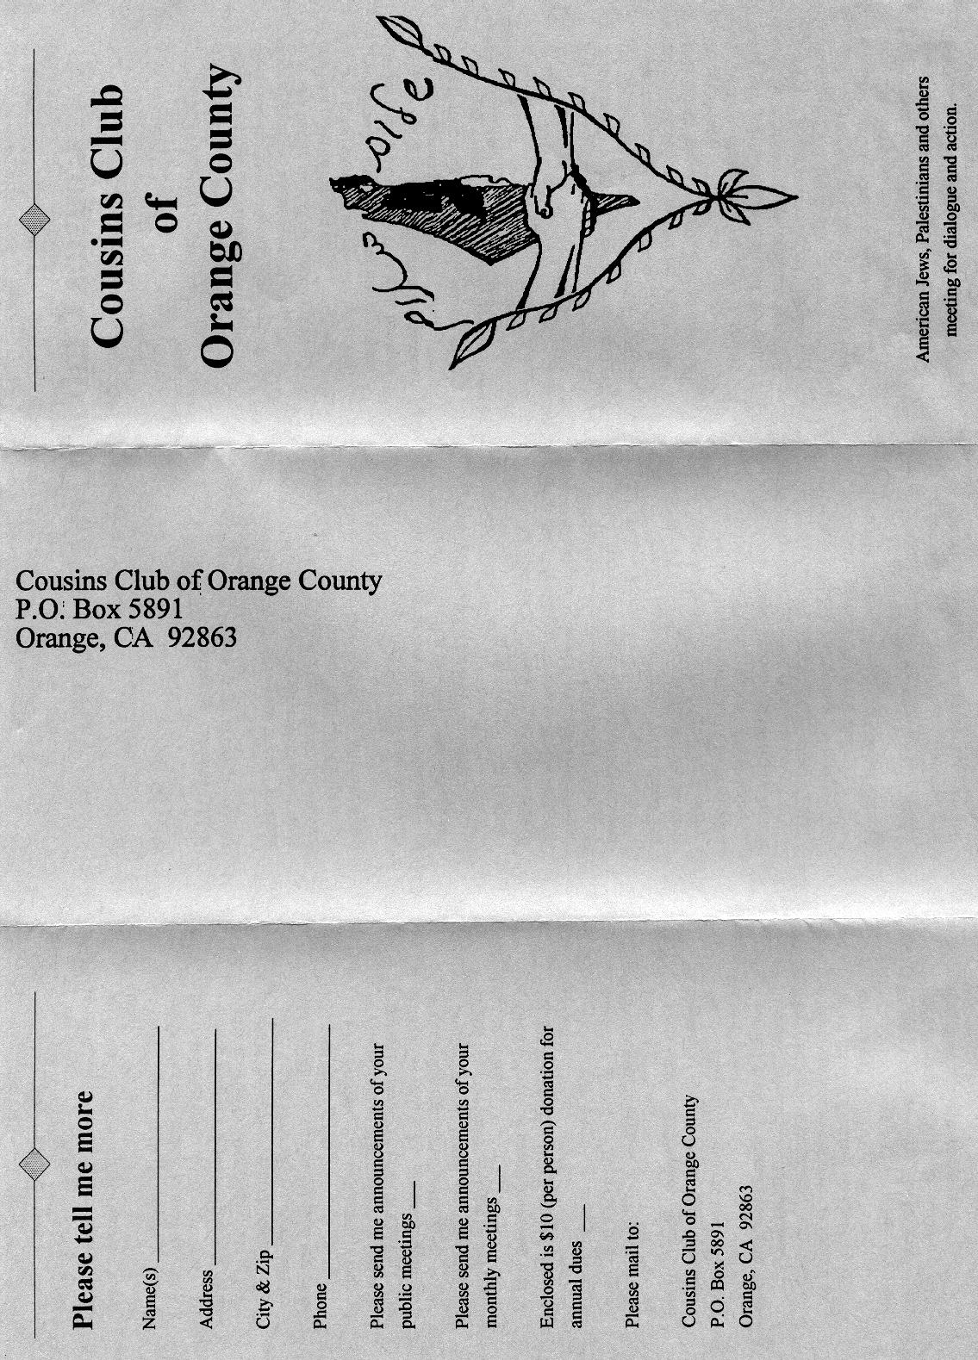

Appendix 5-b

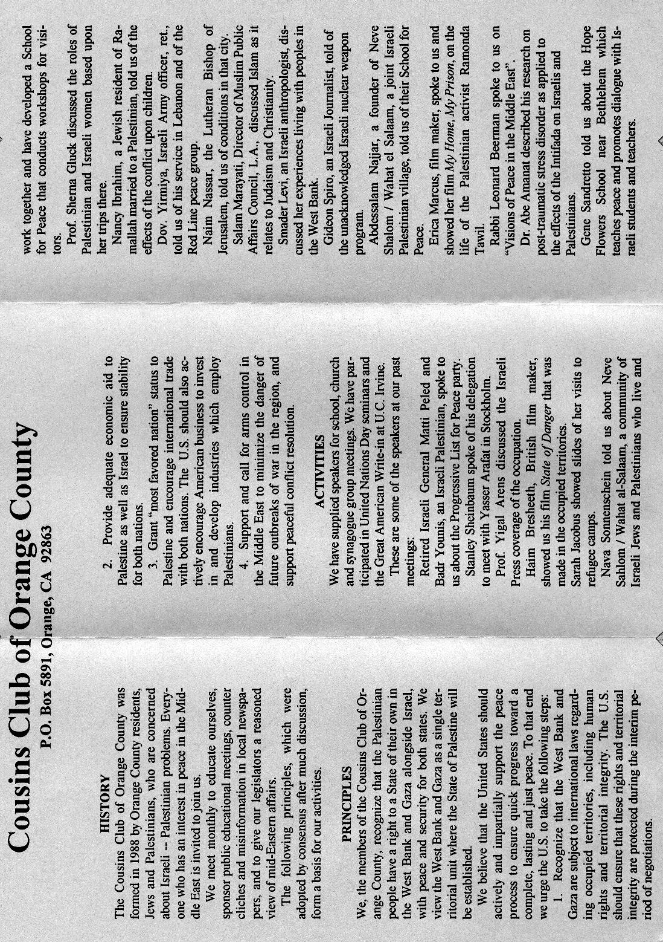

Appendix 5-c

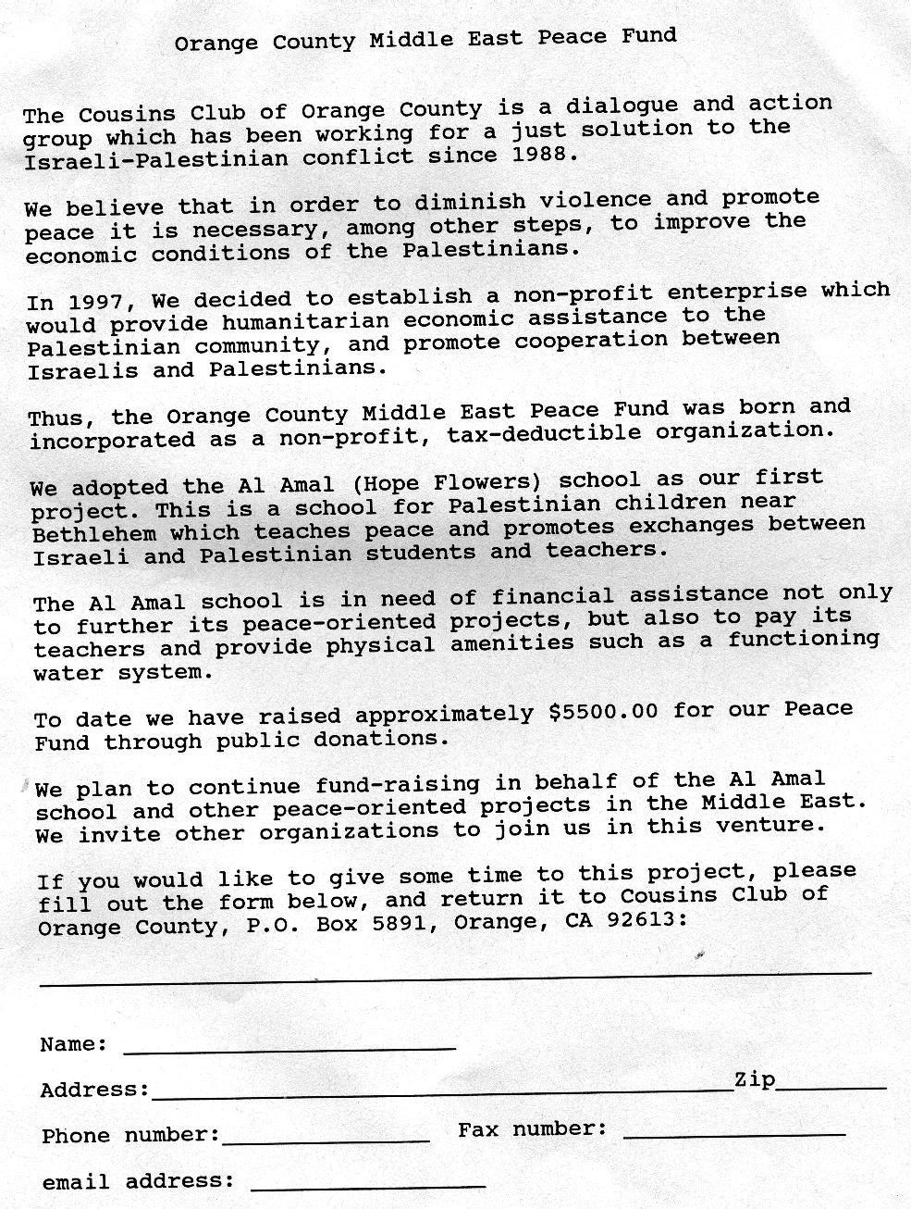

Appendix 5-d

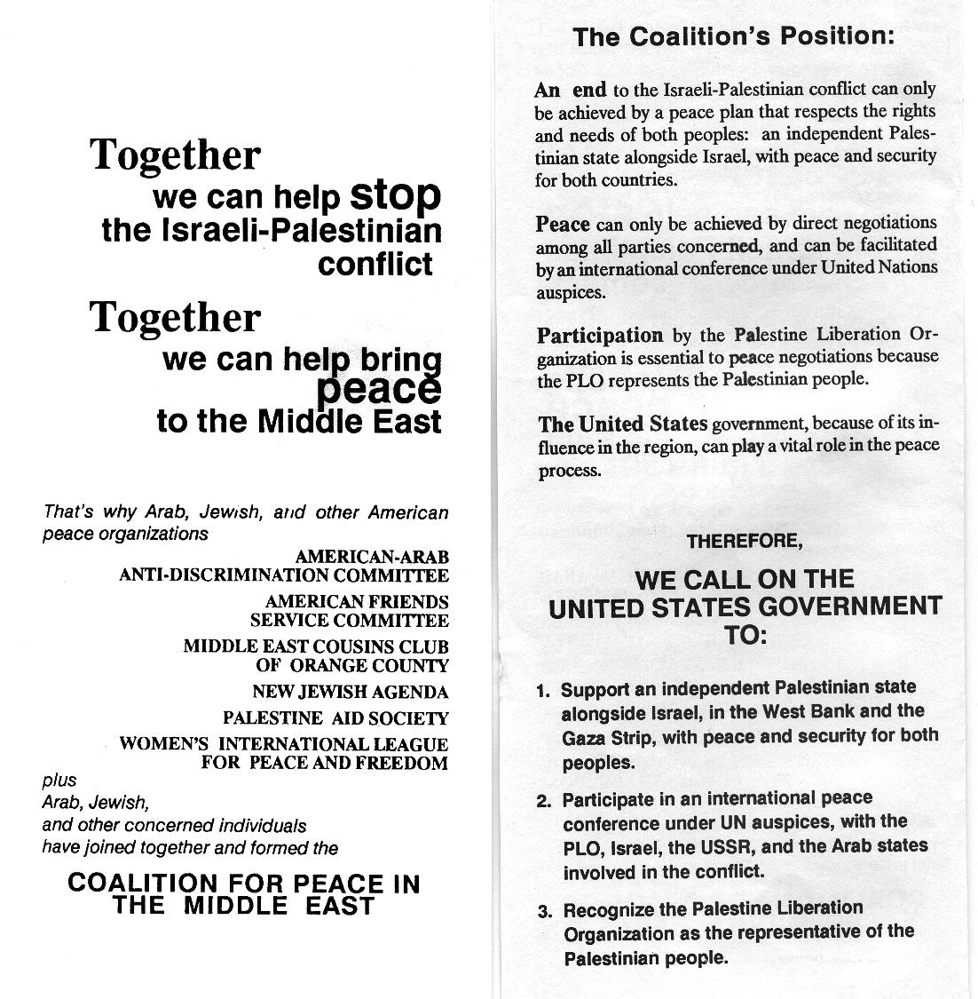

Appendix 5-d

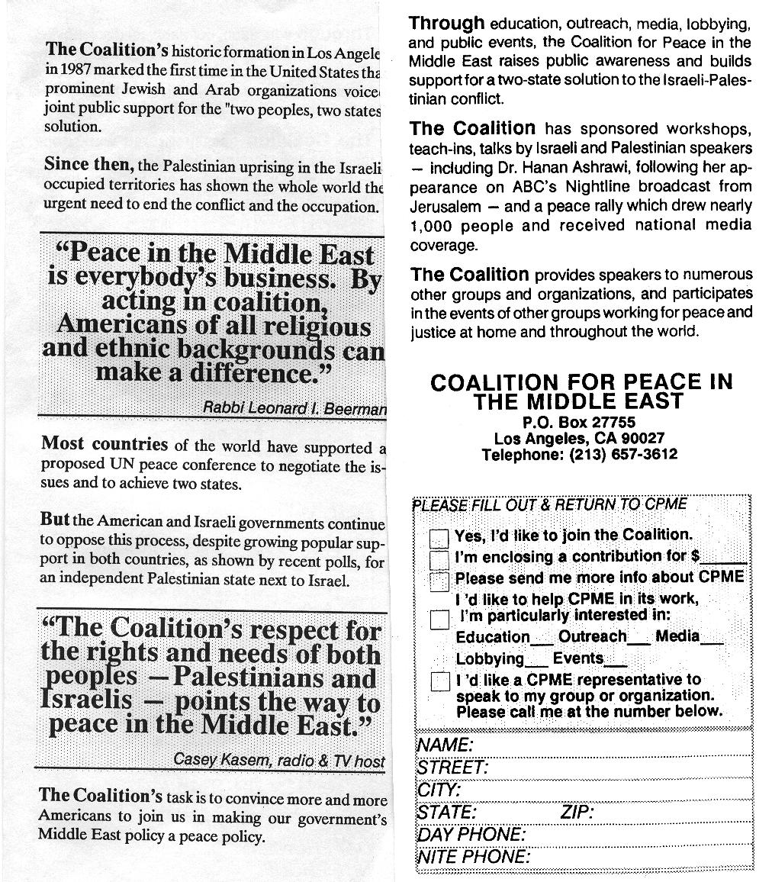

Appendix 5-e

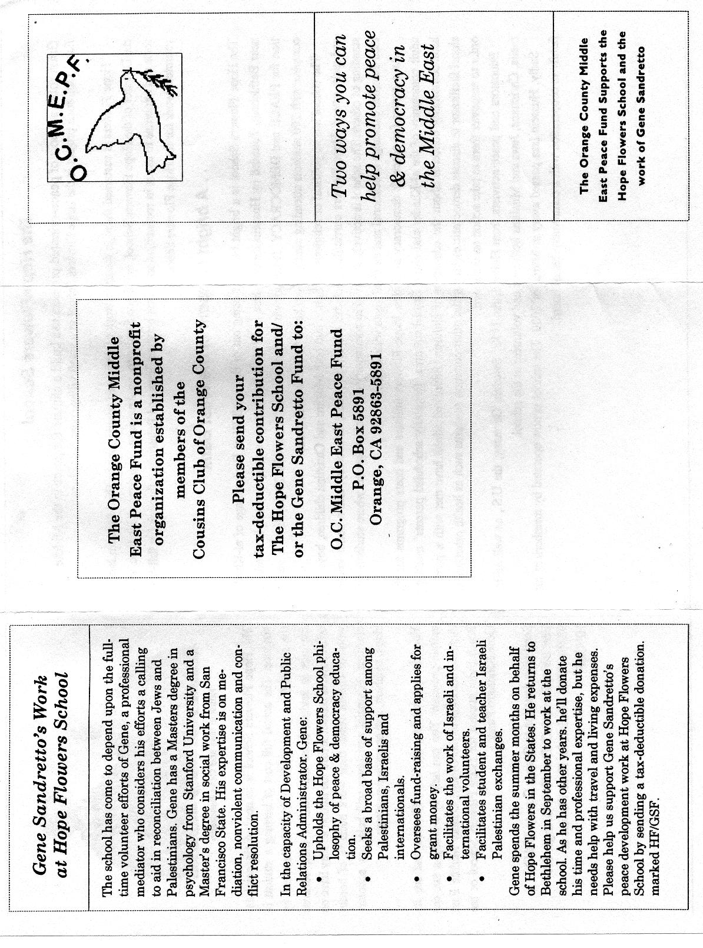
Appendix 5-e

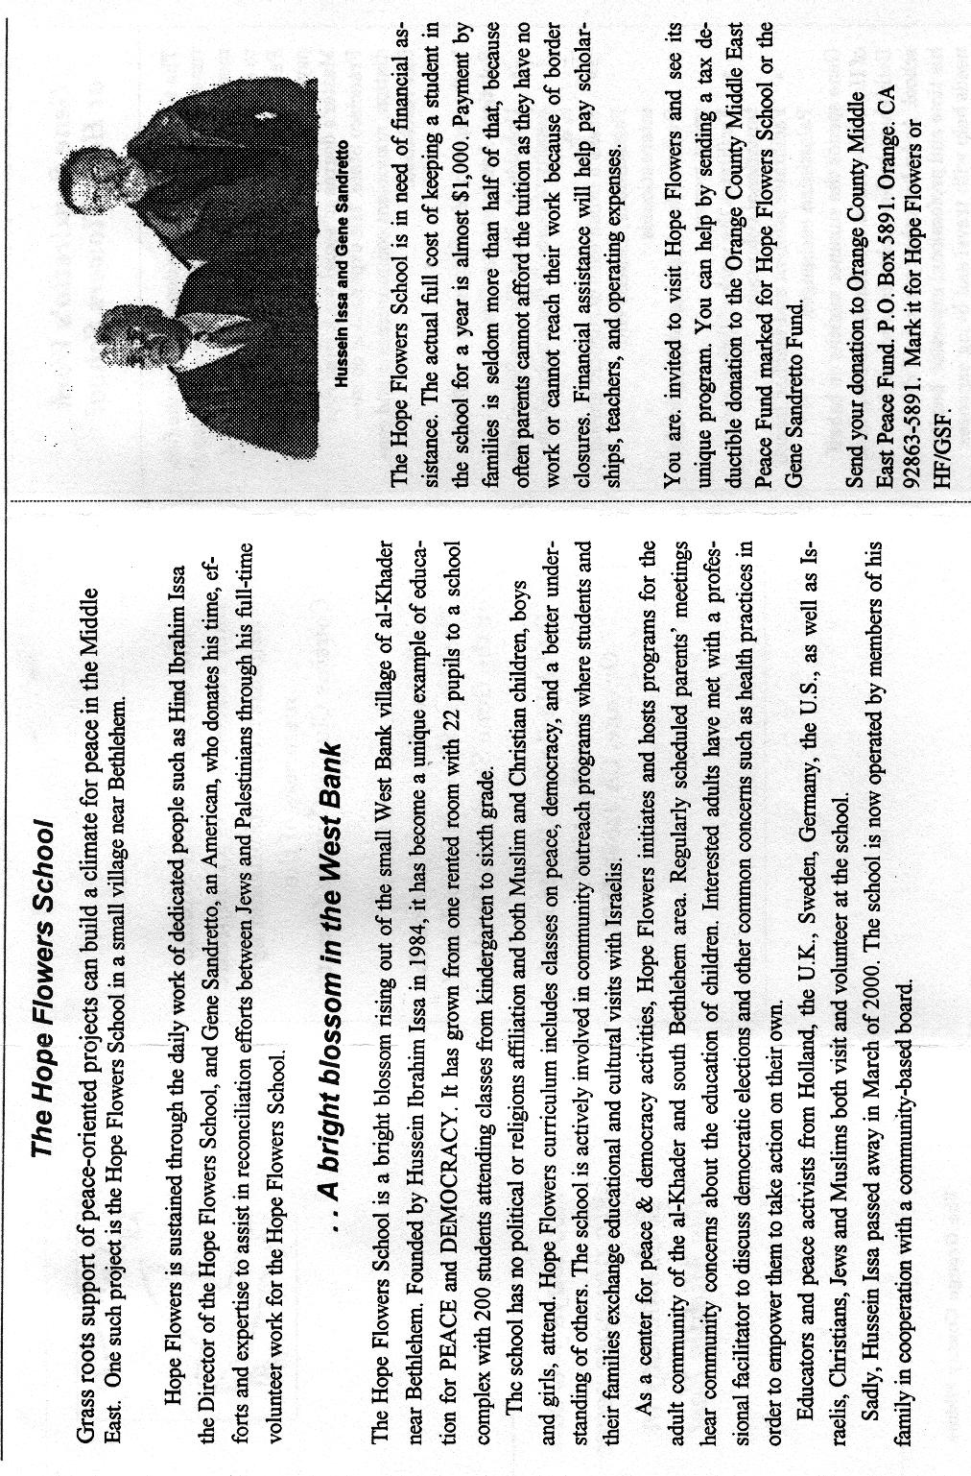
Appendix 5-f

Appendix 5-f

Appendix 6-a
Jewish-Palestinian Dialogue Group of San Mateo Documents

Five Stages of the Public Peace Process

Overview
The public peace process is based on the assumption that there are things governments can do that people cannot; and there are things people can do that governments cannot.
The public dialogue process and resulting action demonstrate that citizens have the freedom to be innovative and to create new, deeper relationships. While governments are the official bodies that make peace agreements, newer ideas and sustainable implementation depend on public consent and involvement. Thus citizens have a critical role in peacemaking, sometimes called "citizen"- or "track two"-diplomacy.
Our colleague Dr. Harold Saunders, former Assistant Secretary of State under President Carter, has had extensive experience in both citizen dialogue and in official diplomacy, as with the Camp David Accords. He first described citizen involvement as the "public peace process." With former Russian diplomat Gennady Chufrin, he delineated the interconnected Five Stages of a Dialogue Process leading to reconciliation and collaboration.

Stage One: Deciding to Engage
The decision to engage is the first requisite to the public peace process. Sensitive to political or even physical risks, citizens may be reluctant to talk with "the enemy." The most likely participants are those who have courage, and who recognize that current methods are not working and could lead to future failure, even disaster. Potential participants will look for a trustworthy, competent convener and a safe, neutral location. Helpful ground-rules will include participants representing themselves, not organizations; sensitive listening; and confidentiality. An open mind and desire to expand one's thinking and worldview is required.

Stage Two: Mapping the Relationship Together
The dialogue opens with a period of expressing and exploring each party's interests, defining the context and scope of the relationship. The central task is to map the relationship together, and starting to understand how specific problems and underlying interests define the relationship.
In time, the nature of the discourse must be changed to unload and transform the dehumanization and “demonization” that has marked the past. Dealing with participants’
Appendix 6-a

life experiences and feelings is important. There may be feelings of gratitude for the opportunity of finally being together face to face, or fear of failure. In the relationship, the earliest feelings to emerge might be anger, resentment, and blame. Hurt, sadness, and guilt could be less forthcoming in the beginning. From the expression of strong feelings, participants can learn to probe for deeper causes or needs rather than letting blame block further discussion.
Dialogue is different from traditional negotiation, which deals with exchanging formal positions and technically defined issues. Dialogue focuses on the state of the relationship and its potential for change. It requires that participants (1) value the relationship and studying it, and (2) will ask themselves, and each other, what underlies the expressed emotions and positions evoked by an issue. They thus learn about underlying needs, and discover essential dynamics of the relationship. Too often groups skip over this critical work by looking for "solutions" before they have experienced the realities of the relationship.

Stage Three: Probing the Dynamics of the Relationship Together

The purpose of each side in Stage Three is not to present or persuade but to understand and reflect back fully how the other's mind works, the other's frame of reference. In addition to the discoveries about the relationship from Stage Two, the diversity of experiences and perceptions that make up the relationship are better understood.
The parties begin to identify with each other. As they expand their own identifications to include one another, they are laying the foundation for problem-solving together. Again, it is essential to take this time to understand the relationship, and overcome the old tendency to "not waste time."

Stage Four: Experiencing the Relationship by Thinking Together

The fourth stage has the participants examining together how to deal with a practical problem. In this process, they further experience the relationship itself. One approach could be to divide into subgroups to create scenarios and their stepwise implementation, describing how each party's interests would be affected, and how resolution and reconciliation would be served. The group could then choose its favorite scenario and course of action.
This collective thinking can lead the group as a whole to change systemic flaws or get around obstacles. Perhaps only one step can be taken, but in time that may make further steps possible. But now a new relationship and process is in place for further progress.
Many dialogues stop at this point, if they get this far at all. Some group participants may share their insights with policy makers; others take fresh understandings into their own constituencies; still others see their work together as establishing a model for others.

Appendix 6-a

Stage Five: Acting Together
The ultimate group experience would be to move out from such meetings and act together to have a concrete impact - to change the relationship and effect a visible social outcome. They could carry out scenarios proposed in Stage Four; take their fresh understandings to community institutions; creatively interact with government officials; or implement the Five Step Public Peace Process with an expanded group of new citizens. The parties, to some degree, have now experienced transforming blame into responsibility, enemies into partners. They have modeled the process of dialogue and reconciliation, thus dispersing this practice into their diverse, evolving culture.

Dr. Harold Saunders' definitive new book is now available. More about A PUBLIC PEACE PROCESS: Sustained Dialogue to Transform Racial and Ethnic Conflicts, 1999, by St. Martin's Press, can be seen at http://www.igc.org/traubman/thebook.htm.

Jewish-Palestinian Living Room Dialogue Group
1448 Cedarwood Drive, San Mateo, CA 94403
Voice: (650) 574-8303 • Fax:(650) 573-1217
Web: http://www.igc.org/traubman
E-mail:LTRAUBMAN@igc.org
Appendix 6-b

Activities of the Jewish-Palestinian Living Room Dialogue Group of San Mateo

In 2001, after 108 meetings and eight years, we have moved from caution to integrity, from alienation to familiarity, from ignorance to understanding, from confrontation to collaboration. As a result, we have:
• Learned about listening, integrity, persistence, and dedication.
• Written joint letters to leaders in the United States and the Middle East, including over 90 leaders and opinion formers in Washington. The final contents of these messages were hard-won after much conflict, dialogue, then agreement, before we all placed our signatures.
• Attended synagogue together, and placed a ground-breaking display of Palestinian art in a local temple.
• Participated in our local Palestinian Cultural Days, and presented an educational table to inform and invite new Palestinians to participate.
• Given public introductory presentations for new people. Typically 50-80 attendees sit at round tables, eating home-made Palestinian and Jewish food and becoming acquainted. Several of us give talks about our personal dialogue group experiences, before the people at tables began moderated, sample dialogues of their own.
• Helped the local Israeli Consulate, at their invitation, with recent Jewish-Palestinian cultural activities which they have begun to initiate.
• Sent $1,300 cash and $20,000 worth of medical equipment to help two hospitals, one in Gaza, and another in western Jerusalem.
• Helped launch three new "spin-off" dialogue groups here in the Bay Area.
• Been interviewed on a local television talk show for 30 minutes about the history, principles, and activities of our dialogue group and about the public peace process.
• Raised $10,000 for schools in need, equally, in Netanya, Israel and Ramallah, Palestine. For their part, the two faculties began meeting in their own new face-to-face dialogue process.
• Co-sponsored an educational fundraising event for Neve Shalom/Wahat al-Salam (Oasis of Peace), a model village where Jews and Palestinians live and learn together. Two hundred attended.
• Published editoral articles On Passover and Peace and To Build a Common Future, A Missing Step in the Peace Process, and Palestinians, Jews can unlearn old habits in major metropolitan newspapers.
• Sponsored "Building A Common Future", a historic, relationship-building dinner near San Francisco for 420 Jewish and Palestinian Americans, and others, to begin changing the nature of their relationships and invigorate the public peace process. About 100 attendees signed up to continue with in-home mealsharing groups.
• Recorded a radio interview for the international broadcast of "Unofficial Channels: Dialogue for Middle East Peace," by the National Radio Project.
• Provided a guest panel for University of California, Santa Cruz, students' first "Jewish-Palestinian Dialogue Workshop."

Appendix 6-b
• Helped educate high school classes studying Palestinian-Jewish conflicts and the value of dialogue in the public peace process.
• Presented a workshop on dialogue, trialogue, and conflict resolution to teen "Future Leaders of the Jewish Community." (Syllabus available upon request.)
• Assisted a synagogue Friday evening dedicated to peace -- Jewish-Palestinian dinner, Shabbos services, exhibits, and panel presentation.
• Helped the 1998 San Francisco Jewish Film Festival with audience development for their North American premier of "AL NAKBA: The Palestinian Catastrophe 1948."
• Provided a "Lunch and Learn" program for the Montefiore Senior Center of the Jewish Community Center.
• Helped YES! Magazine publish an article, "Living Room Dialogues."
• Held a quilting workshop to create squares for the travelling Middle East Peace Quilt of Elizabeth Shefrin, Vancouver, Canada, a fabric artist who teaches "Stitching for Social Change."
• Co-sponsored with the World Affairs Council a public presentation for 350 by M.K. Dr. Yossi Beilin and Palestinian leader Faisal al-Husseini.
• Provided an interview about our Palestinian-Jewish dialogue process for Planetary Dialogues on the Internet.
• Sponsored and facilitated the First All-Bay-Area Meeting of Jewish-Palestinian Living Room Dialogue Groups.
• Participated as panelists in "Dialogue Is Action," a 1999 conference of Stanford University, Office of Multicultural Education.
• Helped financial donors identify worthy projects that join Palestinians and Jews in dialogue, and in activities that help change enemies into partners.
• Mailed dialogue guidelines and relationship-building ideas to over 903 individuals, including 563 institutions, 372 cities, 38 states, and 30 countries.
• Used the Internet to forward encouraging news about successful Palestinian-Jewish collaboration, here and in the Middle East.
• Organized a Spring dinner-ceremony: "A Celebration of Freedom for All the Children of Abraham, Hagar, and Sarah."
• Helped students in high schools, universities, and graduate studies, by providing printed materials and personal interviews about principles and results of citizen relationship-building.
• Celebrated our Third Annual Jewish-Palestinian Dinner in May, 2000 with music and dancing from both cultures, equally.
• Helped a new San Francisco Dialogue Group get launched then, after two years, co-sponsored with the Jewish Community Center an evening Reception for 100 Arabs and Jews.
• Provided media interviews, during the Fall, 2000, violent outbreaks, for local newspapers, radio, and TV, for CNN, and for Canadian radio, to communicate alternative ways of thinking and responding.
• Helped a new dialogue group to begin in Silicon Valley, despite Middle East violence.
• Offered program development assistance for the Christian Science Sentinel - Radio Edition broadcast, "Common ground for peace-building in the Middle East."
Appendix 6-b
• Provided a panel for a November, 2000 "Teens-only Middle East Forum" sponsored by the Jewish Community Center of San Francisco at the request of youth to expand their views.
• Spoke at "Coming Together to Bridge Racial Differences", a community forum sponsored in part by the National Education Association.
• Helped host a "Palestinian-Jewish Introductory Evening" at the Arab Cultural Center of San Francisco, to help begin a new dialogue group.
• Presented two panels, "Jews and Palestinians in Dialogue," at Palo Alto High School's "Worldfest 2001 -- The Worlds We Come From, The Worlds We Make," and at Lincoln High and Piedmont High.
• Supported students in presenting their first Palestinian-Israeli Awareness Week at the University of the Pacific.
Appendix 6-c

A Palestinian-Jewish Introductory Evening

Report and Outline

On February 28, 2001, an Introductory Evening for newly-interested Palestinians and Jews was hosted by the 2-year-old Jewish-Palestinian Living Room Dialogue Group of San Francisco.
Attendees were mostly women and men who had heard of the Dialogue through friends, newspaper articles, or radio or TV broadcasts during these discouraging months of violence. The tone of the evening was honest, accepting, and searching. There was a good quality of compassionate listening. People had heavy hearts, and at the same time were looking for creative ideas and new models for relating.
About all who attended asked to be part of forming a new dialogue group in San Francisco, in addition to the five already active in the Bay Area.
We encourage others to convene similar gatherings for Jews and Palestinians where they live.
For others who might wish to have a similar Introductory Evening, we offer below the elements of that Wednesday night gathering:
6:45 -- Dialogue Group arrives prepare the rooms, displays, food, and nametags
7:30 -- Guests arrive (conversation, nametags, coffee, tea, fruit, cookies)
7:45 -- Host Said Nuseibeh welcomes everyone to the Arab Cultural Center and reviews the agenda already written on a large pad.
7:45 -- Dialogue Group participants introduce themselves simply by name, and as Jewish, Palestinian, or "other." Guests then introduce themselves similarly.
8:00 -- Dialogue participants Melek, Jacob, Gladys, Elias -- 2 Palestinians, 2 Jews -- introduce themselves more in depth. In 3-5 minutes each, they say more about their "story" and thoughts, and why they participate in dialogue.
8:15 -- We divide into three smaller groups ten, which convene with 5 suggested topics for dialogue. (People usually want to tell short forms of their personal life stories and thoughts, with regard to the Middle East.) Each group is facilitated by a Palestinian and Jew -- Melek and Dudy, Muhammad and Jacob, Said and Gladys.
8:50 -- Reconvene in a large group. Hear from each group about the nature of their conversations and any insights. Clarify what dialogue is. Explore possible next steps requested by the guests, including the possibility of forming a new San Francisco dialogue group. Have people write their contact information of 3x5 cards, with their wishes for future participation.
9:15 -- Informal mixing and talking until people begin to leave the meeting.
9:30 -- Clean up!
Jewish-Palestinian Living Room Dialogue Group
1448 Cedarwood Drive, San Mateo, CA 94403
Voice: (650) 574-8303 -- Fax: (650) 573-1217
Web: http://www.igc.org/traubman/
E-mail:LTRAUBMAN@igc.org

Appendix 6-d
Dear colleagues in Jewish-Palestinian dialogue,
While much news from the Middle East is deeply troubling, here many minds, hearts and doors are opening as never before in recent experience.
The San Mateo Jewish-Palestinian Living Room Dialogue Group just became nine-years-old at our 109th meeting. Instead of one, there are now eight similar, yet diverse, groups in the Bay Area. The idea seems to be moving into new cities and campuses.
We thought these examples would interest and encourage you. --L&L
Brooklyn and Manhattan
====================
In Brooklyn, Marcia Kannry (MKfemworks@aol.com) -- she lived in Jerusalem for four years -- made the decision to search her neighborhood for Arabs and Jews to begin a dialogue. She had a lot of help from Frank Bamberger (102217.622@compuserve.com), Chair of the Social Action Committee of the Brooklyn Heights Synagogue, a Reform congregation.
Their introductory evening featured guest speakers Palestinian Aref Dajani (Aref.N.Dajani@census.gov) and his Jewish dialogue partner, Walter Ruby (xenoret@hotmail.com) from the Encounter Arab-Jewish group across the river in Manhattan.
“Dialogue is an antidote to powerlessness,” said Ruby. “This is not a time for Jews to be talking to Jews. This is a time for Jews and Palestinians to be talking to each other.” Dajani described the importance of never withdrawing from these newfound relationships: "If you feel pain in anything I say, let that be an opening for us to create dialogue.”
Over a hundred women and men -- Muslims, Christians, Jews -- attended the first evening, whose success is described by The Jewish Week newspaper, in the online article "Look Who's Talking" at http://64.40.97.132/news/newscontent.php3?artid=4303.
The Brooklyn Dialogue Project of Jews and Arabs, and the Manhattan Encounter, meet monthly and continue to grow!
Some photos of them, and others in New York, are on the Web at http://www.shutterfly.com/my/os.jsp?i=67b0de21b314af14653c.
San Diego
==========
In only months, "quiet" San Diego has birthed four new, well-grounded, sophisticated dialogue groups. It is quite an inspiration!
The first was begun by Gordon and Arleen Kahn Shifrin (ArleenKahnShifrin@compuserve.com).
Another group includes Maurice Friedman, author of "Martin Buber: The Life of Dialogue." Maurice is the world's leading authority on Martin Buber, who taught and lived a life of inclusiveness.
Another dynamic dialogue began with participants of Conservative Congregation Beth El in La Jolla. Convenors include Dr. Manal Swairjo (Swairjo@scripps.edu), and Debbie and Colin Seid (DebSeid@san.rr.com). Doris Bittar and Jim Rauch (JRauch@weber.ucsd.edu) are also backbones of that group.
At the University of California, San Diego, new Arab-Jewish Dialogue is happening because of Ms. Jamie Zimron (JZimron@aol.com), who offers the studetns affection and depth from her experience with The Compassionate Listening Project. Here are portions of what Jamie wrote today about their recent meeting:

"A dozen students were there, including 4 Palestinians. it was a wide-ranging 3-hr+ discussion, with lots of profound sharing, information that surprised "the other," and total respect with plenty of humor too. Quite amazing really!
". . . we feel we have enough of a nucleus and momentum to continue.
"Next Sunday a dear friend of mine, Daniel Mark, will be visiting San Diego with his Palestinian eco-peace activist partner Waseem, a Palestinian Israeli. Rabbi Laurie Coskey is opening her home in Poway for a group to gather to watch 'Children of Abraham' and have a discussion with Daniel, Waseem, and myself."

After the last UCSD campus meeting, a Palestinian participant with roots in Ramallah sent this message: "May God above help people like you and myself lead both our peoples into reconciliation and mutual acceptance in a just and comprehensive peace between both nations. It pains me so much to see the two most closely related people on earth fight, kill and fear one another as they do now. . .I really enjoyed our dialogue, and look forward to participating in the next one."
BIBLIOGRAPHY
Works Cited

Anderson, Benedict. Imagined Communities, Reflections on the Origin and Spread of Nationalism. London: Verso, 1991.

Antonius, George. The Arab Awakening: The Story of the Arab National Movement. Lebanon: Librairie Du Liban, 1969.

Bickerton, Ian J. and Carla L. Klausner. A Concise History of the Arab-Israeli Conflict. New Jersey: Prentice Hall Inc., 1991.

Beit-Halahami, Benjamin. Original Sins: Reflections on the History of Zionism and Israel. New York: Olive Branch Press, 1993.

Bodner, John. Remaking America: Public Memory, Commemoration, and Patriotism I the Twentieth Century. Princeton, N.J.: University Press, 1992.

Boyd, C. Shafer. Nationalism and Internationalism: Belonging in the Human Experience. Melbourne, FL: Kreiger Publishing, 1982.

Carmichael, Joel. “The ‘Palestinain People’–A Lethal Fiction.” Midstream, Feb. 1991, 6-8.

Chacour, Elias. Blood Brothers: A Palestinian Struggles for Reconciliation in the Middle East. Grand Rapids, Michigan: Chosen Books, 1984.

de Toledano, Ralph. “History, Israel, and the Myth of the ‘Occupied Territories’.” Midstream, Jan.1998, 2-4.

Fackenheim, Emil F. “The Heroic Age of the Jewish People.” Midstream, Feb.1991, 30-1.

Gilbert, Martin. Atlas of the Arab-Israeli Conflict New York: Oxford University Press, 1993.

Gilboa, Eytan. American Public Opinion toward Israel and the Arab-Israeli Conflict. Massachusetts: Lexington Books, 1987.

Gorney, Yosef. “Can the Jews Retain a Collective Identity?” Midstream, Aug. 1995.

Greenberg, Irving. “The Ethics of Jewish Power.” In Beyond Occupation: American Jewish, Christian, and Palestinian Voices for Peace. Eds. Marc H. Ellis and Rosemary Radfor Reuther. Boston: Beacon Press, 1990.

Hadawi, Sami. Loss of a Heritage. San Antonio, TX: Naylor Co., 1963.

Hodgsen, Marshall G.S. The Venture of Islam, vol 3. Chicago: University Press, 1974.

Hertzberg, Arthur, “The Illusion of Jewish Unity,” in Beyond Occupation: American Jewish, Christian, and Palestinian Voices for Peace. Ed. Marc H. Ellis and Rosemary Radford Reuther. Boston: Beacon Press, 1990.

Hertzberg, Arthur, ed. The Zionist Idea. Philadelphia: The Jewish Publication Society, 1997.

Hobsbwam, Eric. Nations and Nationalism since 1780. Cambridge: University Press, 1990.

Hobsbwam, Eric, and Terence Ranger eds. The Invention of Tradition. Cambridge: University Press, 1983.

Hourani, Albert. A History of the Arab Peoples. Cambridge, MA: Harvard University Press, 1991.

Hurwitz, David L. “Middle East Newspeak.” Midstream, Dec. 1997, 17-20.

Ingrams, Doreen, ed. Palestine Papers, 1917-1922: Seeds of Conflict. New York: George Braziler, Inc., 1973.

Karsh, Efriam. Fabricating Israeli History: The “New Historians.” London: Frank Cass, 1997.

Karsh, Efriam. “Myth in the Desert, or Not the Great Arab Revolt.” Middle Eastern Studies 33 no. 2 (April 1997): 267-312.

Khalidi, Rashid. Palestinian Identity: The Construction of Modern National Consciousness. New York: Colombia University Press, 1998.

Khalidi, Walid, “Toward Peace in the Holy Land.” In Beyond Occupation: American Jewish, Christian, and Palestinian Voices for Peace. Eds. Marc H. Ellis and Rosemary Radford Reuther. Boston: Beacon Press, 1990.

Kohn, Hans. Nationalism and Imperialism in the Hither East. New York: H. Fertig, 1969.

Laqueur, Walter, and Rubin, eds. Israel-Arab Reader.

Lewis, Bernard. The Jews of Islam. Princeton, New Jersey: University Press, 1984.

Lewis, Bernard. The Shaping of the Modern Middle East. New York: Oxford University Press, 1994.

Linenthal, Edward T. and Tom Englehardt, eds. History Wars: The Enola Gay and Other Battles for the American Past. New York: Henry Holt and Co., 1996.

Maccoby, Hyam. “Pernicious Revisionism Exposed.” Review of Fabricating Israeli History, by Efriam Karsh. Midstream, April, 1998: 40-41.

Marshall, Mark. “Rethinking the Palestine Question: The Apartheid Paradigm.” Journal of Palestine Studies, (Autumn, 1995):15-22.

Masalha, Nur. Expulsion of the Palestinians: The Concept of “Transfer” in Zionist Political Thought 1882-1948. Washington D.C.: Institute for Palestine Studies, 1992.

Morris, Benny. The Birth of the Palestinian Refugee Problem, 1947-1949. Cambridge and New York: Cambridge University Press, 1987.

Muslih, Muhammad Y. The Origins of Palestinian Nationalism. New York: Columbia University Press, 1988.

Peres, Shimon. The New Middle East. New York: Henry Holt and Co., 1993.

Prittie, Terence. Israel, Miracle in the Desert. New York: Frederick A. Praeger, Inc. 1968.

Reich, Bernard, ed. Arab-Israeli Conflict and Conciliation: A Documentary History Westport, CN: Praeger Publishers, 1995.

Schudson, Michael. Watergate I American Memory: How We Remember, Forget, and Reconstruct the Past. New York: Basic Books, 1993.

Seltzer, Robert M. Jewish People, Jewish Thought. New York: Macmillian Publishing, 1980.

Shadid, Mohammed K. The United States and the Palestinians. New York: Saint Martins Press, 1981.

Shlaim, Avi. Collusion Across the Jordan: King Abdullah, the Zionist Movement, and the Partition of Palestine. New York: Columbia University Press, 1988,

Slyomovics, Susan. The Object of Memory, Arab and Jew Narrate the Palestinian Village. Philadelphia: University of Pennsylvania Press, 1998.

Snetsinger, John. Truman, the Jewish Vote, and the Creation of Israel. Stanford, CA: Hoover Institute Press, 1974.

Sarid, Yossi, “The Night of the Broken Clubs,” Ha’aretz 4 May 1989.

Sternhell, Zeev. The Founding Myths of Israel: Nationalism, Socialism, and the Making of the Jewish State. Princeton: Princeton University Press, 1998.

Sturken, Marita. Tangled Memories: The Vietnam War, the Aids Epidemic, and the Politics of Remembering. Berkeley, CA: University of California Press, 1997.

Sultanik, Kalman. “Fabricating Historic Wrong.” Midstream, Jan 1991, 12.

“Three Palestinians Killed in Protests in the Gaza Strip.” Editorial. New York Times, 17 June 1989.

Whitelam, Keith. The Invention of Ancient Israel, the Silencing of Palestinian History. London: Routledge, 1996.

Wright, Clifford A. Facts and Fables: The Arab-Israeli Conflict New York: Kegan Paul International, 1989.

Zerubavel, Yael. Recovered Roots: Collective Memory and the Making of Israeli National Tradition. Chicago: University Press, 1995.

Works Consulted

Historiography

Appleby, Joyce, Lynn Hunt and Margaret Jacob. Telling the Truth About History. New York: W. W. Norton and Company, 1994.

Bloch, Marc. The Historian’s Craft. Canada: Alfred A. Knopf, 1953.

Burke, Peter. History and Social Theory. New York: Cornell University Press,1992.

Burke, Peter. ed. New Perspectives on Historical Writing. Pennsylvania: Pennsylvania State University Press, 1991.

Finey, M.I. “Myth, Memory, and History.” In History and Theory. Ed. George H. Nadel. New York: Harper, 1965.

Lukacs, John. Historical Consciousness, The Remembered Past. New Jersey: Translation Publishers, 1994.

Novick, Peter. That Noble Dream, The “Objectivity Question” and the American Historical Profession. Cambridge: Cambridge University Press, 1988.

Samuel, Raphael, and Paul Thompson, eds. The Myths We Live By. London: Routledge, 1990.

Southgate, Beverley. History: What and Why? Ancient, Modern, and Postmodern Perspectives. London: Routledge, 1996.

Oral History: Theory and Methods

Allen, Barbara. From Memory to History: using oral sources in local historical research. Nashville, TN: American Association for State and Local History, 1981.

Grele, Ronald J. “Movement Without Aim: Methodological and Theoretical Problems in Oral History.” In Envelopes of Sound. Ed. Ronald J. Grele. Chicago: Precedent, 1985.

Henige, David P. Oral Historiography. New York: Longman, 1982.

Vansina, Jan. The Oral Tradition: A Study in Historical Methodology. Chicago: Aldine, 1965.

Yow, Valerie Raleigh. Recording Oral History. Thousand Oaks, California: SAGE Publications, 1994.

Oral Histories of Israel/Palestine

Banks, Lynne Reid. Torn Country: An Oral History of the Israeli War of Independence. New York: Franklin Watts, 1982.

Fleischmann, Ellen. “Crossing the Boundaries of History: Exploring Oral History in Researching Palestinian Women,” Women’s History Review 5 no.9 1996, 351-71.

Gluck, Sherna Berger. An American Feminist in Palestine: The Intifada Years. Philadelphia: Temple University Press, 1994.

Holliday, Laurel. Children of Israel, Children of Palestine: Our Own True Stories. New York: Washington Square Press, 1998.

Lynd, Staughton, Sam Bahour, and Alice Lynd. Homeland: Oral Histories of Palestine and Palestinians. New York: Olive Branch Press, 1994.

Sayigh Rosemary. “Palestinian Camp Women as Tellers of History,” Journal of Palestine Studies 106 (Winter 1998): 42-58.

Israeli/Palestinian History
(Primary Sources)

Ashrawi, Hanan. The Side of Peace: A Personal Account. New York: Simon & Schuster, 1995.

Grose, George B. and Benjamin J. Hubbard, Eds. The Abraham Connection: A Jew, Christian and Muslim in Dialogue. Notre Dame, Indiana: Cross Cultural Publications, Inc, 1994.

Rabinovich, Itamar and Jehuda Reinharz, eds. Israel in the Middle East: Documents and Readings on Society, Politics, and Foreign Relations 1948-present. Oxford: Oxford University Press, 1984.

(Secondary Sources)

Auerbach, Jerold S. “Are We One? American Jews and Israel,” Midstream (January 1998): 20-23.

Caplan, Neil. Palestine Jewry and the Arab Question 1917-1925. New Jersey: Frank Cass and company Limited, 1978.

Funkenstein, Amos. Perceptions of Jewish History. Berkeley: University of California Press, 1993.

Gilbert, Martin. Israel: A History. William Morrow and Co., 1998.

Heller, Mark. A Palestinian State: The Implications for Israel. Cambridge: Harvard Universtiy Press.

Haddad, William, ed. The June 1967 War After Three Decades, Washington D.C.: Association of Arab-American University Graduates, 1999.

Hitti, Phillip K. The Arabs: A Short History. Washington, D.C.: Regnery Publishing, 1996.

“How Fares the Peace Process? A Debate.” Middle East Quarterly (December 1997): 41-54.

Hurwitz, David L. “The Campaign for ‘the West Bank’.” Midstream (April 1998): 33-35.

Kaminer, Reuven. The Politics of Protest: The Israeli Peace Movment and the Palestinian Intifada. Oregon: Sussex Academic Press, 1996.

Khalidi, Walid ed. All That Remains: The Palestinian Villages Occupied and Depopulated by Israel in 1948. Washington D.C.: Institute for Palestine Studies, 1992.

Kushner, Arlene. “American Jewish Identity in the ‘90's and Beyond,” Midstream (January 1998): 31-33.

Lewis, Michael. “Israel’s American Detractor’s--Back Again.” Middle East Quarterly (December 1997): 25-34.

Morris, Benny. “Fabricating 1948." Review of Fabricating Israeli History: The ‘New Historians’,” by Efriam Karsh. Journal of Palestine Studies 106 (Winter 1998): 81-95.

Nicholls, William. “Israel’s Continuing Identity Crisis.” Midstream (December, 1997): 13-16.

Pappe, Ilan. “Israeli Television’s Fiftieth Anniversary ‘Tekumma’ Series: A Post Zionist View?” Review of Tekumma. Journal of Palestine Studies 108 (Summer 1998): 99-105.

Sabet, Amr G. E. “The Peace Process and the Politics of Conflict Resolution.” Journal of Palestine Studies 108 (Summer 1998): 5-19.

Safian, Alexander. “Can Arabs Buy Land in Israel?” Middle East Quarterly (December 1997): 11-16.

Shipler, David. Arab and Jew: Wounded Spirits in a Promised Land. New York: Times Books, 1986.

Urofsky, Melvin I. “Herzl’s Dream.” Midstream, Dec.1997, 7-10.

Weissbrod, Lilly. Arab Relations with Jewish Immigrants and Israel 1891-1991. New York: The Edwin Mellon Press, 1992.

Wright, Clifford A. Facts and Fables: The Arab-Israeli Conflict. New York: Kegan Paul International, 1989.

Biblical passages speaking of a longing for Zion and Jerusalem include Psalms 137:5-6, and Isaiah 62:1.
Robert M. Seltzer, Jewish People, Jewish Thought (New York: Macmillan Publishing, 1980), 189-90.
Bernard Lewis, The Shaping of the Modern Middle East (New York: Oxford University Press, 1994), 91.
The population of Palestine in 1880 is estimated at 470,000 Arabs and 24,000 Jews. The first Aliya (1880s) brought an additional 24,000 Jews to Palestine increasing the total population of Jews to 47,000 and resulted in the establishment of twenty agricultural settlements. The second Aliya (1904-1914) saw an increase of roughly 38,000 Jews bringing the total Jewish population to 85,000. At the outbreak of World War I, 60,000 of the 85,000 Jews were from the Aliyas and viewd “jewishness” as cultural rather than religious. Frequently these Jews were Marxists and atheists; the remaining 25,000 Arab Jews viewd Judaism as a religion and identified culturally with the Arabs. Conflict between the European and Arab Jews was not uncommon. By 1928, the total population of Jews swelled to 150,000 and the Arab population grew to 590,000. Statistics on the population of Palestine during the period from1880 to 1928 were drawn from the works of Robert M. Seltzer, Walter Laqueur, Martin Gilbert, Howard Sacher, the Central Bureau of Statistics, Israel.
The Russian Pogroms were state sponsored persecutions of Jews.
Ian J. Bickerton and Carla L. Klausner, A Concise History of the Arab-Israeli Conflict (New Jersey: Prentice Hall Inc., 1991), 24.
Theodor Herzl, “Der Judenstatt”, in Bickerton, 33.
Ibid.
“The Basel Declaration”, in Bickerton, 34.
“Palestine Mandate”, in Bernard Reich, ed., Arab-Israeli Conflict and Conciliation: A Documentary History (Westport, CN: Praeger Publishers, 1995), 35.
Albert Hourani, A History of the Arab Peoples (Cambridge, MA: Harvard University Press, 1991), 228.
Ahad Ha-am, “The Jewish State and the Jewish Problem,” in Arthur Hertzberg, ed, The Zionist Idea (Philadelphia: The Jewish Publication Society, 1997), 267-8.
Ahad Ha-am, quoted in Hans Kohn, Nationalism and Imperialism in the Hither East (New York: 1932), 291-292.
Holy Koran, 17:1.
Martin Gilbert, Atlas of the Arab-Israeli Conflict (New York: Oxford University Press, 1993), 10.
Sir Winston Churchill, 28 March 1921, quoted in Gilbert, 11.
Gilbert, 10-21.
Genesis 12:21, New Revised Standard Version.
Lewis, Shaping, 26.
Holy Koran, 2:257. Islam not only recognizes but also reveres the two other Abrahamic faiths–Judaism and Christianity, calling believers of those faiths “People of the Book.”
Examples of successful Jews under Islamic rule would include, among others, Samuel ibn Nagrela of Granada, who rose to the position of Vizier and enjoyed a successful military carrer leading several armies; Hasdai ibn Shaprut, appointed to the position of court physician, administrator, diplomat, and the official head of the Jewish community; Moses Maimonides, appointed court physician to a muslin ruler of Egypt, also appointed Vizier by Saladin. For other examples and discussion of the thriving Jewish culture under Islam please see: Bernard Lewis, The Jews of Islam (Princeton, New Jersey: University Press, 1984), 87, 102; and Seltzer, 345.
C. Shafer Boyd, Nationalism and Internationalism: Belonging in the Human Experience, (Melbourne, FL: Kreiger Pub., 1982), 88.
Muhammad Y. Muslih, The Origins of Palestinian Nationalism (New York: Columbia University Press, 1988), 54.
“Announcment to the Arabs, Sons of Qahtan,” in Bickerton, 31.
Negib Azoury, “Program of the League of the Arab Fatherland”, in Bickerton, 31.
“Hussein-McMahon Correspondence,” in Reich, 20-3
“The Balfour Declaration”, in Reich, 28-9.
“Sykes-Picot Agreements,” in Reich, 26-8.
“Recommendations of the King-Crane Commission, 28 August 1919,” in Laqueur and Rubin, Israel-Arab Reader, 28-9. “A national home for the Jewish people is not equivalent to making Palestine into a Jewish State: nor can the erection of such a Jewish State be accomplished without the gravest trespass upon the civil and religious rights of the existing non-Jewish communities in Palestine. The fact came out repeatedly in the Commission’s conference with Jewish representatives, that the Zionists looked forward to a practically complete dispossession of the present non-Jewish inhabitants of Palestine, by various forms of purchase.”
“Col. Meinertzhagen relaying a message from Amir Feisal, Feb 1920,” Doreen Ingrams, ed., Palestine Papers 1917-1922: Seeds of Conflict (New York: George Braziller, Inc., 1973), 88.
Marshall G. S. Hodgsen, The Venture of Islam, vol. 3 (Chicago: University Press, 1974), 279.
“The Chruchill White Paper, 1 July 1922” in Reich, 31-5.
“The Peel White Paper, 22 June 1937,” in Reich, 45.
Bickerton, 95-8
Elias Chacour, Blood Brothers: A Palestinian Struggles for Reconciliation in the Middle East (Grand Rapids, Michigan: Chosen Books, 1984). See also Nur Masalha, Expulsion of the Palestinians: The Concept of “Transfer” in Zionist Political Thought, 1882-1948 (Washington D.C.: Institute for Palestine Studies1992).
Bickerton, 105
The United Nations Relief Works Agency (UNRAW) defines a Palestinian as any Arab inhabitant of Palestine under the British Mandate period (1922-1948) and their descendants. As of 30 June 2000, the agency counts fifty-nine official refugee camps housing 1,211,480 registered refugee Palestinians of 3,737,494 total registered Palestinian refugees. A more complete chart of refugee status can be found in the appendix. Statistical information was drawn from: http://www.un.org/unrwa/refugees/me.html.
Ibid, 99.
Lewis, Shaping,92 and Haidar, Ethnicity, 98.
“Palestinian National Covenant”, in Reich, 93.
“Declaration of the Establishment of the State of Israel, May 1948”, in Reich, 76.
Shimon Peres, The New Middle East (New York: Henry Holt and Co., 1993), 172.
George Antonius. The Arab Awakening, The story of the Arab National Movement (Lebanon: Librairie Du Liban, 1969), 387; John Snetsinger, Truman, the Jewish Vote, and the Creation of Israel (Stanford, CA: Hoover Institute Press, 1974), xi; see also Eytan Gilboa, American Public Opinion toward Israel and the Arab-Israeli Conflict (Massachusetts: Lexington Books, 1987).
The term “History War” was borrowed from: Edward T Linenthal and Tom Englehardt, eds., History Wars: The Enola Gay and Other Battles for the American Past (NY: Henry Holt and Co., 1996).
Hyam Maccoby, “Pernicious Revisionism Exposed,” Midstream, April, 1998.
Please see works by: Benny Morris, The Birth of the Palestinian Refugee Problem, 1947-1949 (Cambridge and New York: Cambridge University Press, 1987); Avi Shlaim, Collusion across the Jordan: Kind Abdullah, the Zionist Movement, and the Partition of Palestine (New York: Columbia University Press, 1988); Nur Masalha, Expulsion of the Palestinians: The Concept of “Transfer” in Zionist Political Thought, 1882-1948 (Washington D.C.: Institute for Palestine Studies, 1992); Benjamin Beit-Hallahmi Original Sins: Reflections on the history of Zionism and Israel (New York: Olive Branch Press, 1993); Keith Whitelam, The Invention of Ancient Israel, the Silencing of Palestinian History (London: Routledge, 1996); Zeev Sternhell, The Founding Myths of Israel: Nationalism, Socialism, and the Making of the Jewish State (Princeton: Princeton University Press, 1998)
Historians adhering to the traditional interpretations of Israeli history include Efriam Karsh, Itamar Rabinovich, Shabtai Teveth, and Elie Kedourie among others.
Terence Prittie, Israel, Miracle in the Desert, revised ed. (New York: Frederick A. Praeger, Inc. 1968).
Prittie, 11.
Ralph de Toledano, “History, Israel, and the Myth of the 'Occupied Territories'“ also express this argument Midstream, (Jan. 1998): 2-4. The author lists seven anti-Zionist myths, positions held by revisionist and Palestinian historians, and systematically refutes each myth with a pro-Israeli viewpoint. See also Efriam Karsh, “Myth in the Desert, or Not the Great Arab Revolt,” Middle Eastern Studies 33, no2. (April 1997): 267-312.
Please see Joel Carmichael, “The ‘Palestinian People’—A Lethal Fiction,” Midstream, A Monthly Jewish Review (Feb. 1991): 6-8; and David L. Hurwitz, “Middle East Newspeak,” Midstream, (Dec. 1997): 17-20.
For discussion of Palestinian national identity see George Antonius, The Arab Awakening (Lebanon: Librarie Du Liban, 1969); Rashid Khalidi, Palestinian Identity: The Construction of Modern National Consciousness (New York: Colombia University Press, 1997); and Muhammad Muslih, The Origins of Palestinian Nationalism (New York: Colombia University Press, 1988).
Ralph de Toledano, “History, Israel, and the Myth of the ‘Occupied Territories,’” Midstream, Jan. 1998, 2.
John Bodnar, Remaking America: Public Memory, Commeroration, and Patriotism in the Twentieth Century (Princeton, N.J.: University Press, 1992), 15; and Irving Greenberg, “The Ethics of Jewish Power,” in Beyond Occupation, 24.
Kalman Sultanik, “Fighting Historical Wrong,” Midstream, Jan. 1991, 12.
Efraim Karsh. Fabricating Israeli History: The “New Historians” (London: Frank Cass, 1997).
Hyam Maccoby, “Pernicious Revisionism Exposed,” review of Fabricating Israeli History, by Efraim Karsh, Midstream, (April, 1998): 40-41.
For more examples of revisionism vs. traditionalism please see: Emil L. Fackenheim, “The Heroic Age of the Jewish People,” Midstream, Feb. 1991, 30-1; Mark Marshall, “Rethinking the Palestine Question: The Apartheid Paradigm,” Journal of Palestine Studies, Autumn, 1995, 15-22; Clifford A. Wright, Facts and Fables: The Arab-Israeli Conflict (New York: Kegan Paul International, 1989); and Rashid Khalidi, Palestinian Identity, The Construction of Modern National Consciousness (New York: Columbia University Press, 1997).
Marita Sturken, Tangled Memories: The Vietnam War, the Aids Epidemic, and the Politics of Remembering (Berkeley, California: University of California Press, 1997). John Bodnar, Remaking America: Public Memory, Commemoration, and Patriotism in the Twentieth Century (Princeton, N.J.: Princeton University Press, 1992).
This theory of the formation of nations and nationalism is explored by Benedict Anderson, Imagined Communities, Reflections on the Origin and Spread of Nationalism (London: Verso, 1991); also important to the study of the formation of nations and nationalism is Eric Hobsbwan, Nations and Nationalism since 1780 (Cambridge: University Press, 1990); Eric Hobsbawn and Terence Ranger, eds., The Invention of Tradition (Cambridge: University Press, 1983).
Michael Schudson, Watergate in American Memory: How We Remember, Forget, and Reconstruct the Past (New York: Basic Books, 1993).
Sturken, 8.
Please see: Yael Zerubavel, Recovered Roots, Collective Memory and the Making of Israeli National Tradition (Chicago: University Press, 1995); Susan Slyomovics, The Object of Memory, Arab and Jew Narrate the Palestinian Village (Philadelphia: University of Pennsylvania Press, 1998); and Yosef Gorney, “Can the Jews Retain a Collective Identity?” Midstream Aug/Sept 1995.
Please see appendix for a listing of dialogue groups and dialogue resources.
Sultanik, 12.
Arthur Hertzberg, “The Illusion of Jewish Unity,” in Beyond Occupation: American Jewish, Christian, and Palestinian Voices for Peace, eds. Rosemary Radford Reuther and Marc H. Ellis (Boston: Beacon Press, 1990), 105.
Mohammed K. Shadid, The United States and the Palestinians (New York, N.Y.: St. Martins Press, 1981),15.
Reuther, 9-11.
Walid Khalidi, “Toward Peace in the Holy Land,” in Beyond Occupation, 205-206.
Greenberg, 28.
“Three Palestinians Killed in Protests in the Gaza Strip,” New York Times, 17 June 1989.
Yossi Sarid, “The Night of the Broken Clubs,” Ha’aretz, 4,May 1989.
Hertzberg, 78.
Rosemary Radford Reuther, introduction to Beyond Occupation, 13.
Sami Hadawi, Palestine: Loss of a Heritage, (San Antonio, Texas: Naylor Company, 1963), 141.
A quick internet search using any search engine will yield a large number of web-sites for inter-faith, inter-ethnic, and specifically Jewish-Palestinian dialogue groups around the world. Please see appendix for a partial listing of inter-faith and inter ethnic dialogue groups related to the Arab-Israeli conflict.
Allison Rubalcava conducted all interviews in their entirety unless otherwise noted.
The New Jewish Agenda was founded in the 1980 by left-wing “progressive” Jews concerned about conservative political trends of many Jewish organizations including views on Gay rights among other issues. This organization enjoyed a national following for close to a decade with chapters established across the country in large cities. Please see appendix for a related phamphlet.
Please see appendix for the “Cousins Club Principles of Unity.”
Elias Chacour, Blood Brothers: A Palestinian Struggles for Reconciliation in the Middle East, (Grand Rapids, Michigan: Chosen Books, 1984) and Ralph Schoeman, The Hidden History of Zionism, (S.F. CA: Socialist Action, 1988).
Originally called “Beyond War” and later changed to “The Foundation for a Global Community” is an organization that focuses on conflict resolution between ethnic and religious groups here in the United States as well as abroad. www.globalcommunity.org
Harold H. Saunders, A Public Peace Process: Sustained Dialogue to Transform Racial and Ethnic Conflicts, (Saint Martins Press, 1999).
The king David Hotel in Jerusalem housed the British military head quarters and Irgun leader Menachem Begin orchestrated the bombing in July of 1946.
Abscam was the code name for the 1978 FBI sting operation in which agents posed as rich Arab Sheiks from the front organization Abdul Enterprises, Ltd., offering selected public officials money among other things in exchange for special favors. The sting operation resulted in the indictments of several congressmen.
“There was no such thing as Palestinians.” Golda Meir, Prime Minsister of Israel, London Sunday Times, 15 June 1969.
Unitarianism is a spiritual/religious philosophy that denies the doctrine of the trinity and therefore the divinity of Jesus and individual members have a variety of spiritual understandings. However, Unitarian Universalists are united by the enlightenment principles of freedom, reason, and tolerance as well as the idea of universal salvation.
Jewish mysticism
The reconstructionist movement focuses on Judaism as a culture rather than only a religion.
Nadim Zarour, a member of the JPLRDG in “Abraham’s Children,” San Jose Mercury News, Sat. Nov.15, 1997
The “Right of Return” for Palestinians is a controversial subject because the large influx of Palestinians would seriously alter the religious and ethnic demographics of Israel likely creating a Jewish minority.
Please see appendix for a map of historical Jerusalem and the expanded Jerusalem.
Israel has basically two political parties, the Likud and Labor. The Likud party is associated with a “Hawkish” conservatism that is less friendly to negotiations with Palestinians.
Mr. Odeh’s comments refer to comments made by Israeli leaders over time, for example in a speech to the Knesset Prime Minister Menachem Begin referred to the Palestinians as “beasts walking on two legs.” Quoted in New Stateman, 25, June 1982.
Many formally Arab villages were razed and replaced with Jewish settlements. See Walid Khalidi, All That Remains: The Palestinian Villages Occupied and Depopulated by Israel in 1948 (Washington D.C.: Institute for Palestine Studies, 1992).
This comment refers to the election of Ariel Sharon in 2001.
This quote represents the philosophy the Traubman’s dialogue efforts and can be found on their letter head.
John Hutchinson and Anthony D. Smith, Ethnicity (Oxford: University Press, 1996), 4-7.
http://www.mideastweb.org
http://www.mideastweb.org
The following documents have been written and/or compiled by Len Traubman and can be found on the dialogue groups web page: http://www.igc.org/traubman/global.htm

